Figures and Tables
Manuscript: Regional Warming Event in Winter on the Ross Ice Shelf, Antarctica as Observed by UW-Madison Automatic Weather Stations
Authors: D. E. Mikolajczyk, Jonathan E. Martin, Linda M. Keller, Matthew A. Lazzara

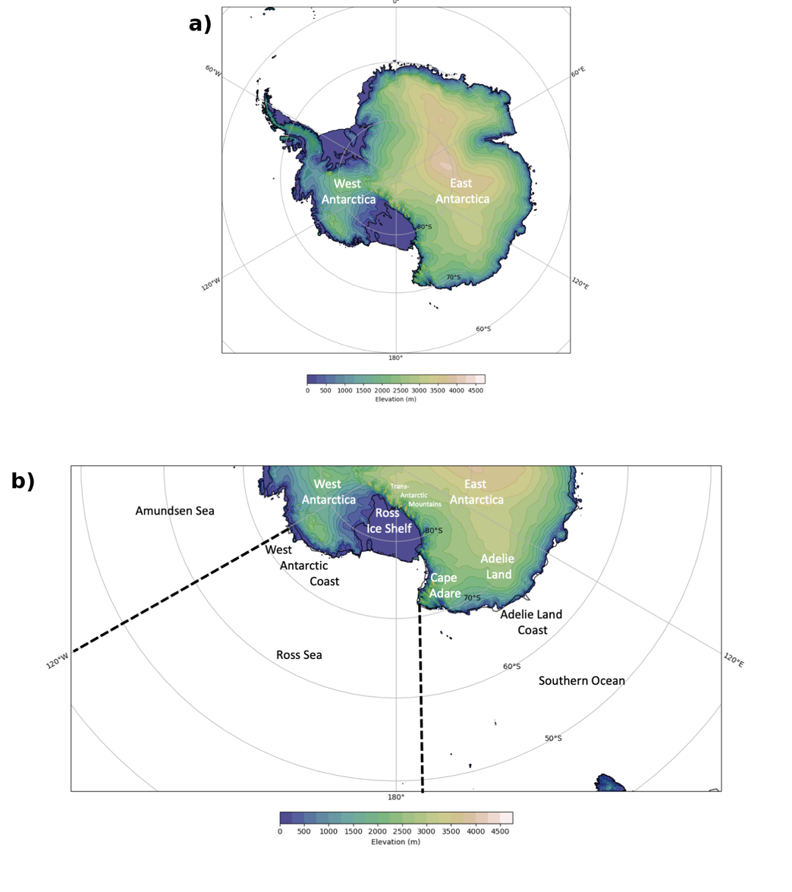
Figure 1: a) The topography of Antarctica (m). Contours are every 250 m. b) Labels of regions referenced in this study. The black dashed lines separate the Southern Ocean, Ross Sea, and Amundsen Sea.

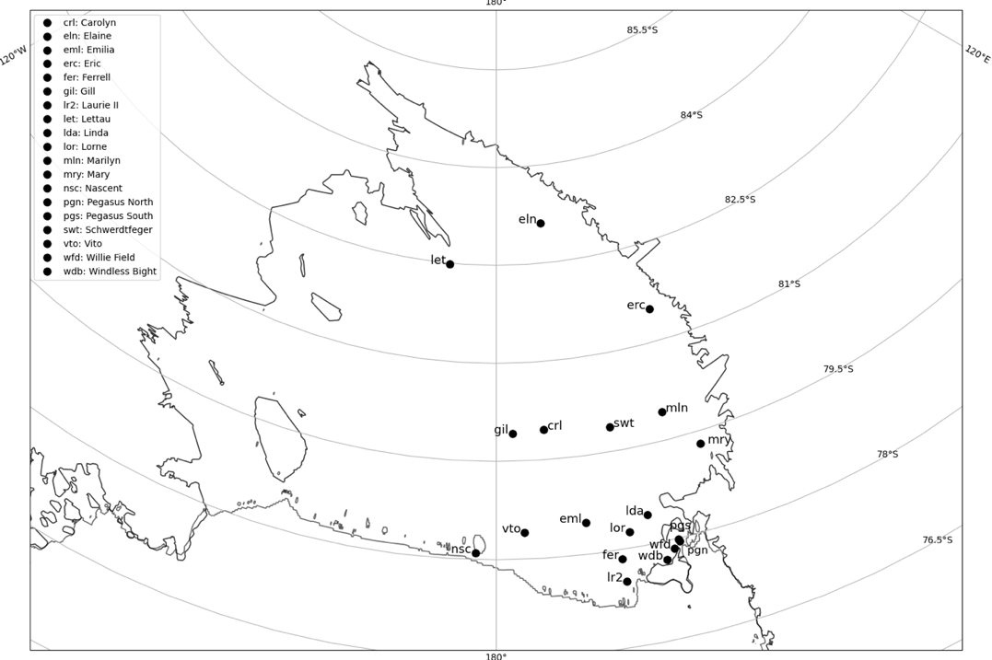
Figure 2: All AWS installed on the Ross Ice Shelf in 2007.

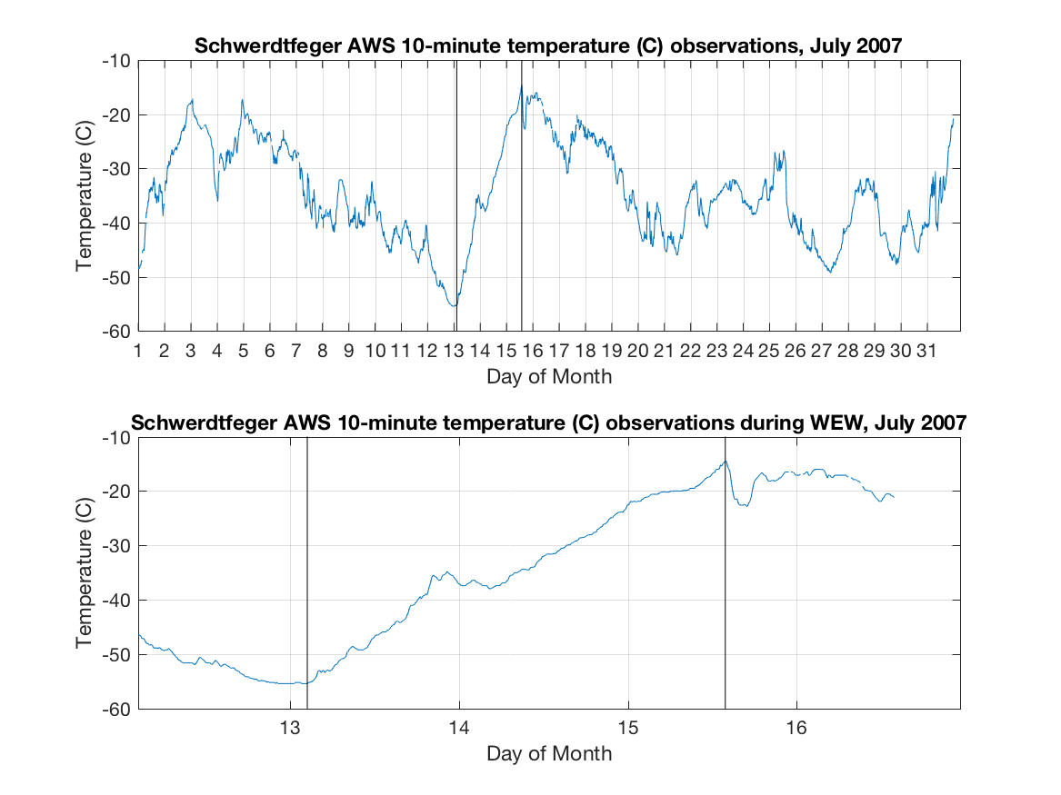
Figure 3: Temperature observations at Schwerdtfeger for July 2007 (top) and 12-16 July 2007 (bottom). The black vertical lines denote the beginning and ending of the warming event.

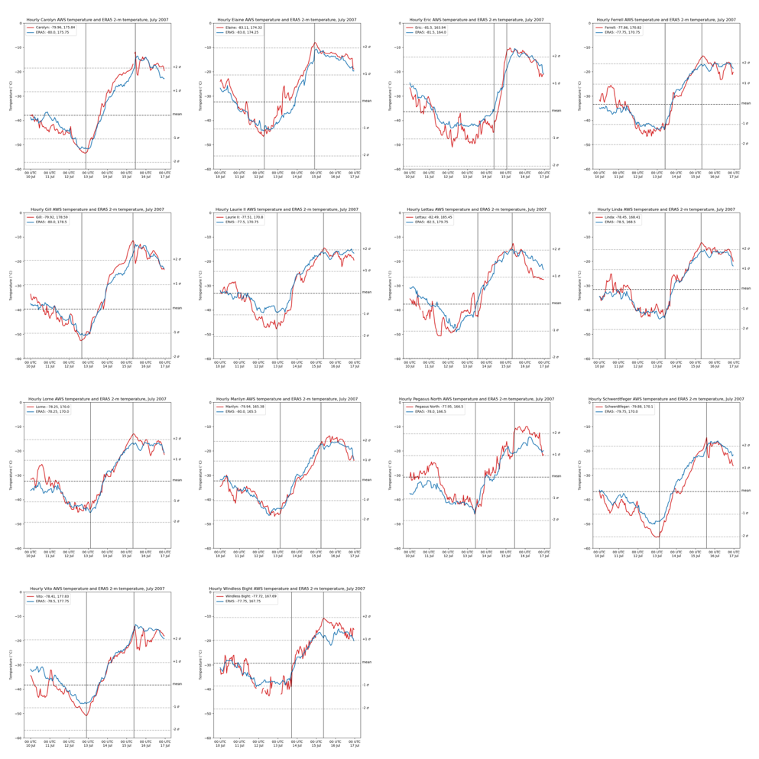
Figure 4: Hourly temperatures of AWS observations (red) and ERA5 2-m temperatures (blue) (° C) from 10 through 17 July 2007, with separate plots for each of the 14 AWS observing warming. Black vertical lines denote the beginning and ending of the warming events. Horizontal dashed lines indicate the respective AWS climatological July monthly mean temperature and +/-1 and +/-2 standard deviations from the mean. The legend includes the AWS coordinates and the ERA5 coordinates of the nearest grid cell.

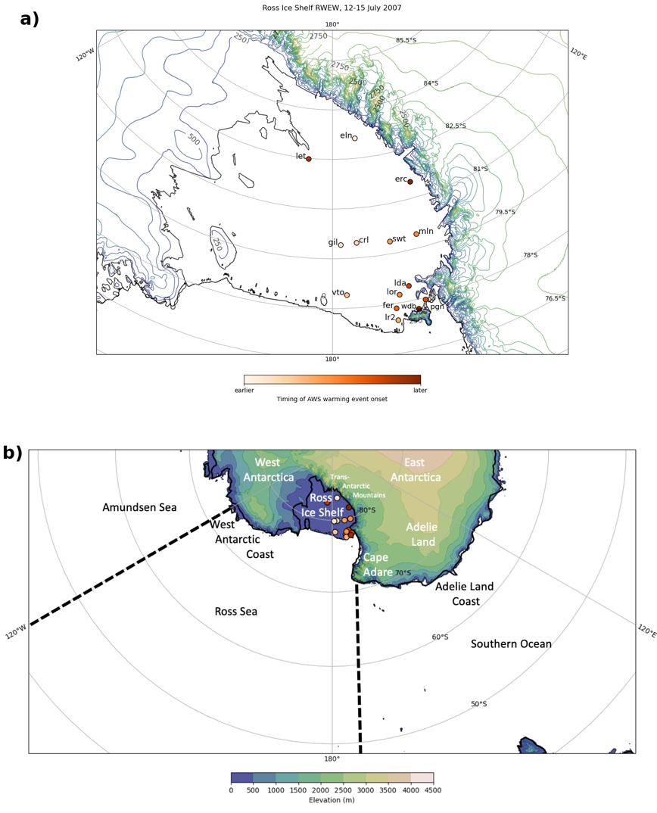
Figure 5: a) Map of the RIS with each AWS location color-coded based on onset of warming event, and topographical contours every 250 m and color-coded as shown in the legend in b), and b) as in Fig. 1b, but with the AWS locations included, color-coded as in a).

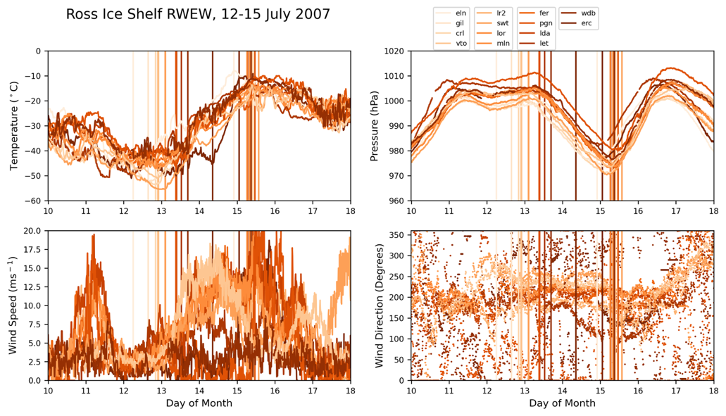
Figure 6: AWS observations from 10-17 July 2007 of temperature (º C) (upper left), pressure (hPa) (upper right), wind speed (m s⁻¹) (lower left), and wind direction (degrees) (lower right). All data plotted are color-coded as in Fig. 5a.

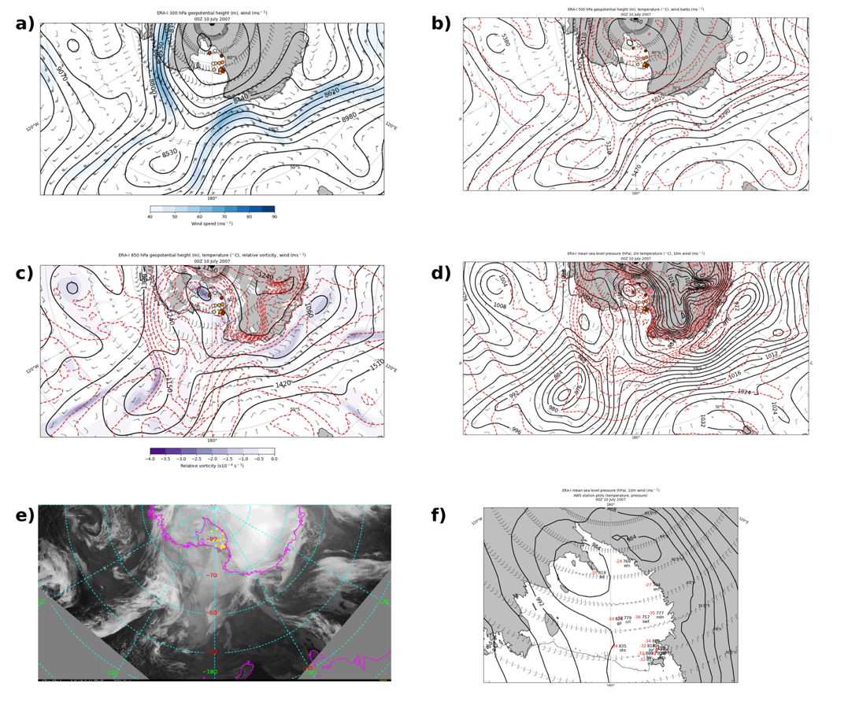
Figure 7: ERA-I 00 UTC 10 July a) 300-hPa geopotential height (m) (black contours), wind speed (m s⁻¹) (fill contours every 5 m s⁻¹ from 40 to 90 m s⁻¹), wind barbs (m s⁻¹); b) 500-hPa geopotential height (m) (black contours), temperature (° C) (dashed red contours), wind barbs (m s⁻¹); c) 850-hPa geopotential height (m) (black contours), temperature (° C) (dashed red contours), relative vorticity (10⁻⁴ s⁻¹) (fill contours from -4 to 0 every 0.5), wind barbs (m s⁻¹); d) mean sea level pressure (hPa) (black contours), 2-m temperature (° C) (dashed red contours), 10-m wind barbs (m s⁻¹); e) infrared satellite composite image with yellow dots denoting AWS locations; f) mean sea level pressure (hPa) (black contours), 10-m wind barbs (m s⁻¹), station plots of AWS observations of temperature (° C, red) in upper left and pressure in upper right where the leading two digits are dropped if the pressure is greater than or equal to 1000 hPa and the leading first digit is dropped if the pressure is less than 1000 hPa. For a)-d), geopotential heights are contoured every 90 m, temperatures are contoured every 4° C, and AWS are plotted as in Fig. 5a.

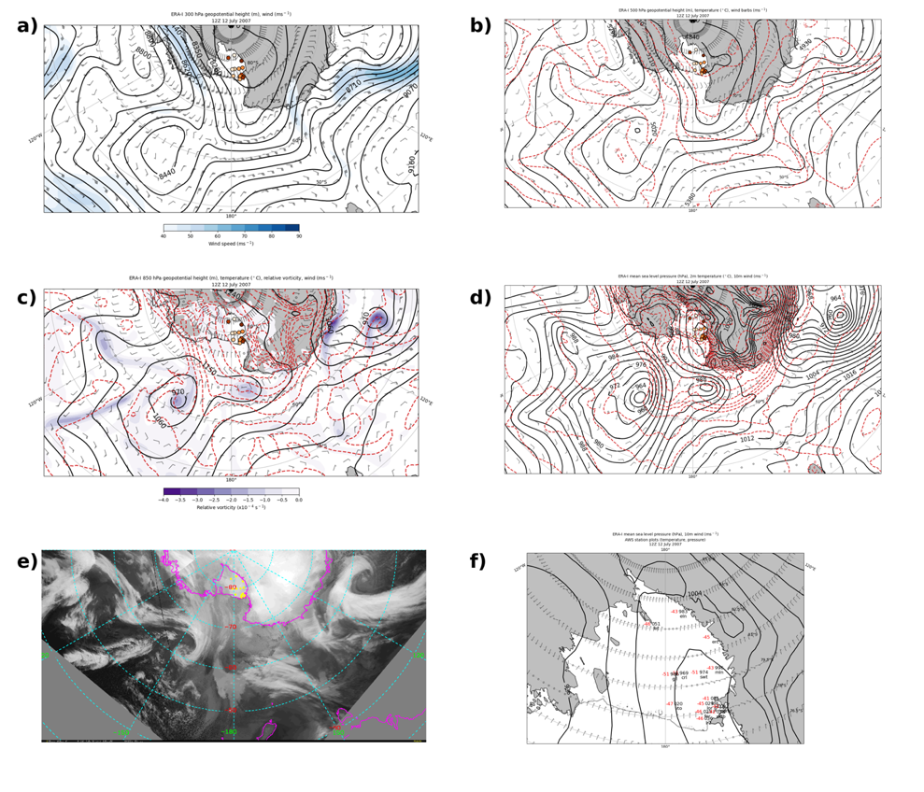
Figure 8: As in Fig. 7 but for 12 UTC 12 July.

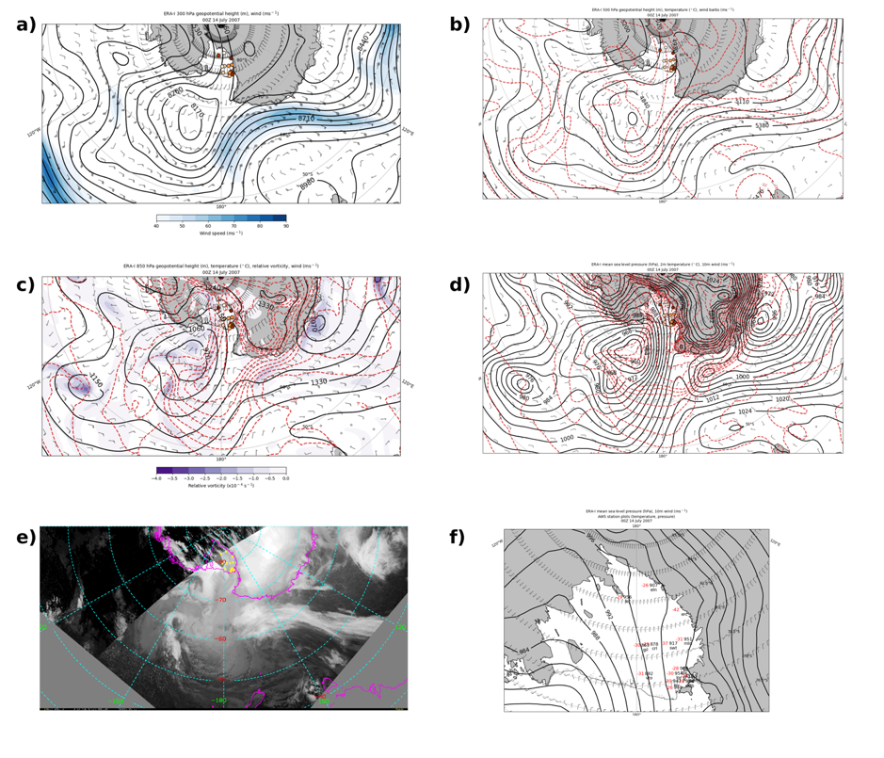
Figure 9: As in Fig. 7 but for 00 UTC 14 July.

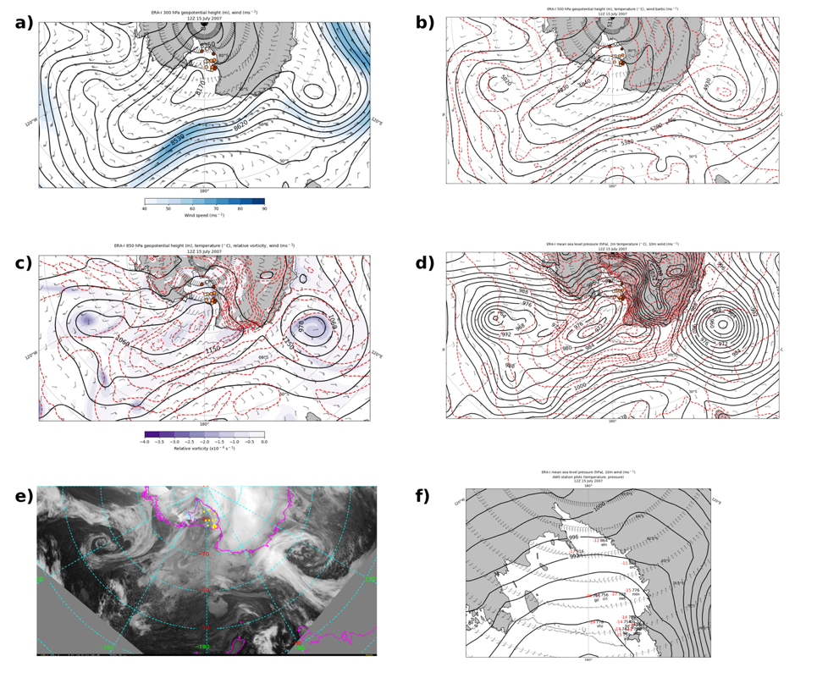
Figure 10: As in Fig. 7 but for 12 UTC 15 July.

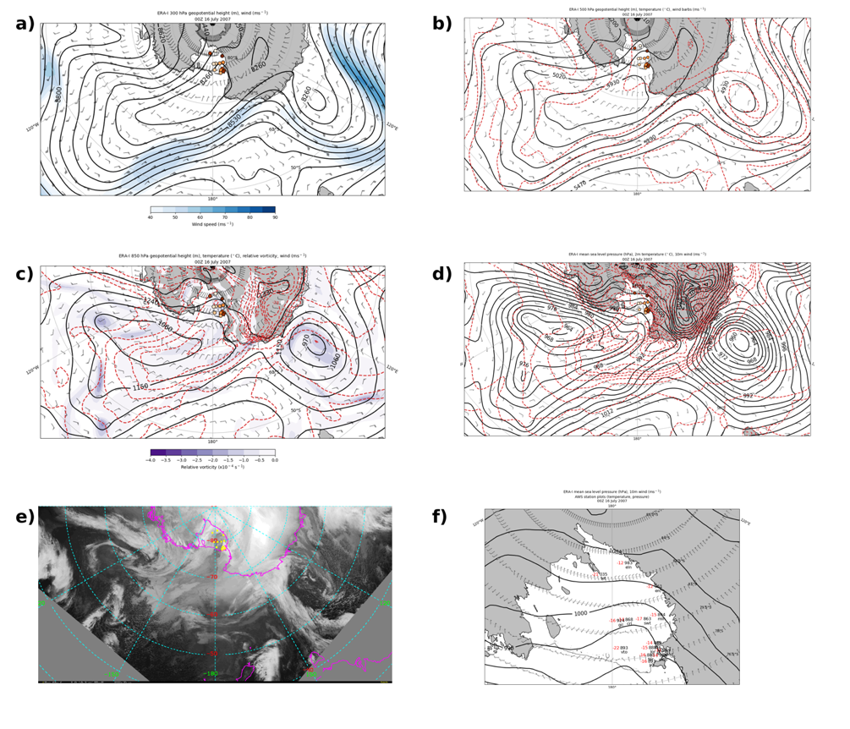
Figure 11: As in Fig. 7 but for 00 UTC 16 July.

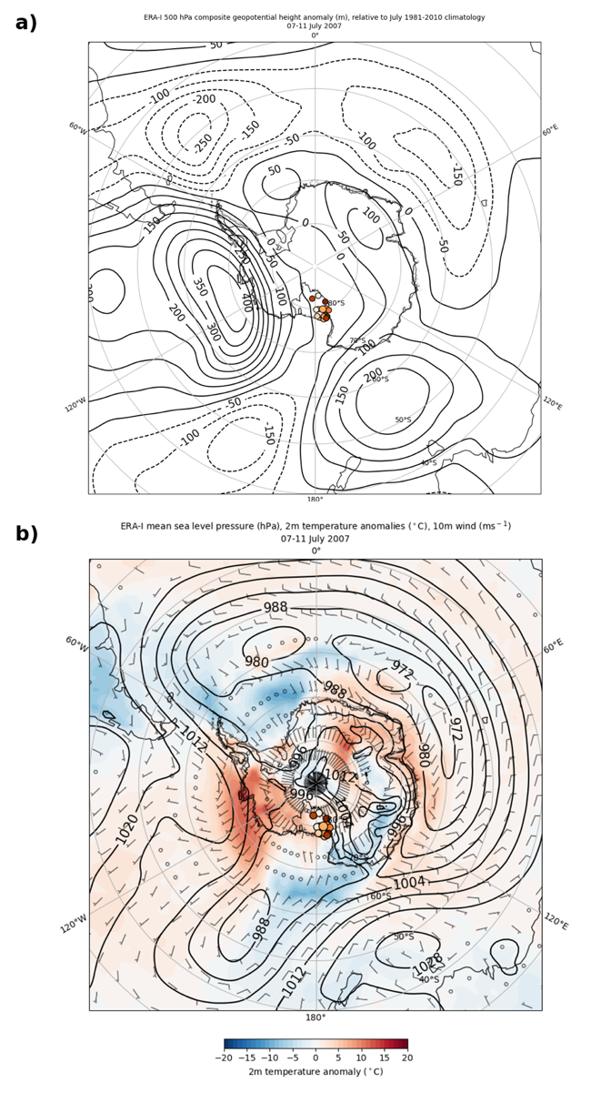
Figure 12: ERA-I composite plots from 07-11 July 2007 of a) 500-hPa geopotential height anomalies (m) (black contours, every 50 m, with negative values dashed); b) mean sea level pressure (hPa) (black contours), 2-m temperature anomalies (° C) (color fill), wind barbs (m s⁻¹). Anomalies are relative to the July 1981-2010 climatology. For a) and b), AWS are plotted as in Fig. 5a.

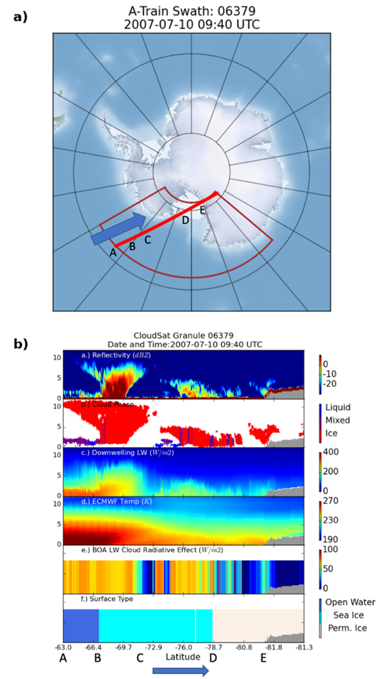
Figure 13: CloudSat/CALIPSO A-train satellite constellation data retrievals at 09:40 UTC 10 July 2007. a) The path of the A-train satellite constellation (red) with the blue arrow denoting the direction of travel. Letters correspond to locations discussed in text. b) Panel a) reflectivity (dBZ) from 0 to -30 dBZ; b) Cloud phase: liquid (blue), mixed (purple), ice (red); c) Downwelling longwave radiation (W m⁻²) from 0 to 400 W m⁻²; d) ECMWF temperature (K) from 190 to 270 K; e) bottom-of-atmosphere longwave cloud radiative effect (W m⁻²) from 0 to 100 W m⁻²; f) surface type: open water (dark blue), sea ice (light blue), and permanent ice (white). Blue arrow and letters A through E at the bottom correspond to a). The time denotes the time the satellites were at the midpoint of the red line in a).

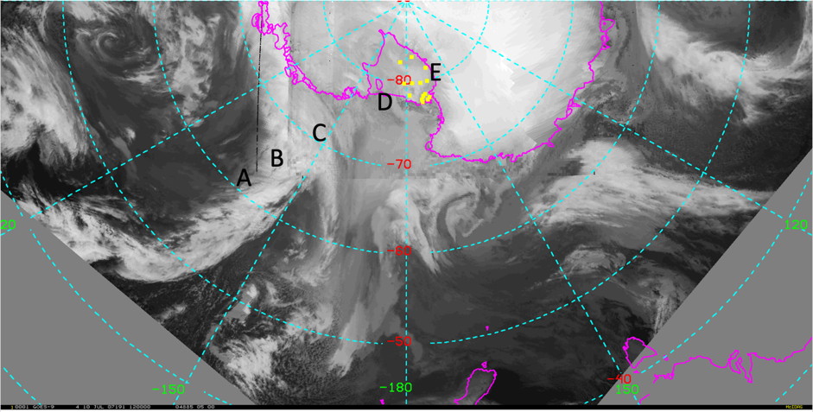
Figure 14: Infrared satellite composite image with annotated letters corresponding to locations in Fig. 13 and yellow dots denoting AWS locations.

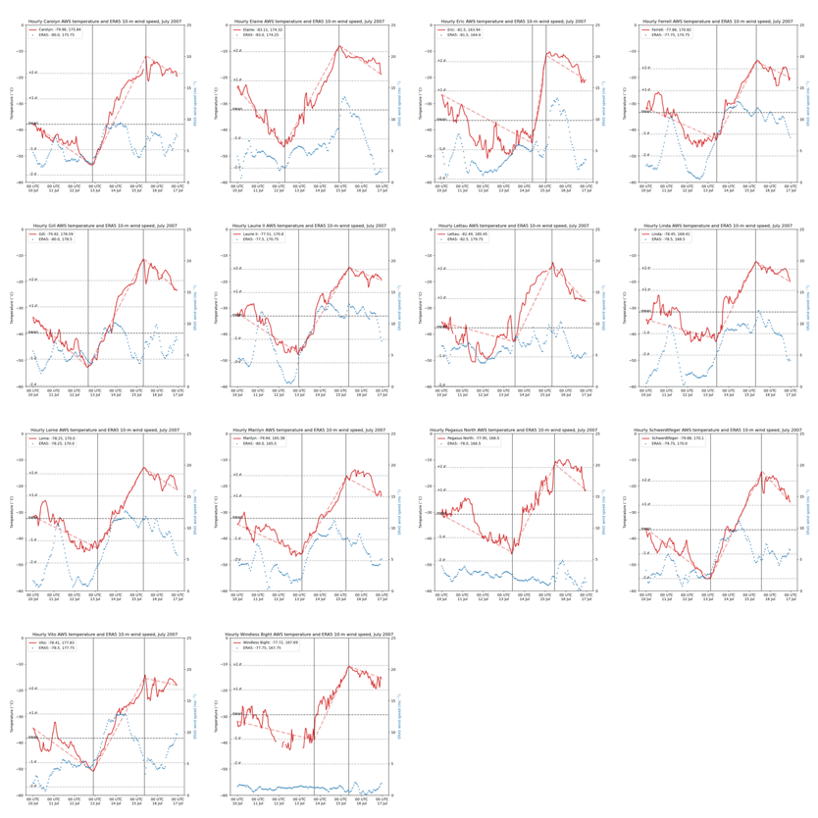
Figure 15: As in Fig. 4, except blue dots are ERA5 10-m wind speeds (m s⁻¹), and dashed red lines denote the temperature trend before, during, and after each respective warming event.

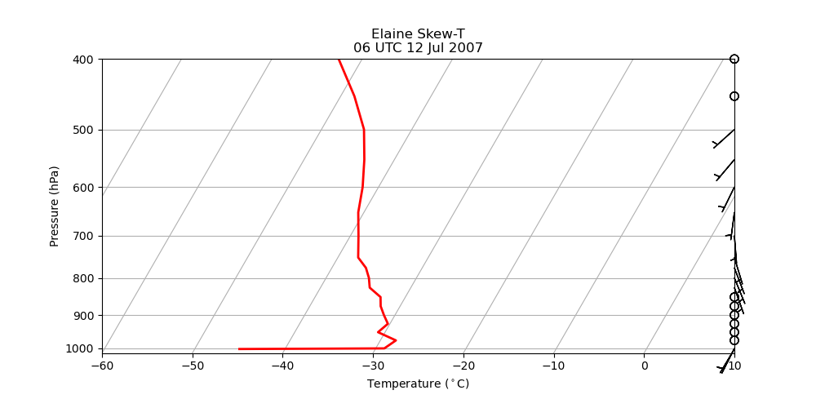
Figure 16: ERA-I 06 UTC 12 July 2007 vertical temperature (° C) profile (solid red line) versus pressure (hPa, note the logarithmic scale) and wind barbs (m s⁻¹) at the grid point nearest Elaine (-83.16°, 174.38°).

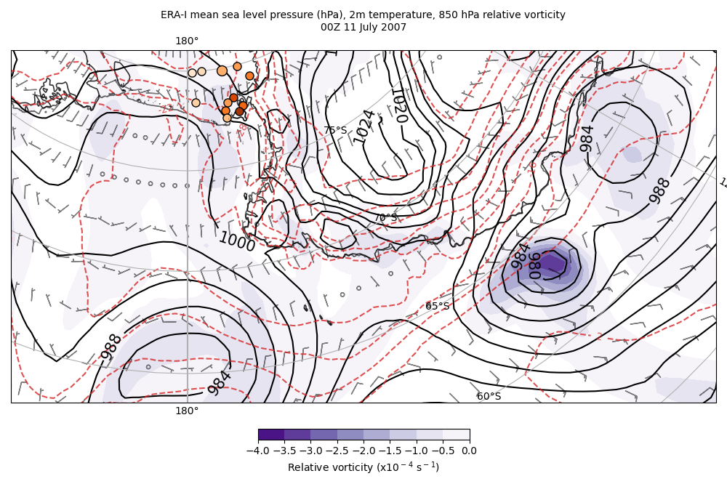
Figure 17: ERA-I 00 UTC 11 July 2007 mean sea level pressure (hPa) (black contours), 2-m temperature (° C) (dashed red contours, 850-hPa relative vorticity (10⁻⁴ s⁻¹) (fill contours from -4 to 0 every 0.5), and 10-m wind barbs (m s⁻¹). AWS are plotted as in Fig. 5a.

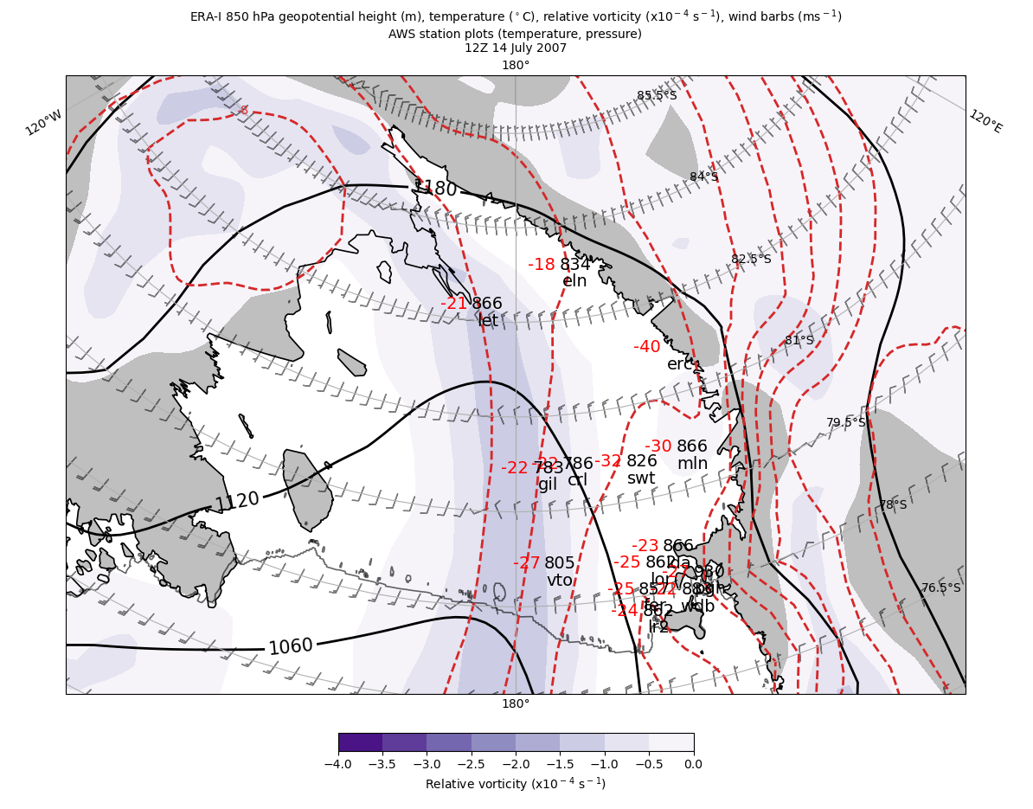
Figure 18: ERA-I 12 UTC 14 July geopotential height (m) (black contours), temperature (° C) (dashed red contours), relative vorticity (10⁻⁴ s⁻¹) (fill contours from -4 to 0 every 0.5), and wind barbs (m s⁻¹).

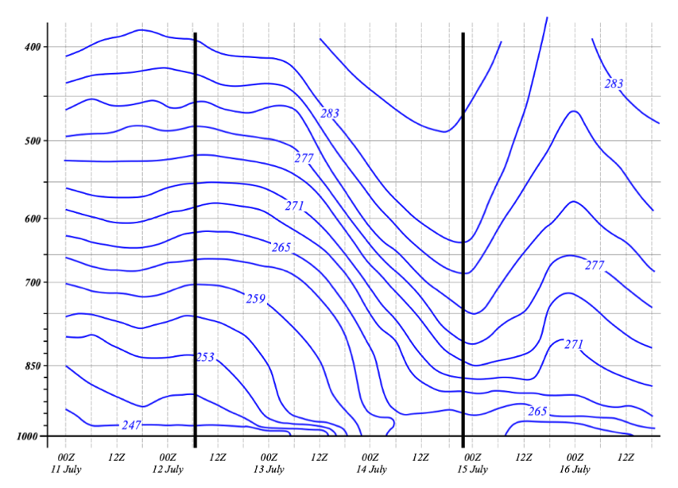
Figure 19: ERA5 time versus pressure (hPa, note the logarithmic scale) of temperature (K) (blue contours) at the grid point nearest Elaine. Black vertical lines denote beginning and ending of warming event.

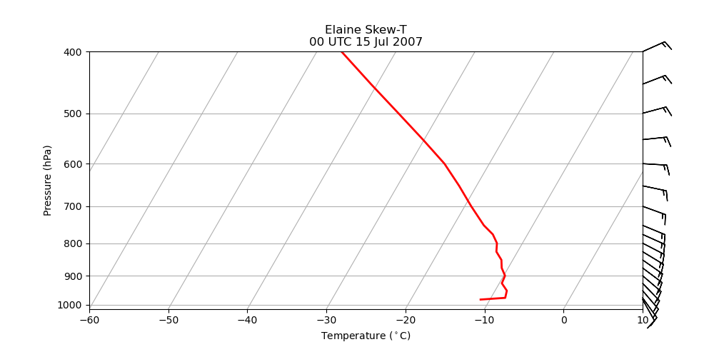
Figure 20: As in Fig. 16 but for 00 UTC 15 July 2007.

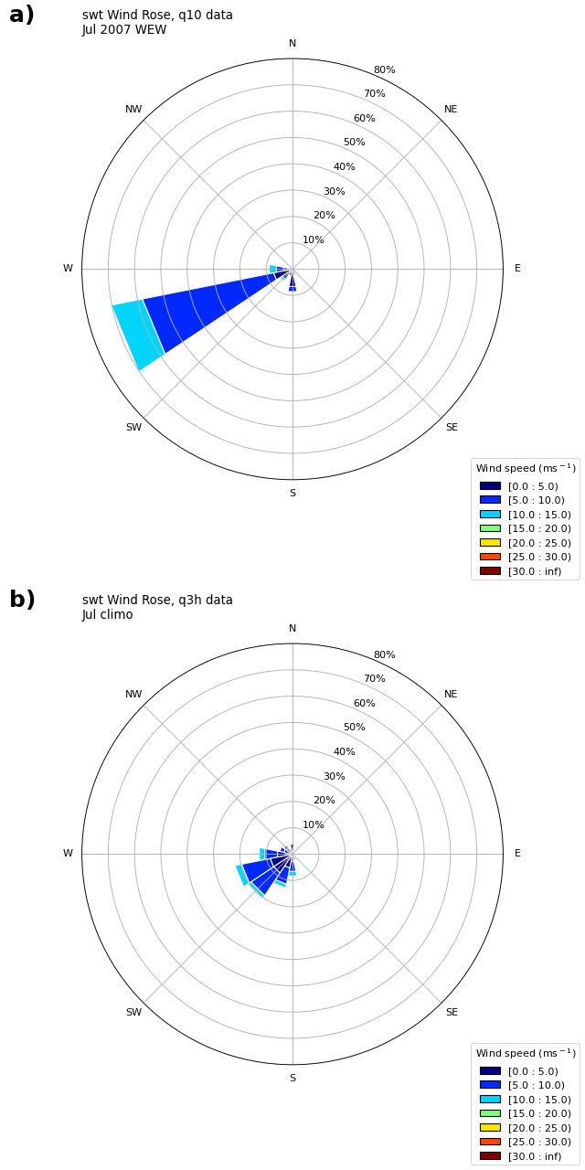
Figure 21: Schwerdtfeger wind rose plots a) during the warming event and b) for its July 1991-2020 climatology.

