O-283 UW AWS Pictures
2025-2026



AWS listed alphabetically
Date listed is when picture was taken

Alexander Tall Tower! (2023/12/08)
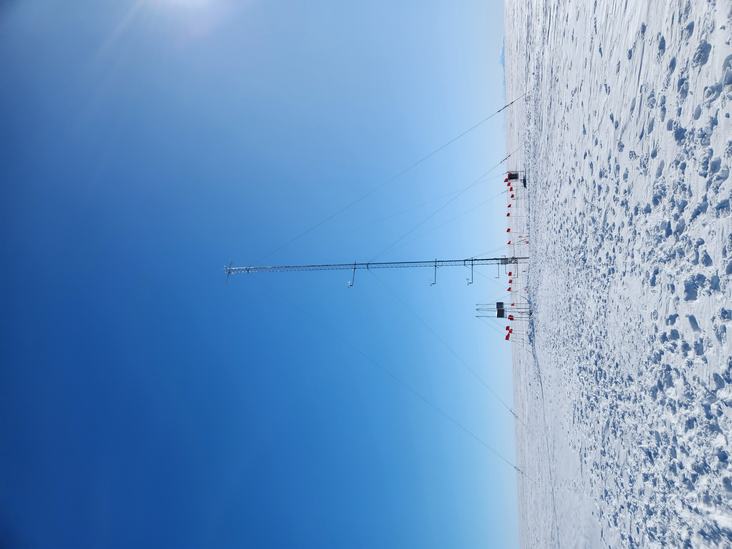
Austin (2019/01/12)
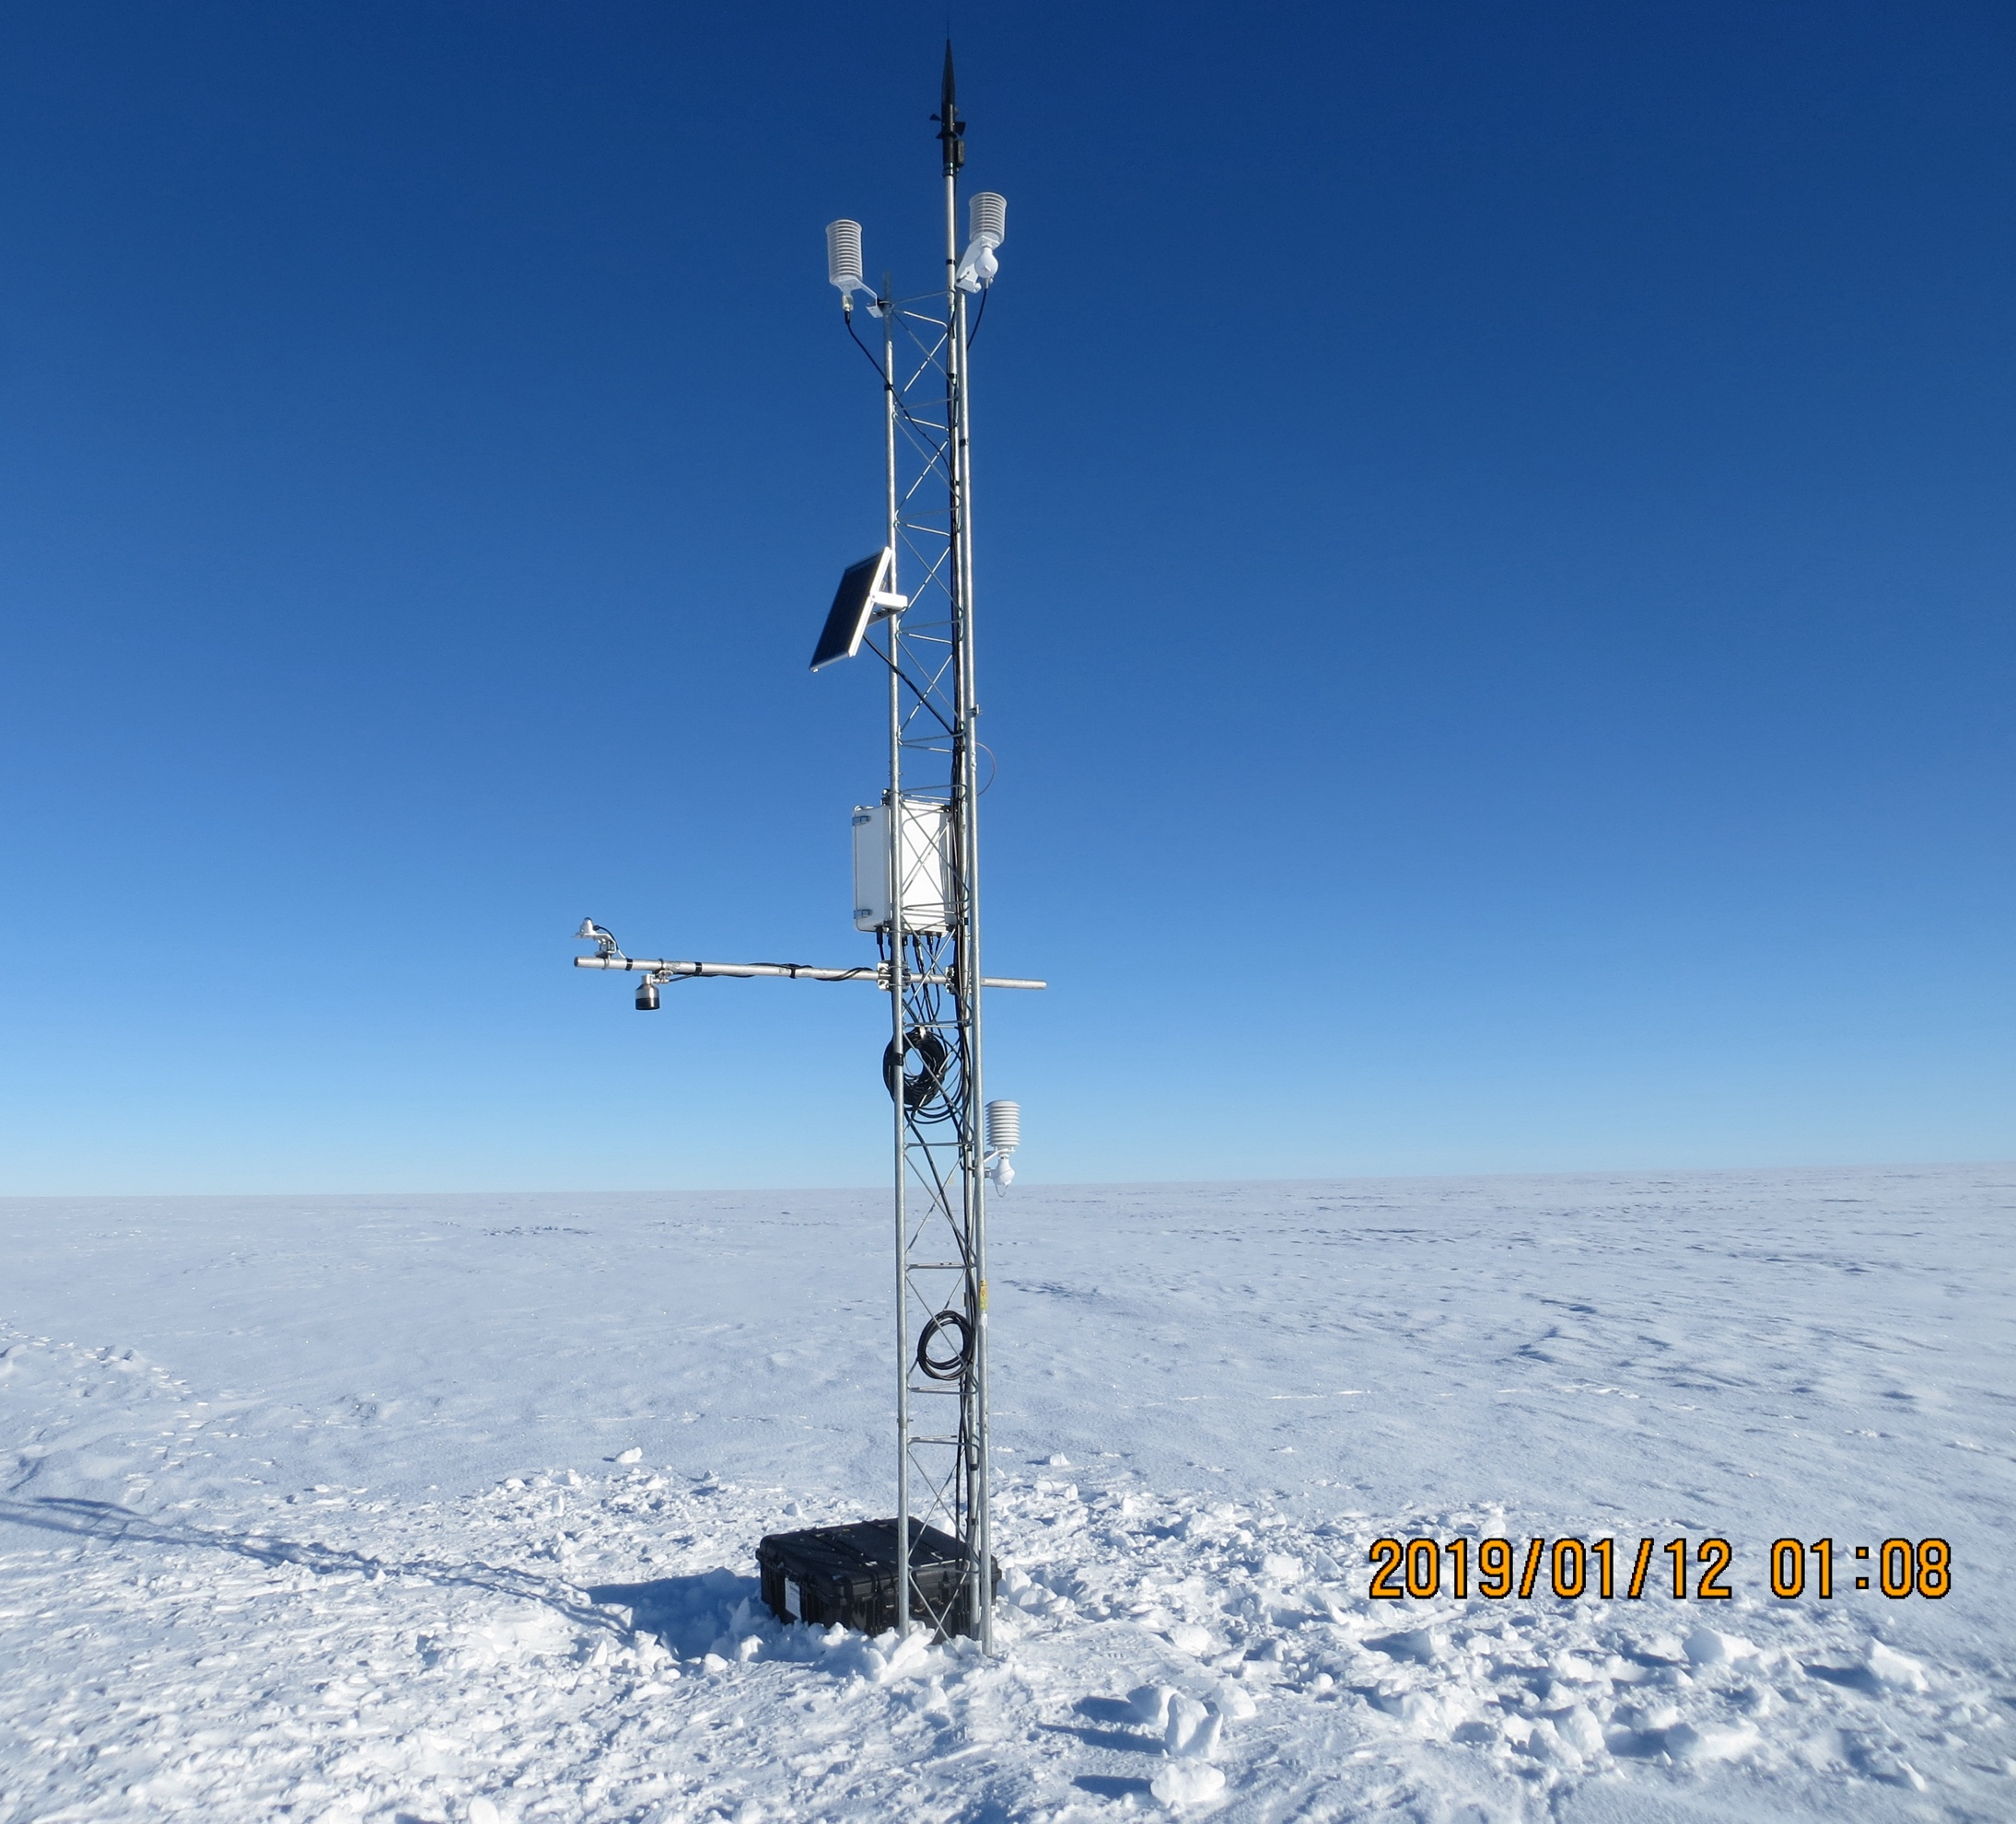

Bear Peninsula (2019/01/07)
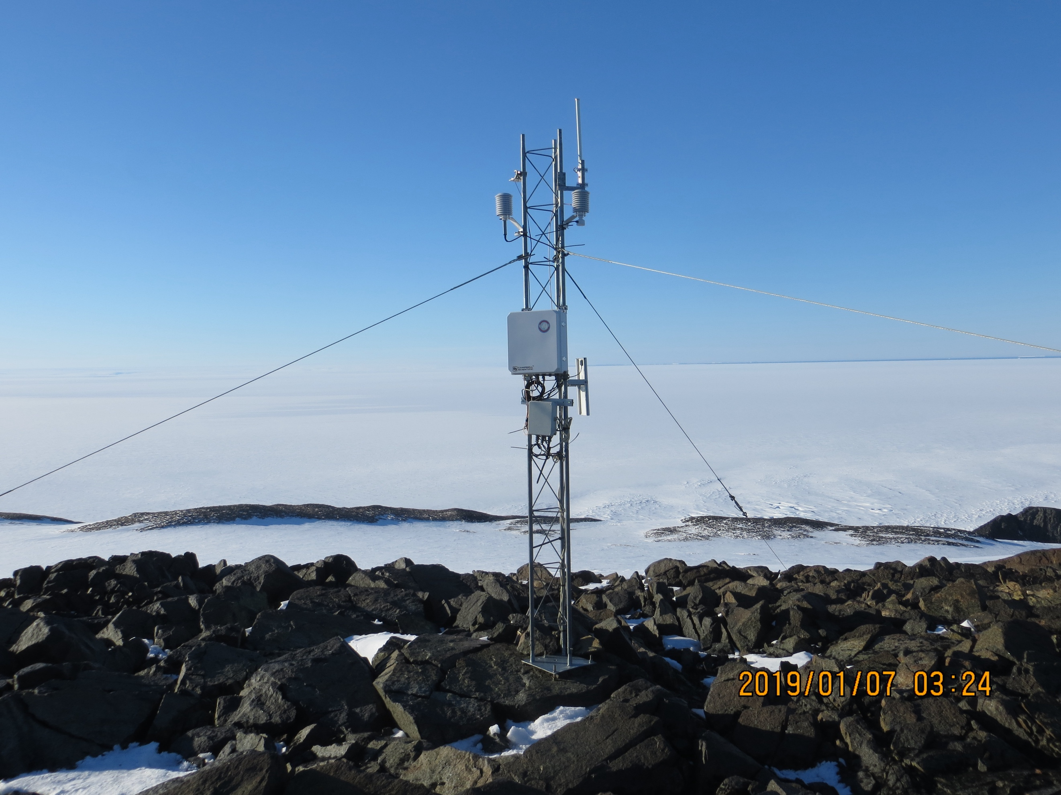

Byrd (2023/11/28)
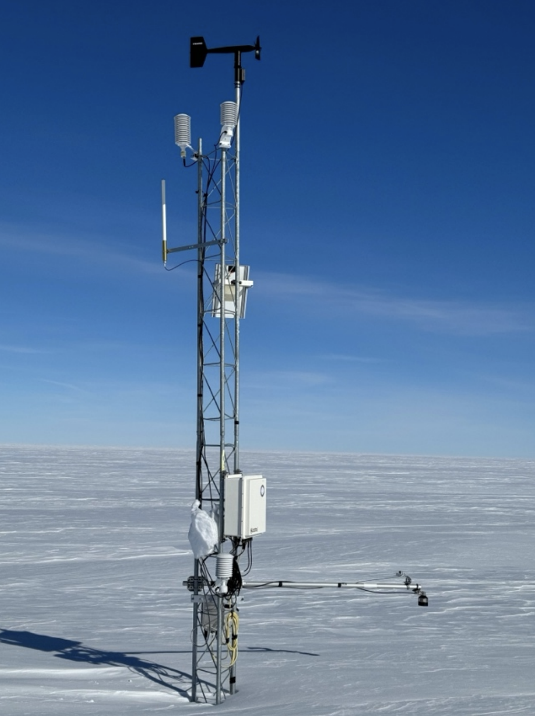

Cape Bird (2023/11/23)
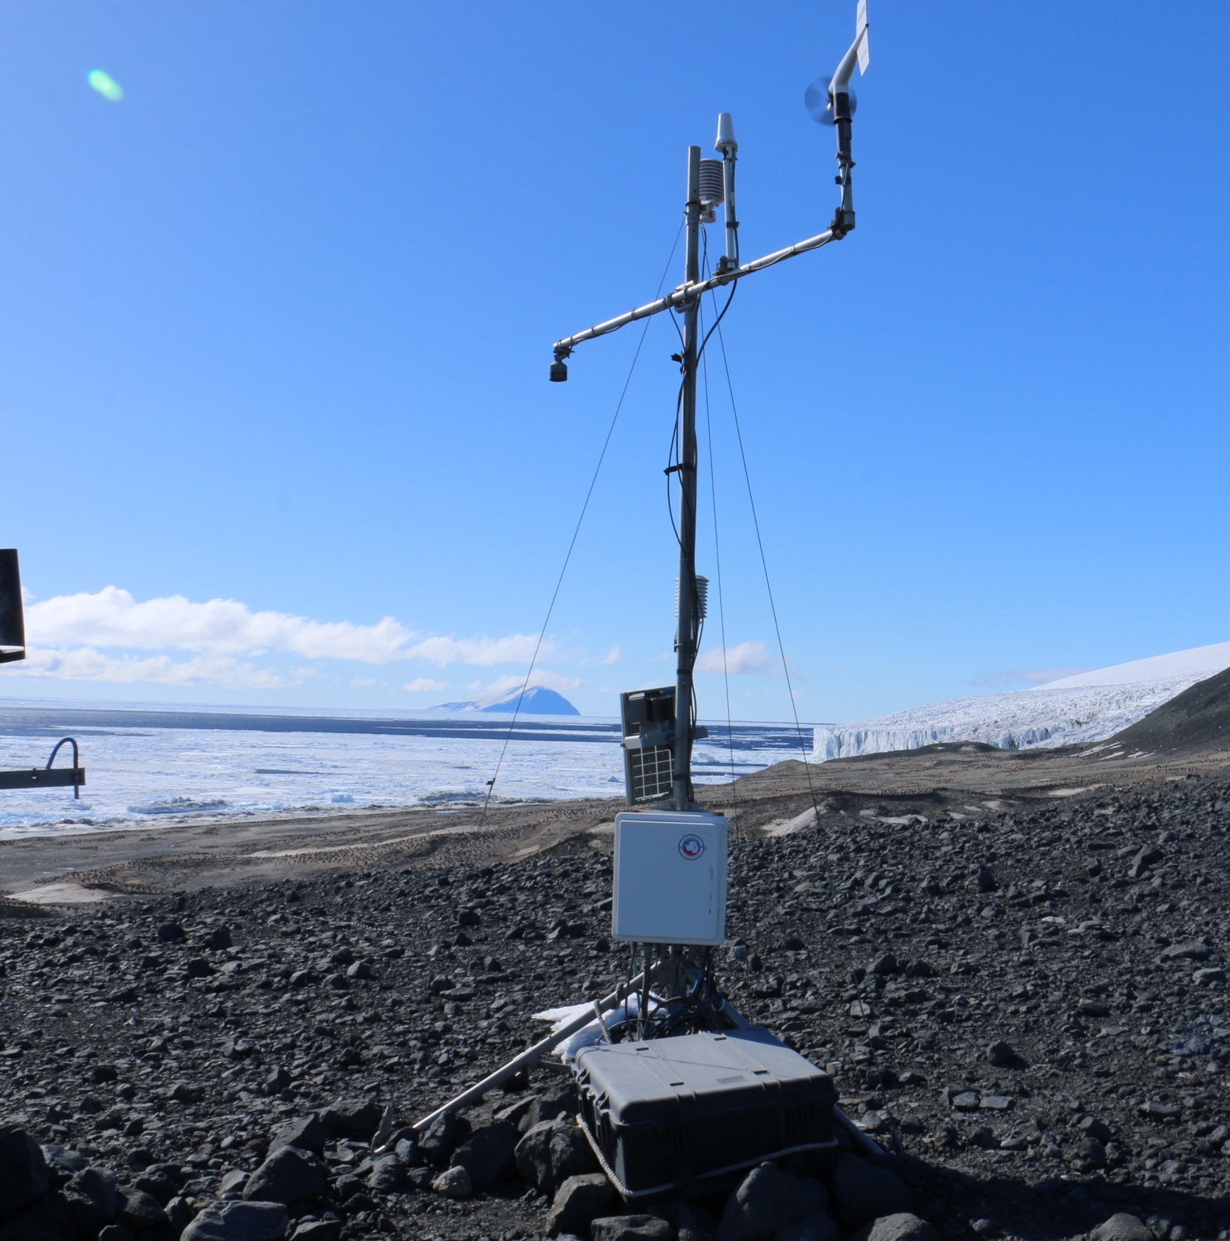
Cape Hallett (2022/11/16)
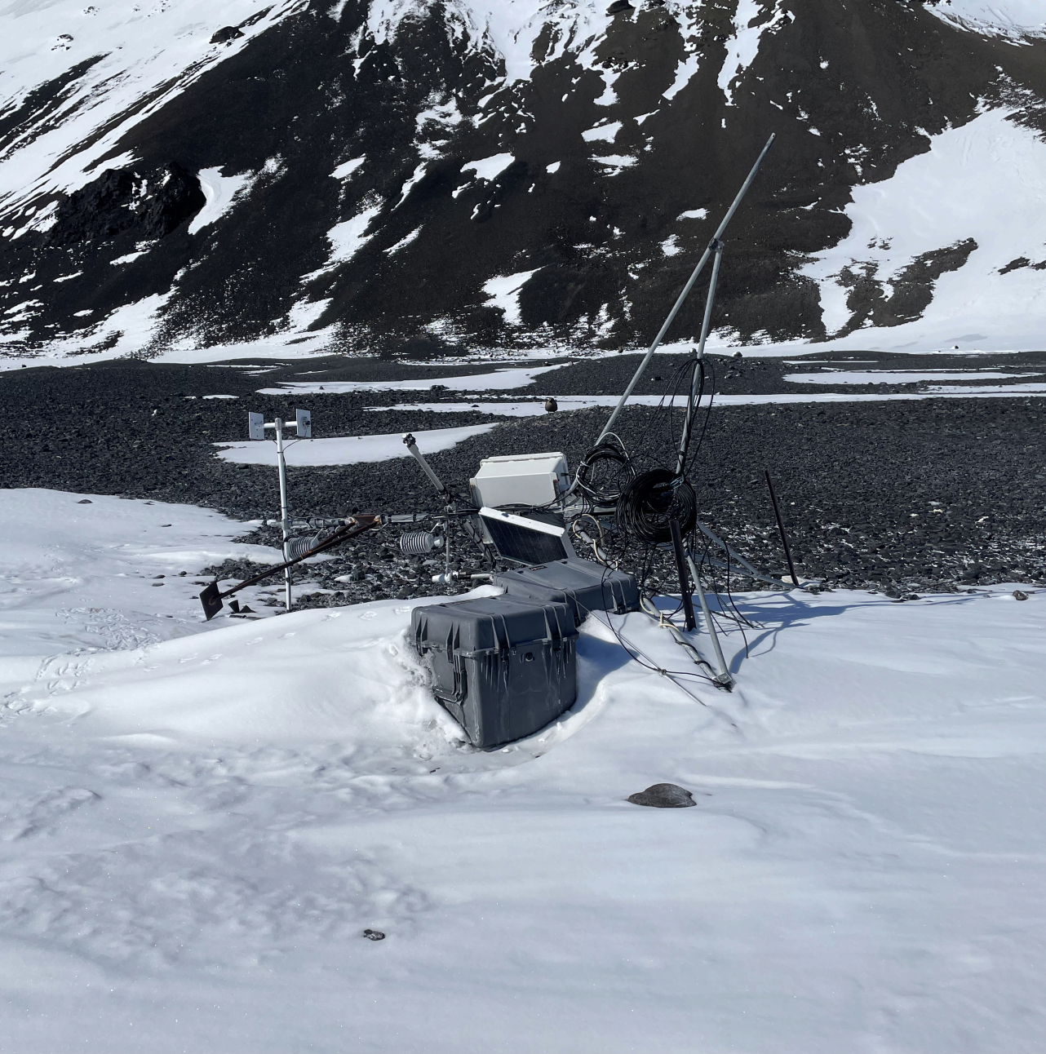

Elaine (left) and NIWC (2022/01/14)
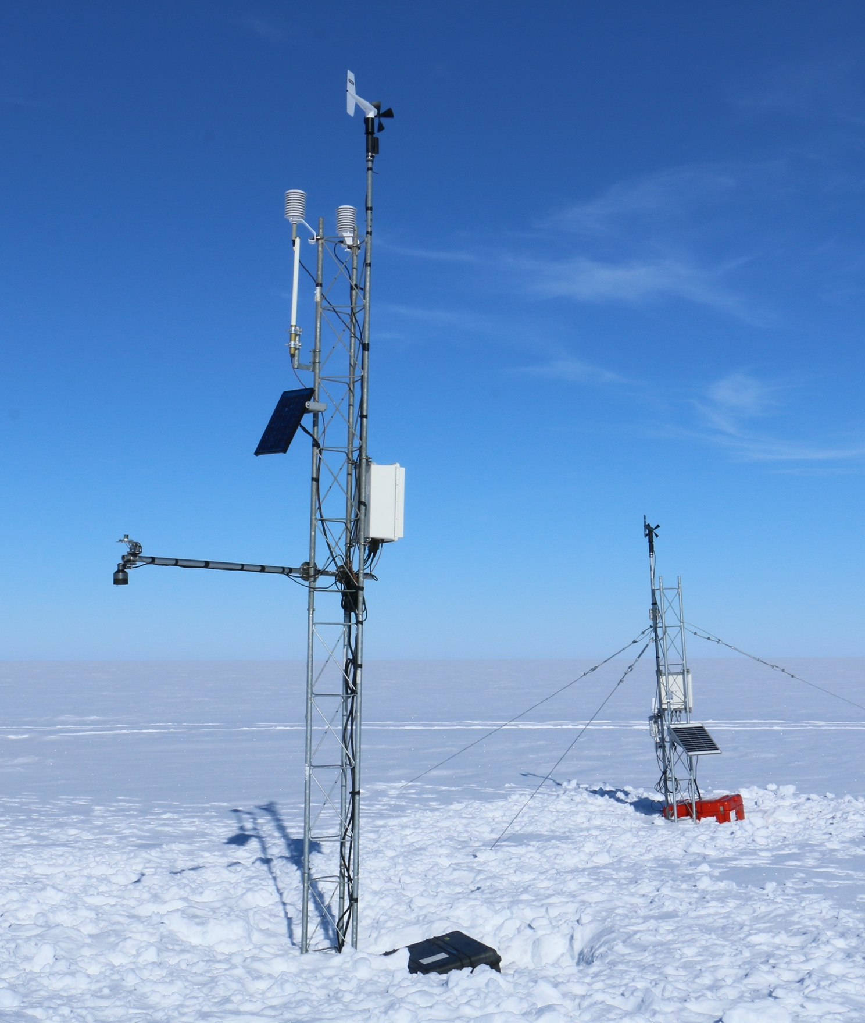
Erin (2019-01-17)
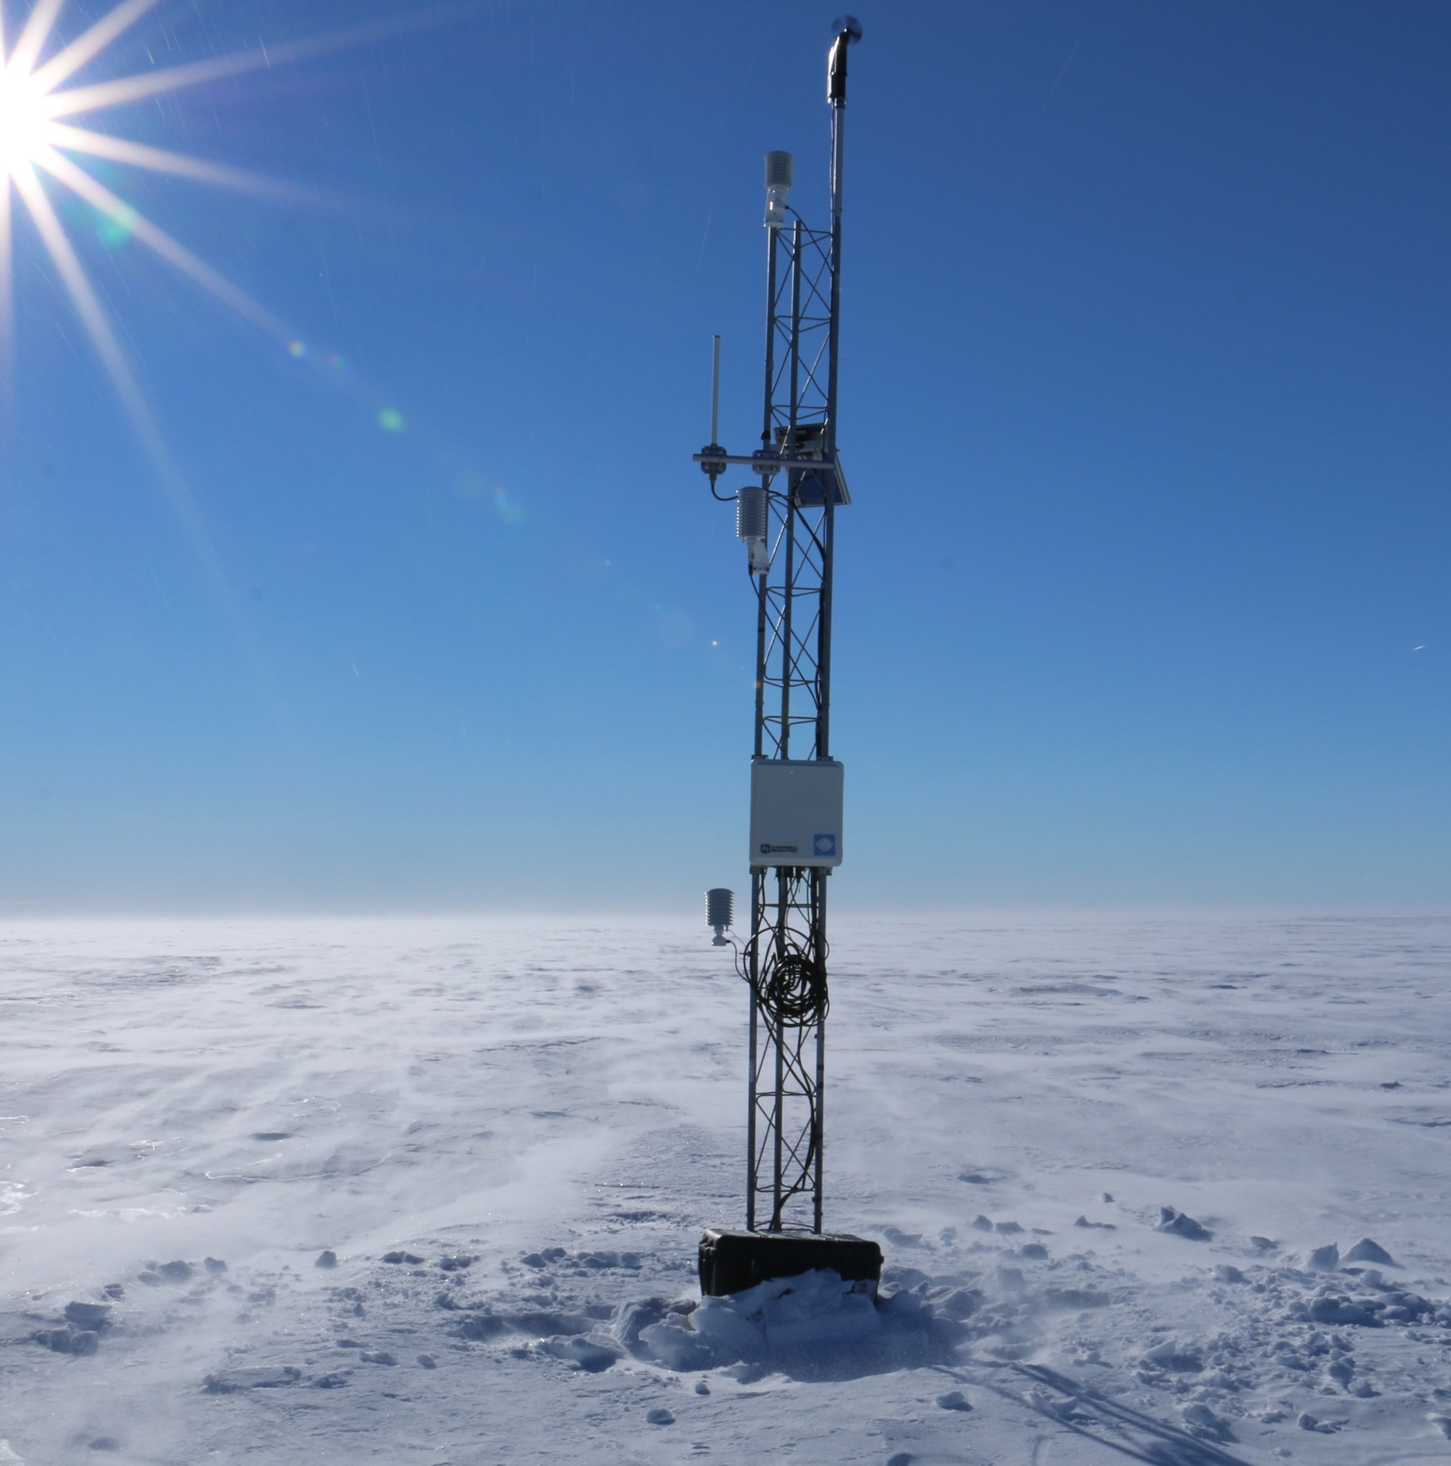

Harry (2019-01-21)
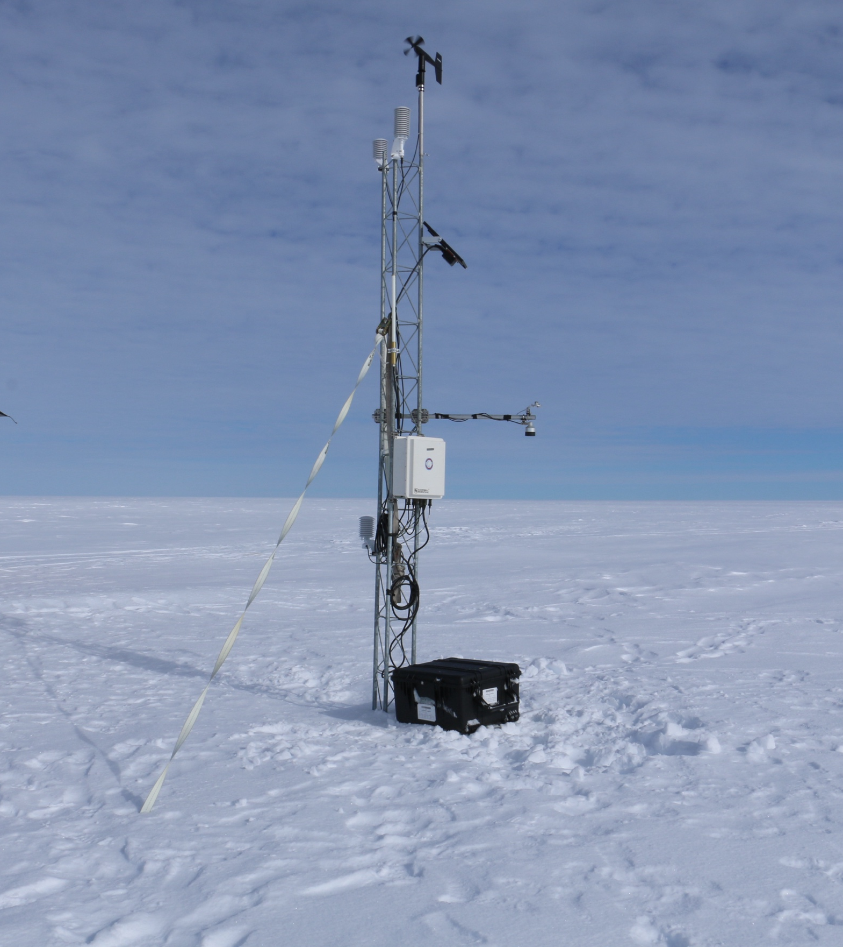

Janet (2019-01-21)
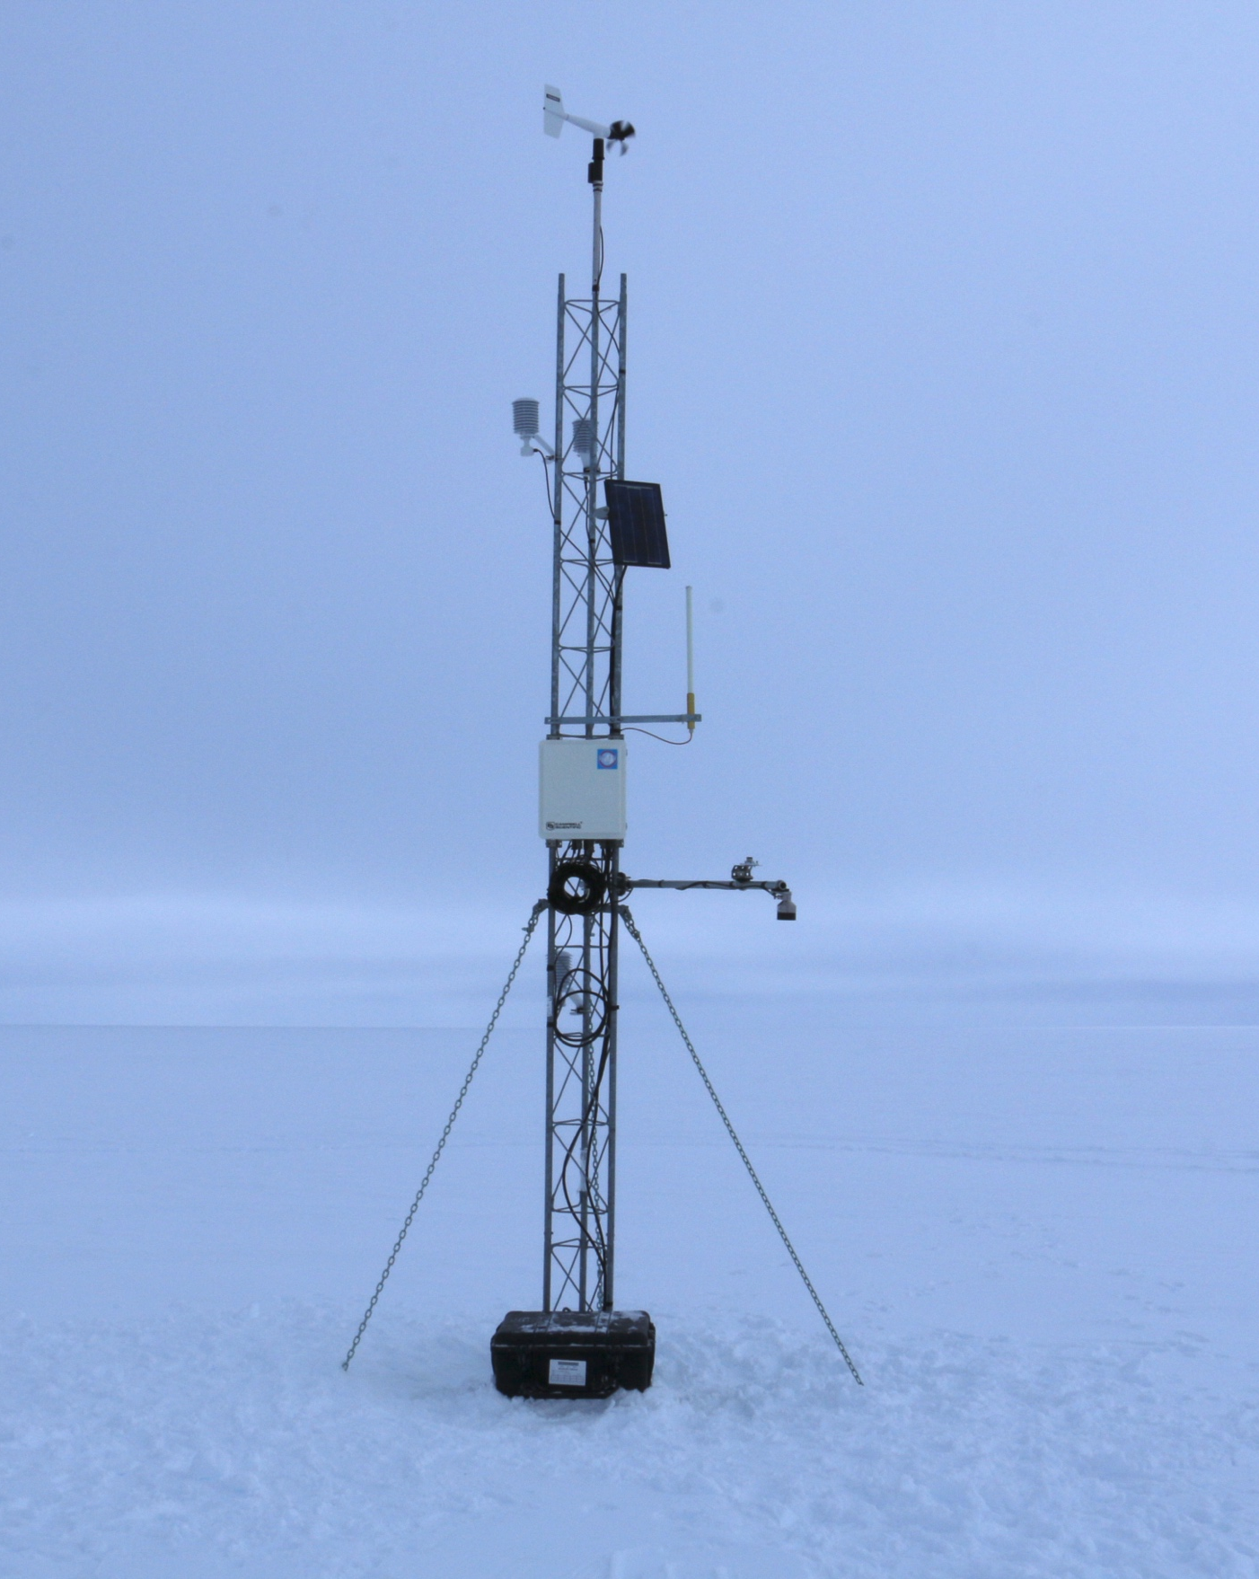

Kathie (2017-12-29)
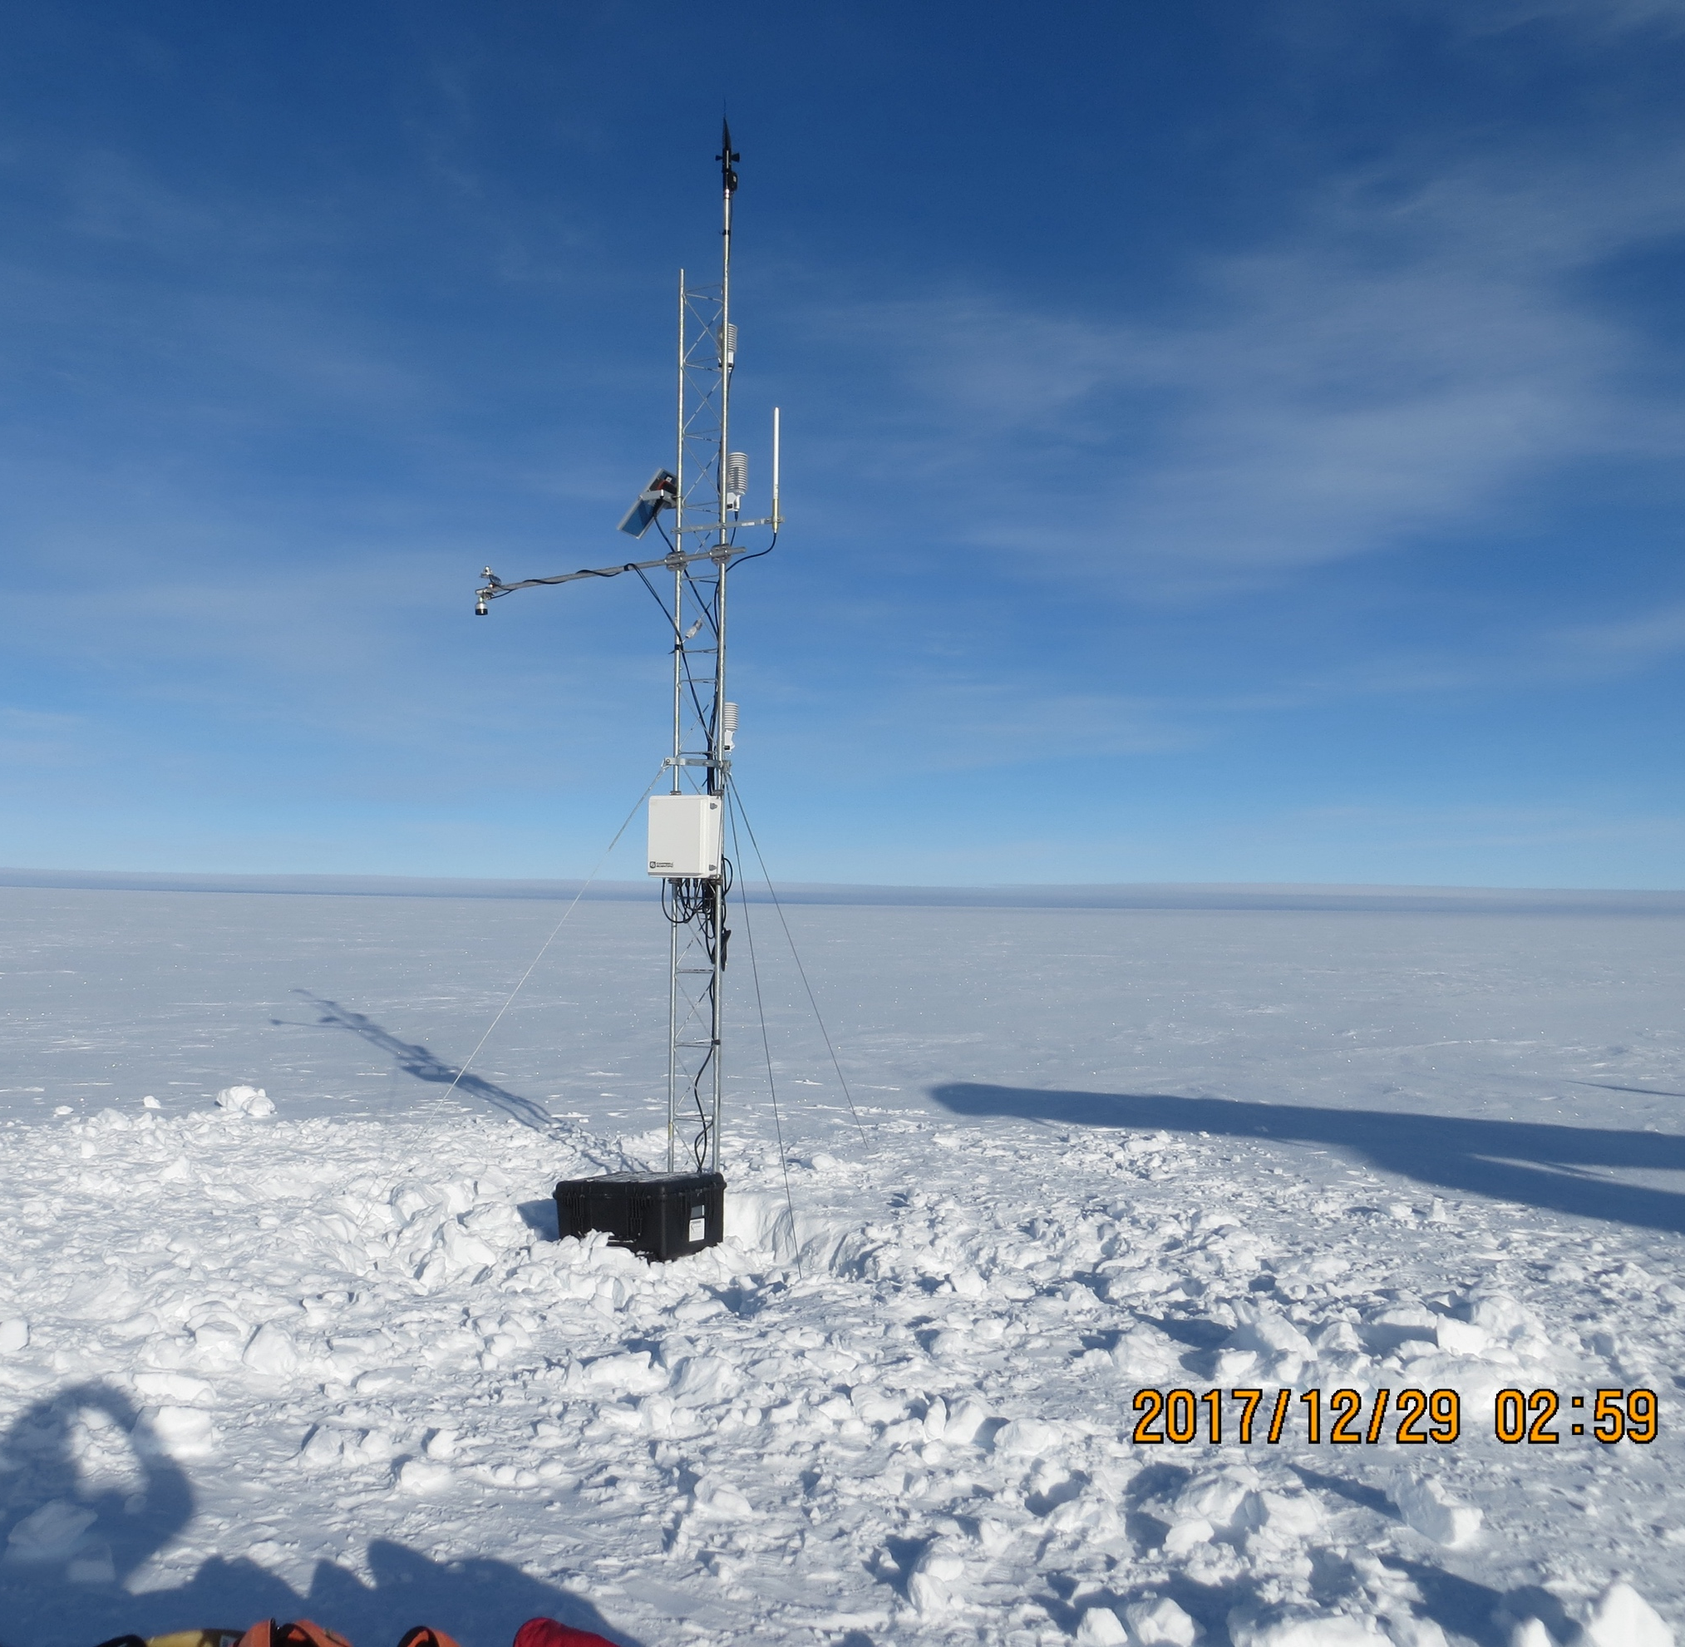
Kominko-Slade (2023/12/13)
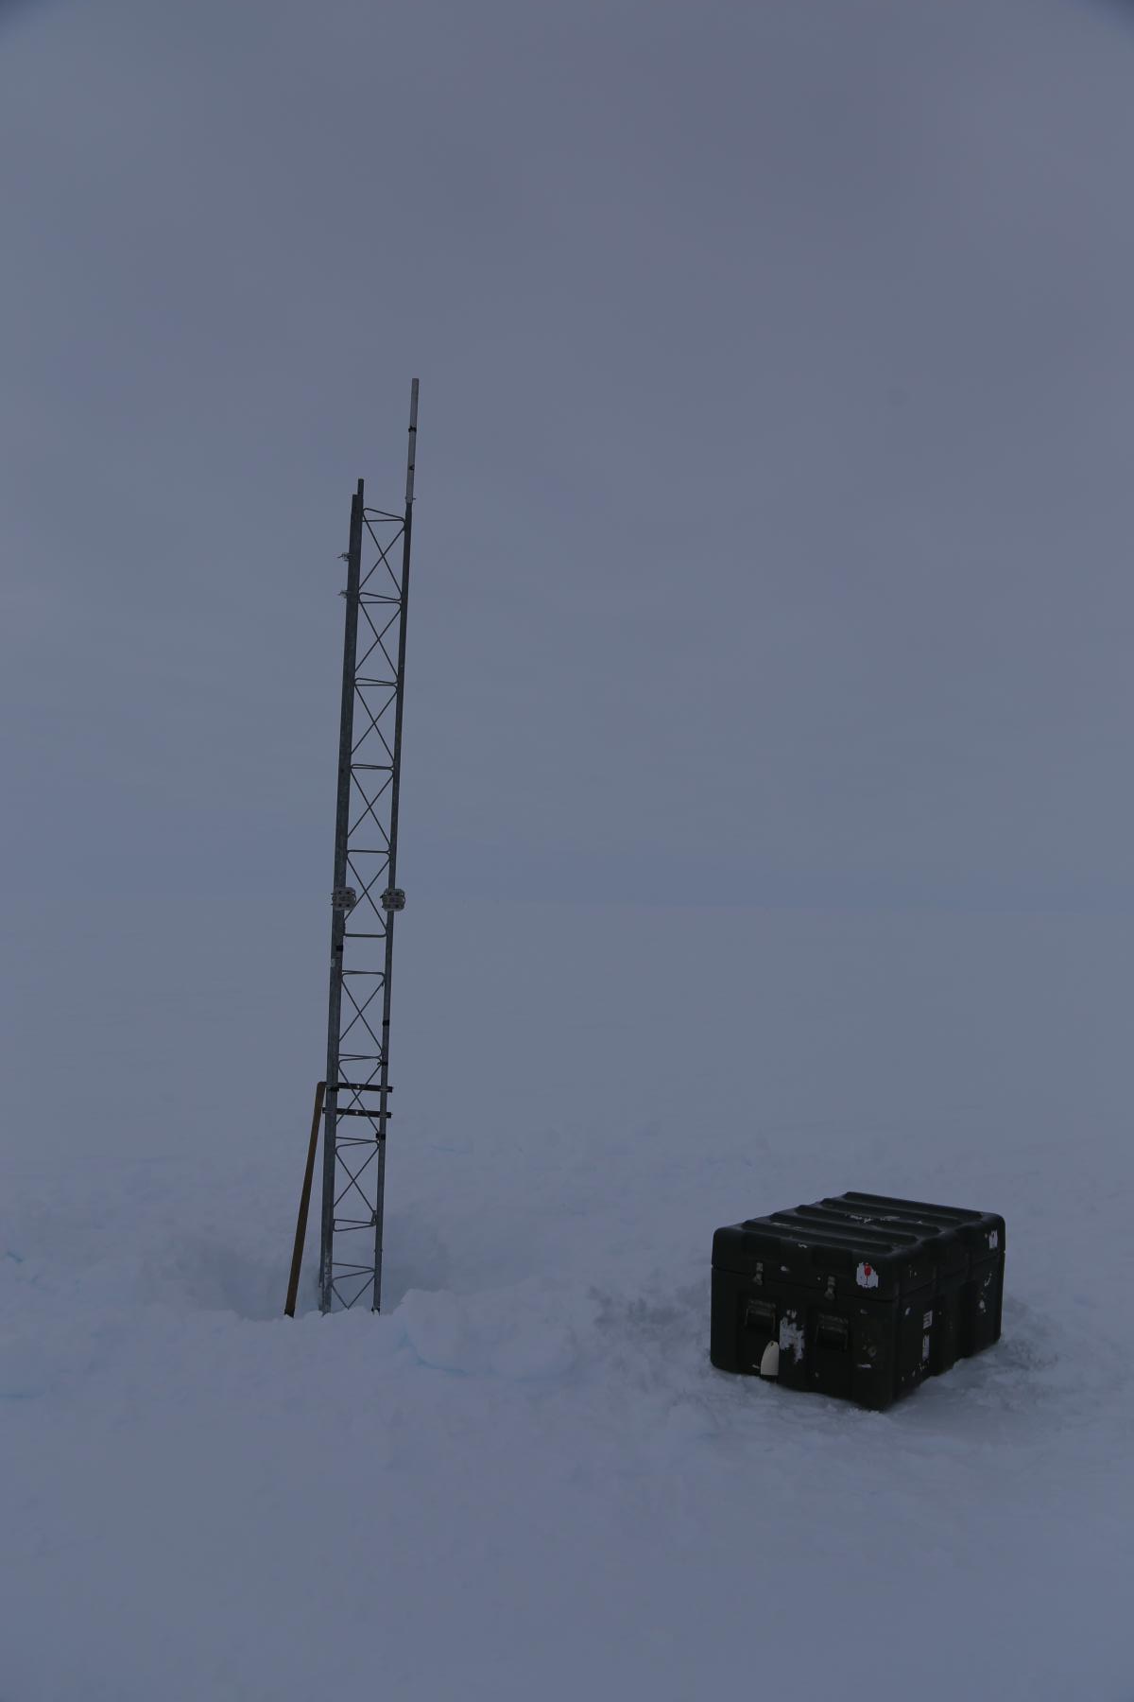

Laurie II (2023/12/01)
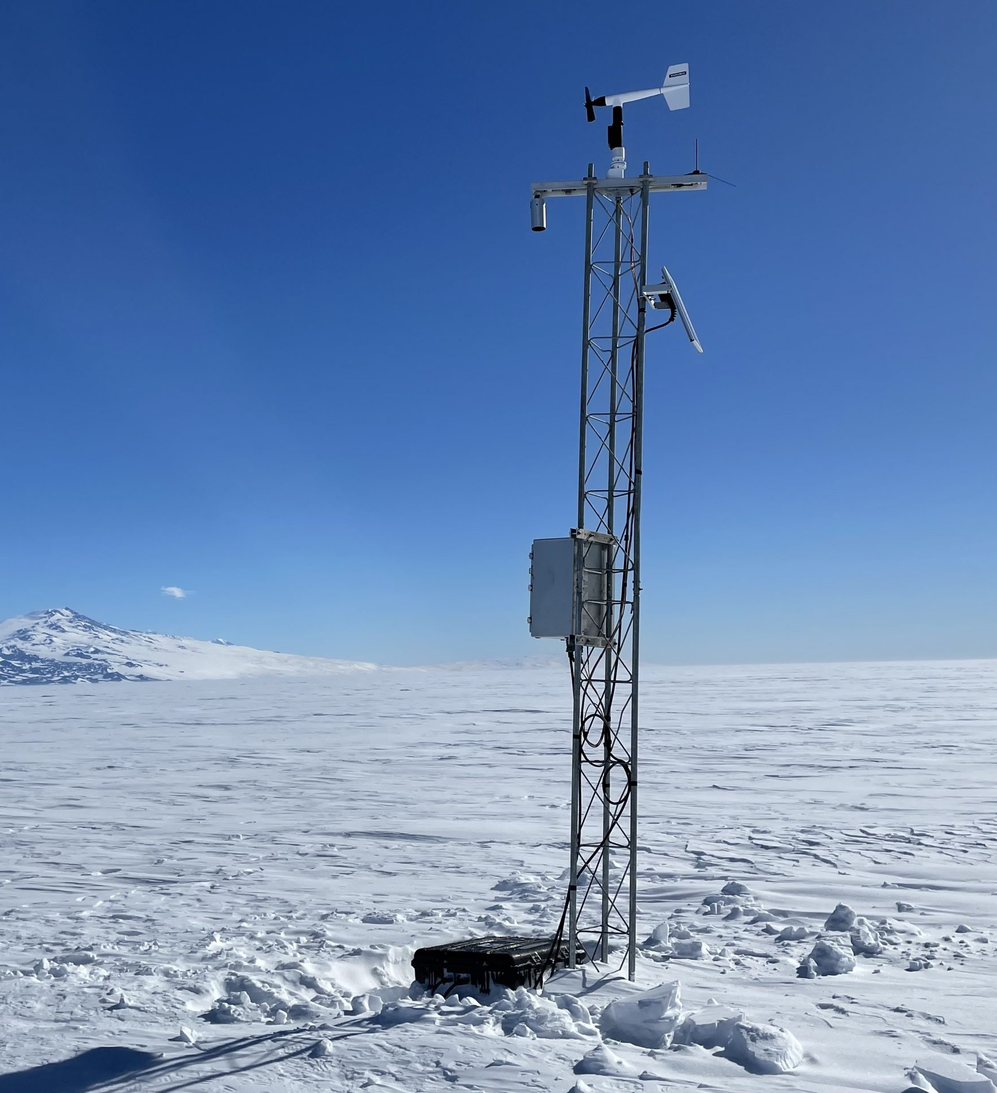

Lettau (2023/12/19)
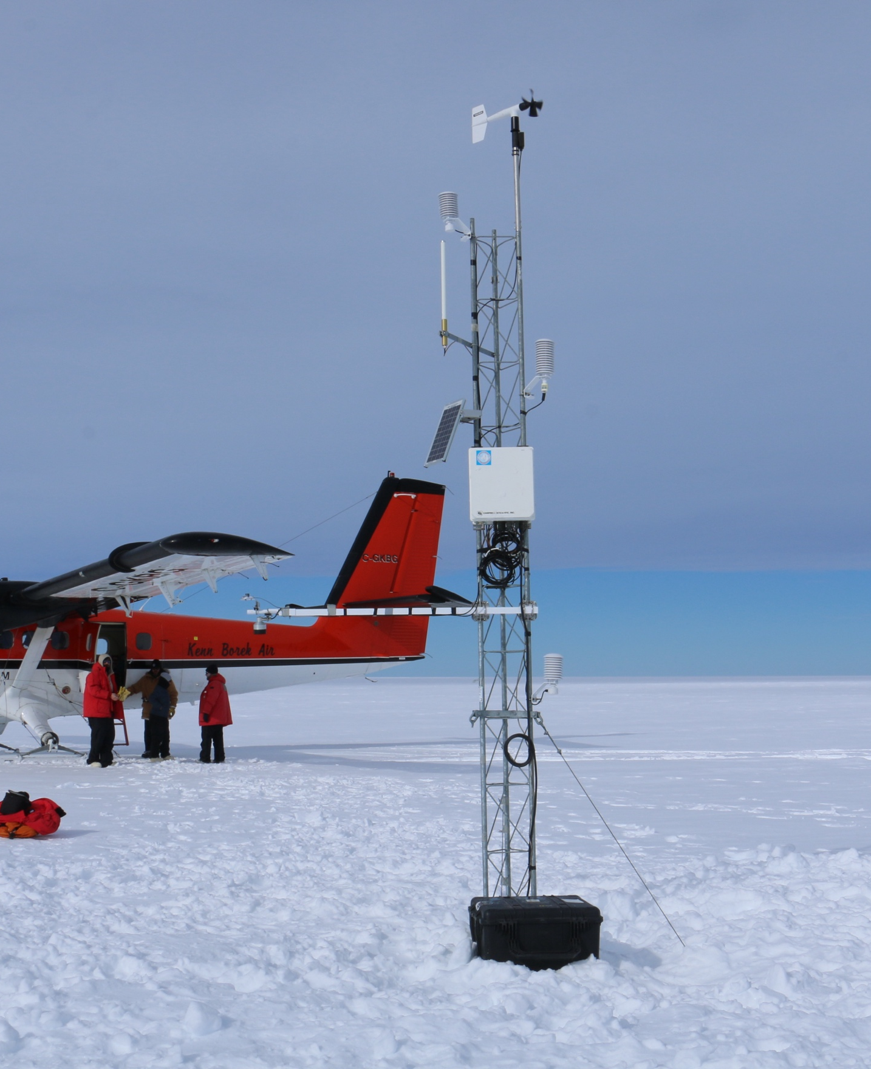

Lorne (2025/01/16)
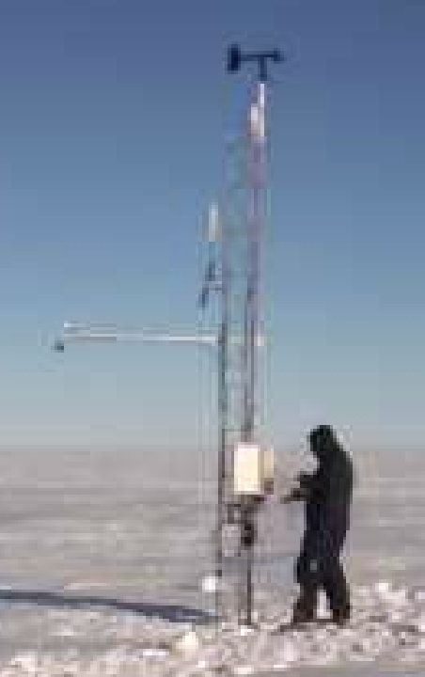

Marble Point (2023/11/17)
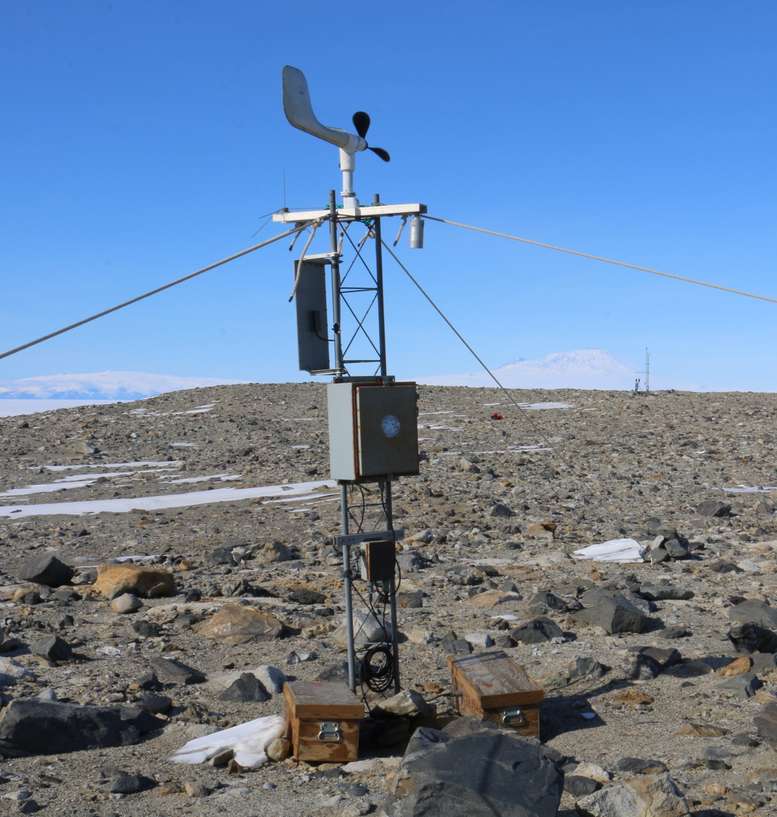

Marble Point II (2023/11/17)
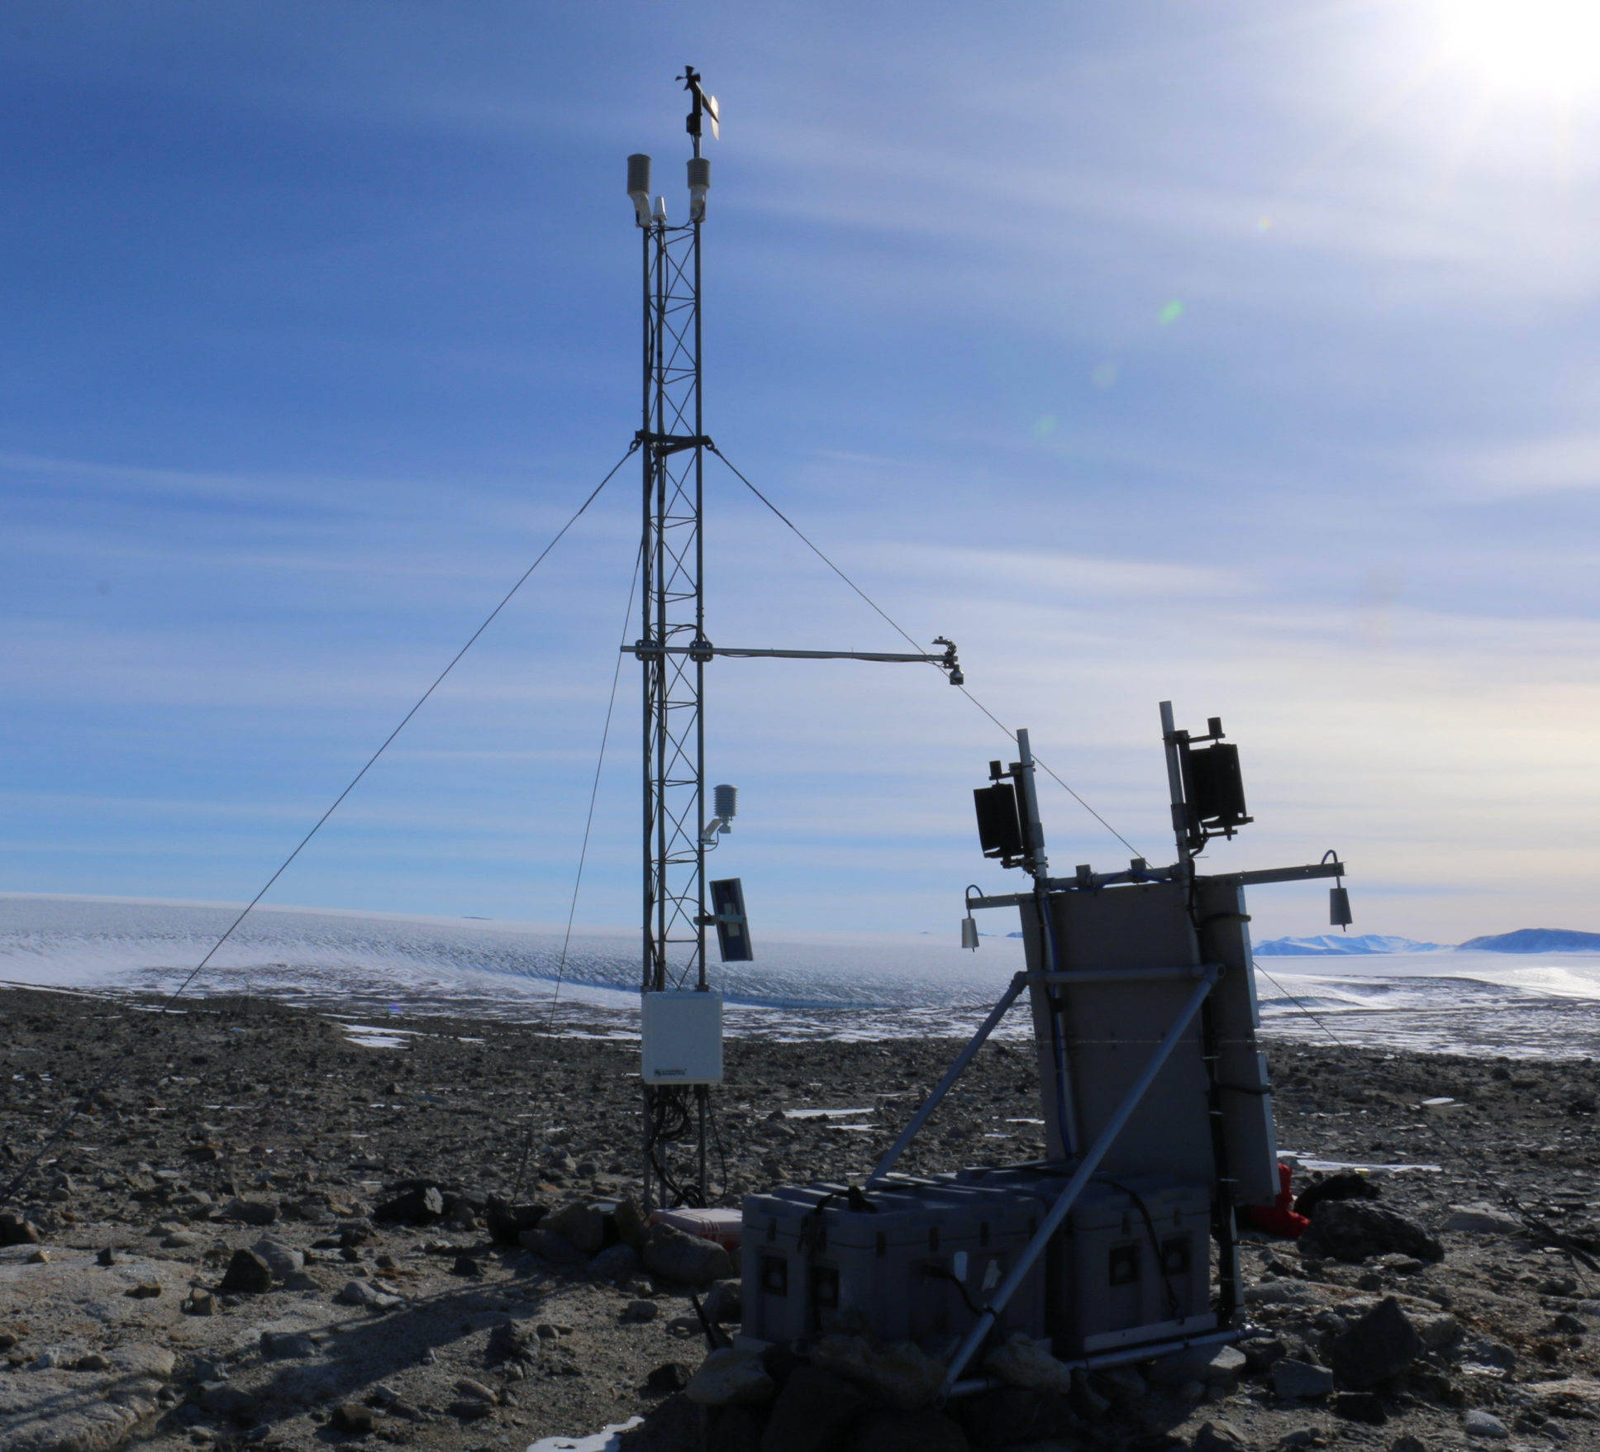

Marilyn (left) and NIWC (2022/01/15)
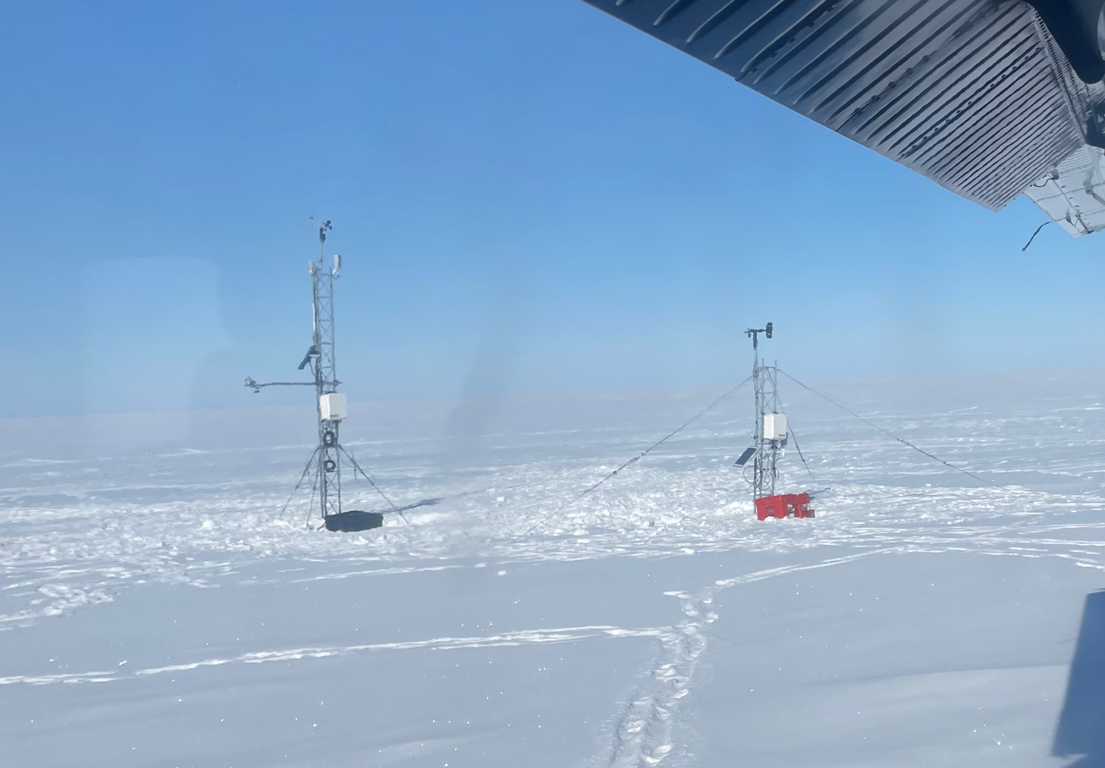
Minna Bluff (2023/11/22)
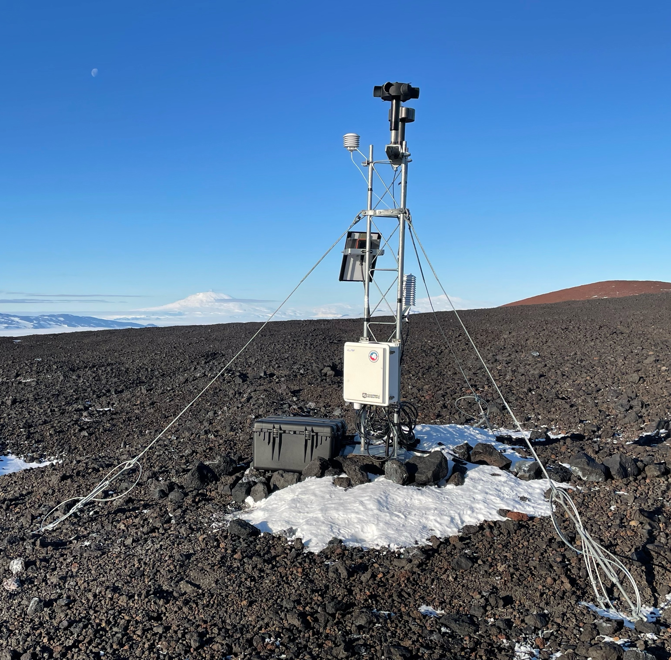

Phoenix (2023-12-12)
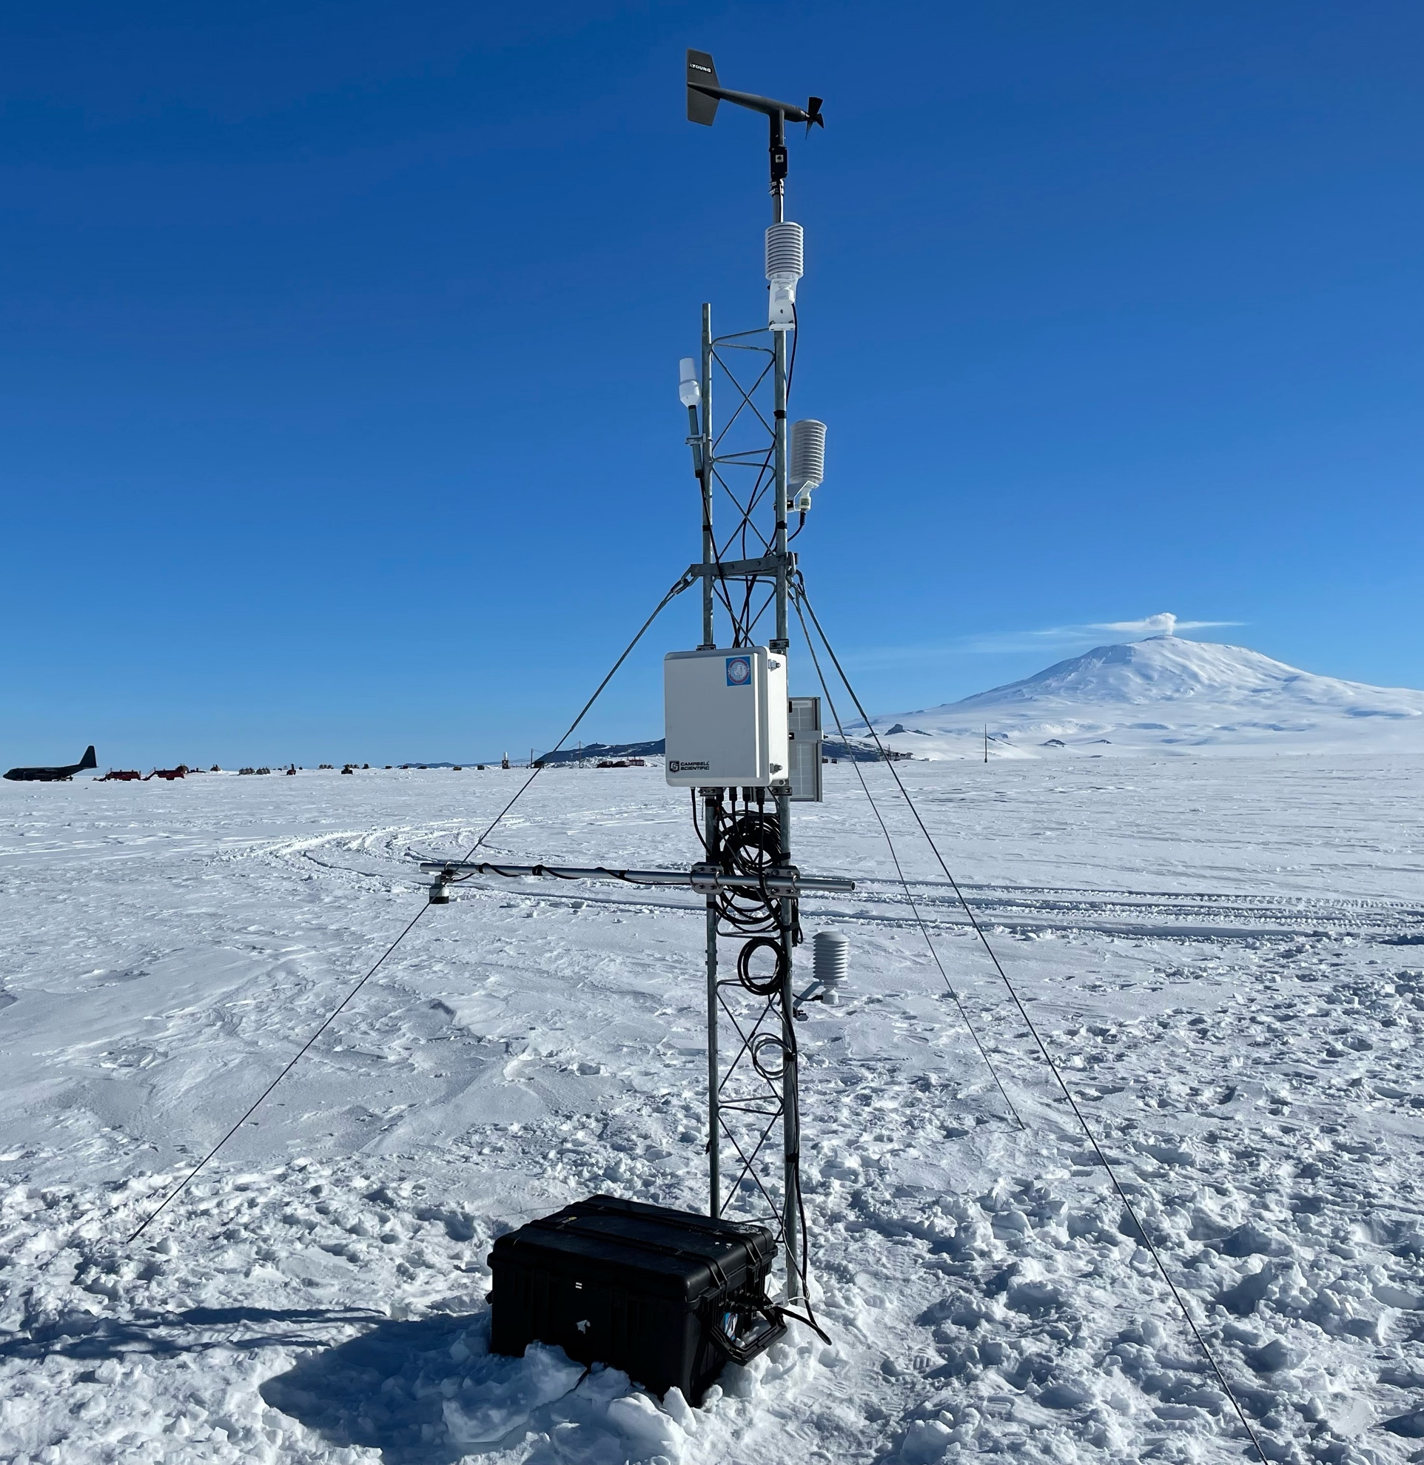

Sarah (2025/01/19)
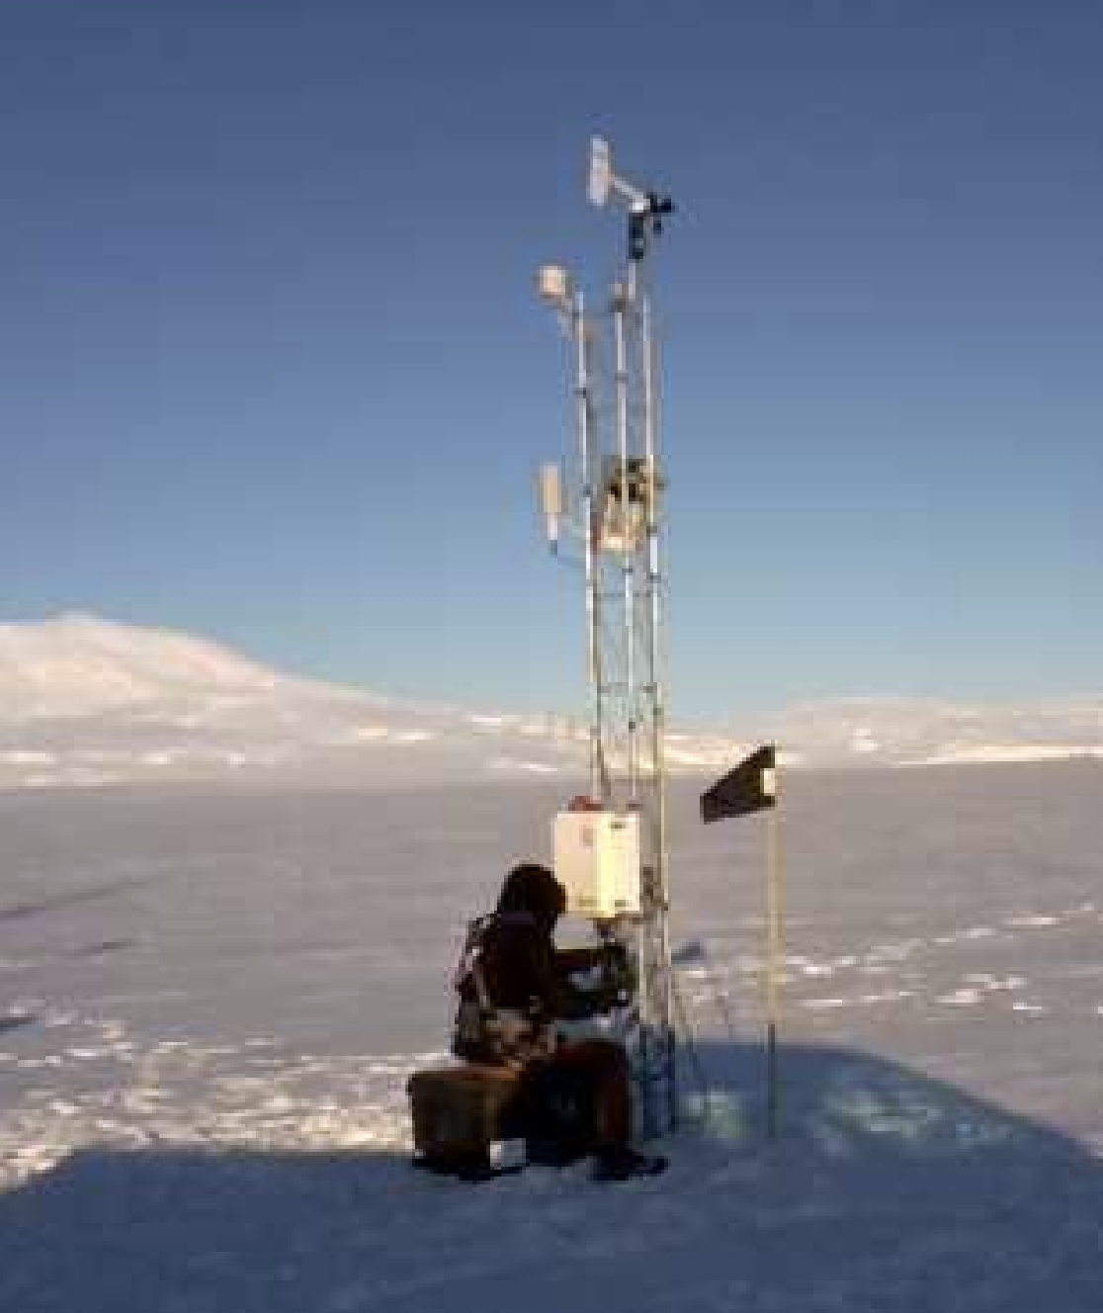

Schwerdtfeger (2024/12/20)
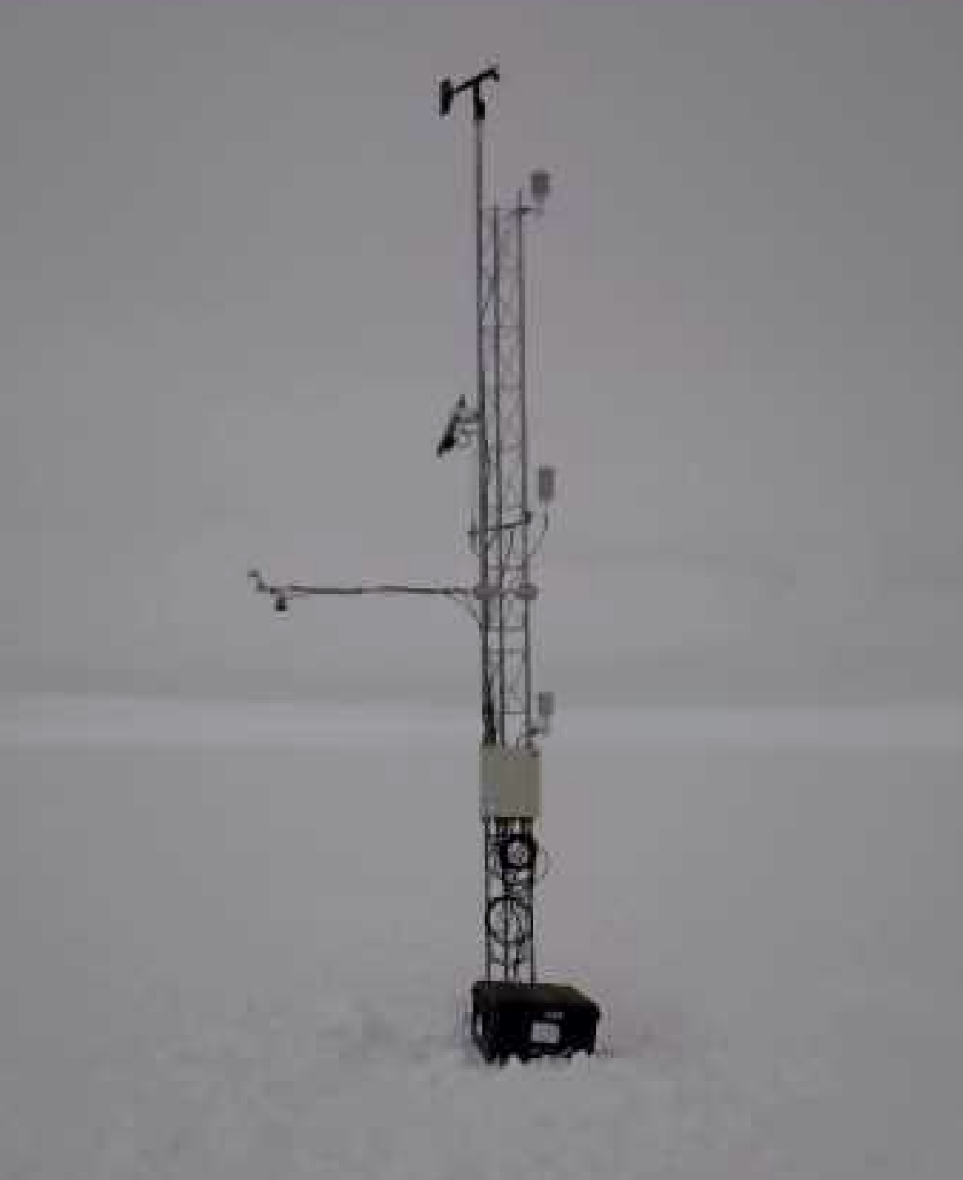

(2022/01/26) Skomik PCWS (left), Schwerdtfeger AWS (middle), NIWC (right)
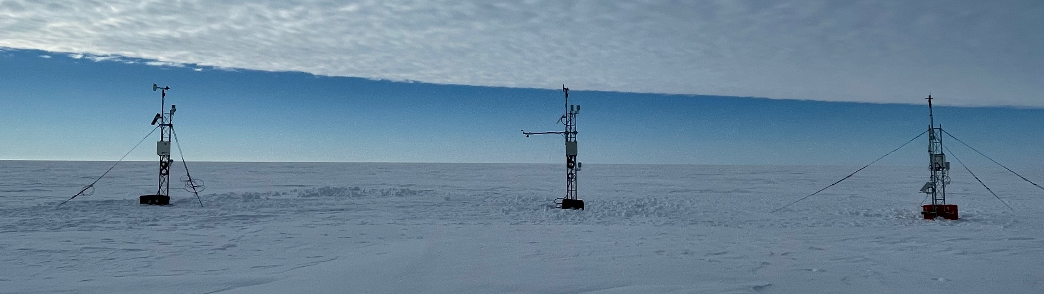
Siple Dome (2019/01/17)
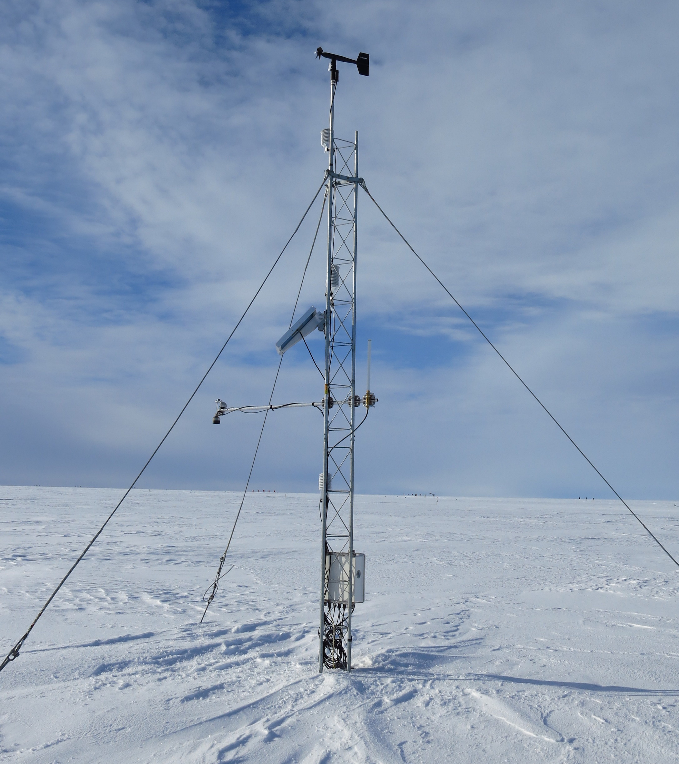

Skomik (2022/01/28)
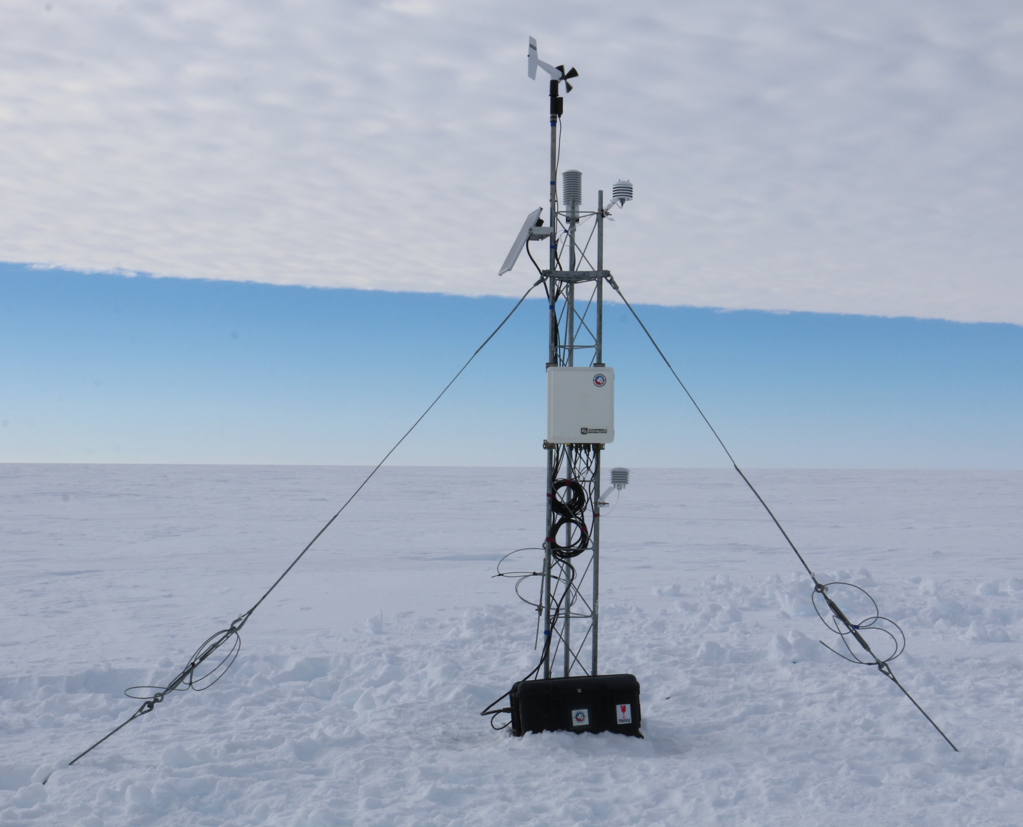

Theresa (2019/01/17)
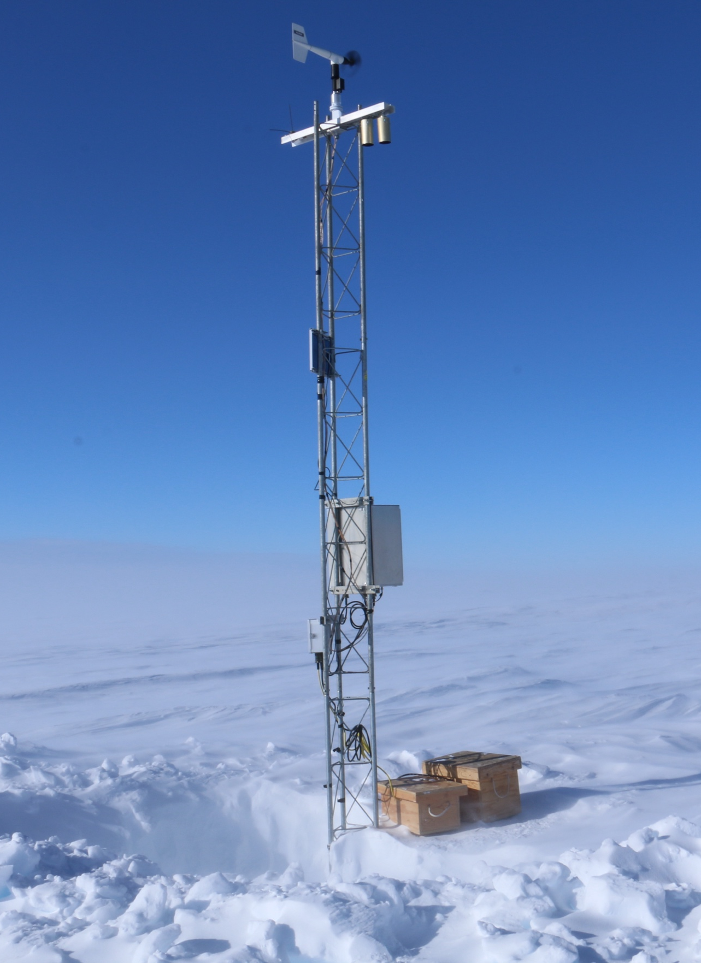

Thurston Island (2019/01/15)
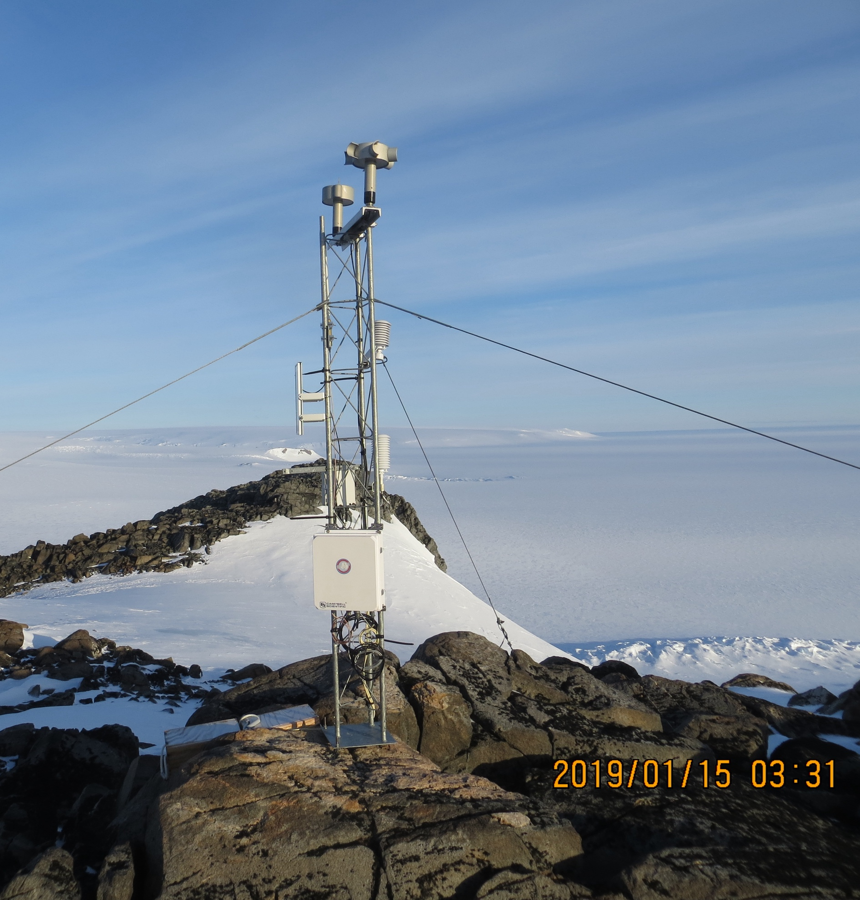

White Island (2023/11/18)
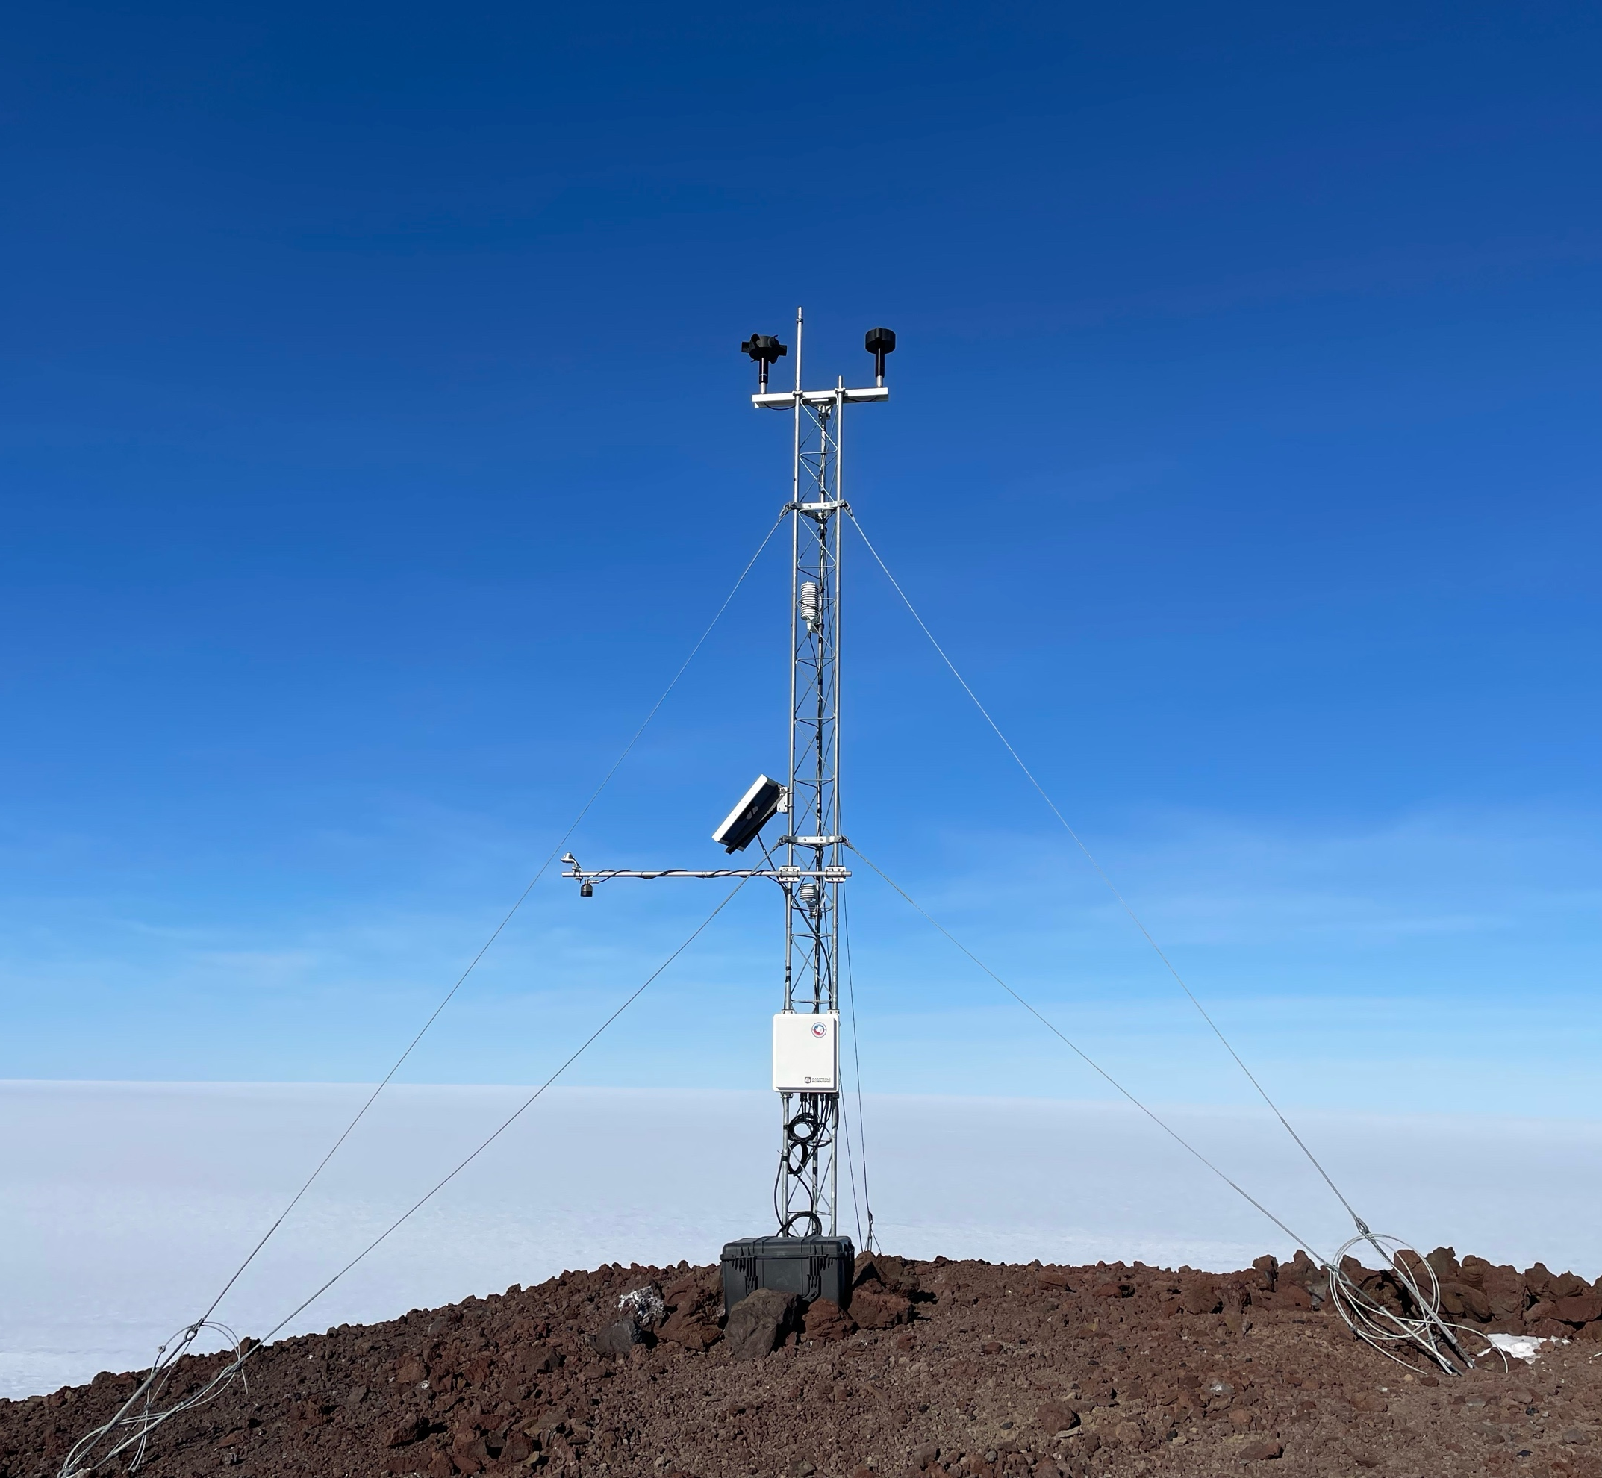

Willie Field (2025/01/19)
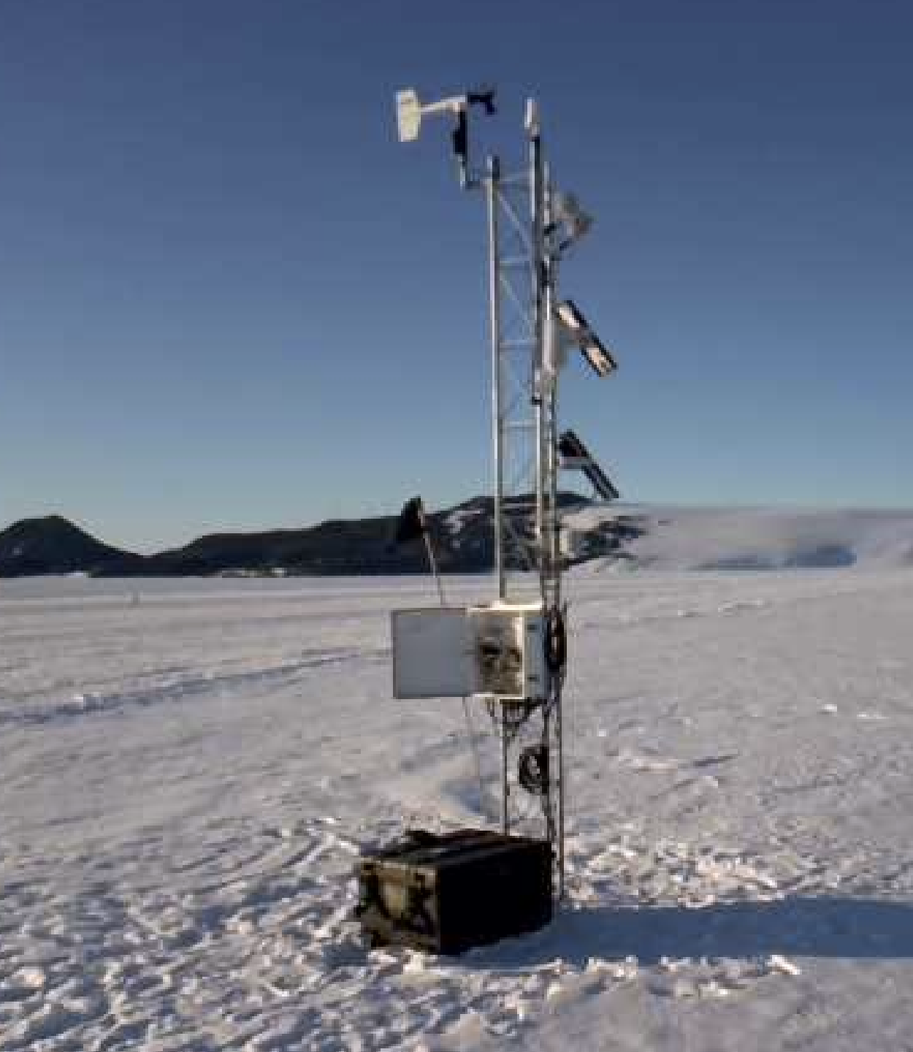

Windless Bight (2025/01/04)
