O-283 – UW AWS | 2025-2026 AWS Visits
AWS | GPS Lat/Lon | Date of GPS | Work
Alexander TT! | 78° 58.02’ S / 170° 48.96’ E | Jan 2025 | Service
Austin | 75° 59.64’ S / 87° 28.68’ W | Jan 2019 | Reinstall
Bear Peninsula | 74° 32.88’ S / 111° 52.08’ W | Jan 2019 | Replace Taylor HWS. Check Argos & power system
Byrd | 80° 0.66’ S / 119° 26.28’ W | Dec 2018 | Replace power system, raise
Cape Bird | 77° 13.02’ S / 166° 26.34’ E | Nov 2024 | Full system replacement
Cape Hallett | 72° 19.32’ S / 170° 13.50’ E | Jan 2022 | Full system replacement
Elaine | 83° 03.42’ S / 174° 13.08’ E | Jan 2022 | Service
Elijah Tall Tower | 77° 50.76’ S / 166° 52.14’ E | Dec 2024 | Service
Elizabeth | 82° 36.48’ S / 137° 04.80’ W | Jan 2019 | Raise
Erin | 84° 54.12’ S / 128° 51.96’ W | Jan 2019 | Raise
Harry | 83° 00.30’ S / 121° 24.54’ W | Jan 2019 | Raise
Janet | 77° 10.50’ S / 123° 23.46’ W | Jan 2019 | Raise
Kathie | 77° 59.70’ S / 97° 15.96’ W | Dec 2017 | Reinstall
Kominko-Slade | 79° 27.96’ S / 112° 06.42’ W | Dec 2023 | Reinstall
Laurie II | 77° 23.70’ S / 170° 42.84’ E | Dec 2024 | Reinstall
Lettau | 82° 26.52’ S / 174° 40.80’ W | Dec 2023 | Fix power system
Lorne | 78° 09.00’ S / 170° 02.76’ E | Jan 2025 | Fix spotty transmissions
Marble Point I/II | 77° 26.34’ S / 163° 45.24’ E | Dec 2024 | Service
Marilyn | 79° 53.82’ S / 165° 51.36’ E | Jan 2022 | Service
Minna Bluff | 78° 33.24’ S / 166° 41.46’ E | Dec 2024 | Replace Taylor HWS direction sensor
Phoenix | 77° 56.88’ S / 166° 44.70’ E | Jan 2025 | Check Paros pressure
Sarah PCWS | 77° 51.03’ S / 166° 54.24’ E | Jan 2025 | Service
Schwerdtfeger | 79° 46.86’ S / 170° 30.30’ E | Dec 2024 | Service
Siple Dome | 81° 39.12’ S / 148° 59.52’ W | Jan 2016 | Raise
Skomik PCWS | 79° 46.86’ S / 170° 30.30’ E | Dec 2024 | Service
Theresa | 84° 36.12’ S / 115° 50.76’ W | Jan 2019 | Fix power system
Thurston Island | 72° 55.92’ S / 97° 32.70’ W | Jan 2019 | Replace: Taylor HWS, RH
White Island | 78° 04.56’ S / 167° 27.06’ E | Dec 2024 | Service
Willie Field | 77° 51.03’ S / 166° 54.24’ E | Jan 2025 | Service
Windless Bight | 77° 43.92’ S / 167° 39.66’ E | Jan 2025 | Service

2025-2026 McMurdo Twin Otter AWS Visits
AWS | GPS Lat/Lon | Date
Alexander TT | 78° 58.02’ S / 170° 48.96’ E | Jan 2025
Cape Hallett | 72° 19.32’ S / 170° 13.50’ E | Jan 2022
Elaine | 83° 03.42’ S / 174° 13.08’ E | Jan 2022
Lettau | 82° 26.52’ S / 174° 40.80’ W | Dec 2023
Marilyn | 79° 53.82’ S / 165° 51.36’ E | Jan 2022
Schwerdtfeger | 79° 46.86’ S / 170° 30.30’ E | Dec 2024
Siple Dome | 81° 39.12’ S / 148° 59.52’ W | Jan 2016
Skomik | 79° 46.86’ S / 170° 30.30’ E | Dec 2024

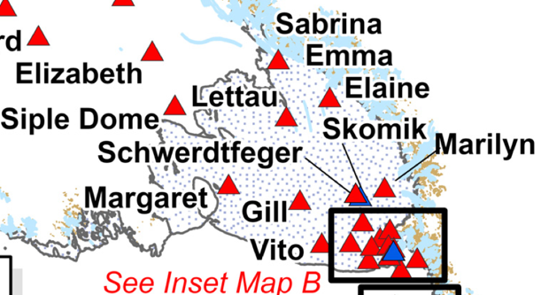
E
S
N
W
GRID NORTH
2025-2026 Helo AWS Visits
AWS | GPS Lat/Lon | Date
Cape Bird | 77° 13.02’ S / 166° 26.34’ E | Nov 2024
Ferrell | 77° 44.76’ S / 170° 48.60’ E | Jan 2025
Laurie II | 77° 23.70’ S / 170° 42.84’ E | Dec 2024
Linda | 78° 21.72’ S / 168° 28.44’ E | Jan 2025
Lorne | 78° 09.00’ S / 170° 02.76’ E | Jan 2025
Marble Point I/II | 77° 26.34’ S / 163° 45.24’ E | Dec 2024
Minna Bluff | 78° 33.30’ S / 166° 41.46’ E | Dec 2024
White Island | 78° 04.56’ S / 167° 27.06’ E | Dec 2024
Windless Bight | 77° 43.92’ S / 167° 39.66’ E | Jan 2025
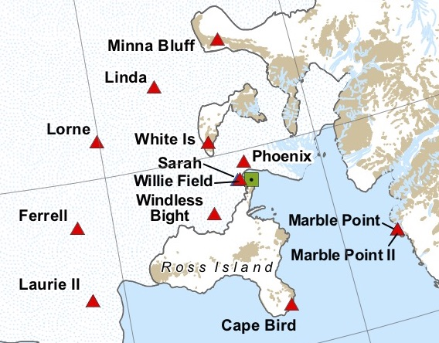
S
N
E
W
GRID NORTH
2025-2026 WAIS Twin Otter AWS Visits
AWS | GPS Lat/Lon | Date
Austin | 75° 59.64’ S / 87° 28.68’ W | Jan 2019
Bear Peninsula | 74° 32.88’ S / 111° 52.08’ W | Jan 2019
Byrd | 80° 0.66’ S / 119° 26.28’ W | Dec 2018
Elizabeth | 82° 36.48’ S / 137° 04.80’ W | Jan 2019
Erin | 84° 54.12’ S / 128° 51.96’ W | Jan 2019
Harry | 83° 00.30’ S / 121° 24.54’ W | Jan 2019
Janet | 77° 10.50’ S / 123° 23.46’ W | Jan 2019
Kathie | 77° 59.70’ S / 97° 15.96’ W | Dec 2017
Siple Dome | 81° 39.12’ S / 148° 59.52’ W | Jan 2016
Theresa | 84° 36.12’ S / 115° 50.76’ W | Jan 2019
Thurston Island | 72° 55.92’ S / 97° 32.70’ W | Jan 2019
Grid North
E
N
S
W
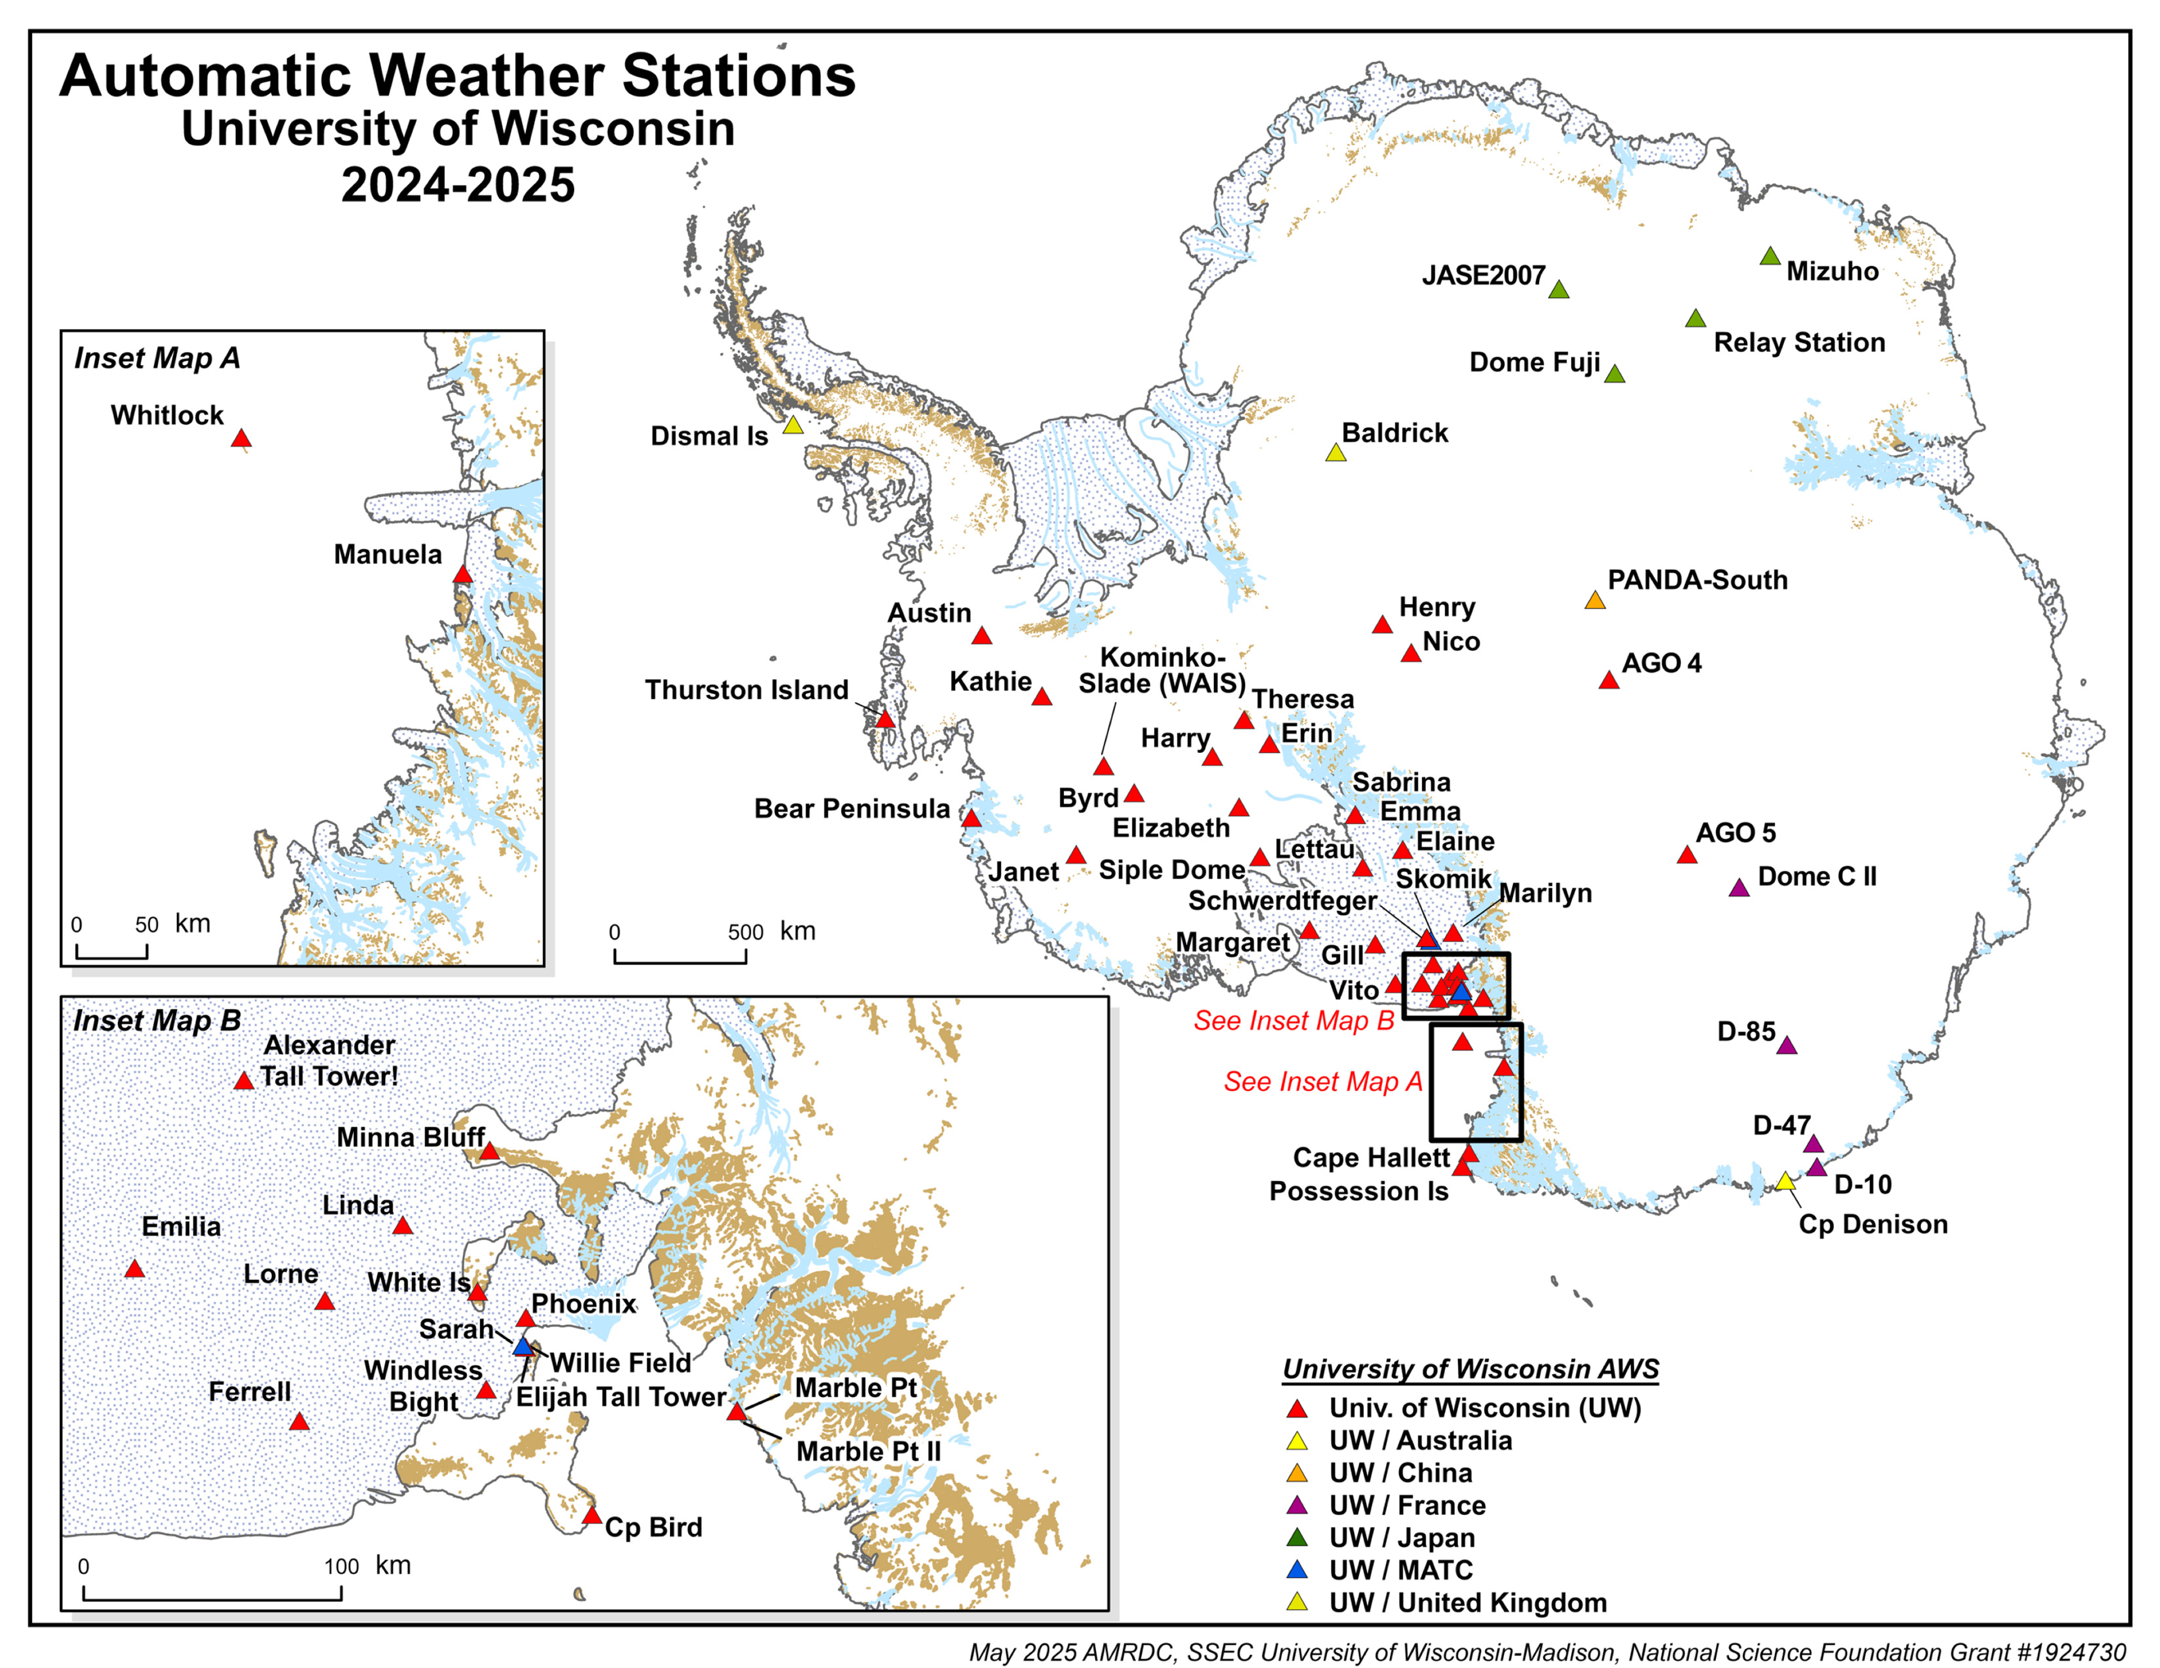
N
S
W
E
GRID NORTH
All AWS | O-283 UW AWS | 2025
Name | Lat | Lon | Elevation | Date last visited | ID | Argos
AGO-4 (P4) | -82.010 | 96.760 | 3597m | 2012-01-01 | AG4 | 8927
AGO-5 (P5) | -77.240 | 123.520 | 3519m | 2020-01-20 | AG5 | 21362
Alexander Tall Tower! | -78.967 | 170.816 | 55m | 2025-01-03 | BAT | 99601
Austin | -75.994 | -87.478 | 1292m | 2019-01-12 | ATN | 8901
Baldrick (M-83) | -82.774 | -13.054 | 1968m | 2014-01-01 | BAL | 9116
Bear Peninsula | -74.548 | -111.868 | 415m | 2019-01-07 | BRP | 8922
Byrd (Byrd Station) | -80.011 | -119.438 | 1538m | 2018-12-30 | BYD | 8903
Cape Bird | -77.217 | 166.439 | 38m | 2024-11-27 | CBD | 99609
Cape Denison | -67.009 | 142.664 | 31m | 2021-12-19 | CDN | 8909
Cape Hallett | -72.322 | 170.225 | 1m | 2022-11-16 | CHA | 99602
D-10 (Dumont D'Urville) | -66.703 | 139.843 | 243m | 2024-12-28 | D10 | 8914
D-47 | -67.376 | 138.726 | 1560m | 2024-12-21 | D47 | 8916
D-85 | -70.426 | 134.147 | 2651m | 2024-11-27 | D85 | 8912
Dismal Island | -68.088 | -68.826 | 12m | 2017-02-05 | DIS | 8932
Dome C II | -75.106 | 123.347 | 3250m | 2025-01-01 | DC2 | 8989
Dome F (Fuji) | -77.310 | 39.700 | 3810m | 2023-12-09 | FUJ | 8904
Elaine | -83.057 | 174.218 | 59m | 2022-01-14 | ELN | 21357
Elijah Tall Tower | -77.846 | 166.869 | 8m | 2024-12-18 | ELJ | 99616
Elizabeth | -82.608 | -137.080 | 523m | 2019-01-19 | ELZ | 21361
Emilia | -78.362 | 173.235 | 51m | 2024-12-11 | EML | 8939
Erin | -84.902 | -128.866 | 988m | 2019-01-17 | ERN | 21363
Ferrell | -77.746 | 170.810 | 41m | 2025-01-07 | FER | 8947
Gill | -79.789 | -178.515 | 53m | 2023-11-30 | GIL | 8911
Harry | -83.005 | -121.409 | 956m | 2019-01-19 | HRY | 8900
Henry | -89.000 | -0.411 | 2780m | 2018-12-22 | HEN | 8985
Janet | -77.175 | -123.391 | 2085m | 2019-01-21 | JNT | 8936
JASE2007 | -75.888 | 25.834 | 3661m | 2007-09-27 | JAS | 30305
Kathie | -77.995 | -97.266 | 1607m | 2017-12-29 | KTH | 8929
Kominko-Slade (WAIS) | -79.466 | -112.107 | 1801m | 2023-12-13 | KMS | 21364
Laurie II | -77.388 | 170.707 | 34m | 2024-12-19 | LR2 | 21360
Lettau | -82.442 | -174.680 | 39m | 2023-12-19 | LET | 8928
Linda | -78.362 | 168.474 | 38m | 2025-01-15 | LDA | 99603
Lorne | -78.150 | 170.046 | 41m | 2025-01-16 | LOR | 99612
Manuela (Inexpressible Island) | -74.946 | 163.687 | 78m | 2013-12-16 | MLA | 8905
Marble Point | -77.439 | 163.754 | 108m | 2024-12-04 | MPT | 8906
Marble Point II | -77.439 | 163.759 | 111m | 2024-12-04 | MP2 | 99608
Margaret (Roosevelt Island) | -79.962 | -165.196 | 67m | 2022-11-30 | MGT | 8910
Marilyn (Byrd Glacier) | -79.897 | 165.856 | 62m | 2022-01-15 | MLN | 8934
Minna Bluff | -78.554 | 166.691 | 895m | 2024-12-18 | MNB | 99606
Mizuho | -70.700 | 44.290 | 2260m | 2023-11-20 | MIZ | 21359
Nico | -89.000 | 90.021 | 2979m | 2018-12-21 | NIC | 8924
PANDA-South | -82.325 | 75.989 | 4027m | 2008-01-14 | PDA | 30416
Phoenix | -77.948 | 166.745 | 10m | 2025-01-19 | PHX | 8908
Possession Island | -71.891 | 171.210 | 30m | 1992-12-29 | POS | 8984
Relay Station | -74.017 | 43.062 | 3353m | 2023-11-27 | RLS | 8918
Sabrina | -84.231 | -170.386 | 86m | 2023-12-07 | SAB | 8915
Sarah PCWS | -77.855 | 166.904 | 8m | 2025-01-19 | SRH | 99613
Schwerdtfeger | -79.781 | 170.505 | 54m | 2024-12-20 | SWT | 8913
Siple Dome | -81.652 | -148.992 | 666m | 2016-01-27 | SID | 30393
Skomik PCWS | -79.781 | 170.505 | 54m | 2024-12-20 | SKM | 99614
Theresa | -84.602 | -115.846 | 1453m | 2019-01-17 | TRS | 21358
Thurston Island | -72.532 | -97.545 | 225m | 2019-01-15 | THI | 8930
Vito | -78.408 | 177.829 | 50m | 2022-12-22 | VTO | 8931
White Island | -78.076 | 167.451 | 686m | 2024-12-13 | WTI | 99610
Whitlock (Franklin Island) | -76.142 | 168.394 | 262m | 2011-01-28 | WTL | 8988
Willie Field | -77.855 | 166.904 | 8m | 2025-01-19 | WFD | 99607
Windless Bight | -77.732 | 167.661 | 39m | 2025-01-04 | WDB | 99611

