O-283 UW AWS Pictures
2026-2027



AWS listed alphabetically
Date listed is when picture was taken

Alexander Tall Tower! (2023/12/08)
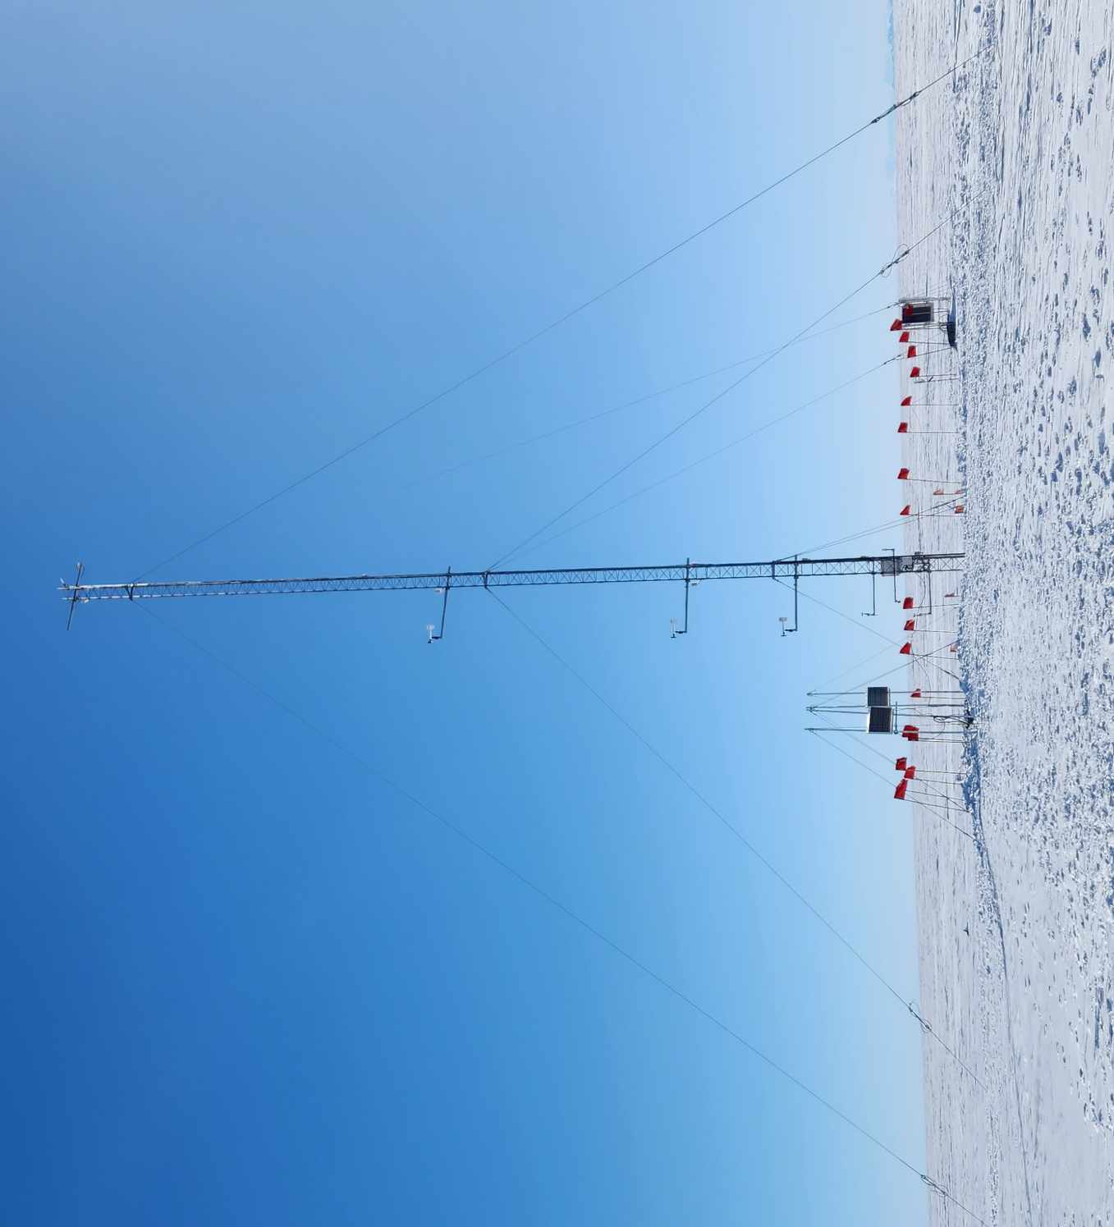
Austin (2019/01/12)
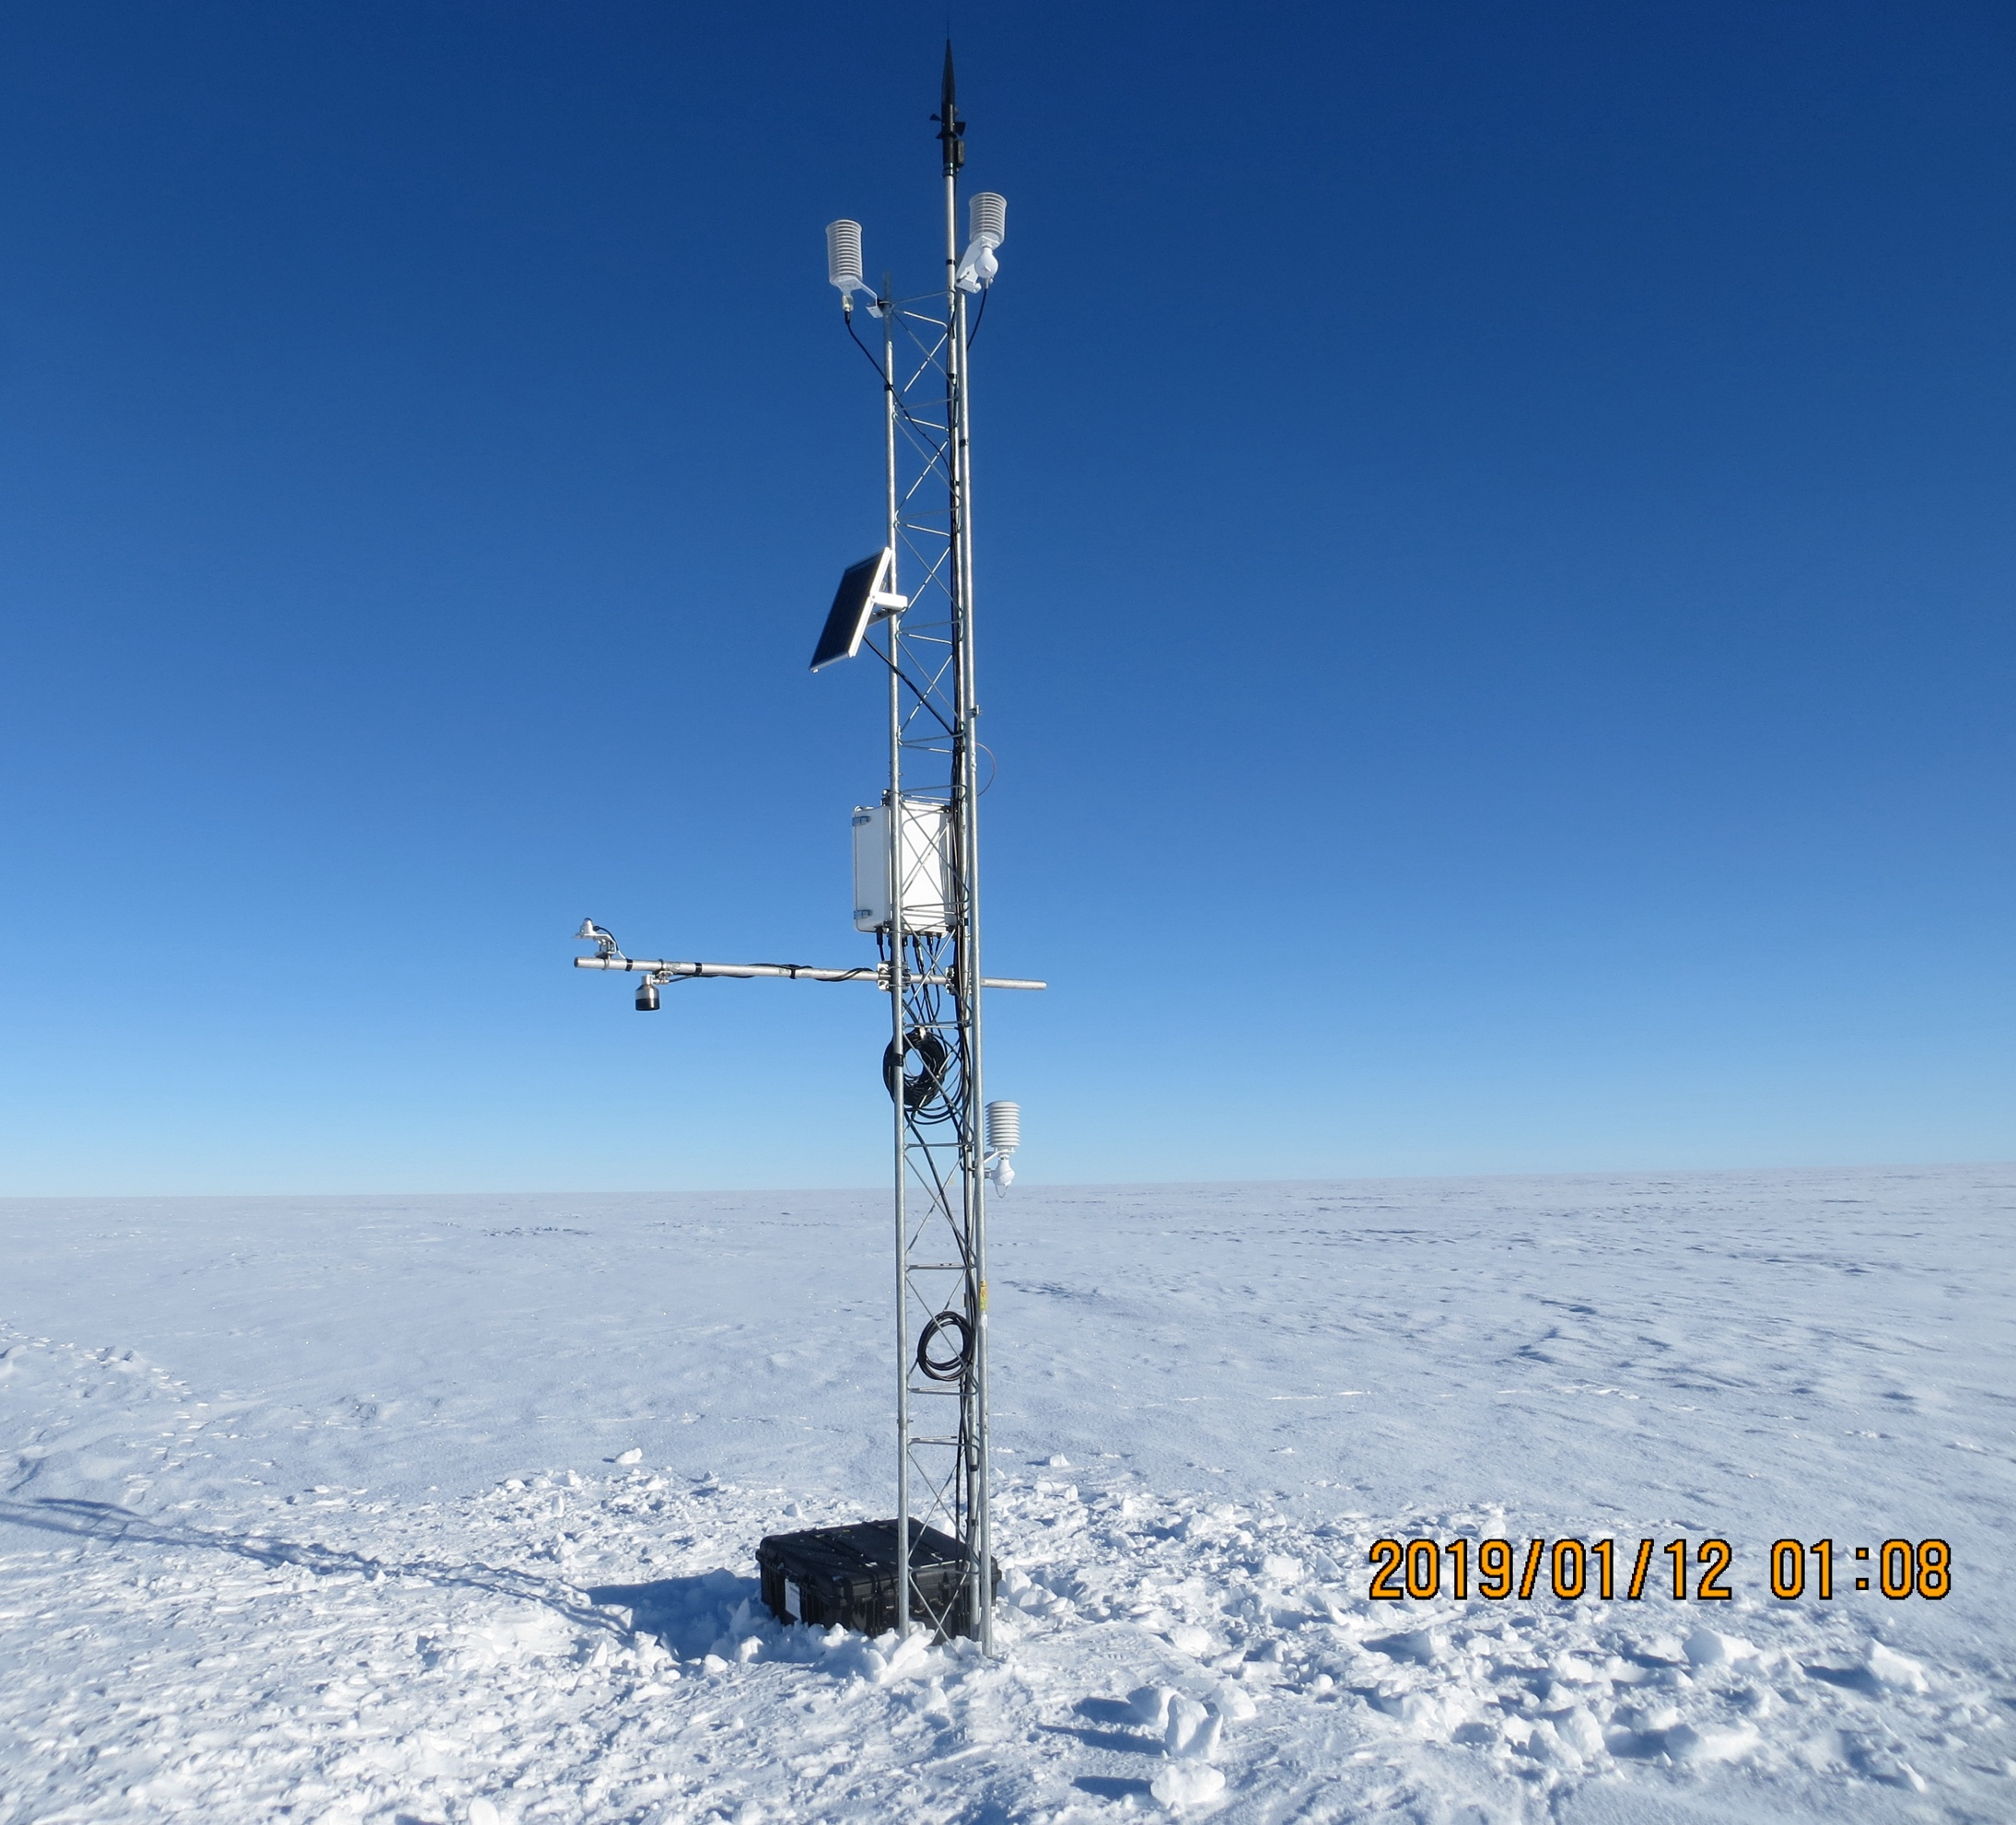

Bear Peninsula (2019/01/07)
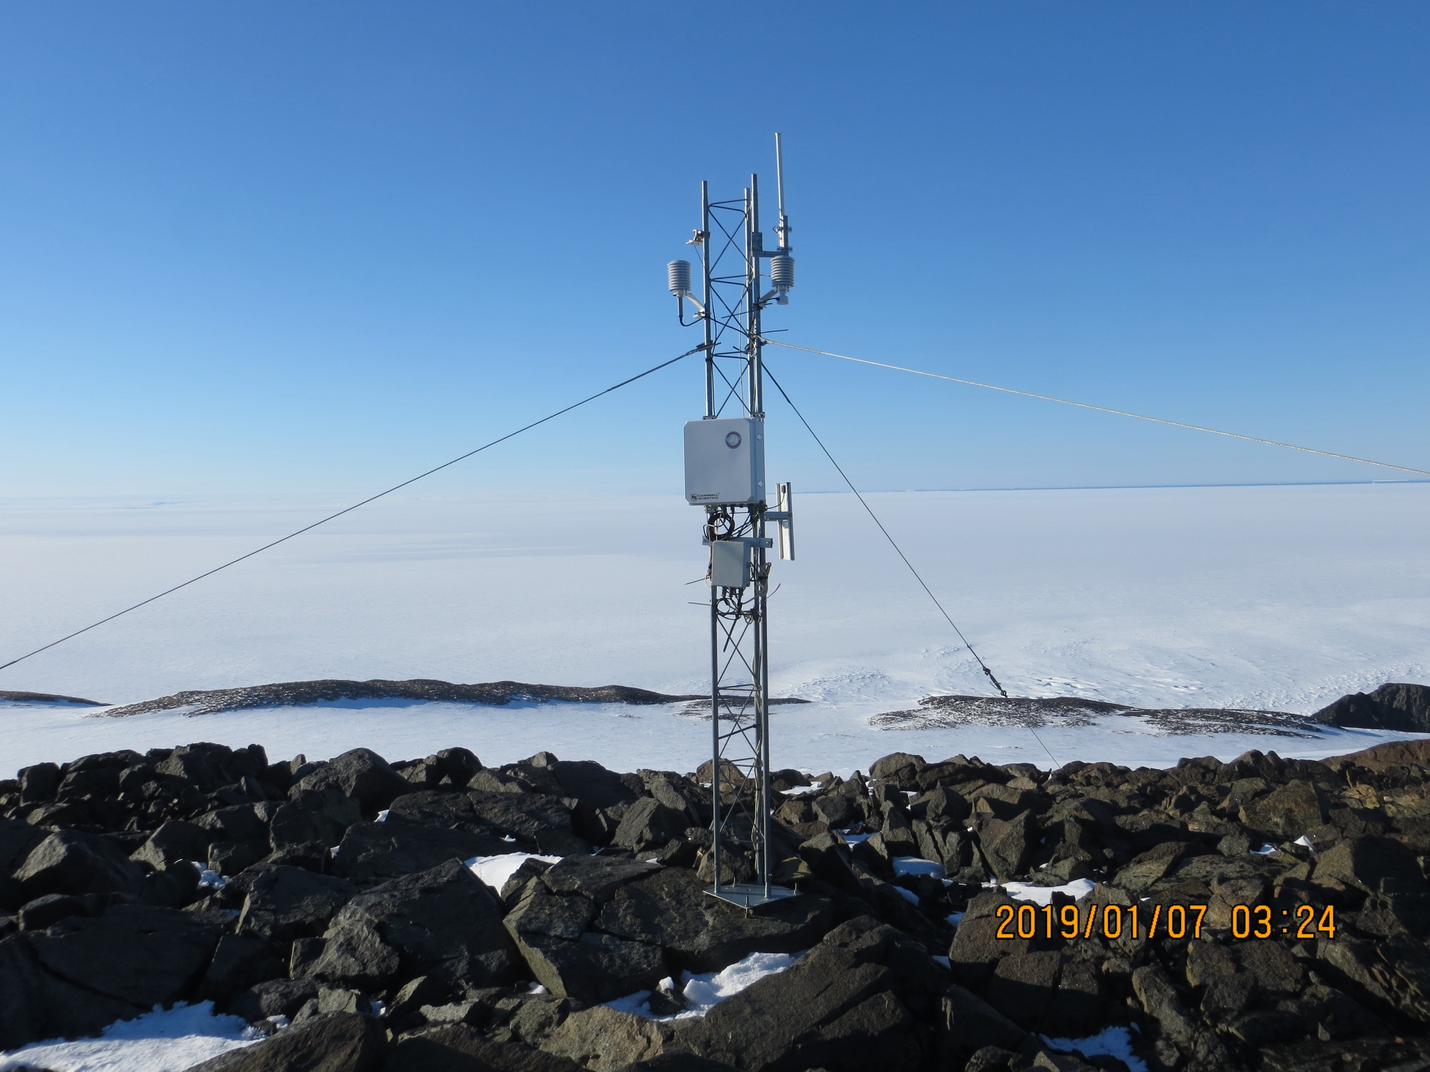

Byrd (2026/01/18) pointing towards West
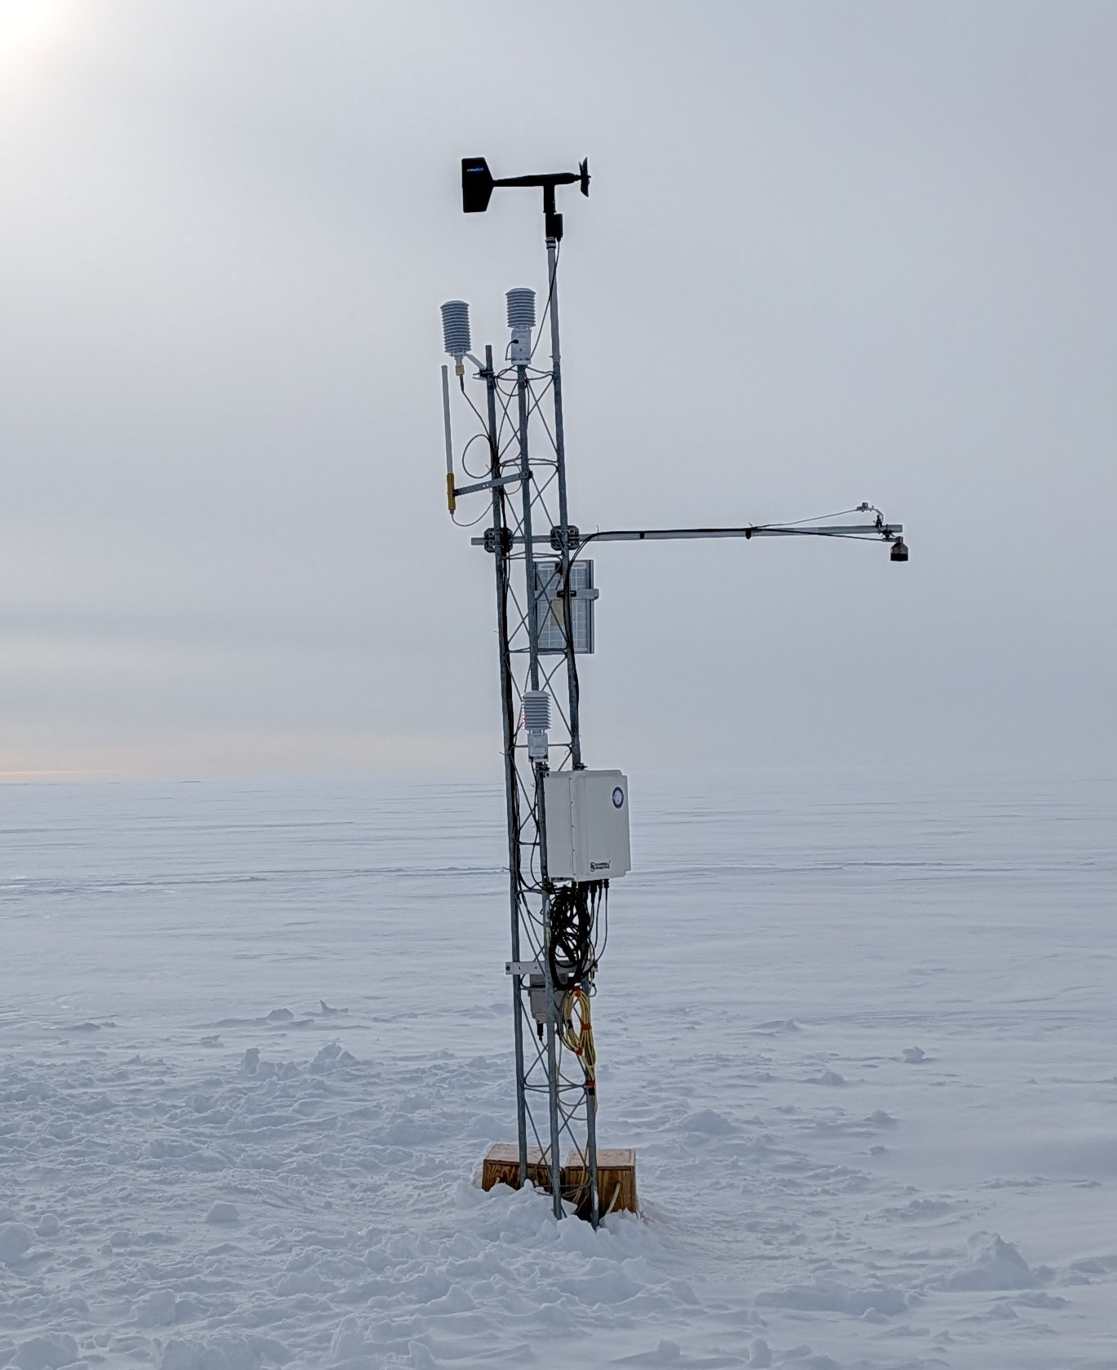

Cape Bird (2025/12/24) pointing towards East
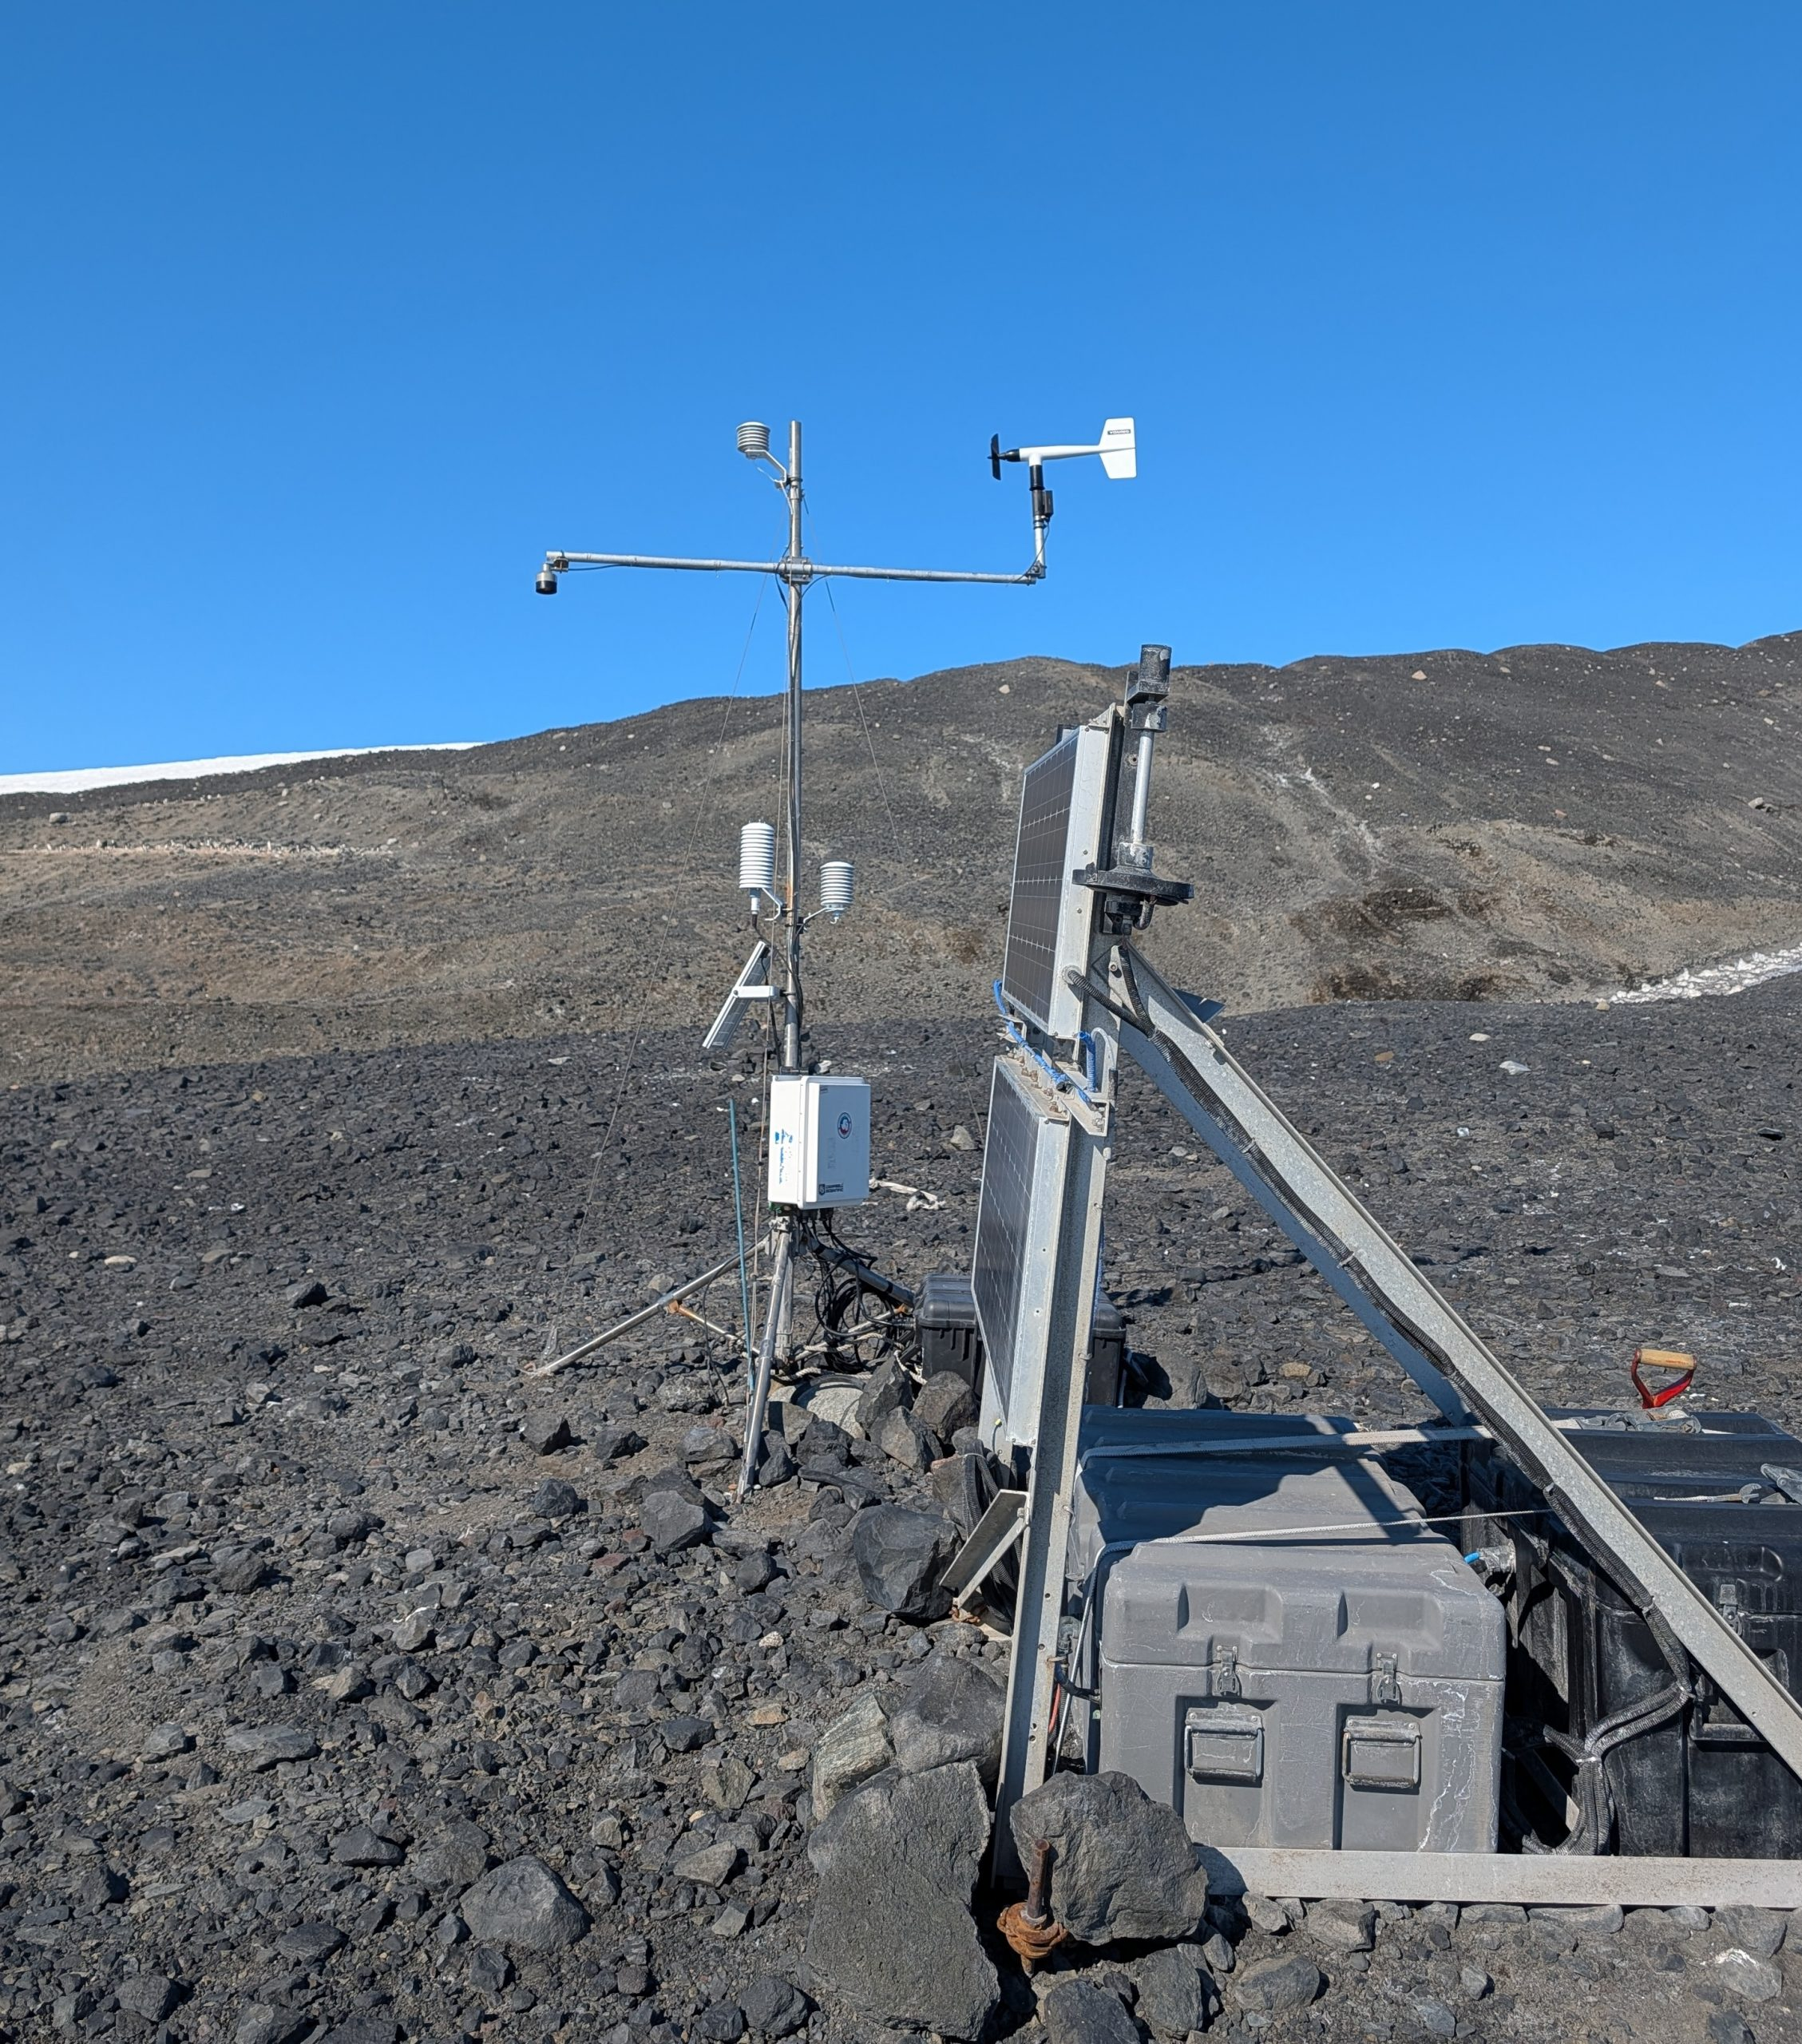

Elaine (left) and NIWC (2022/01/14)
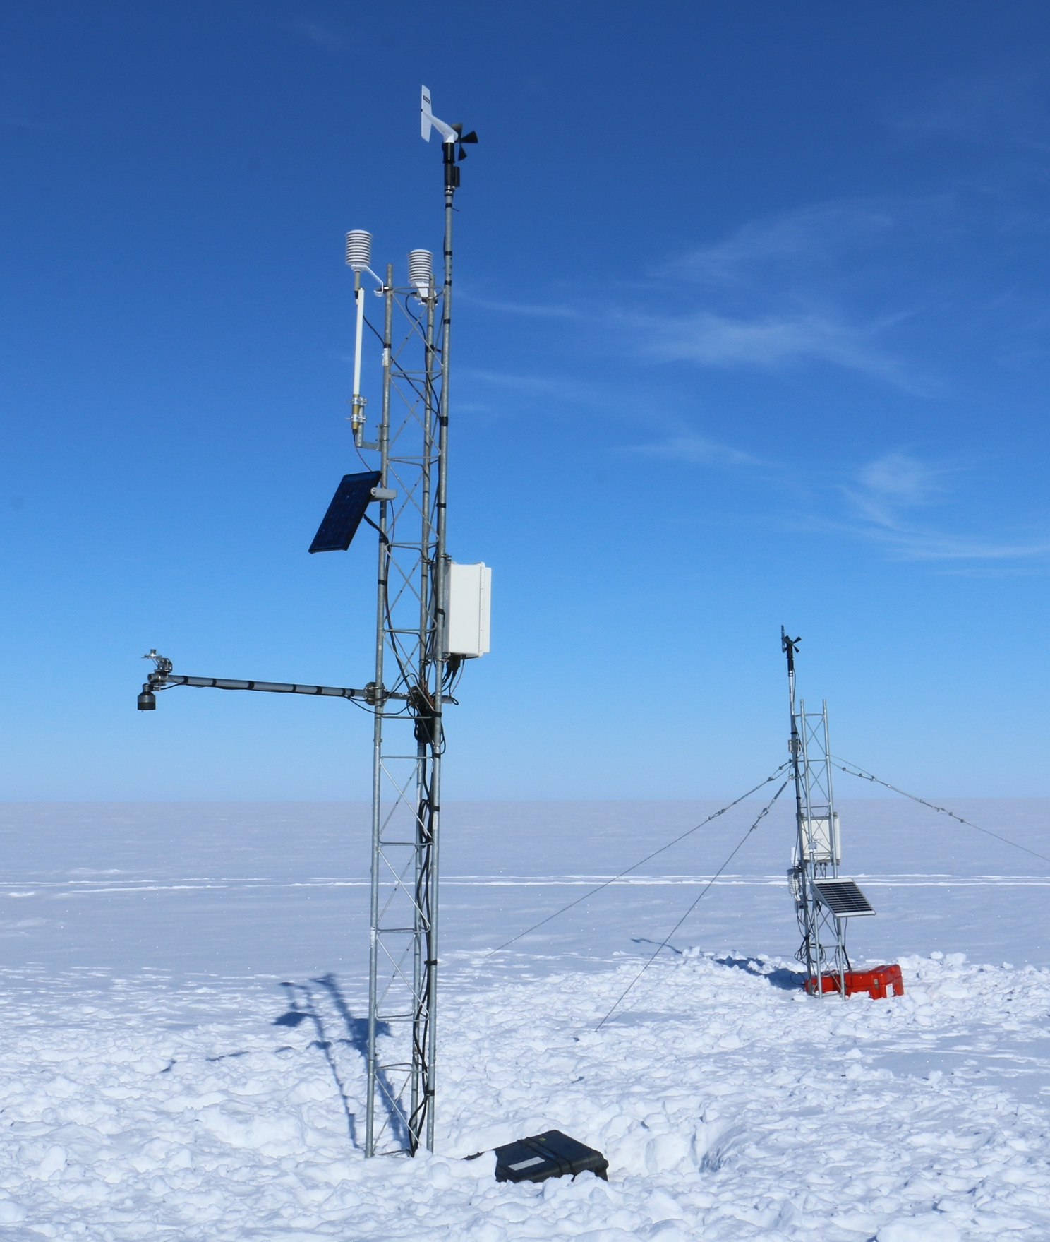
Elijah Tall Tower (2025-12-07) pointing towards North
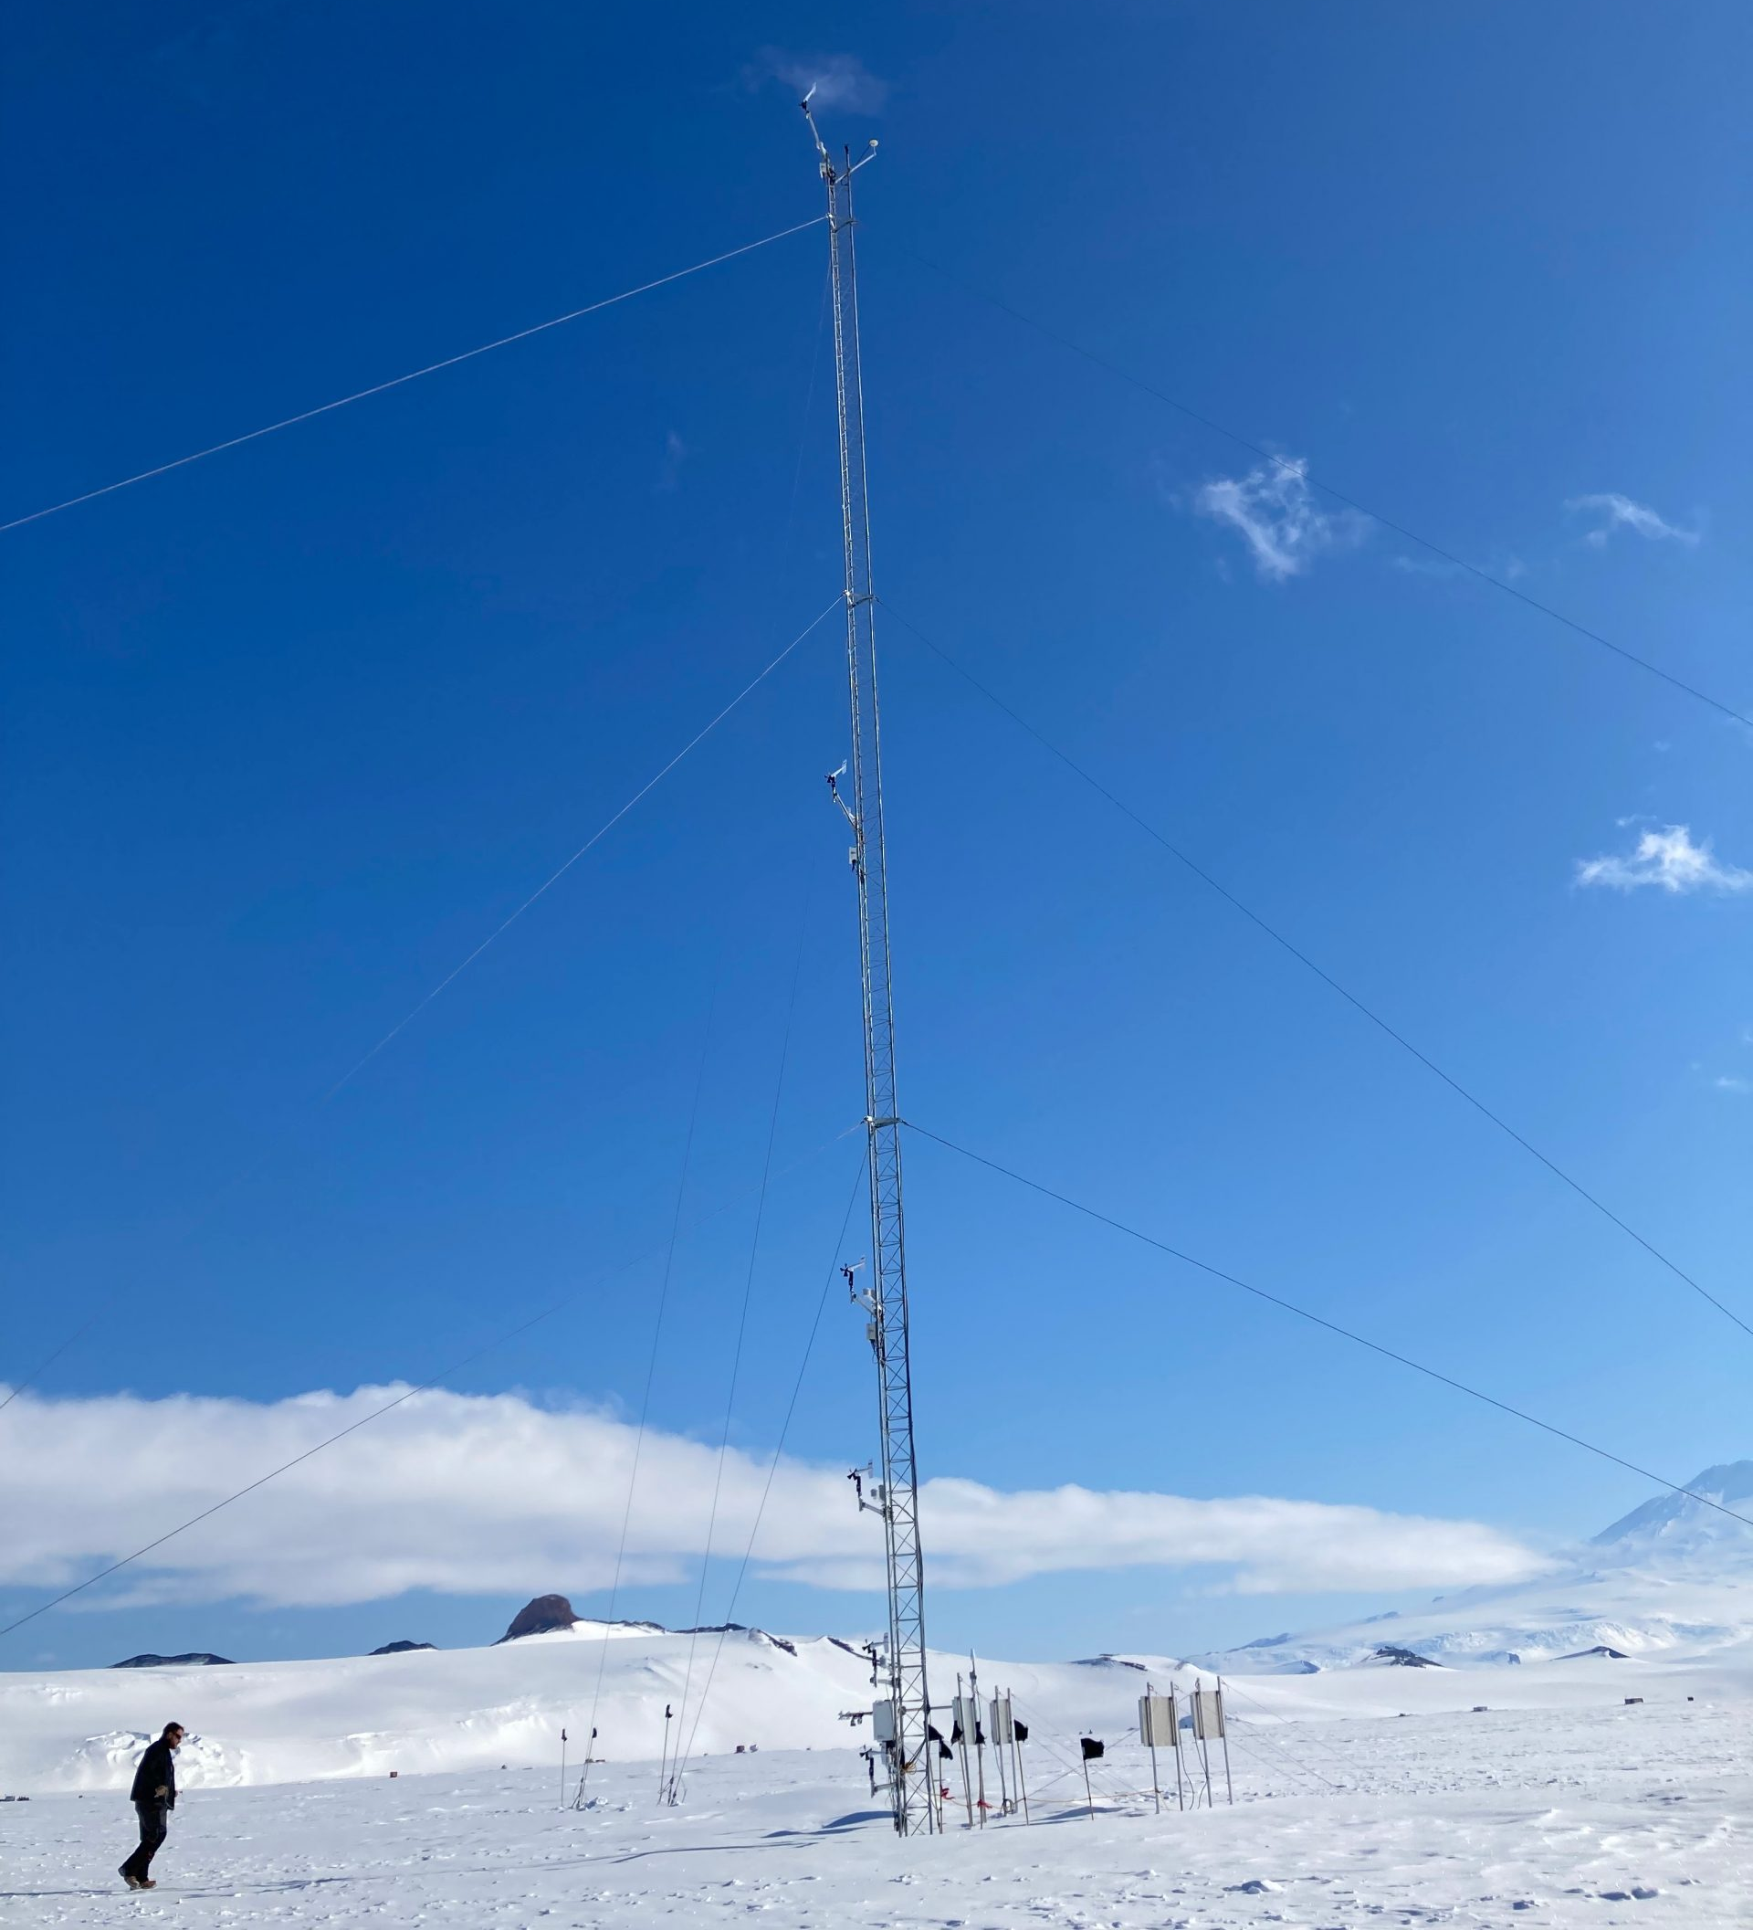

Elizabeth (2019-01-19)
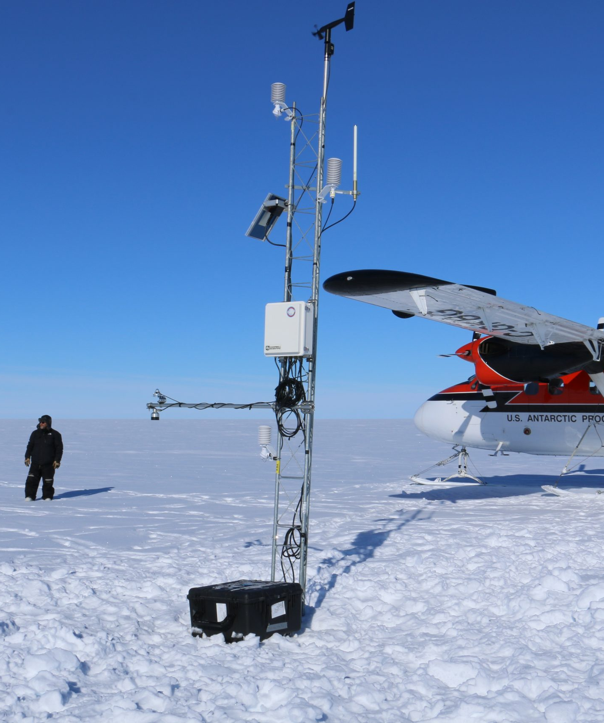

Emilia (2024-12-11)
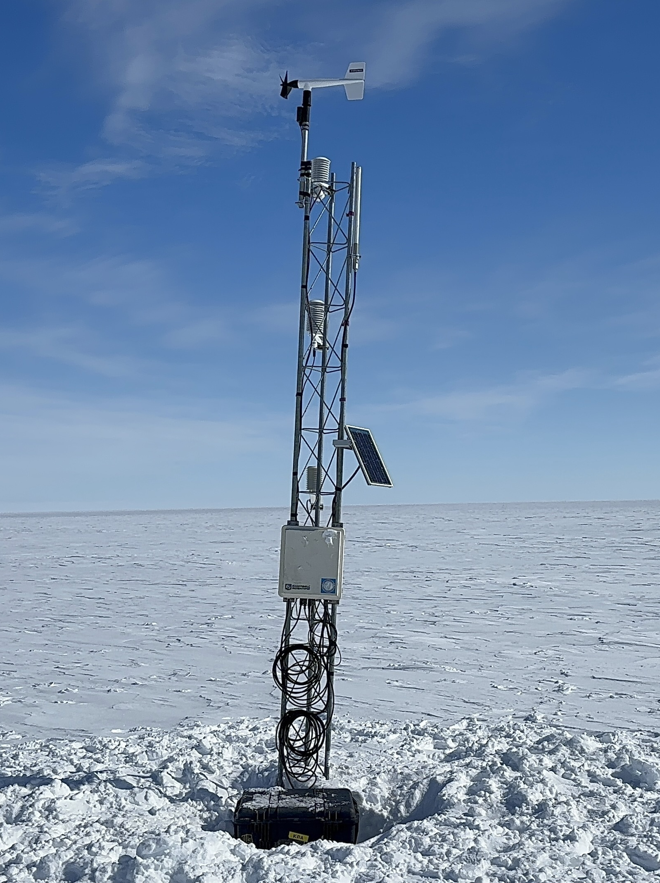

Erin (2019-01-17)
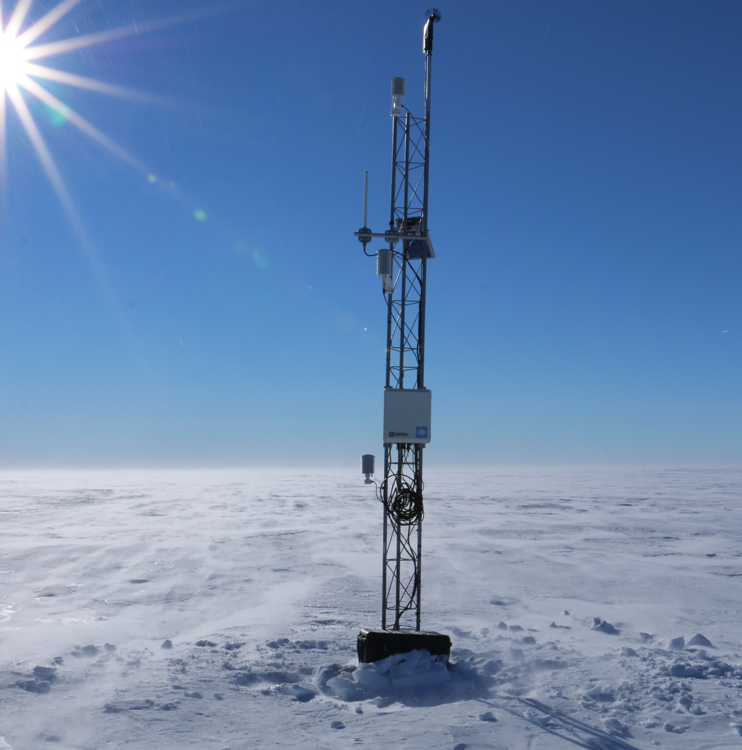

Ferrell (2022-12-03)
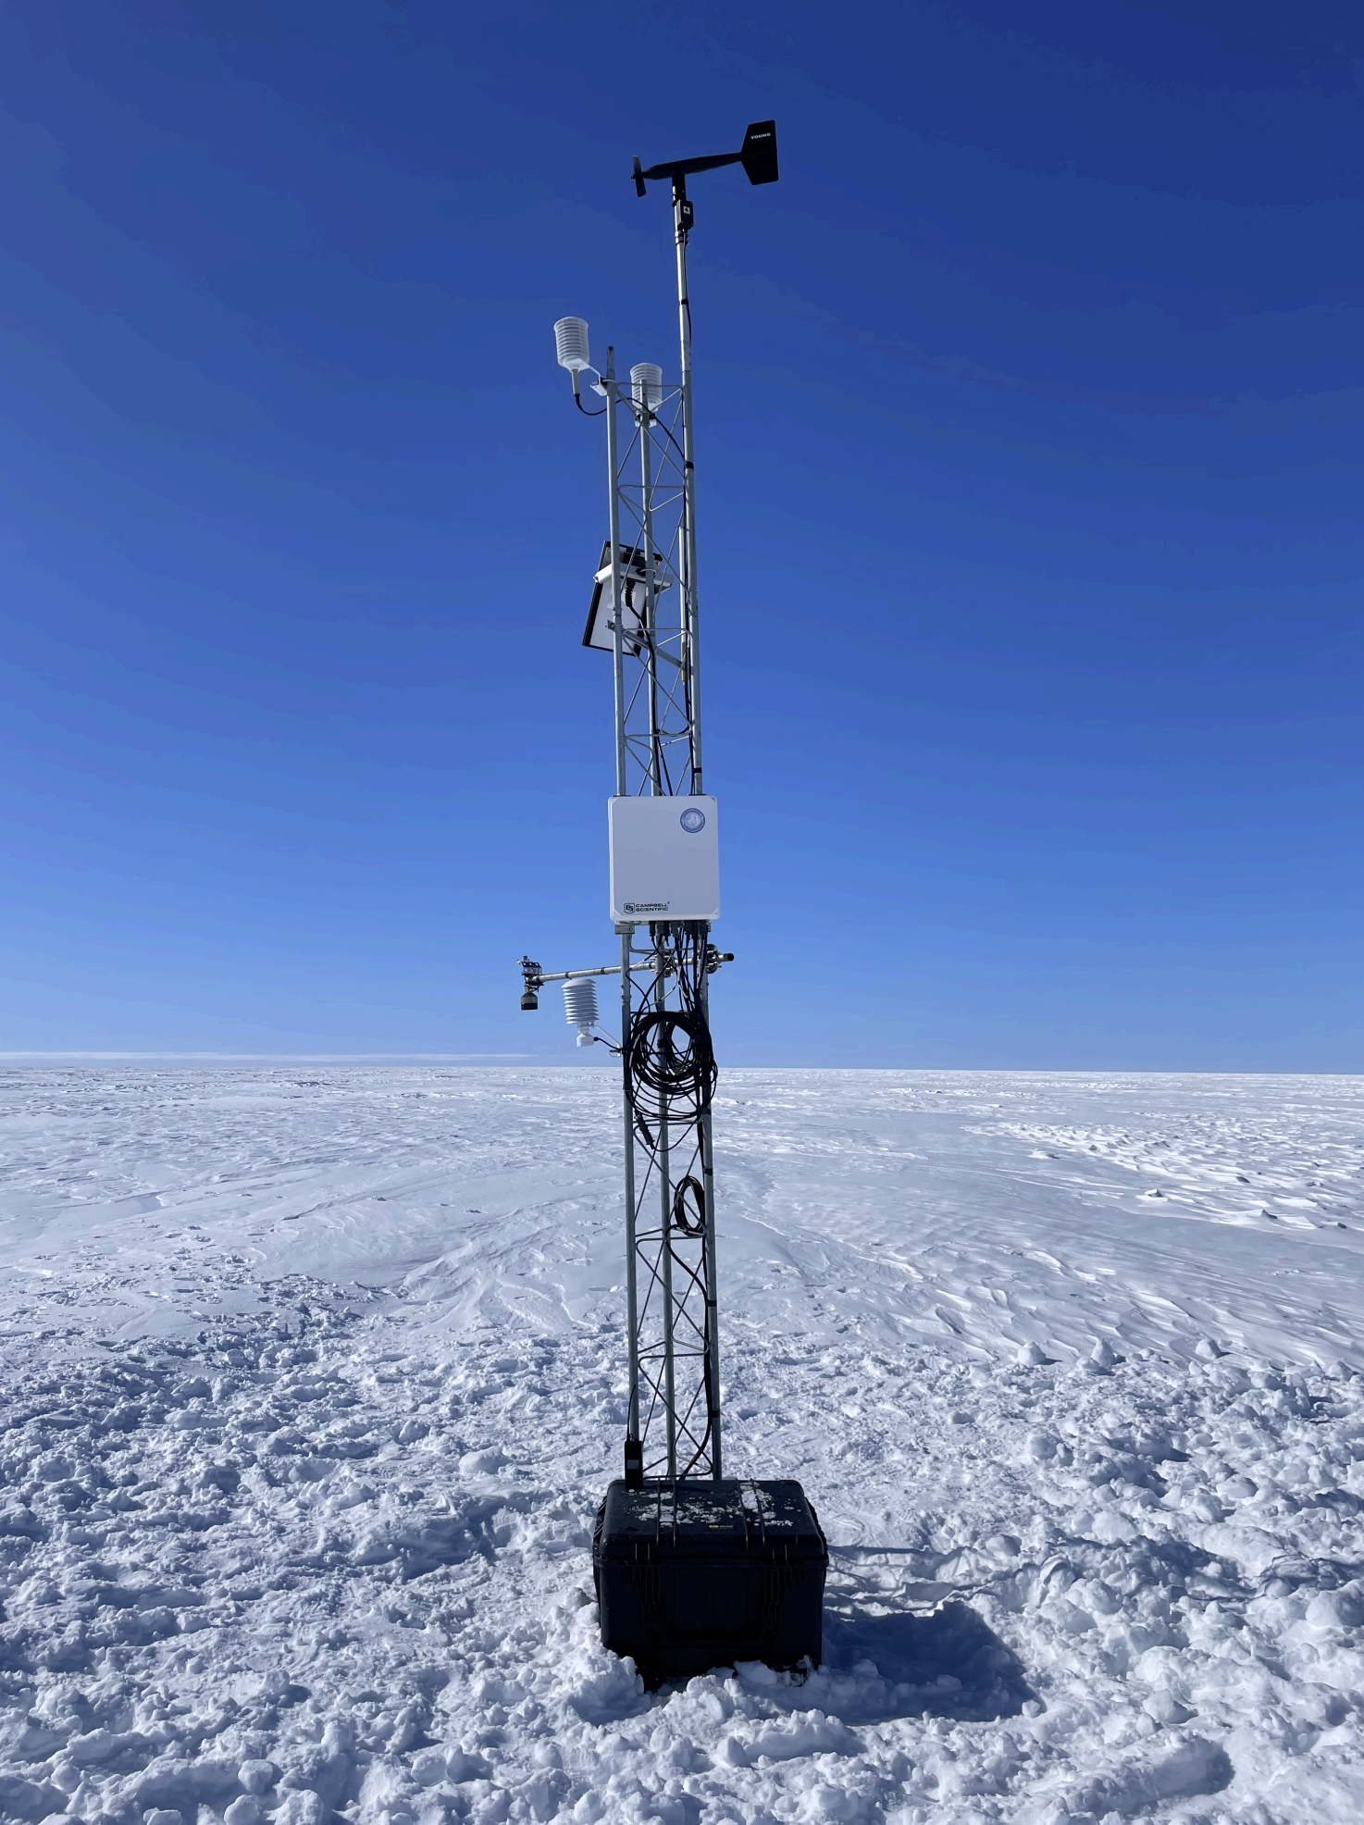

Harry (2019-01-21)
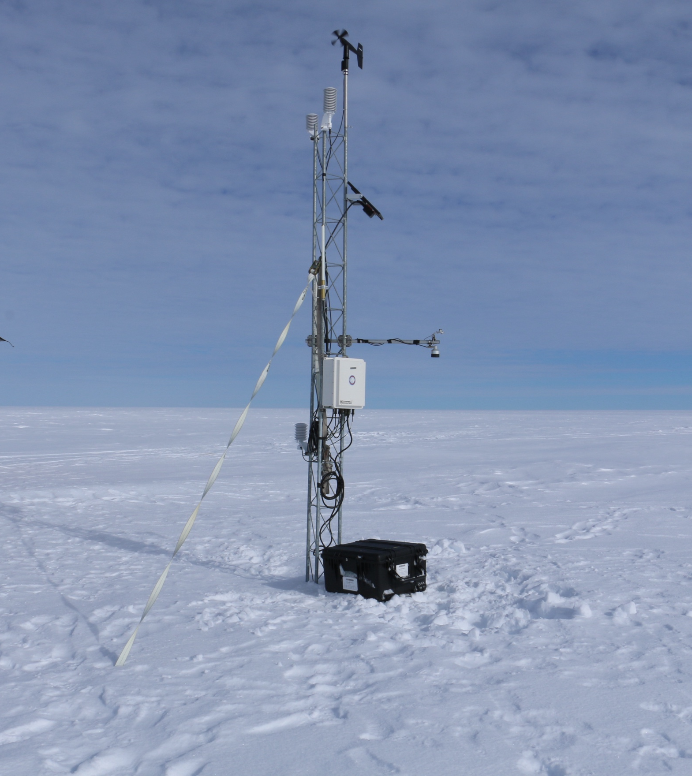

Henry (2018-12-22)
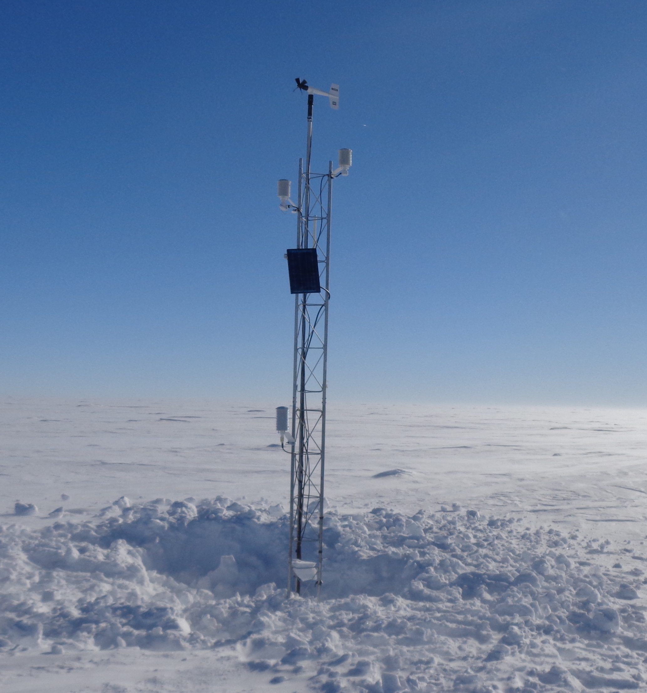

Janet (2019-01-21)
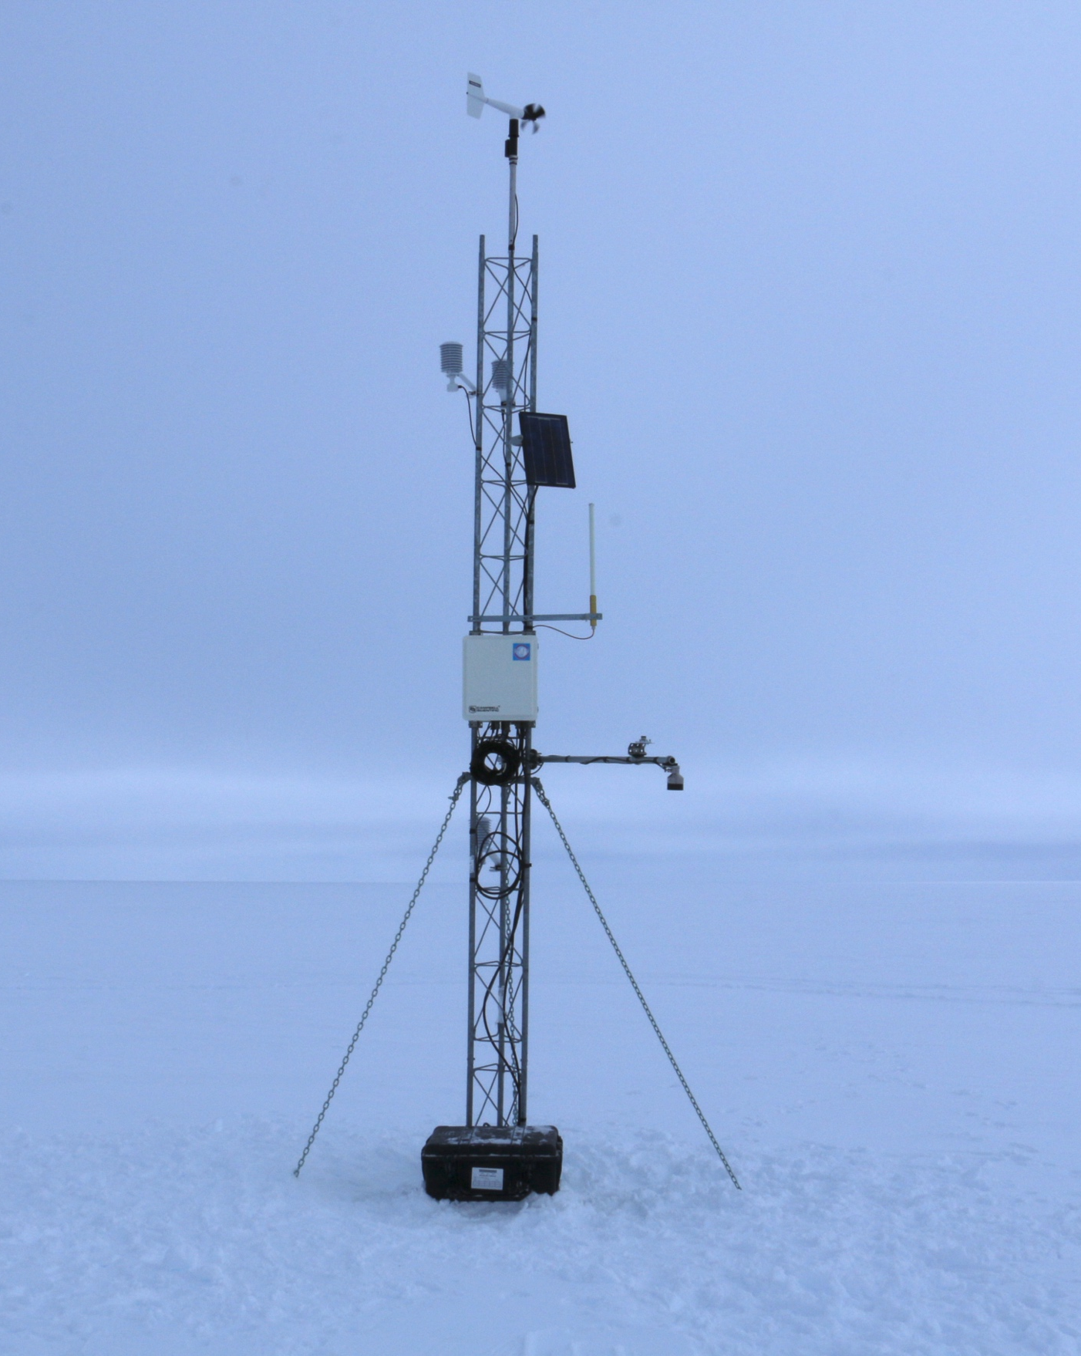

Kathie (2026-01-20) pointing towards North
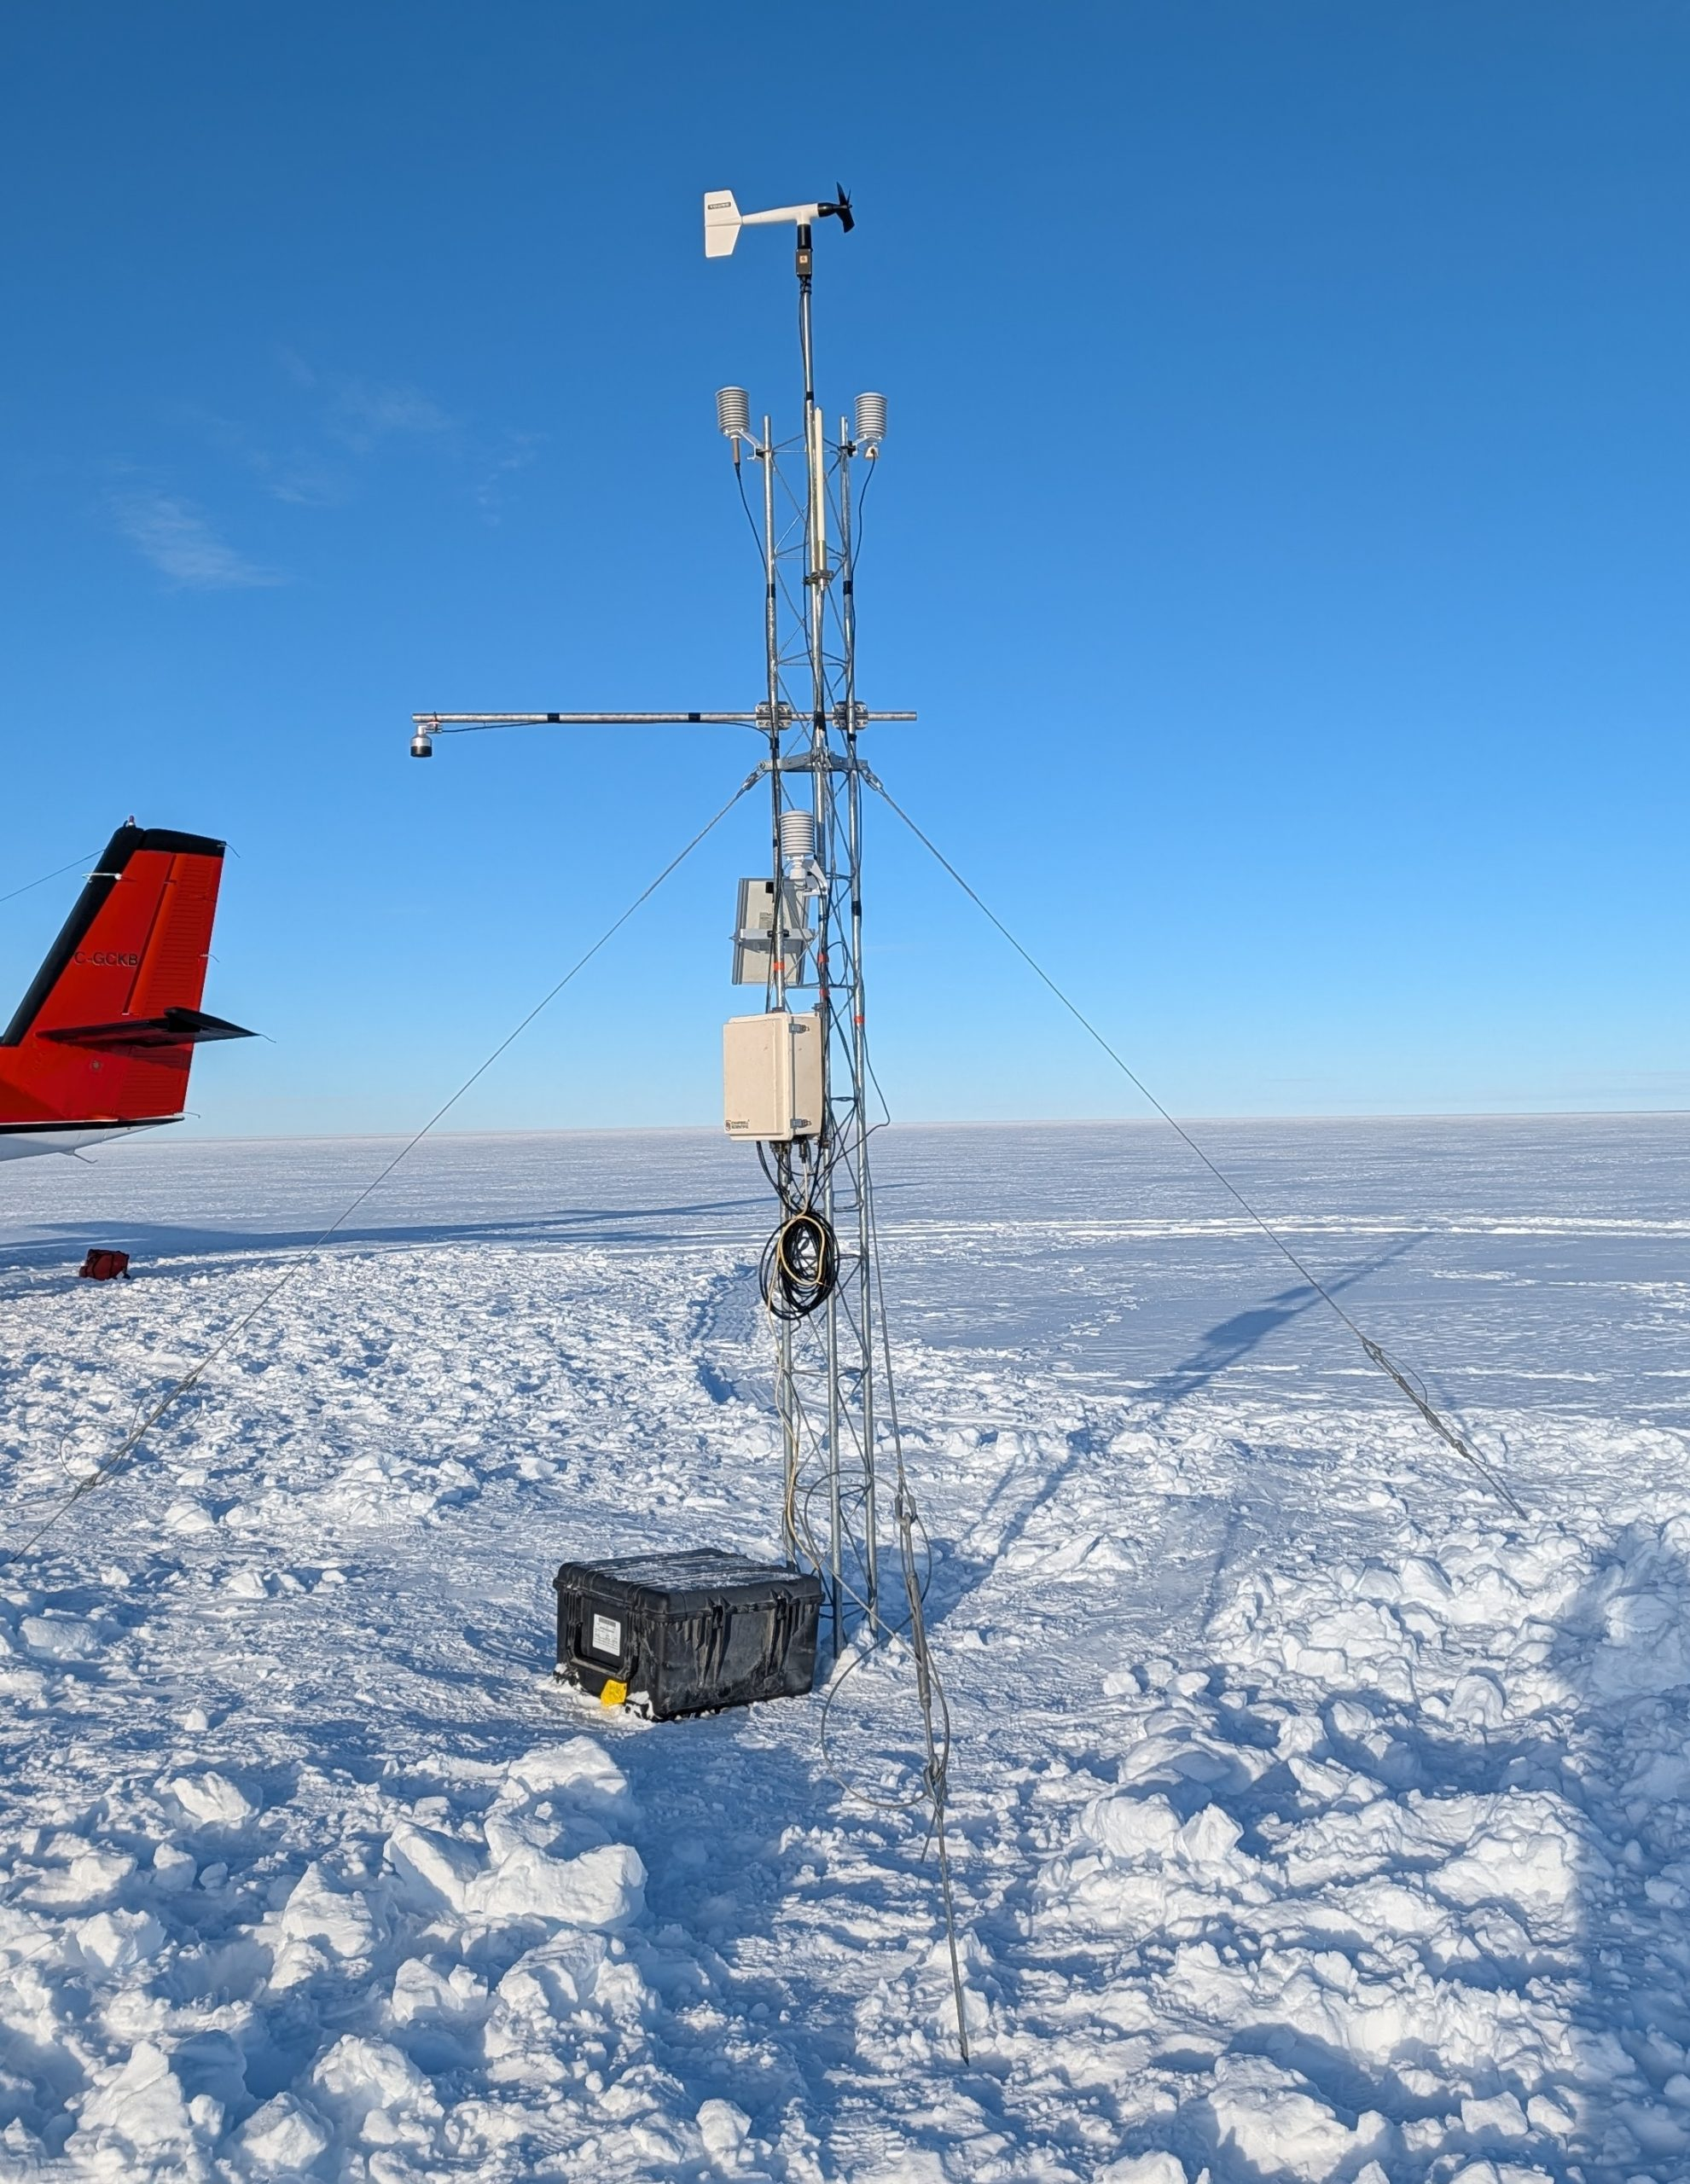
Kominko-Slade (2026/01/22) pointing towards West
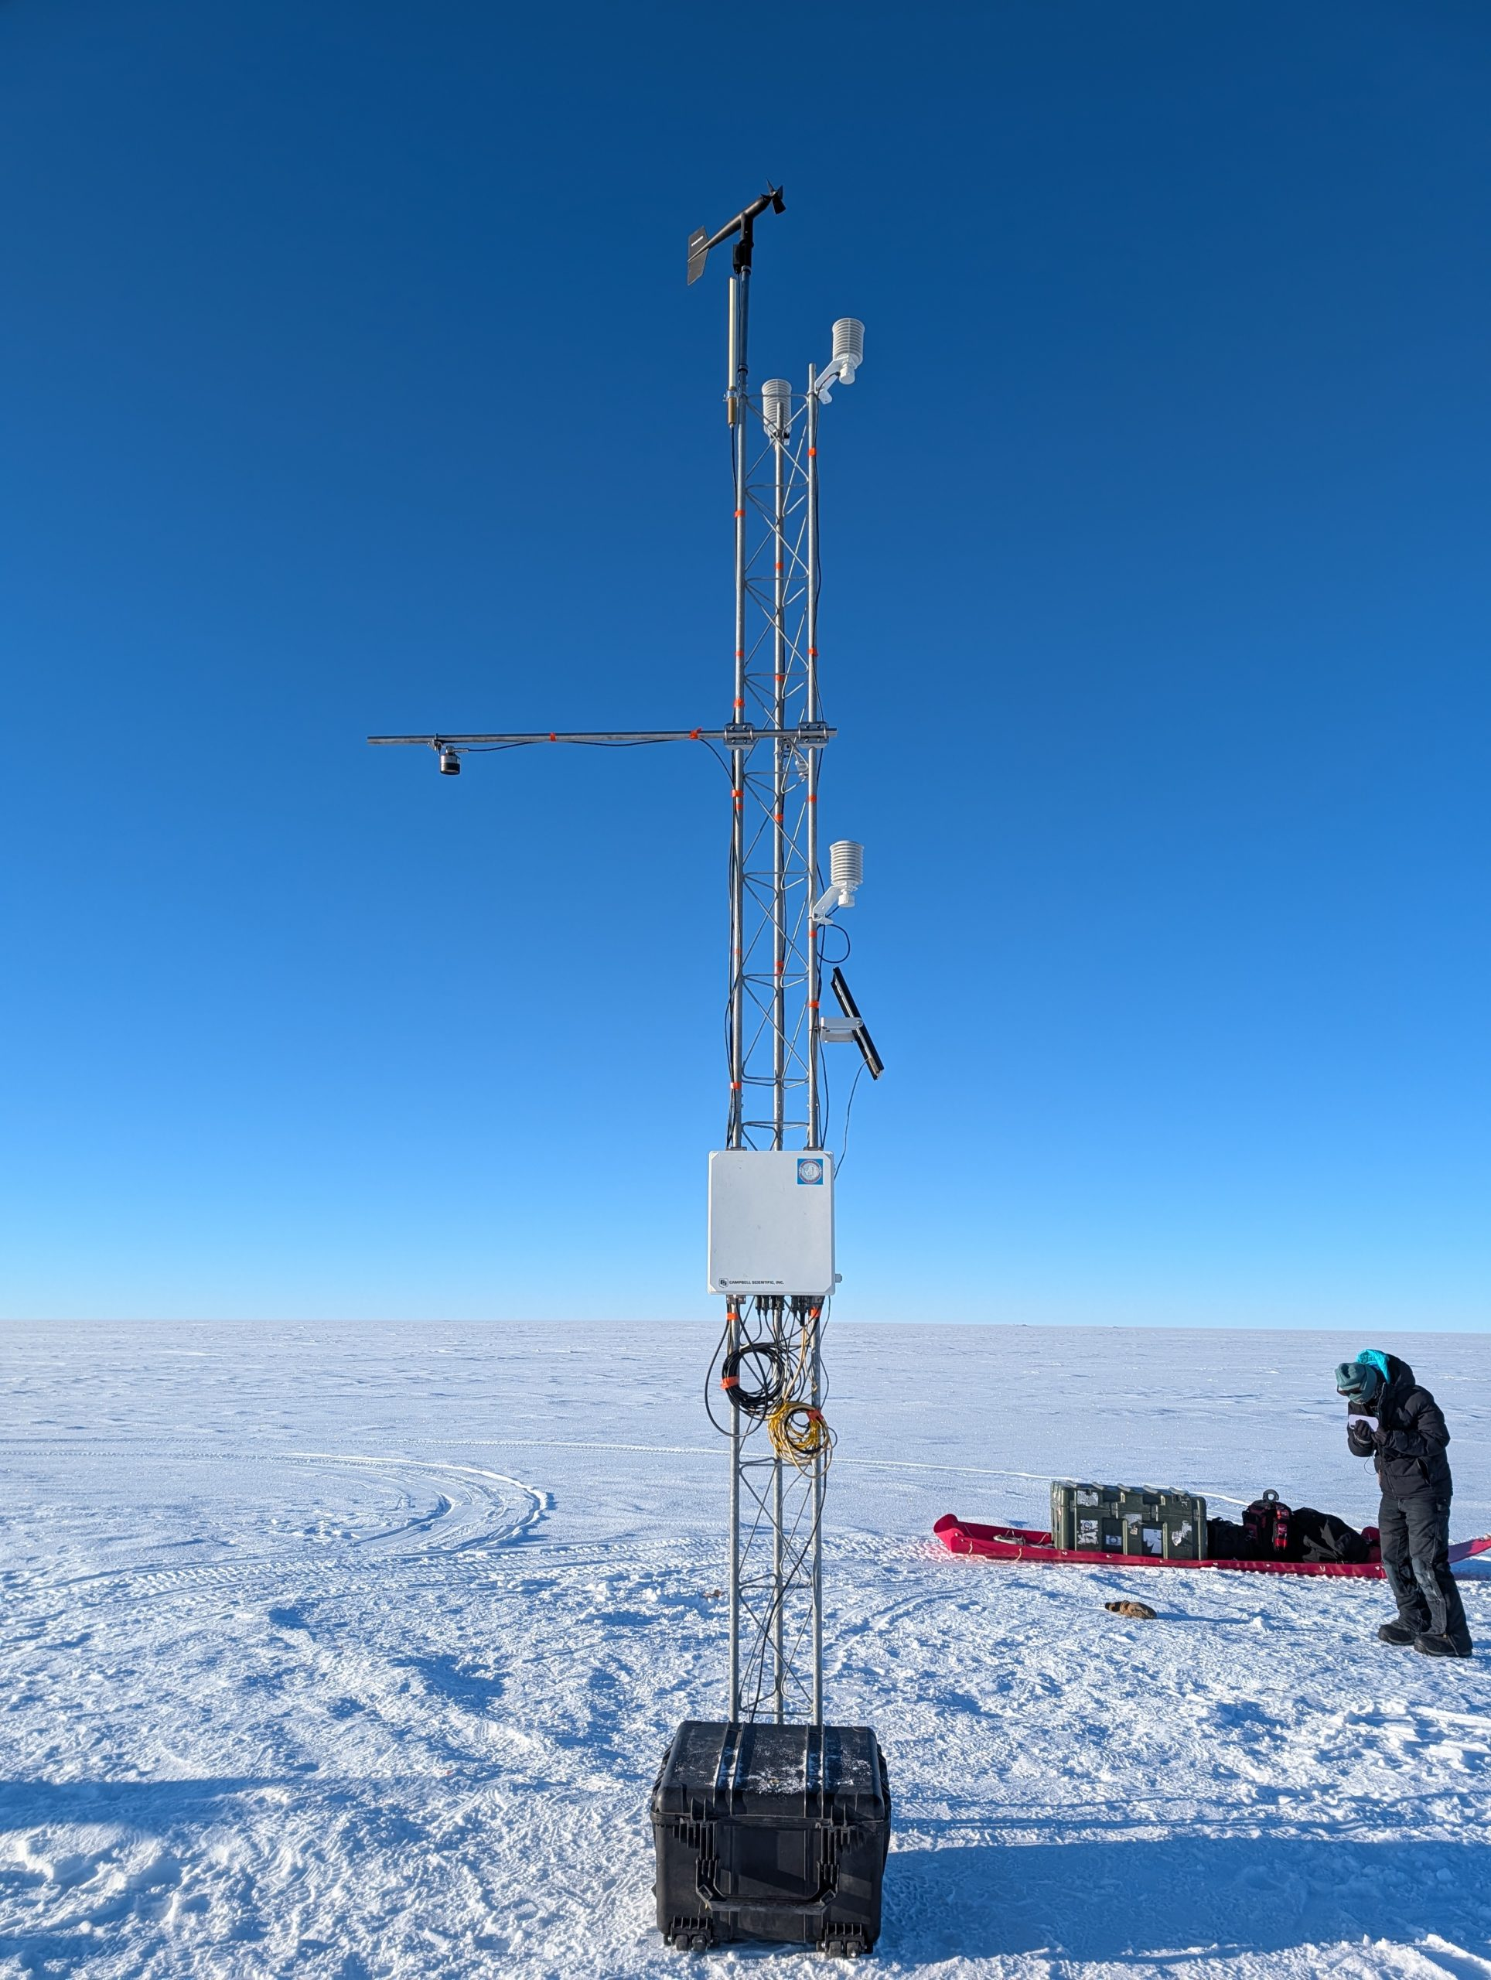

Laurie III (2026/01/27) pointing towards North
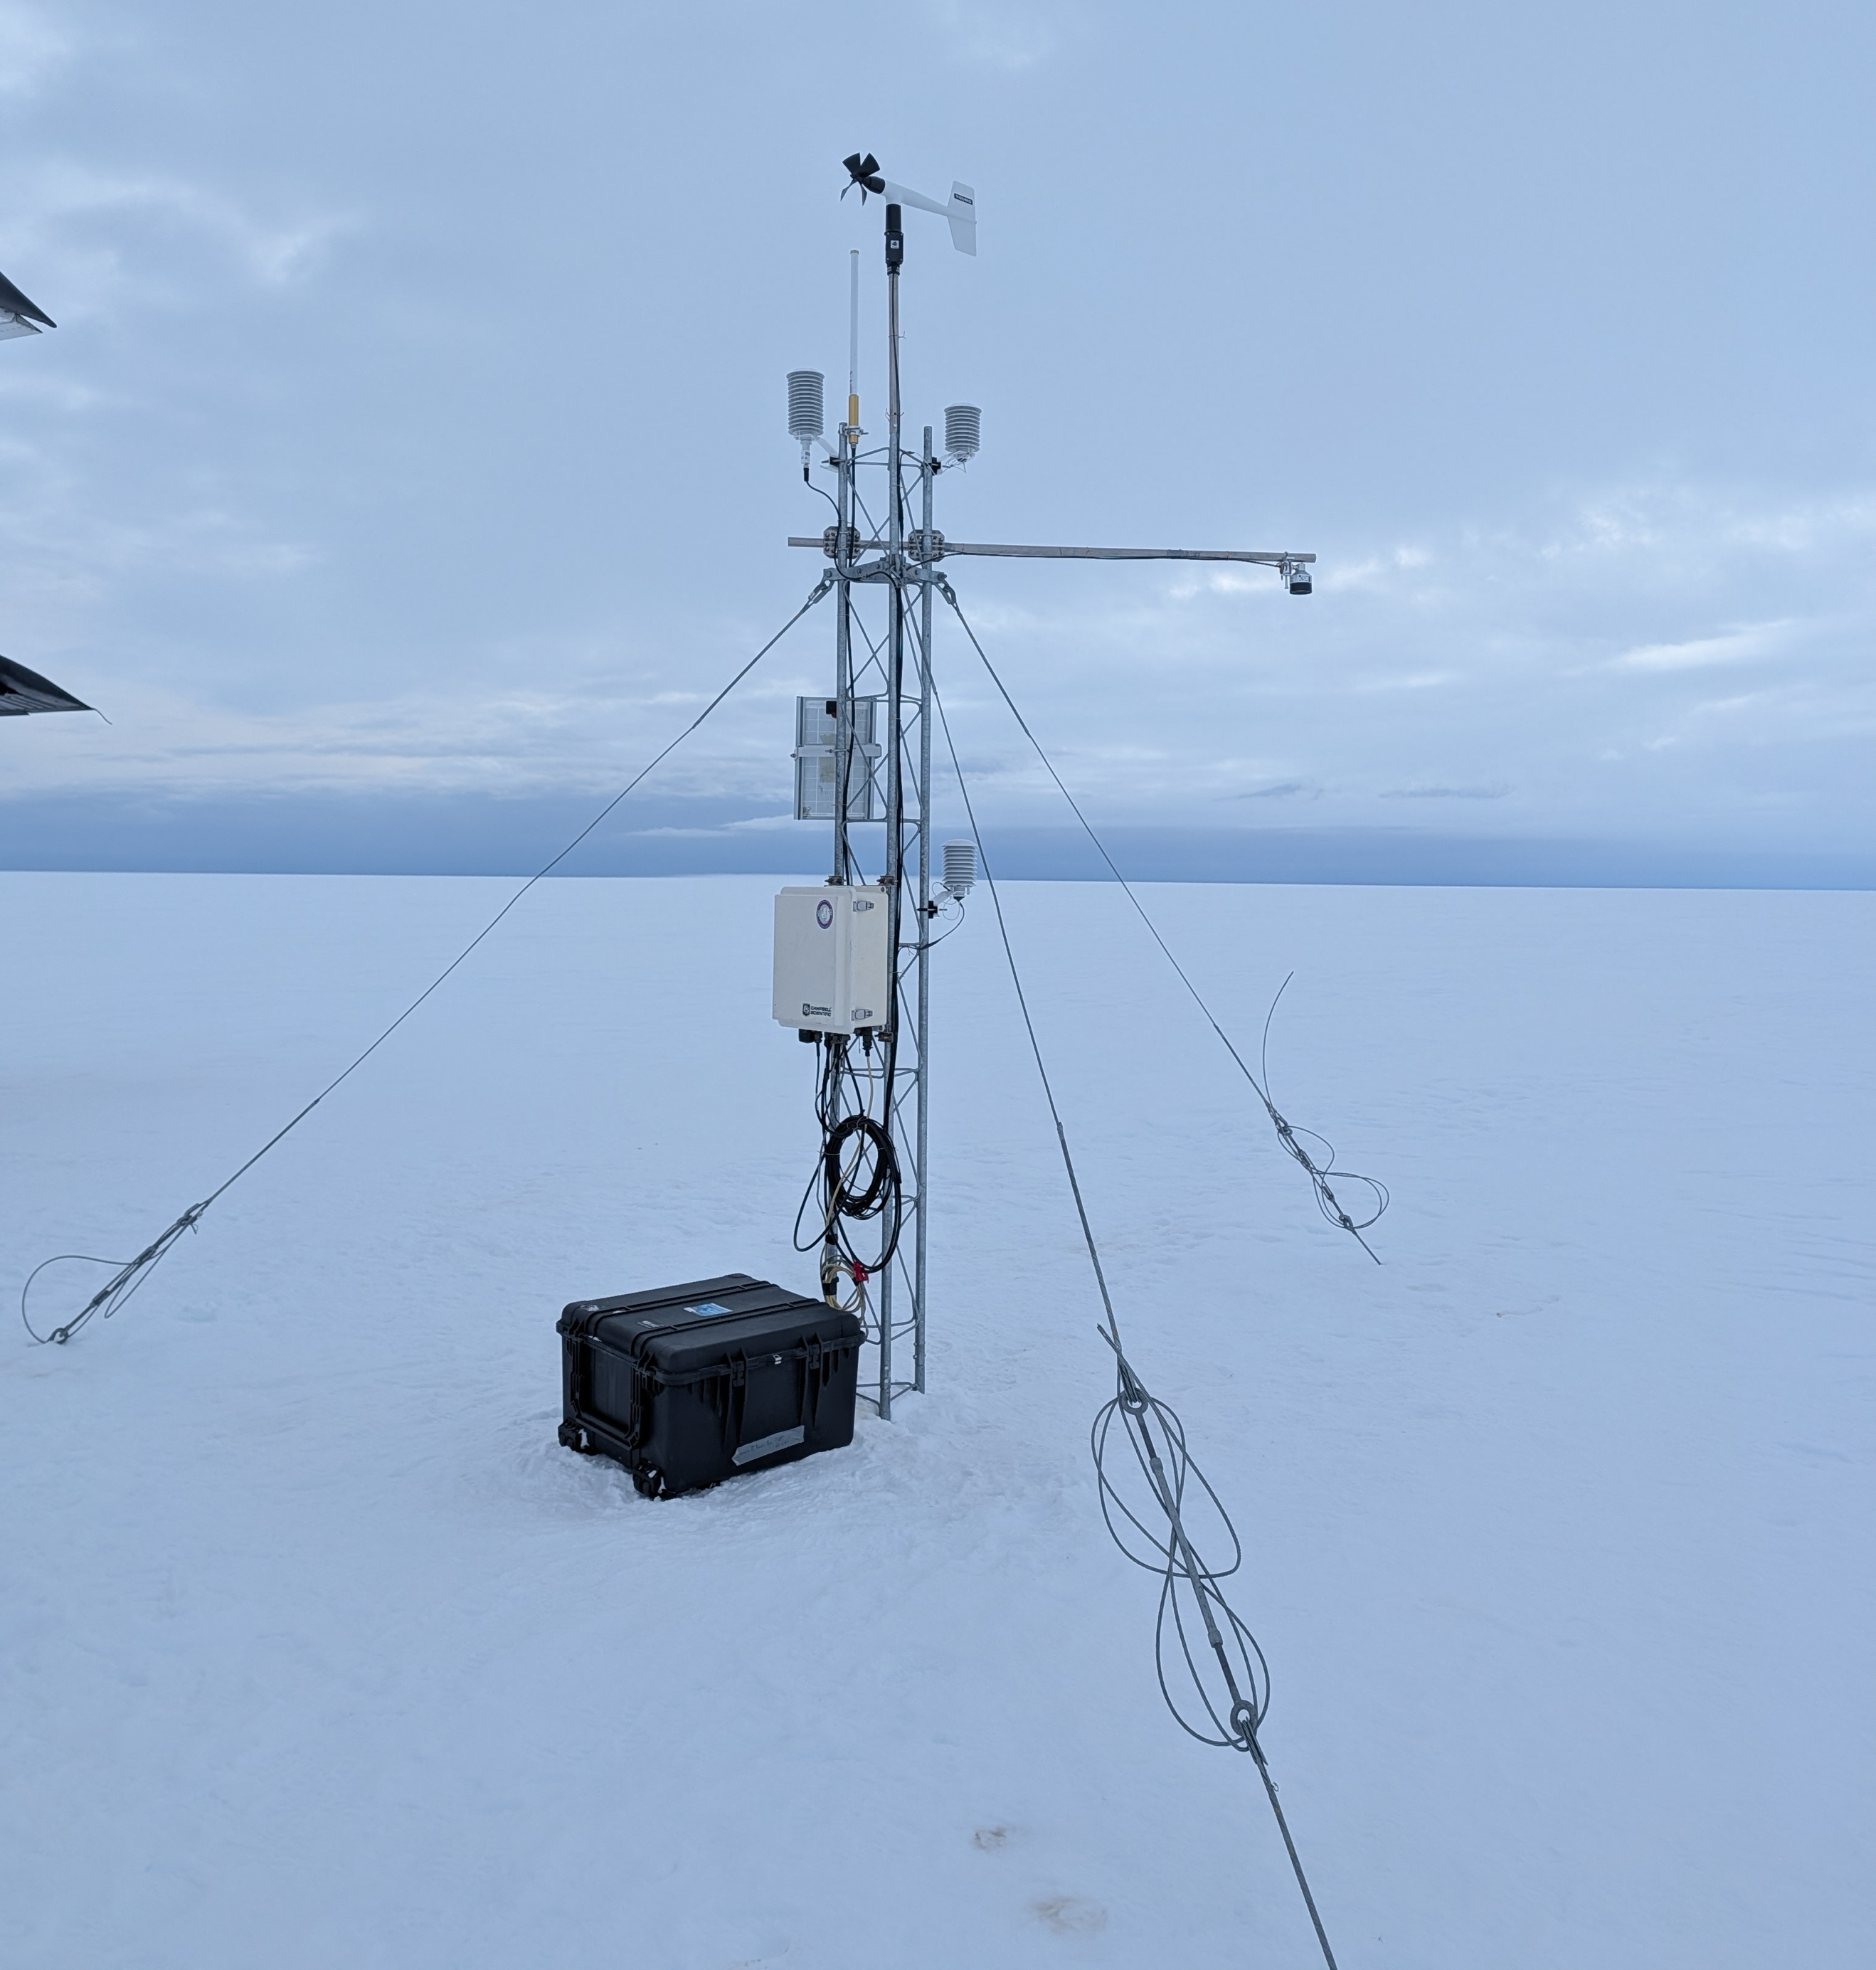

Lettau (2023/12/19)
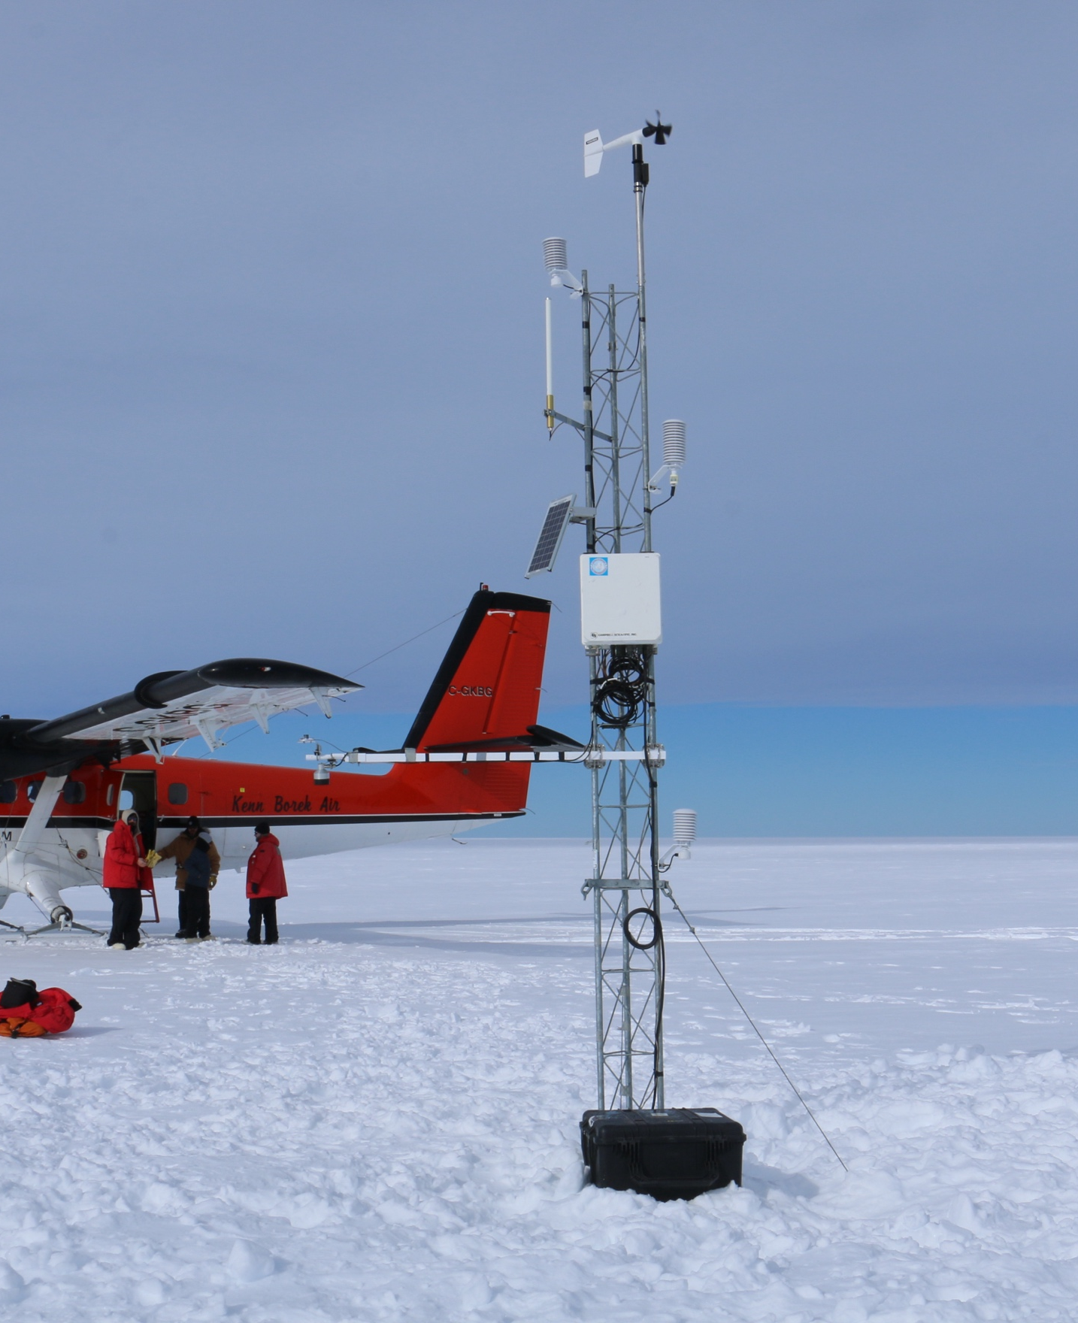

Lorne (2025/12/25) pointing towards North
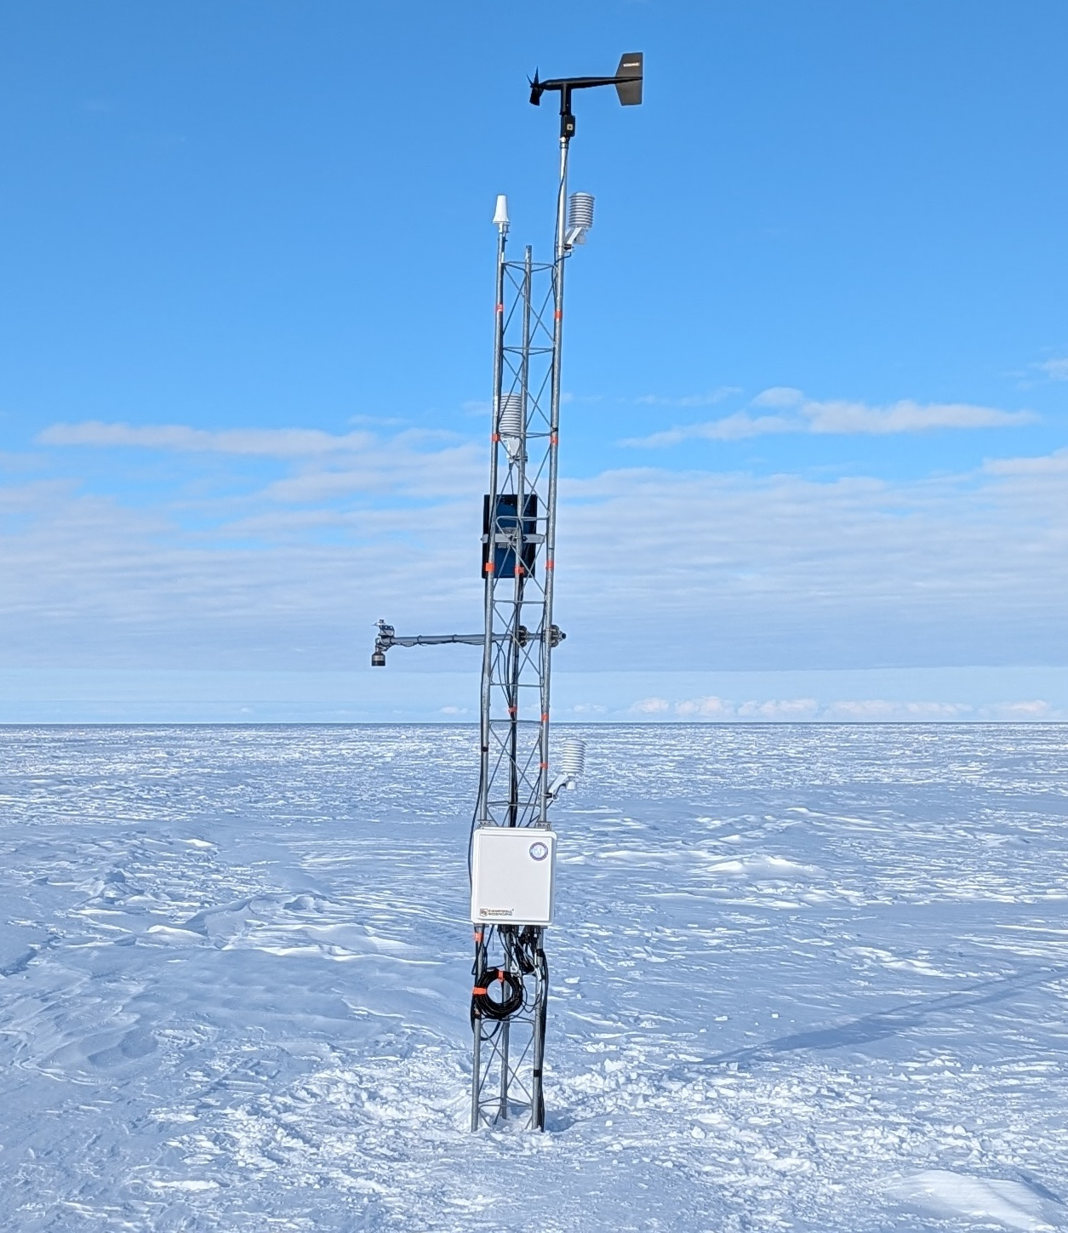

Marble Point (2025/12/13) pointing towards North
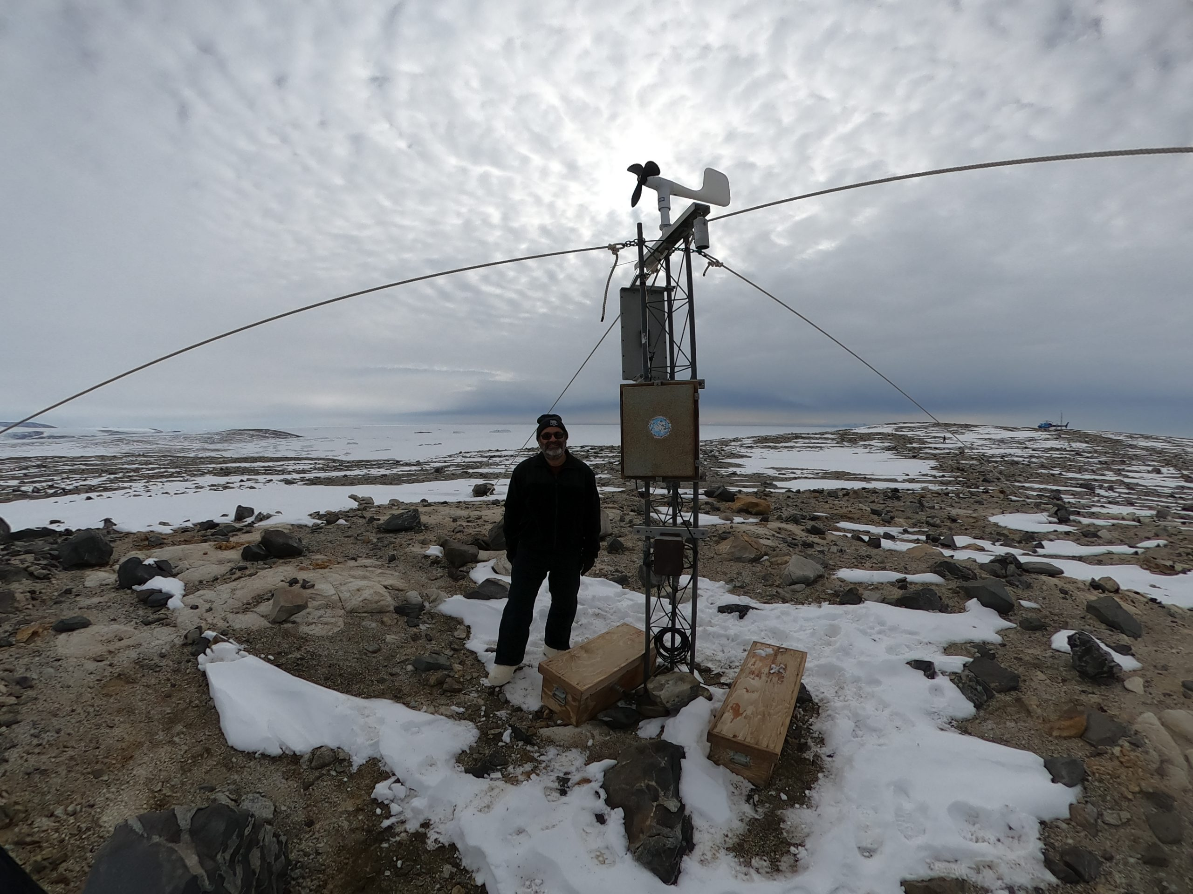

Marble Point II (2025/12/13) pointing towards South
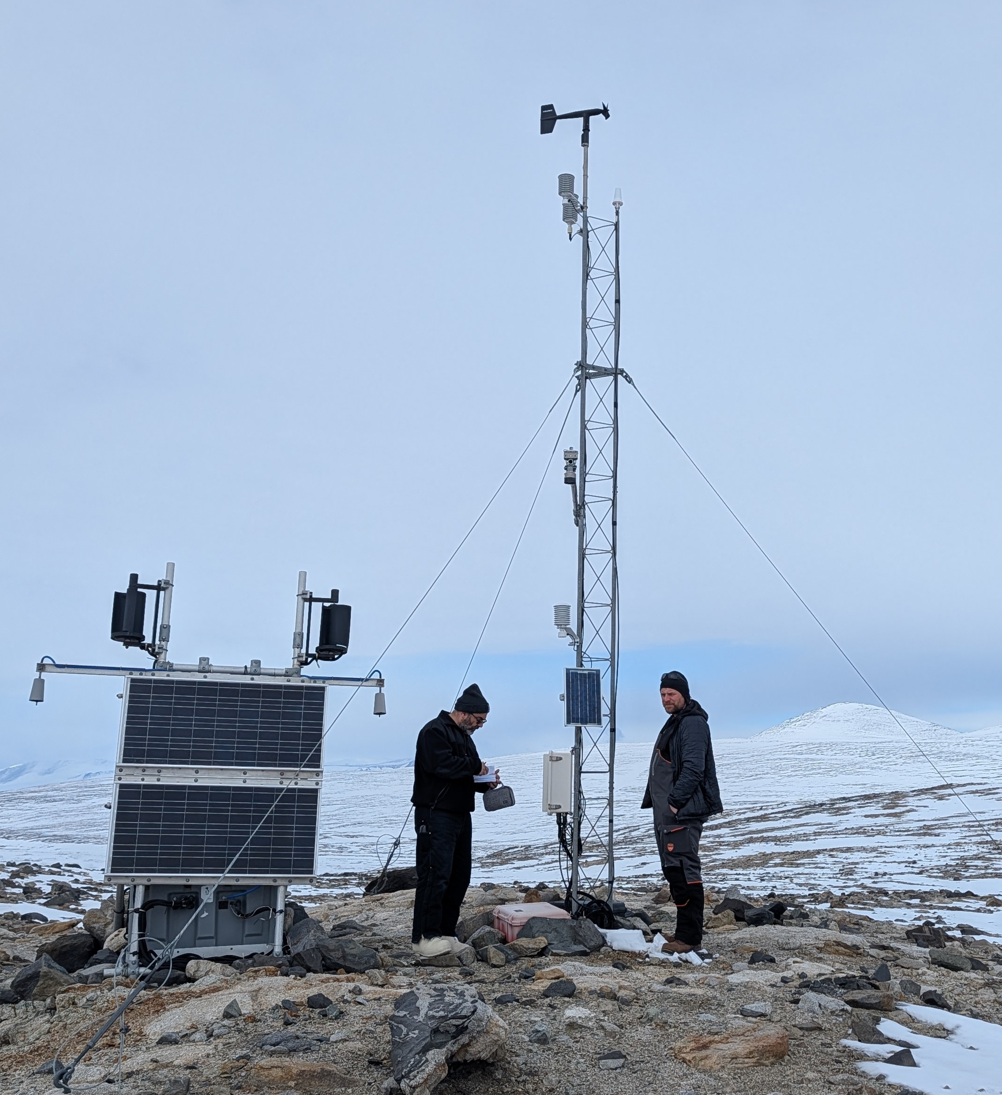

Margaret (2022/11/30)
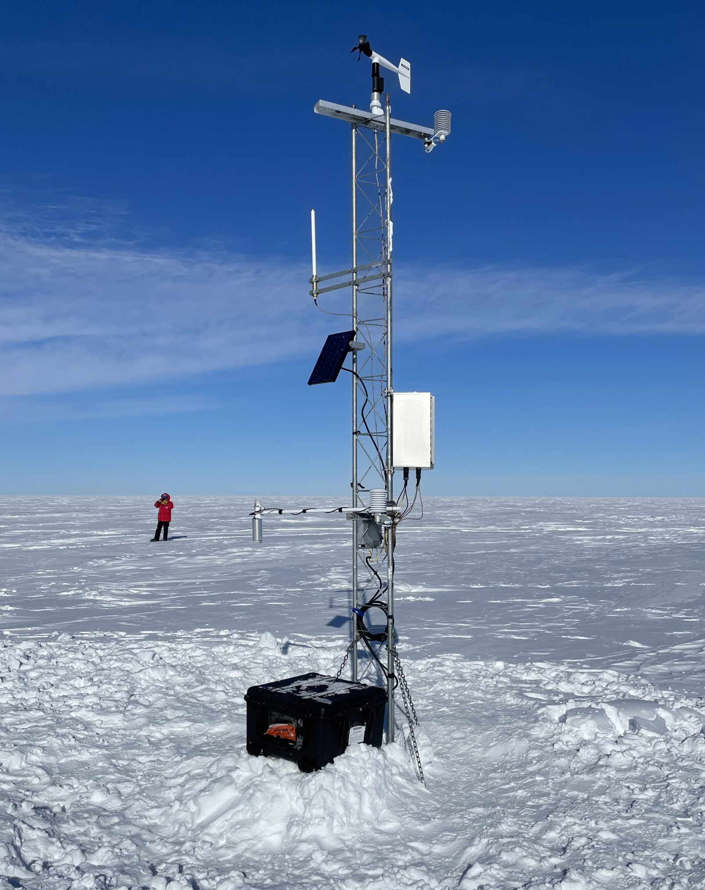

Marilyn (left) and NIWC (2022/01/15)
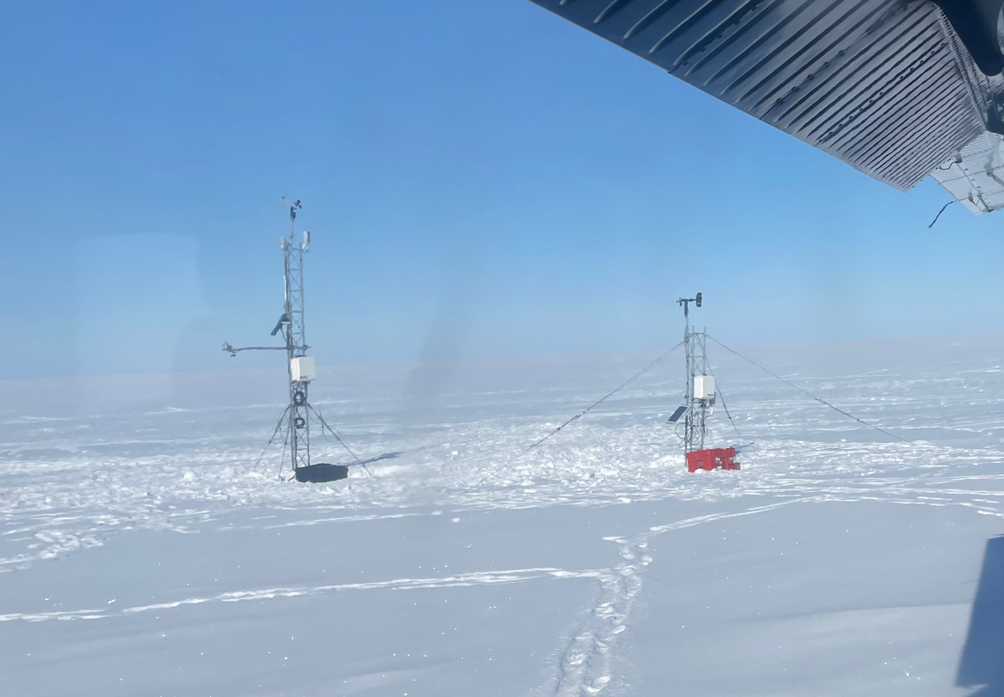
Minna Bluff (2023/11/22)
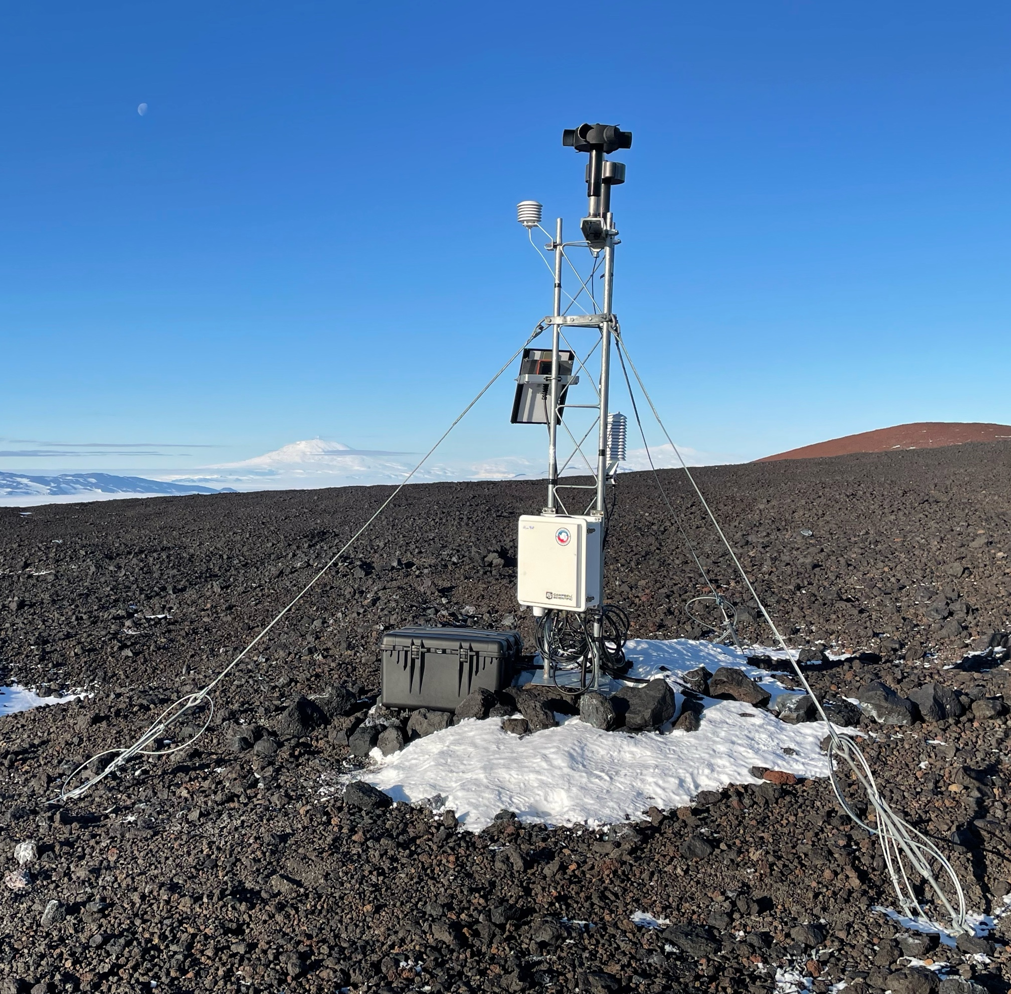

Nico (2018-12-21)
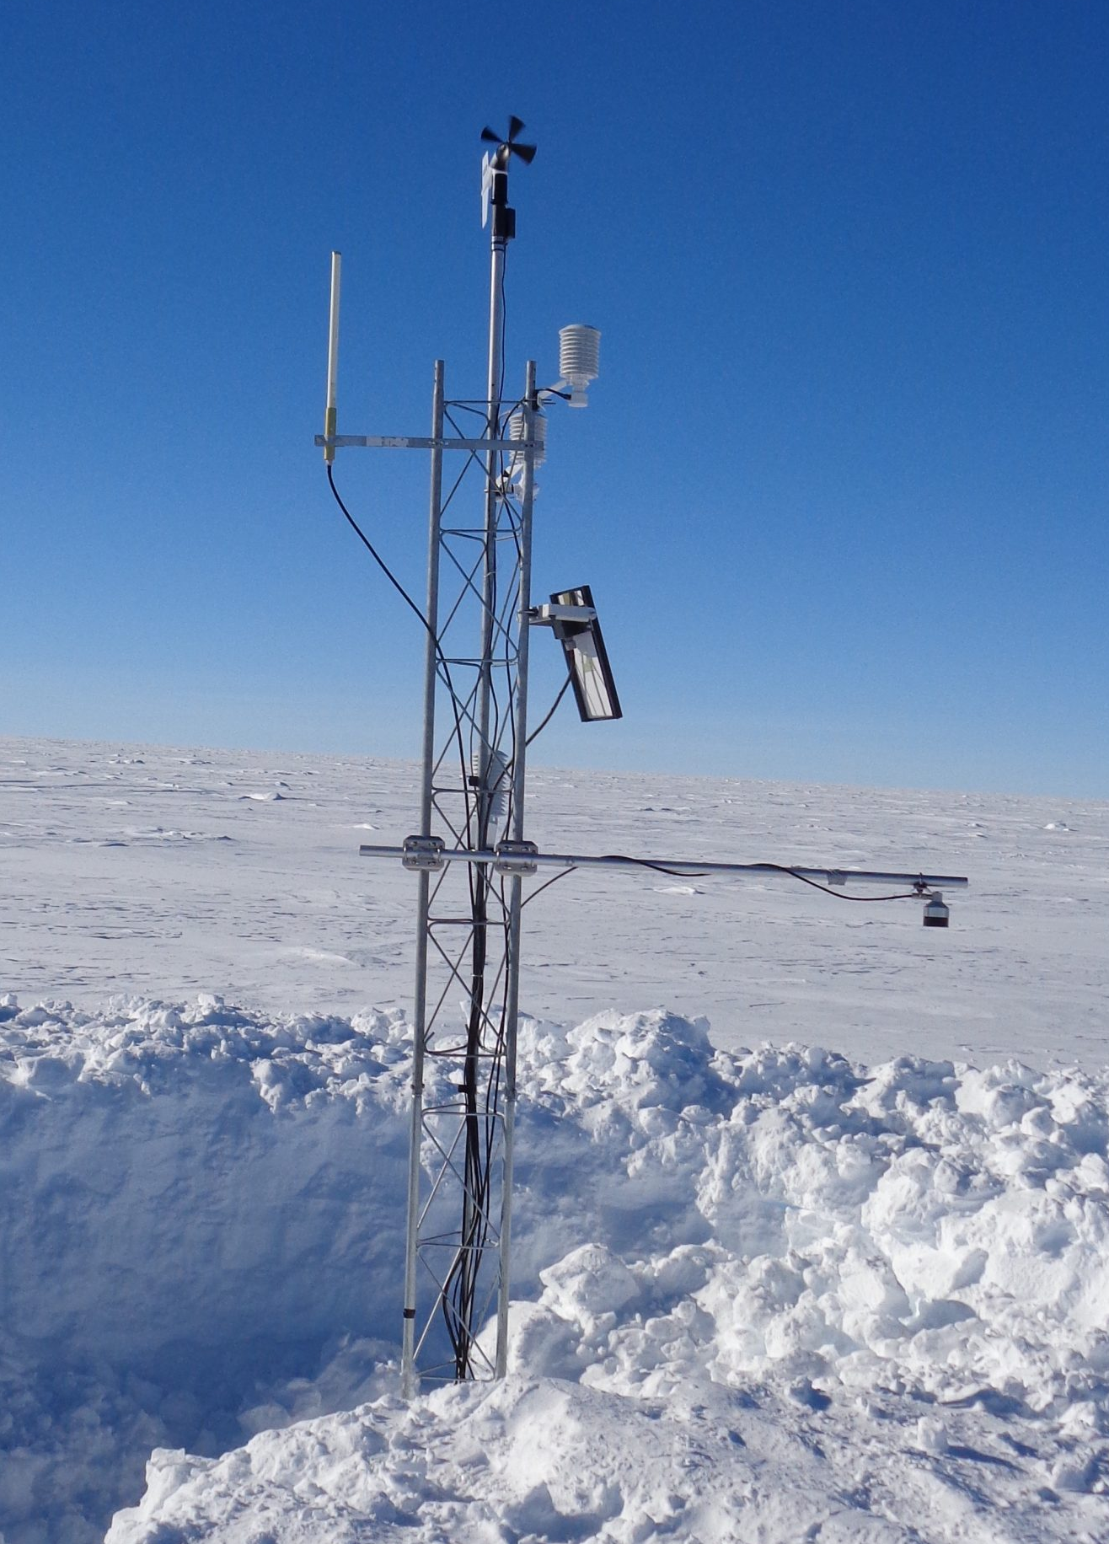
Phoenix (2023-12-12)
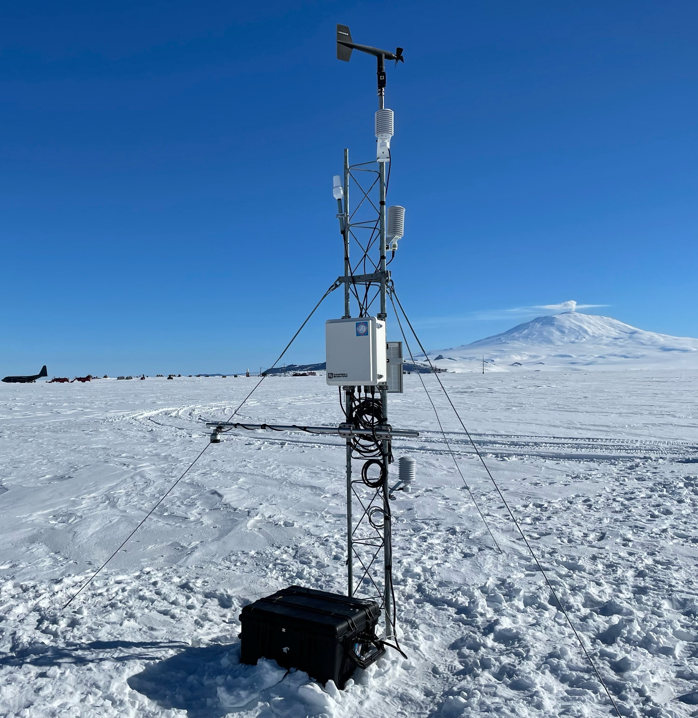

Sabrina (2023-12-07)
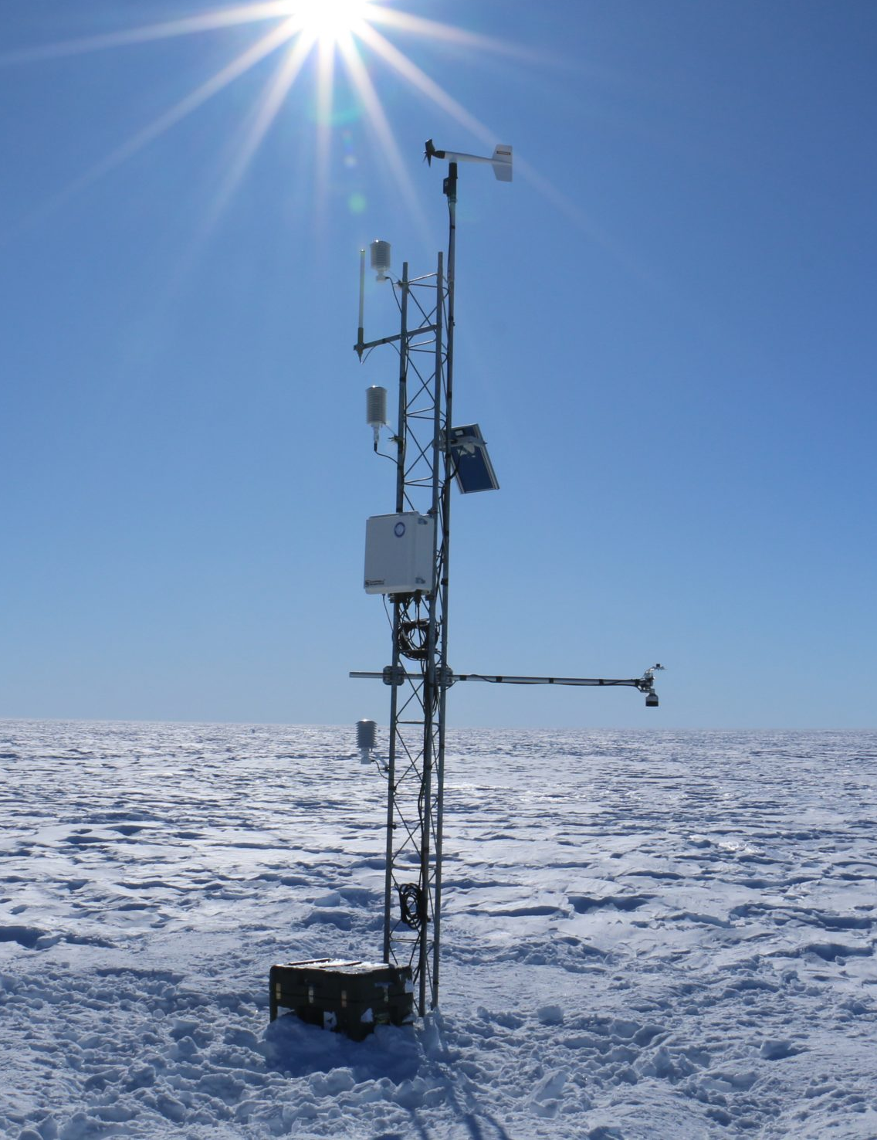
Sarah M-AWS (2026/01/07), pointing towards East
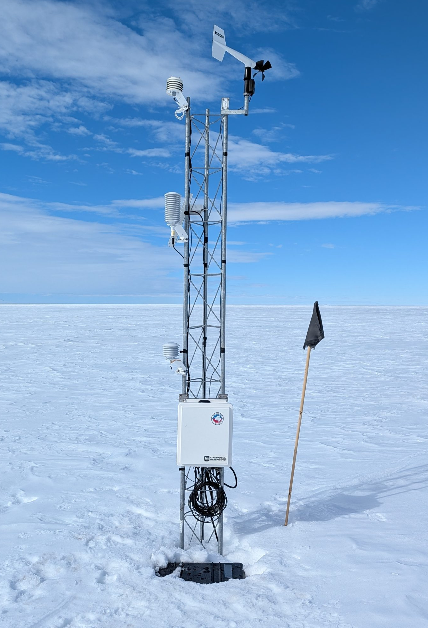

Schwerdtfeger (2026/01/30), pointing towards East
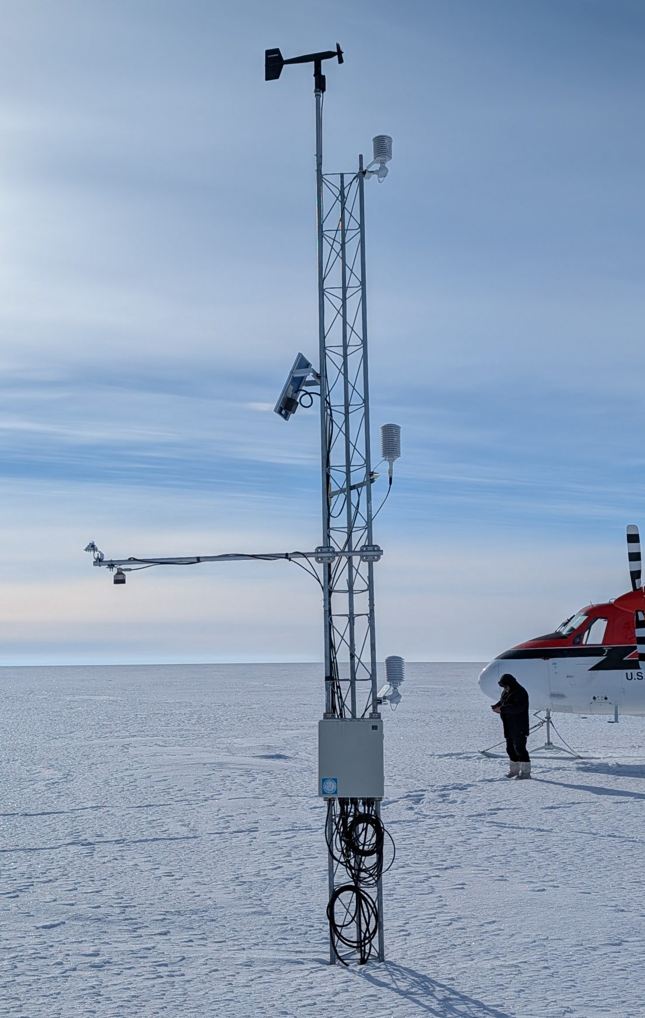

(2022/01/26) Skomik M-AWS (left), Schwerdtfeger AWS (middle), NIWC (right)
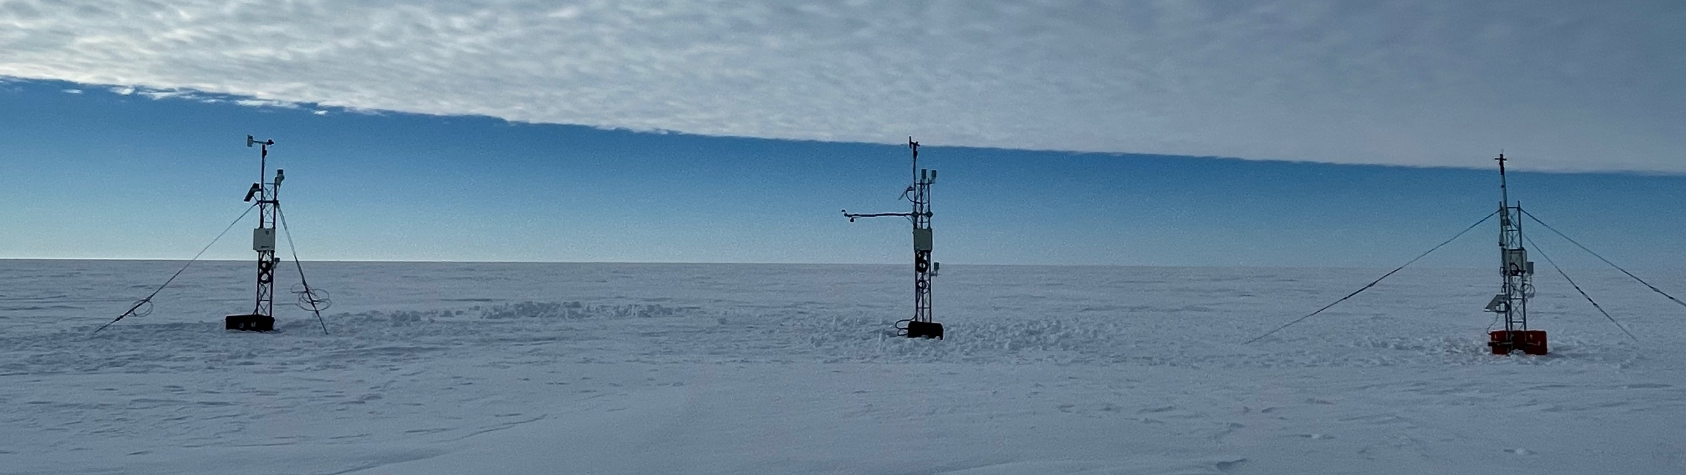
Siple Dome (2026/01/21)
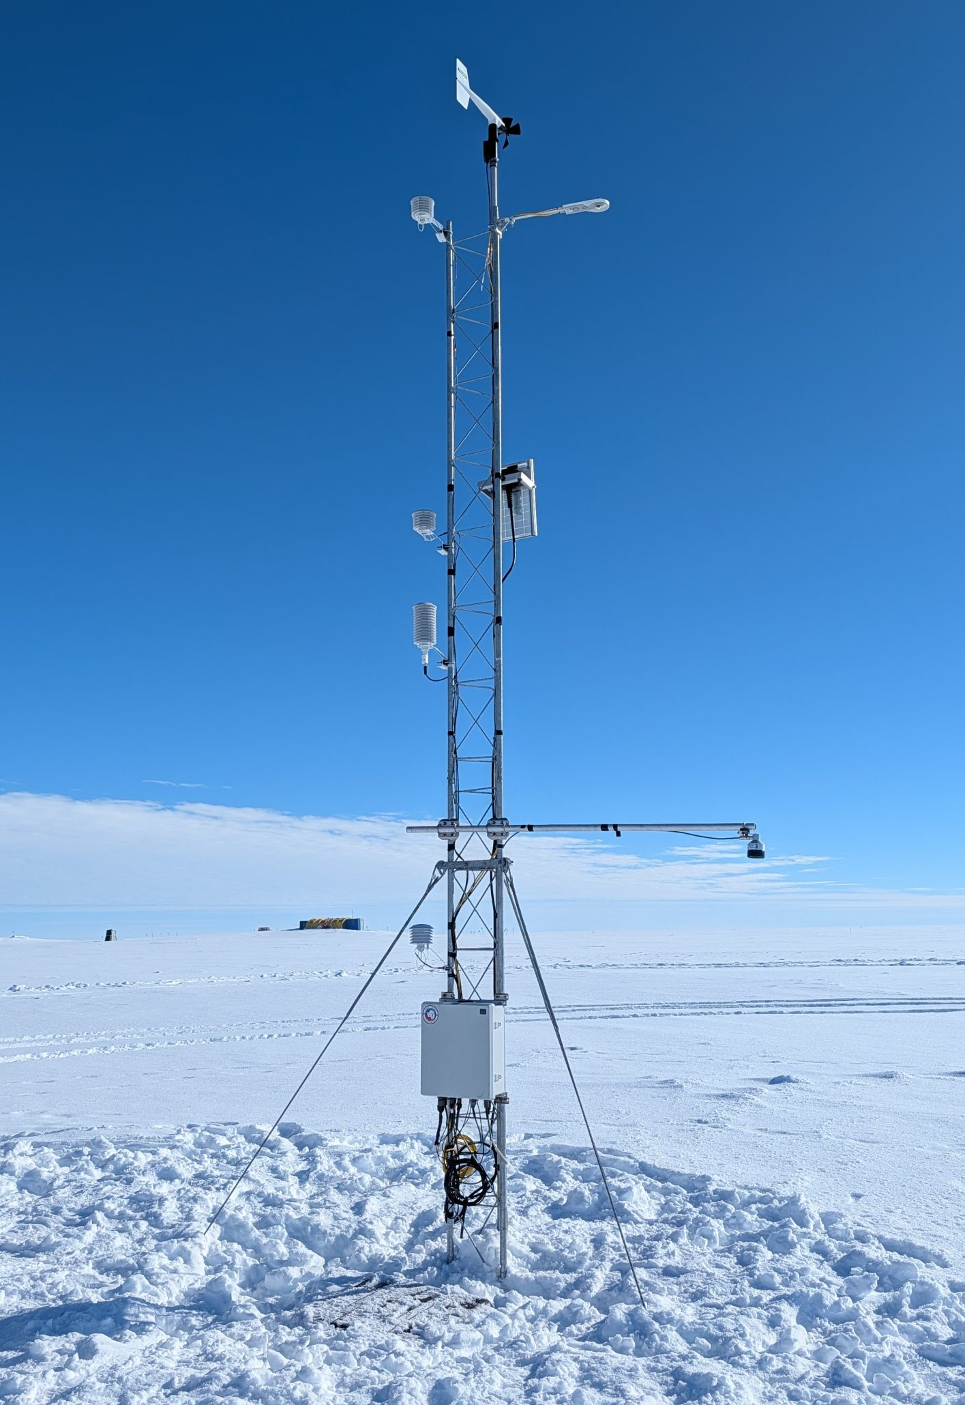

Skomik M-AWS (2026/01/30), pointing towards East
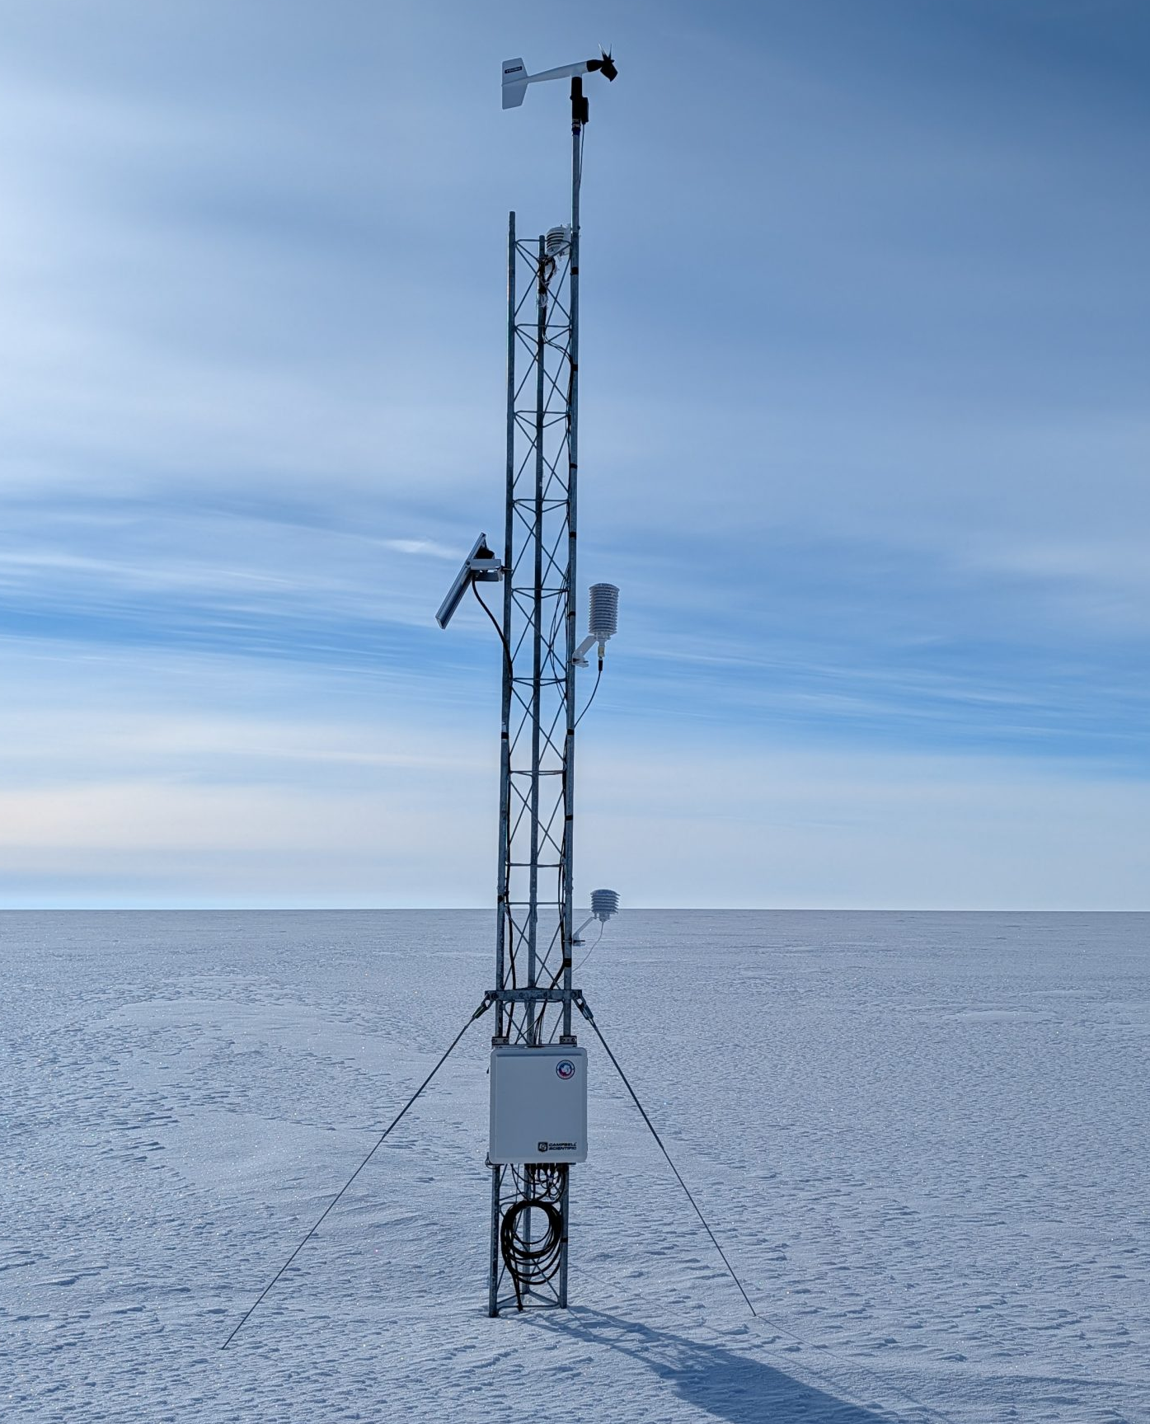

Theresa (2019/01/17)
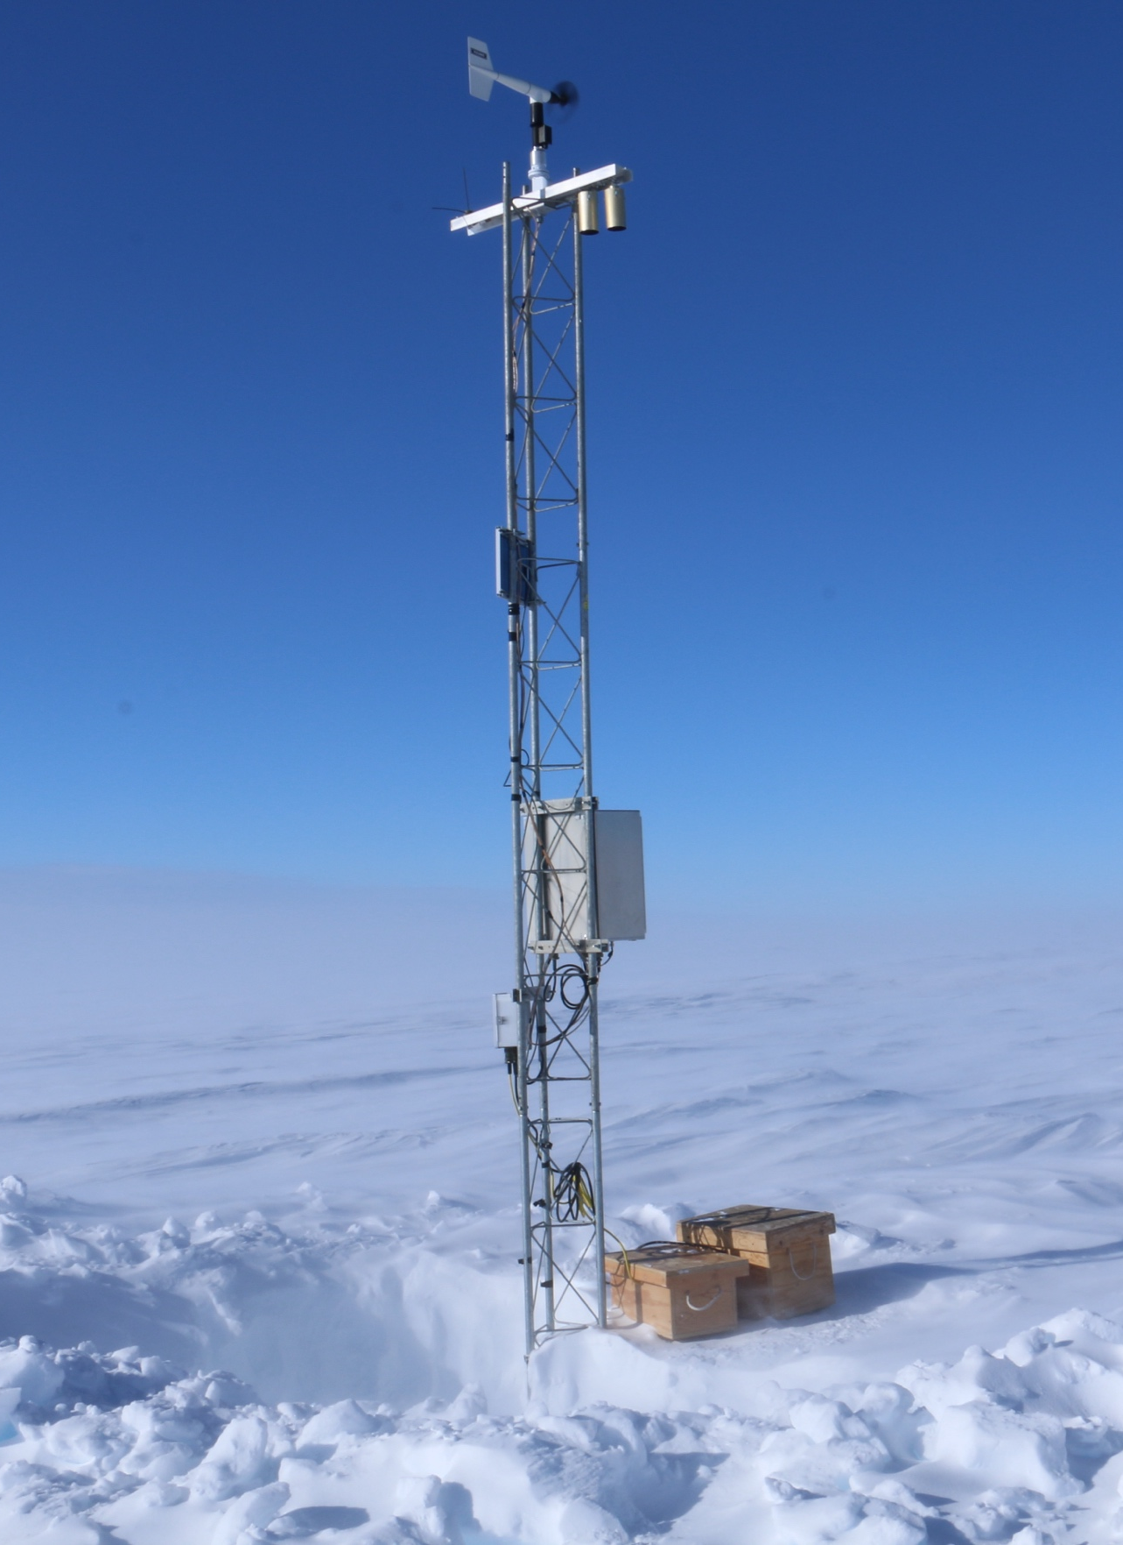

Thurston Island (2019/01/15)
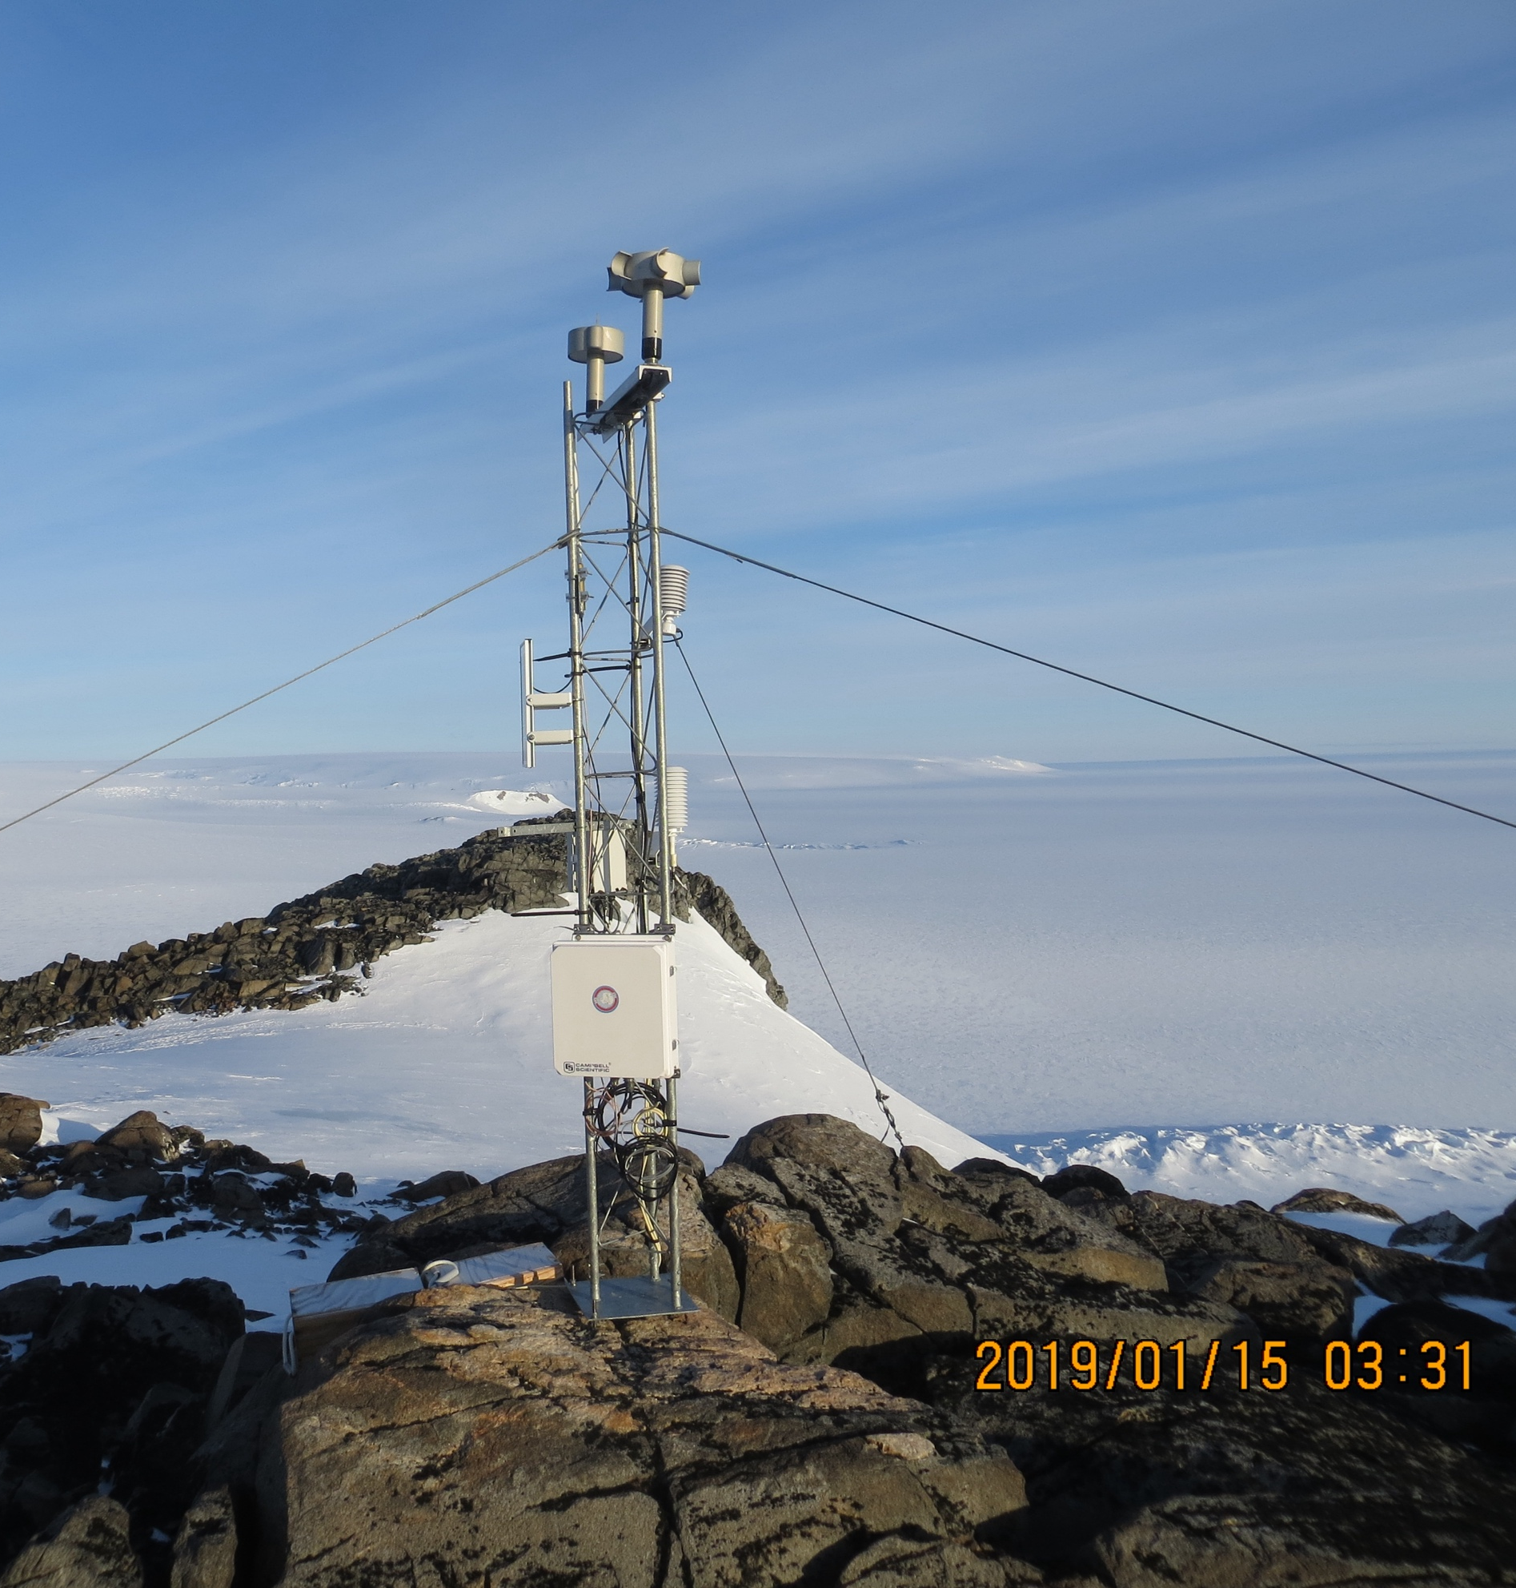

Vito (2025/12/27), pointing towards West
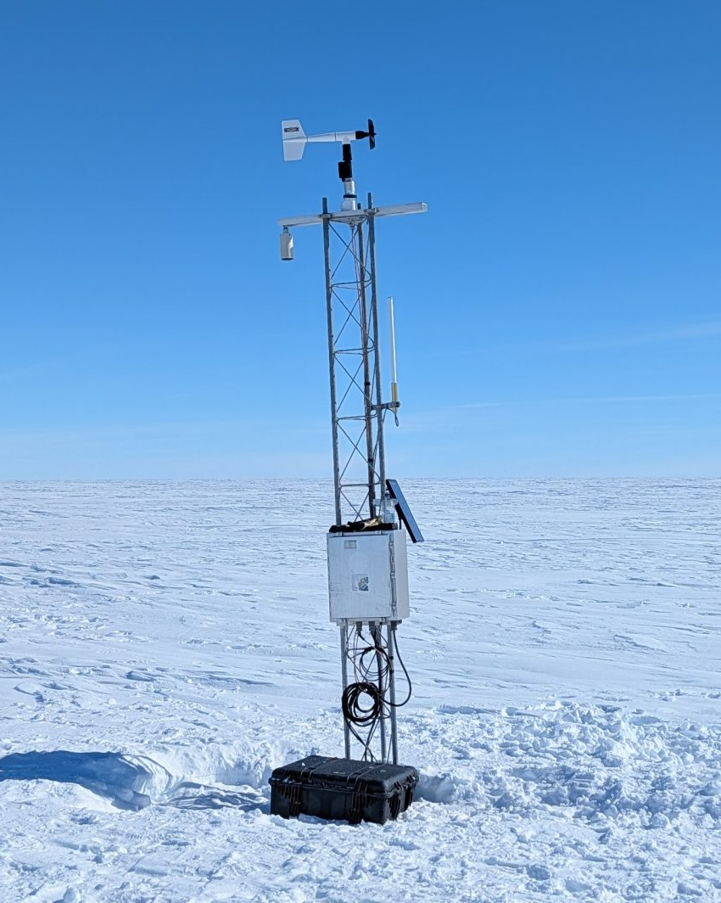
White Island (2025/12/01), pointing towards East
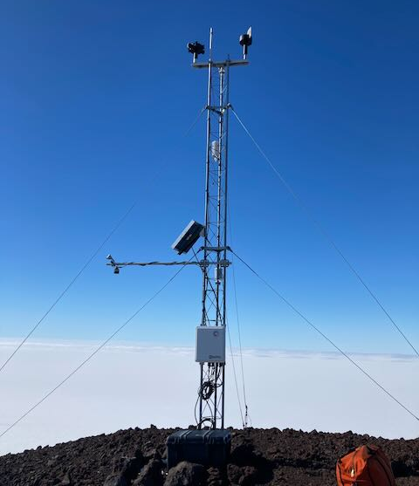

Willie Field (2026/01/29), pointing towards East
Sarah M-AWS in background on the right
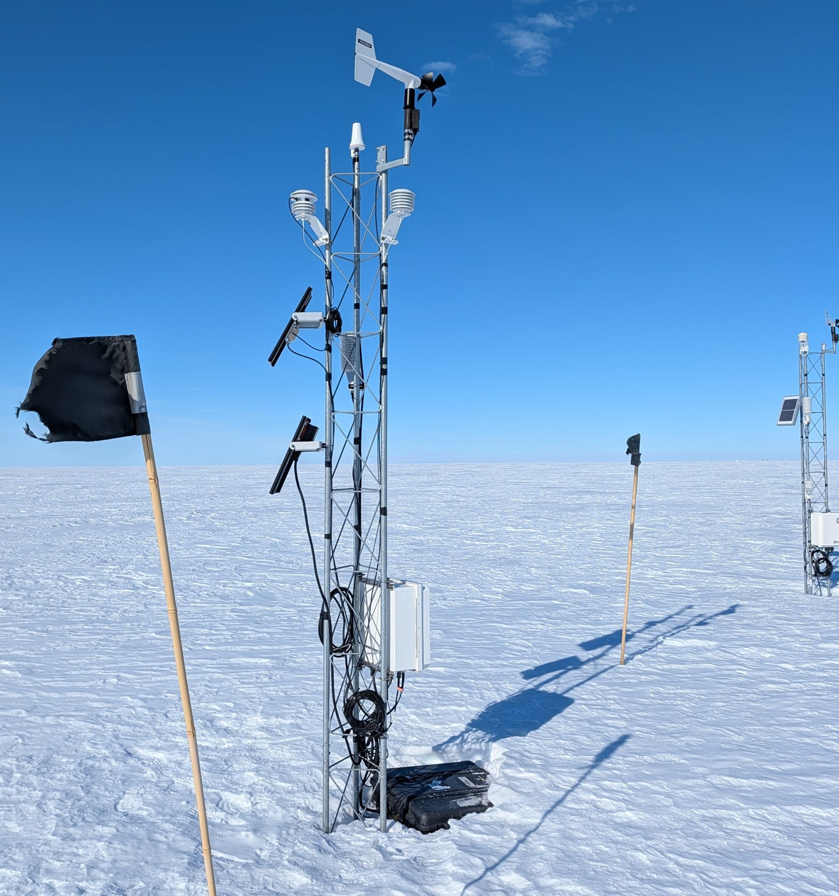

Windless Bight (2025/12/11)
