O-283 – UW AWS | 2026-2027 AWS Planned Visits
AWS | Lat (DD) | Lon (DD) | Lat (DDM) | Lon (DDM) | Date of GPS | Priority*, Work
Alexander TT! | -78.967˚ | 170.816˚ | 78˚ 58.02' S | 170˚ 48.96' E | Jan 2025 | B.6 Raise power system
Austin | -75.994˚ | -87.478˚ | 75˚ 59.64' S | 87˚ 28.68' W | Jan 2019 | D.1 Reinstall AWS
Bear Peninsula | -74.548˚ | -111.868˚ | 74˚ 32.88' S | 111˚ 52.08' W | Jan 2019 | D.2 Reinstall instrumentation
Byrd | -80.011˚ | -119.438˚ | 80˚ 00.66' S | 119˚ 26.28' W | Dec 2018 | D.5 Replace pwrsys, check RH
Cape Bird | -77.217˚ | 166.439˚ | 77˚ 13.02' S | 166˚ 26.34' E | Nov 2024 | A.6 Service
Elaine | -83.057˚ | 174.218˚ | 83˚ 03.42' S | 174˚ 13.08' E | Jan 2022 | B.4 NIWC work. Raise
Elijah Tall Tower | -77.846˚ | 166.869˚ | 77˚ 50.76' S | 166˚ 52.14' E | Dec 2024 | C.5 Service
Elizabeth | -82.608˚ | -137.080˚ | 82˚ 36.48' S | 137˚ 04.80' W | Jan 2019 | D.9 Raise
Emilia | -78.362˚ | 173.235˚ | 78˚ 21.72' S | 173˚ 14.10' E | Dec 2024 | B.9 Raise
Erin | -84.902˚ | -128.866˚ | 84˚ 54.12' S | 128˚ 51.96' W | Jan 2019 | D.8 Raise
Ferrell | -77.746˚ | 170.810˚ | 77˚ 44.76' S | 170˚ 48.60' E | Dec 2022 | A.7 Raise, fix ADG
Harry | -83.005˚ | -121.409˚ | 83˚ 00.30' S | 121˚ 24.54' W | Jan 2019 | D.7 Raise
Henry | -89.000˚ | -0.411˚ | 89˚ 00.00' S | 0˚ 24.66' W | Dec 2018 | E.1 Raise
Janet | -77.175˚ | -123.391˚ | 77˚ 10.50' S | 123˚ 23.46' W | Jan 2019 | D.6 Raise
Kathie | -77.995˚ | -97.267˚ | 77˚ 59.70' S | 97˚ 16.02' W | Jan 2026 | D.10 Replace RH
Kominko-Slade | -79.466˚ | -112.108˚ | 79˚ 27.96' S | 112˚ 06.48' W | Jan 2026 | D.11 Service
Laurie III | -77.388˚ | 170.707˚ | 77˚ 23.28' S | 170˚ 42.42' E | Jan 2026 | A.1 Fix TX
Lettau | -82.442˚ | -174.680˚ | 82˚ 26.52' S | 174˚ 40.80' W | Dec 2023 | B.2 Fix power system
Linda | -78.362˚ | 168.474˚ | 78˚ 21.72' S | 168˚ 28.44' E | Jan 2025 | A.4 Raise
Lorne | -78.150˚ | 170.046˚ | 78˚ 09.00' S | 170˚ 02.76' E | Dec 2025 | A.5 Service, replace ADG
Marble Point | -77.439˚ | 163.754˚ | 77˚ 26.34' S | 163˚ 45.24' E | Dec 2025 | A.8 Service
Marble Point II | -77.439˚ | 163.759˚ | 77˚ 26.34' S | 163˚ 45.54' E | Dec 2025 | A.9 Service
Margaret | -79.962˚ | -165.196˚ | 79˚ 57.72' S | 165˚ 11.76' W | Nov 2022 | B.7 Raise
Marilyn | -79.897˚ | 165.856˚ | 79˚ 53.82' S | 165˚ 51.36' E | Jan 2022 | B.3 NIWC. Raise, replace RH
Minna Bluff | -78.554˚ | 166.691˚ | 78˚ 33.24' S | 166˚ 41.46' E | Dec 2025 | A.2 Fix Taylor HWS wind dir
Nico | -89.000˚ | 90.021˚ | 89˚ 00.00' S | 90˚ 01.26' E | Dec 2018 | E.2 Raise
Phoenix | -77.948˚ | 166.745˚ | 77˚ 56.88' S | 166˚ 44.70' E | Jan 2025 | C.1 Fix Paros pressure
Sabrina | -84.231˚ | -170.386˚ | 84˚ 13.86' S | 170˚ 23.16' W | Dec 2023 | B.5 Raise
Sarah M-AWS | -77.855˚ | 166.904˚ | 77˚ 51.30' S | 166˚ 54.24' E | Jan 2026 | C.2 Service
Schwerdtfeger | -79.781˚ | 170.505˚ | 79˚ 46.86' S | 170˚ 30.30' E | Dec 2024 | B.1 NIWC work. Service
Siple Dome | -81.652˚ | -148.992˚ | 81˚ 39.12' S | 148˚ 59.52' W | Jan 2026 | B.10 Service
Theresa | -84.602˚ | -115.846˚ | 84˚ 36.12' S | 115˚ 50.76' W | Jan 2019 | D.4 Fix pwr system (AWS2B)
Thurston Island | -72.532˚ | -97.545˚ | 72˚ 31.92' S | 97˚ 32.70' W | Jan 2019 | D.3 Replace: Taylor HWS, RH
Vito | -78.322˚ | 177.901˚ | 78˚ 19.32' S | 177˚ 54.06' E | Dec 2025 | B.8 Raise
White Island | -78.076˚ | 167.451˚ | 78˚ 04.56' S | 167˚ 27.06' E | Dec 2025 | A.3 Service
Willie Field | -77.855˚ | 166.904˚ | 77˚ 51.30' S | 166˚ 54.24' E | Jan 2026 | C.3 Service
Windless Bight | -77.732˚ | 167.661˚ | 77˚ 43.92' S | 167˚ 39.66' E | Dec 2025 | C.4 Service

* Priority: <region, transport method>.<rank>

<region, transport method>:
A: McMurdo, helo
B: McMurdo, twin otter
C: McMurdo, ground
D: WAIS/Byrd/Siple, twin otter
E: South Pole, twin otter

<rank>:
1: highest priority
…
11: lowest priority

McMurdo Helo (A) AWS planned visits 2026-2027
AWS | Lat (DD) | Lon (DD) | Lat (DDM) | Lon (DDM) | Date of GPS | Priority, Work
Laurie III | -77.388˚ | 170.707˚ | 77˚ 23.28' S | 170˚ 42.42' E | Jan 2026 | A.1 Fix TX
Minna Bluff | -78.554˚ | 166.691˚ | 78˚ 33.24' S | 166˚ 41.46' E | Dec 2025 | A.2 Fix Taylor HWS wind dir
White Island | -78.076˚ | 167.451˚ | 78˚ 04.56' S | 167˚ 27.06' E | Dec 2025 | A.3 Service
Linda | -78.362˚ | 168.474˚ | 78˚ 21.72' S | 168˚ 28.44' E | Jan 2025 | A.4 Raise
Lorne | -78.150˚ | 170.046˚ | 78˚ 09.00' S | 170˚ 02.76' E | Dec 2025 | A.5 Service, replace ADG
Cape Bird | -77.217˚ | 166.439˚ | 77˚ 13.02' S | 166˚ 26.34' E | Nov 2024 | A.6 Service
Ferrell | -77.746˚ | 170.810˚ | 77˚ 44.76' S | 170˚ 48.60' E | Dec 2022 | A.7 Raise, fix ADG
Marble Point | -77.439˚ | 163.754˚ | 77˚ 26.34' S | 163˚ 45.24' E | Dec 2025 | A.8 Service
Marble Point II | -77.439˚ | 163.759˚ | 77˚ 26.34' S | 163˚ 45.54' E | Dec 2025 | A.9 Service
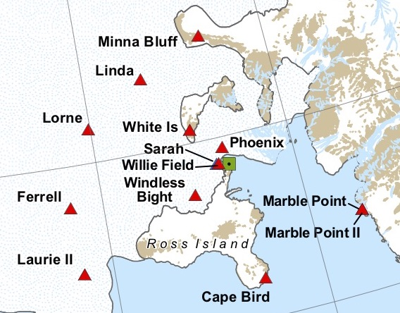
S
N
E
W
GRID NORTH
McMurdo Twin Otter (B) AWS planned visits 2026-2027
AWS | Lat (DD) | Lon (DD) | Lat (DDM) | Lon (DDM) | Date of GPS | Priority, Work
Schwerdtfeger | -79.781˚ | 170.505˚ | 79˚ 46.86' S | 170˚ 30.30' E | Dec 2024 | B.1 NIWC work. Service
Lettau | -82.442˚ | -174.680˚ | 82˚ 26.52' S | 174˚ 40.80' W | Dec 2023 | B.2 Fix power system
Marilyn | -79.897˚ | 165.856˚ | 79˚ 53.82' S | 165˚ 51.36' E | Jan 2022 | B.3 NIWC. Raise, replace RH
Elaine | -83.057˚ | 174.218˚ | 83˚ 03.42' S | 174˚ 13.08' E | Jan 2022 | B.4 NIWC work. Raise
Sabrina | -84.231˚ | -170.386˚ | 84˚ 13.86' S | 170˚ 23.16' W | Dec 2023 | B.5 Raise
Alexander Tall Tower! | -78.967˚ | 170.816˚ | 78˚ 58.02' S | 170˚ 48.96' E | Jan 2025 | B.6 Raise power system
Margaret | -79.962˚ | -165.196˚ | 79˚ 57.72' S | 165˚ 11.76' W | Nov 2022 | B.7 Raise
Vito | -78.322˚ | 177.901˚ | 78˚ 19.32' S | 177˚ 54.06' E | Dec 2025 | B.8 Raise
Emilia | -78.362˚ | 173.235˚ | 78˚ 21.72' S | 173˚ 14.10' E | Dec 2024 | B.9 Raise
Siple Dome | -81.652˚ | -148.992˚ | 81˚ 39.12' S | 148˚ 59.52' W | Jan 2026 | B.10 Service

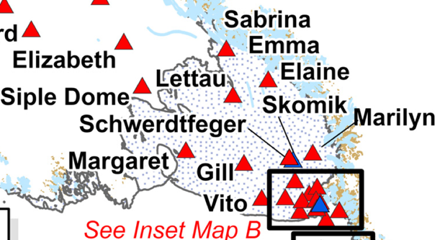
GRID NORTH
W
S
N
E
WAIS Twin Otter (D) AWS planned visits 2026-2027
AWS | Lat (DD) | Lon (DD) | Lat (DDM) | Lon (DDM) | Date of GPS | Priority, Work
Austin | -75.994˚ | -87.478˚ | 75˚ 59.64' S | 87˚ 28.68' W | Jan 2019 | D.1 Reinstall AWS
Bear Peninsula | -74.548˚ | -111.868˚ | 74˚ 32.88' S | 111˚ 52.08' W | Jan 2019 | D.2 Reinstall instrumentation
Thurston Island | -72.532˚ | -97.545˚ | 72˚ 31.92' S | 97˚ 32.70' W | Jan 2019 | D.3 Replace: Taylor HWS, RH
Theresa | -84.602˚ | -115.846˚ | 84˚ 36.12' S | 115˚ 50.76' W | Jan 2019 | D.4 Fix pwr system (AWS2B)
Byrd | -80.011˚ | -119.438˚ | 80˚ 00.66' S | 119˚ 26.28' W | Dec 2018 | D.5 Replace pwrsys, check RH
Janet | -77.175˚ | -123.391˚ | 77˚ 10.50' S | 123˚ 23.46' W | Jan 2019 | D.6 Raise
Harry | -83.005˚ | -121.409˚ | 83˚ 00.30' S | 121˚ 24.54' W | Jan 2019 | D.7 Raise
Erin | -84.902˚ | -128.866˚ | 84˚ 54.12' S | 128˚ 51.96' W | Jan 2019 | D.8 Raise
Elizabeth | -82.608˚ | -137.080˚ | 82˚ 36.48' S | 137˚ 04.80' W | Jan 2019 | D.9 Raise
Kathie | -77.995˚ | -97.267˚ | 77˚ 59.70' S | 97˚ 16.02' W | Jan 2026 | D.10 Replace RH
Kominko-Slade | -79.466˚ | -112.108˚ | 79˚ 27.96' S | 112˚ 06.48' W | Jan 2026 | D.11 Service
S
W
E
N
Grid North
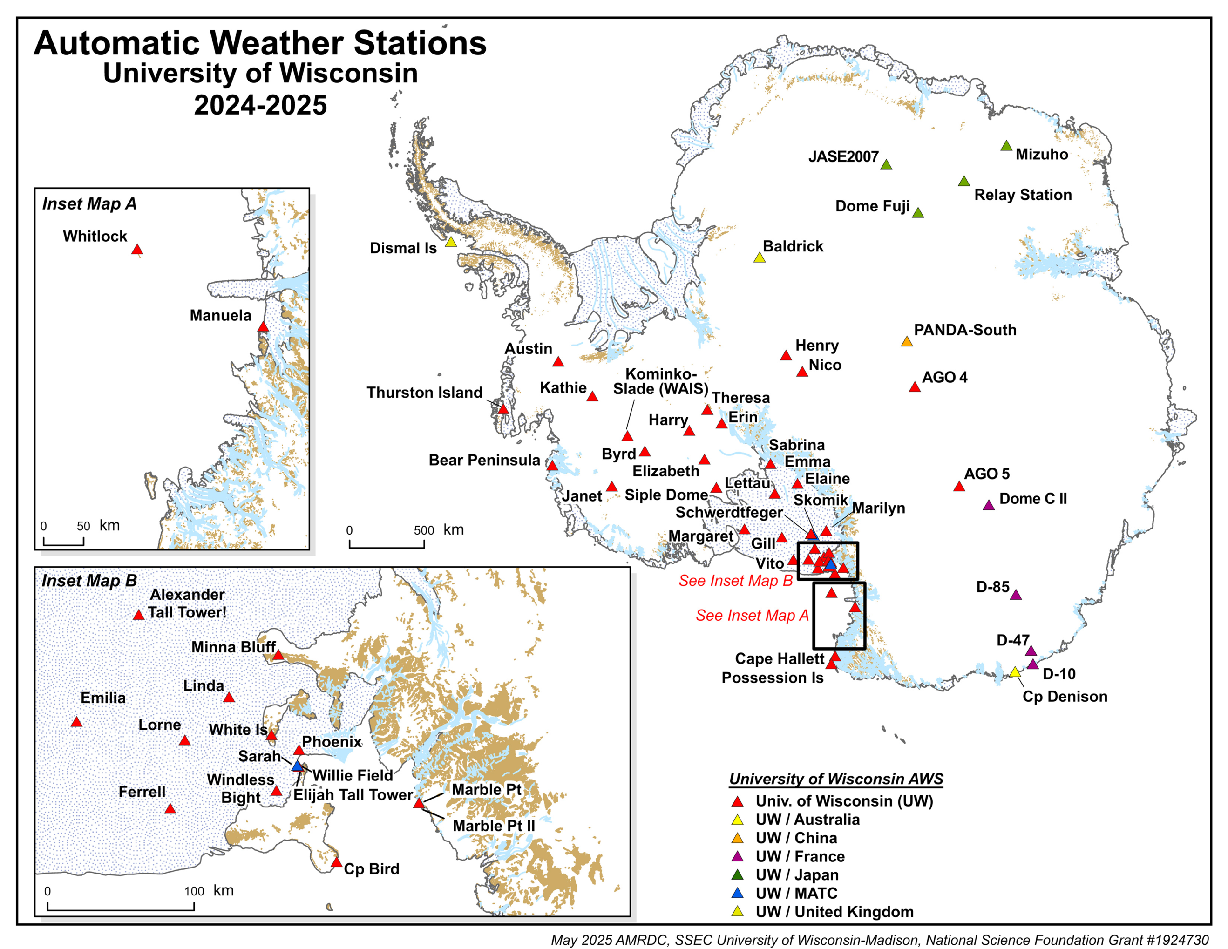
GRID NORTH
N
W
S
E
All AWS | O-283 UW AWS | 2026
Name | Lat (DD) | Lon (DD) | Lat (DDM) | Lon (DDM) | Elevation | Date last visit | Site Code | ID
AGO-4 (P4) | -82.010˚ | 96.760˚ | 82˚ 00.60' S | 96˚ 45.60' E | 3597m | 2012-01-01 | AG4 | 8927
AGO-5 (P5) | -77.240˚ | 123.520˚ | 77˚ 14.40' S | 123˚ 31.20' E | 3519m | 2020-01-20 | AG5 | 21362
Alexander Tall Tower! | -78.967˚ | 170.816˚ | 78˚ 58.02' S | 170˚ 48.96' E | 55m | 2026-02-16 | BAT | 99601
Austin | -75.994˚ | -87.478˚ | 75˚ 59.64' S | 87˚ 28.68' W | 1292m | 2019-01-12 | ATN | 8901
Baldrick (M-83) | -82.774˚ | -13.054˚ | 82˚ 46.44' S | 13˚ 03.24' W | 1968m | 2014-01-01 | BAL | 9116
Bear Peninsula | -74.548˚ | -111.868˚ | 74˚ 32.88' S | 111˚ 52.08' W | 415m | 2026-01-19 | BRP | 8922
Byrd (Byrd Station) | -80.011˚ | -119.438˚ | 80˚ 00.66' S | 119˚ 26.28' W | 1538m | 2018-12-30 | BYD | 8903
Cape Bird | -77.217˚ | 166.439˚ | 77˚ 13.02' S | 166˚ 26.34' E | 38m | 2026-01-14 | CBD | 99609
Cape Denison | -67.009˚ | 142.664˚ | 67˚ 00.54' S | 142˚ 39.84' E | 31m | 2021-12-19 | CDN | 8909
Cape Hallett | -72.322˚ | 170.225˚ | 72˚ 19.32' S | 170˚ 13.50' E | 1m | 2022-11-16 | CHA | 99602
D-10 (Dumont D'Urville) | -66.703˚˚ | 139.843˚ | 66˚ 42.18' S | 139˚ 50.58' E | 243m | 2025-12-07 | D10 | 8914
D-47 | -67.376˚ | 138.726˚ | 67˚ 22.56' S | 138˚ 43.56' E | 1560m | 2025-12-31 | D47 | 8916
D-85 | -70.426˚ | 134.147˚ | 70˚ 25.56' S | 134˚ 08.82' E | 2651m | 2024-11-27 | D85 | 8912
Dismal Island | -68.088˚ | -68.826˚ | 68˚ 05.28' S | 68˚ 49.56' W | 12m | 2017-02-05 | DIS | 8932
Dome C II | -75.106˚ | 123.347˚ | 75˚ 06.36' S | 123˚ 20.82' E | 3250m | 2025-01-01 | DC2 | 8989
Dome F (Fuji) | -77.310˚ | 39.672˚ | 77˚ 18.60' S | 39˚ 40.32' E | 3810m | 2026-01-06 | FUJ | 8904
Elaine | -83.057˚ | 174.218˚ | 83˚ 03.42' S | 174˚ 13.08' E | 59m | 2022-01-14 | ELN | 21357
Elijah Tall Tower | -77.846˚ | 166.869˚ | 77˚ 50.76' S | 166˚ 52.14' E | 8m | 2025-12-07 | ELJ | 99616
Elizabeth | -82.608˚ | -137.080˚ | 82˚ 36.48' S | 137˚ 04.80' W | 523m | 2019-01-19 | ELZ | 21361
Emilia | -78.362˚ | 173.235˚ | 78˚ 21.72' S | 173˚ 14.10' E | 51m | 2024-12-11 | EML | 8939
Erin | -84.902˚ | -128.866˚ | 84˚ 54.12' S | 128˚ 51.96' W | 988m | 2019-01-17 | ERN | 21363
Ferrell | -77.746˚ | 170.810˚ | 77˚ 44.76' S | 170˚ 48.60' E | 41m | 2025-01-07 | FER | 8947
Gill | -79.774˚ | -178.508˚ | 79˚ 46.44' S | 178˚ 30.48' W | 53m | 2025-11-20 | GIL | 8911
Harry | -83.005˚ | -121.409˚ | 83˚ 00.30' S | 121˚ 24.54' W | 956m | 2019-01-19 | HRY | 8900
Henry | -89.000˚ | -0.411˚ | 89˚ 00.00' S | 0˚ 24.66' W | 2780m | 2018-12-22 | HEN | 8985
Janet | -77.175˚ | -123.391˚ | 77˚ 10.50' S | 123˚ 23.46' W | 2085m | 2019-01-21 | JNT | 8936
JASE2007 | -75.888˚ | 25.834˚ | 75˚ 53.28' S | 25˚ 50.04' E | 3661m | 2007-09-27 | JAS | 30305
Kathie | -77.995˚ | -97.267˚ | 77˚ 59.70' S | 97˚ 16.02' W | 1627m | 2026-01-20 | KTH | 8929
Kominko-Slade (WAIS) | -79.466˚ | -112.108˚ | 79˚ 27.96' S | 112˚ 06.48' W | 1798m | 2026-01-22 | KMS | 21364
Laurie III | -77.388˚ | 170.707˚ | 77˚ 23.28' S | 170˚ 42.42' E | 8m | 2026-01-27 | LR3 | 21360
Lettau | -82.442˚ | -174.680˚ | 82˚ 26.52' S | 174˚ 40.80' W | 39m | 2023-12-19 | LET | 8928
Linda | -78.362˚ | 168.474˚ | 78˚ 21.72' S | 168˚ 28.44' E | 38m | 2025-01-15 | LDA | 99603
Lorne | -78.150˚ | 170.046˚ | 78˚ 09.00' S | 170˚ 02.76' E | 41m | 2025-12-12 | LOR | 99612
Manuela (Inexpressible Isl.) | -74.946˚ | 163.687˚ | 74˚ 56.76' S | 163˚ 41.22' E | 78m | 2025-12-05 | MLA | 8905
Marble Point | -77.439˚ | 163.754˚ | 77˚ 26.34' S | 163˚ 45.24' E | 108m | 2025-12-13 | MPT | 8906
Marble Point II | -77.439˚ | 163.759˚ | 77˚ 26.34' S | 163˚ 45.54' E | 111m | 2025-12-13 | MP2 | 99608
Margaret (Roosevelt Isl.) | -79.962˚ | -165.196˚ | 79˚ 57.72' S | 165˚ 11.76' W | 67m | 2022-11-30 | MGT | 8910
Marilyn (Byrd Glacier) | -79.897˚ | 165.856˚ | 79˚ 53.82' S | 165˚ 51.36' E | 62m | 2022-01-15 | MLN | 8934
Minna Bluff | -78.554˚ | 166.691˚ | 78˚ 33.24' S | 166˚ 41.46' E | 895m | 2025-12-01 | MNB | 99606
Mizuho | -70.700˚ | 44.290˚ | 70˚ 42.00' S | 44˚ 17.40' E | 2260m | 2023-11-20 | MIZ | 21359
Mizuho II | -70.708˚ | 44.248˚ | 70˚ 42.48' S | 44˚ 14.88' E | 2260m | 2026-01-23 | MI2 | 21359
Nico | -89.000˚ | 90.021˚ | 89˚ 00.00' S | 90˚ 01.26' E | 2979m | 2018-12-21 | NIC | 8924
PANDA-South | -82.325˚ | 75.989˚ | 82˚ 19.50' S | 75˚ 59.34' E | 4027m | 2008-01-14 | PDA | 30416
Phoenix | -77.948˚ | 166.745˚ | 77˚ 56.88' S | 166˚ 44.70' E | 10m | 2025-01-19 | PHX | 8908
Possession Island | -71.891˚ | 171.210˚ | 71˚ 53.46' S | 171˚ 12.60' E | 30m | 1992-12-29 | POS | 8984
Relay Station | -74.017˚ | 43.062˚ | 74˚ 01.02' S | 43˚ 03.72' E | 3353m | 2023-11-27 | RLS | 8918
Sabrina | -84.231˚ | -170.386˚ | 84˚ 13.86' S | 170˚ 23.16' W | 86m | 2023-12-07 | SAB | 8915
Sarah M-AWS | -77.855˚ | 166.904˚ | 77˚ 51.30' S | 166˚ 54.24' E | 8m | 2026-01-07 | SRH | 99613
Schwerdtfeger | -79.781˚ | 170.505˚ | 79˚ 46.86' S | 170˚ 30.30' E | 54m | 2026-01-30 | SWT | 8913
Siple Dome | -81.652˚ | -148.992˚ | 81˚ 39.12' S | 148˚ 59.52' W | 667m | 2026-01-21 | SID | 99617
Skomik M-AWS | -79.781˚ | 170.505˚ | 79˚ 46.86' S | 170˚ 30.30' E | 54m | 2026-01-30 | SKM | 99614
Theresa | -84.602˚ | -115.846˚ | 84˚ 36.12' S | 115˚ 50.76' W | 1453m | 2019-01-17 | TRS | 21358
Thurston Island | -72.532˚ | -97.545˚ | 72˚ 31.92' S | 97˚ 32.70' W | 225m | 2019-01-15 | THI | 8930
Vito | -78.322˚ | 177.901˚ | 78˚ 19.32' S | 177˚ 54.06' E | 50m | 2025-12-27 | VTO | 8931
White Island | -78.076˚ | 167.451˚ | 78˚ 04.56' S | 167˚ 27.06' E | 686m | 2025-12-01 | WTI | 99610
Whitlock (Franklin Isl.) | -76.142˚ | 168.394˚ | 76˚ 08.52' S | 168˚ 23.64' E | 262m | 2011-01-28 | WTL | 8988
Willie Field | -77.855˚ | 166.904˚ | 77˚ 51.30' S | 166˚ 54.24' E | 8m | 2026-01-07 | WFD | 99607
Windless Bight | -77.732˚ | 167.661˚ | 77˚ 43.92' S | 167˚ 39.66' E | 39m | 2025-12-11 | WDB | 99611

