AWS Field Report 2023-24
Field Team: Dave Mikolajczyk, Wenhua Wu

- Nov 17 – Marble Pt I and II (8906 and 99608) Checkup
- Nov 18 – White Island (99610) Replace enclosure, swap instrumentation
- Nov 22 – Minna Bluff (99606) Replace enclosure, swap instrumentation
- Nov 23 – Cape Bird (99609) Station checkup
- Nov 30 – Gill (8911) Raise with 5’ tower section
- Nov 30 – Skomik (99614) NIWC visit to remove Skomik enclosure
- Dec 1 – Laurie II (21360) Swap the two 100-Ahr batteries in the power system
- Dec 2 – Windless Bight (99611) Raise with 5’ tower section
- Dec 5 – Emilia (8939) Swap enclosure
- Dec 7 – Sabrina (8915) Raise instruments and power system; replace wind, RH, ADG
- Dec 8 – Alexander Tall Tower! (99601) Rigger tower checkup
- Dec 11 – Phoenix (99615), Willie Field (99607), Sarah (99613) PHX swap batteries in power system, WFD & SRH remove for future relocation
- Dec 12 – Phoenix (99615) Wire in 3rd battery in power system
- Dec 13 – Kominko-Slade (21364) Remove all equipment
- Dec 19 – Lettau (8928) Raise with 7’ tower section, replace power system, wind monitor, ADG
- Jan 4 – Emma (8919) Remove station

2023-11-17: Helo to Marble Pt (MPT) and Marble Pt II (MP2) AWS
Purpose: Station checkups

Helo pilot: Slinky
AWS Team: Dave, Wenhua

1449: Depart McMurdo
1519: Arrive MPT

Conditions: Sunny, warm, calm winds

Both Marble Pt and Marble Pt II looked great, no issues found. We swapped the 256 MB datacard at MP2 for a 2 GB datacard.

1711: Depart MPT
1740: Arrive McMurdo

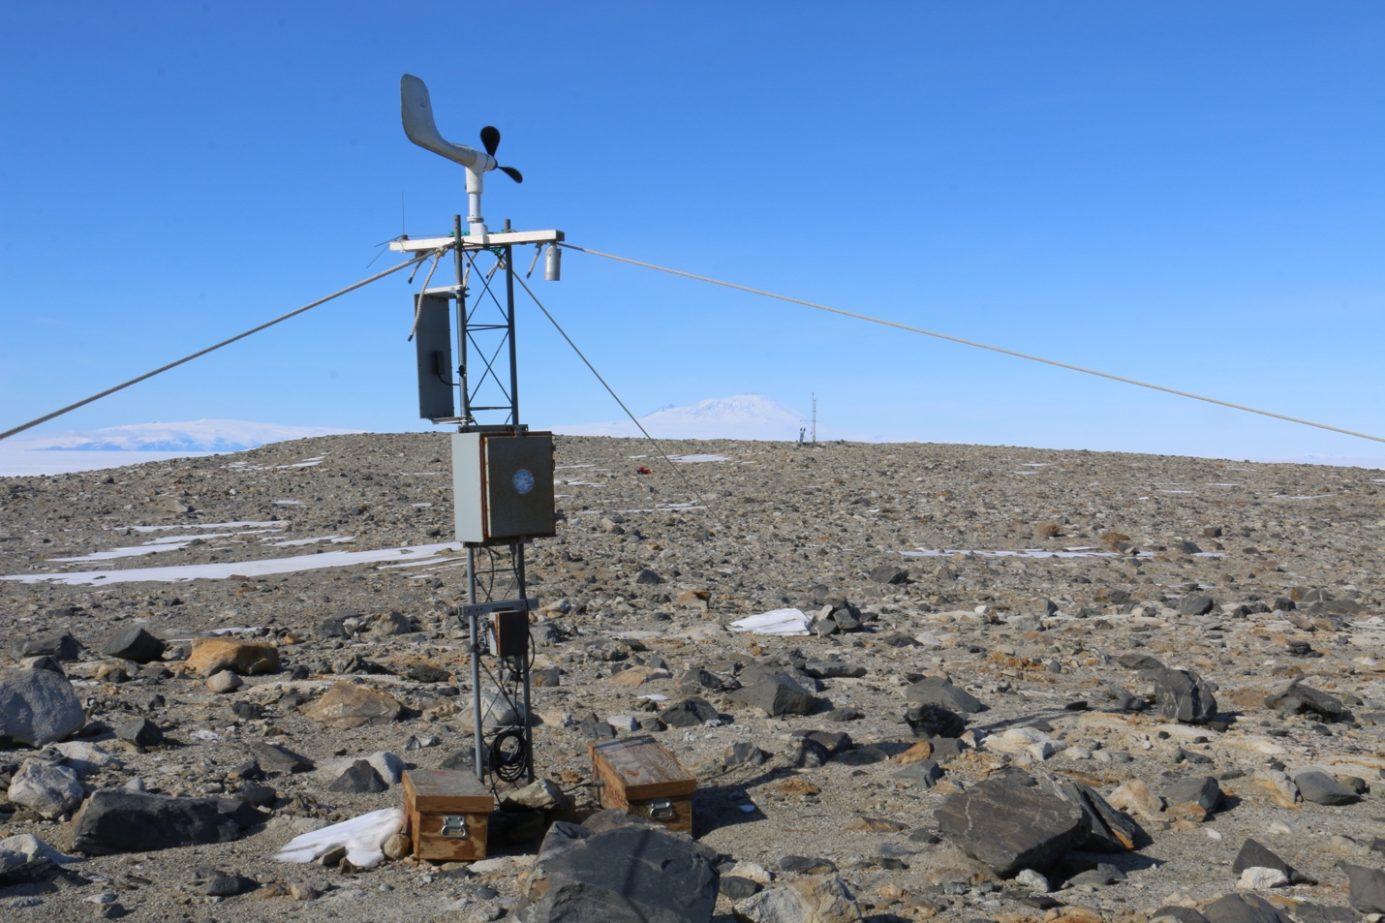
Marble Point (MP2 in background).

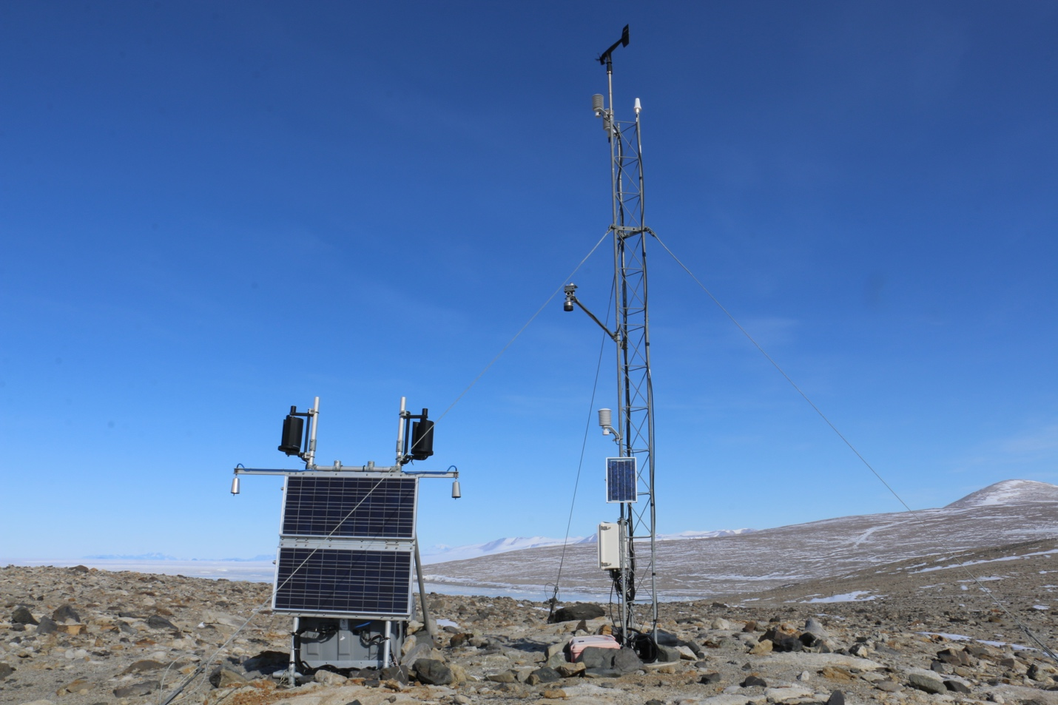
Marble Pt II.

2023-11-18: Helo to White Island (WTI) AWS
Purpose: Swap out enclosure (but retain existing Iridium modem), Taylor high wind system (the wind direction wasn’t working), upper and lower temperature sensors, relative humidity sensor. Troubleshoot why station had stopped transmitting.

Helo pilot: Jay
AWS team: Dave, Wenhua
Morale: Eric (fleet ops)

1316: Depart McMurdo
1330: Arrive WTI

Conditions: Very windy, but relatively warm with temperatures around -8 C (17 F).

The power system was reporting good voltage, around 13.8 V, upon arrival, and the station was running. All instruments and antenna on the tower looked fine, except the lower temperature radiation shield was a little loose and slightly hanging off the tower. Inside the enclosure, the antenna cable had come loose (but not fully undone) from the Iridium modem, hence no transmissions.

We installed a new enclosure, which has a CR1000X running program WTI1000x_iridium.CR1X, and has a Paroscientific pressure sensor, SN 153807. We retained the existing Iridium modem from the old enclosure and installed it in the new one. We installed a new Taylor high wind system. We swapped the upper and lower temperature sensors with thermistors. We replaced the relative humiditiy sensor.

All sensor heights were the same as previous except the RH sensor (now 168”) and the lower temperature (now at 93”).

After powering up the new system and before leaving, we called Lee to confirm successful transmissions.

CR1000X program running: WTI1000x_iridium.CR1X

1820: Depart WTI
1835: Arrive McMurdo

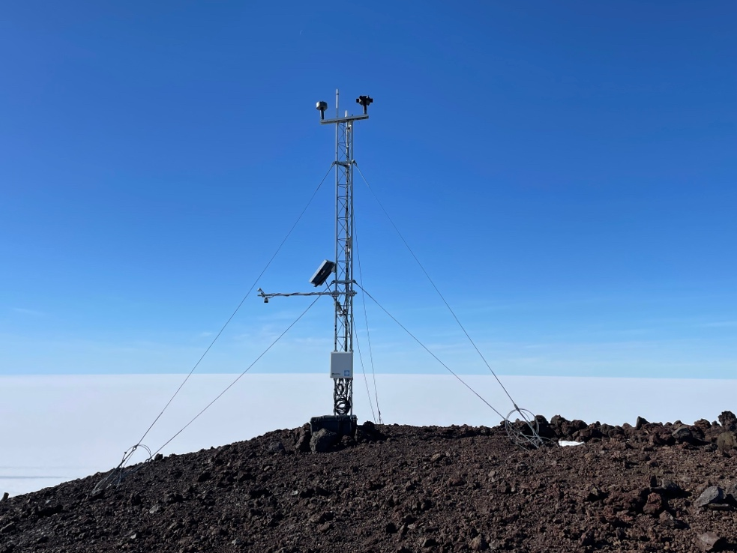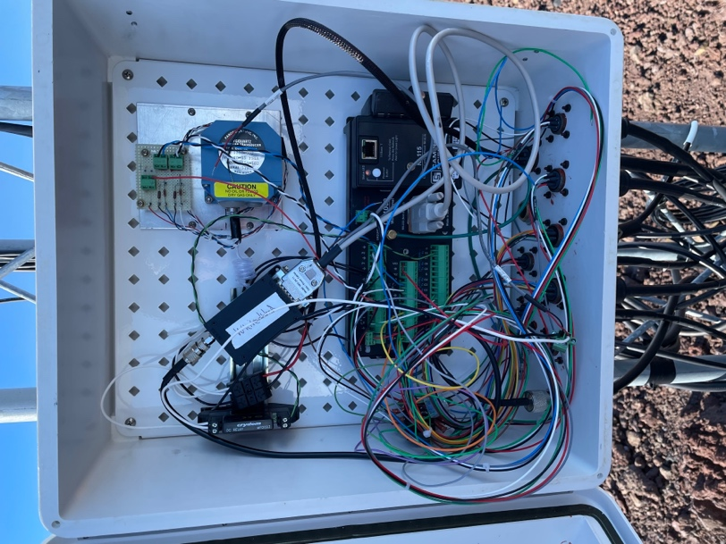
WTI on arrival. Inside enclosure on arrival.
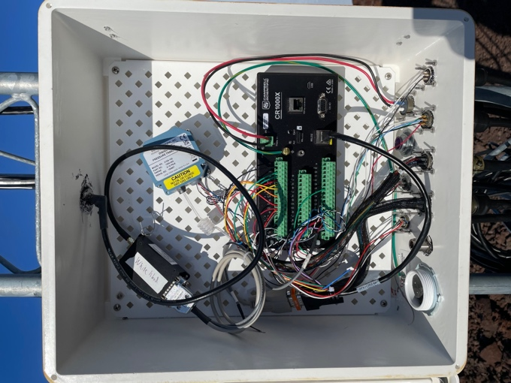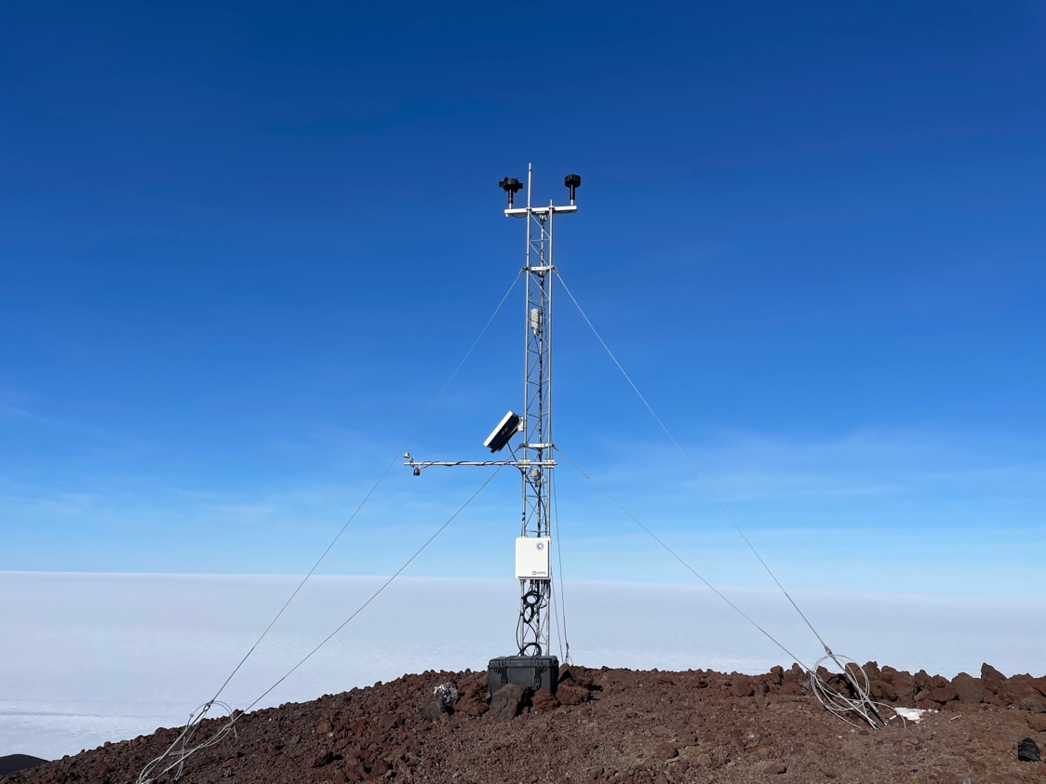
Inside new enclosure. White Island after.

2023-11-22: Helo to Minna Bluff (MNB) AWS
Purpose: Swap out enclosure (but retain existing Iridium modem), Taylor high wind system (but retain existing wind direction sensor), temperature sensor, relative humidity sensor.

Pilot: George
AWS team: Dave, Wenhua
Morale: Jon (boiler room mechanic)

1855: Depart McMurdo
1921: Arrive MNB

Conditions: Light winds, cold with temps around -15 C (5 F).

Upon arrival, we noticed the high wind system boom was dangling off the top of the tower, with the anemometer about 30 ft away on the ground. That explains why the winds were reporting 0. For the power cable connecting to the power system, the outer sheathing was becoming torn from the plug. We taped it with electrical tape and reoriented the power system case such that the tower base (which can twist slightly) doesn’t scrape against the cabling.

We installed a new enclosure, which has a CR1000X running program MNB1000x_iridium.CR1X, and has a Paroscientific pressure sensor, SN 153795. We retained the existing Iridium modem from the old enclosure and installed it in the new one. We replaced the Taylor high wind system with a new boom and high wind speed sensor, and reinstalled the high wind direction sensor. We replaced the temperature with a thermistor and replaced the relative humidity sensor.

We installed the relative humidity sensor at 43”.

After powering up the new system and before leaving, we called Lee to confirm successful transmissions.

CR1000X program running: MNB1000x_iridium.CR1X

2150: Depart MNB
2217: Arrive McMurdo

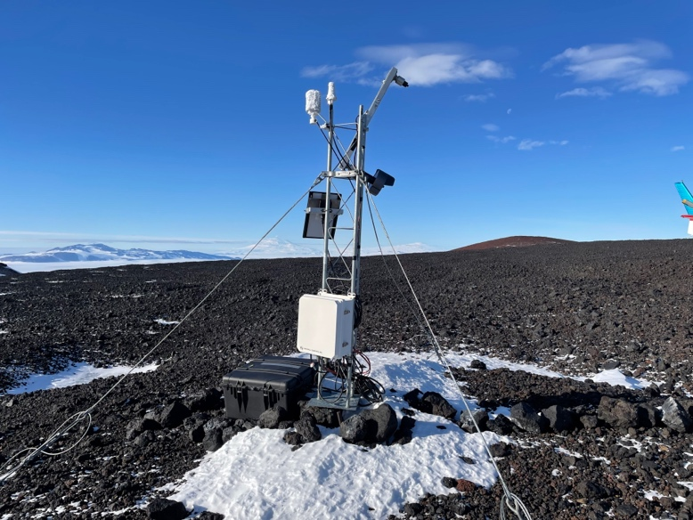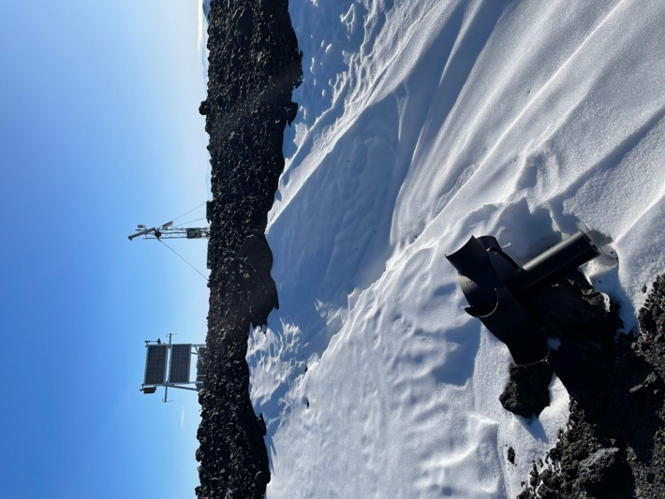
MNB on arrival. Anemometer on the ground ~30 ft away.

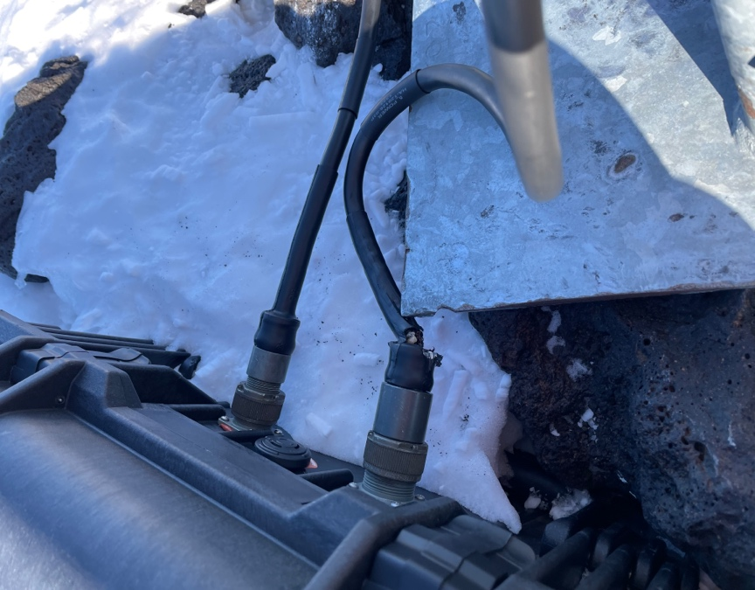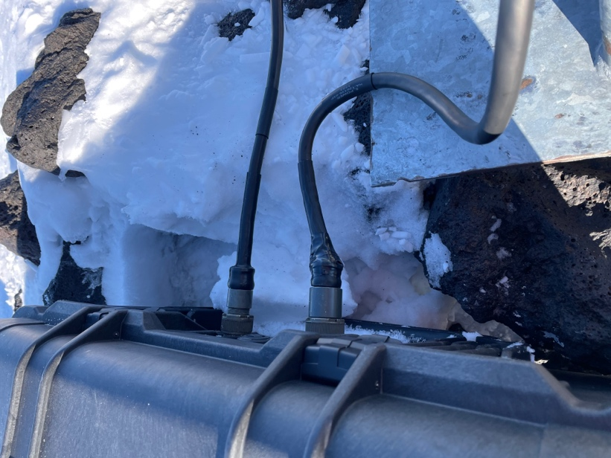
Upon arrival, noticed damage to power cable. Our fix: electrical tape.

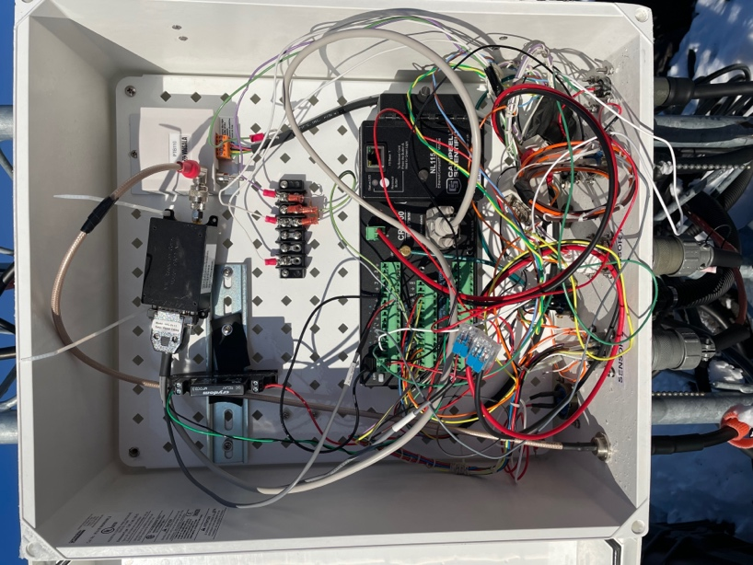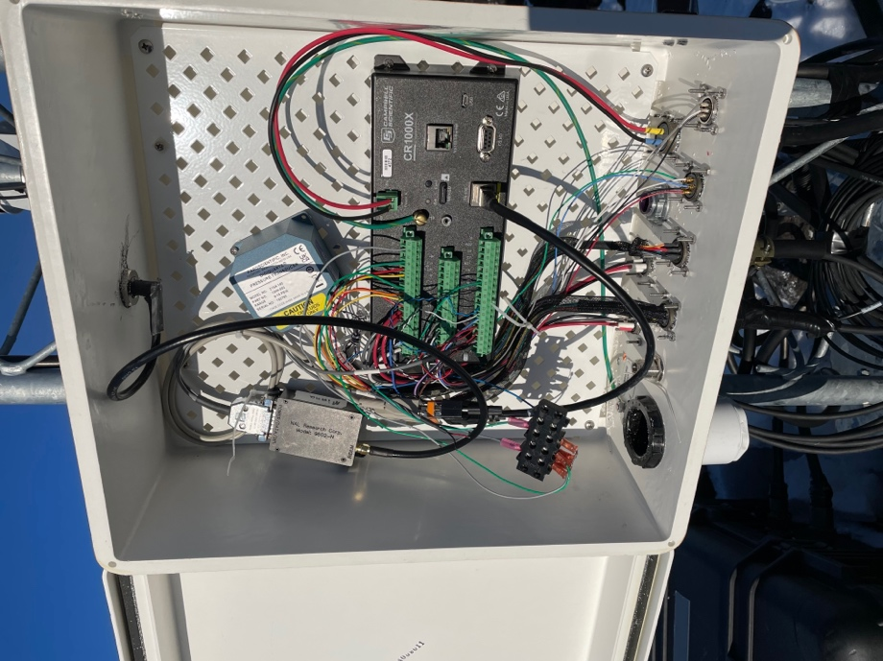
Enclosure upon arrival. New enclosure.

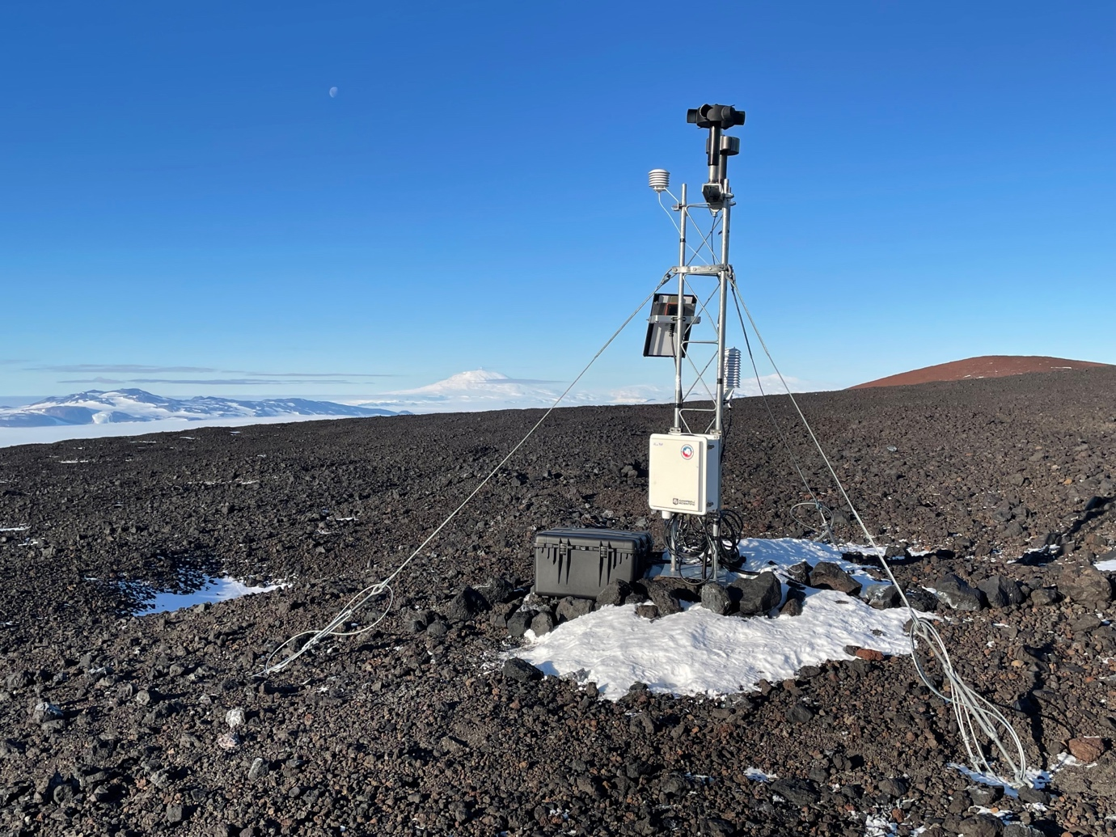
Minna bluff after.

2023-11-23: Helo to Cape Bird (CBD) AWS
Purpose: Station checkup.

Pilot: Ryan Skorecki
AWS Team: Dave, Wenhua

1348: Depart McMurdo
1414: Arrive CBD

Conditions: Windy, sunny, warm (temps around -5C, mid 20s F).

The station looked all good, no issues found except maybe the guy wire in the south side of the AWS (enclosure side), is slightly loose. We swapped the 2 GB datacard with a 2 GB datacard.

1533: Depart CBD
1603: Arrive McMurdo

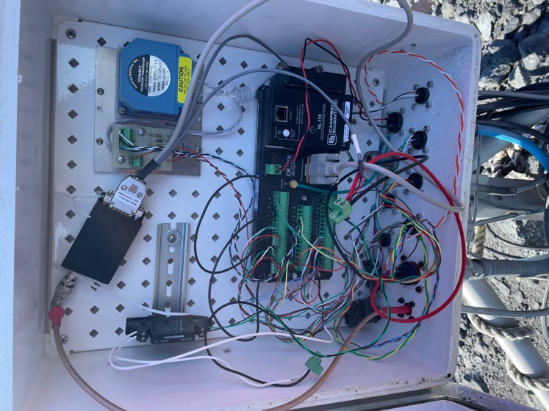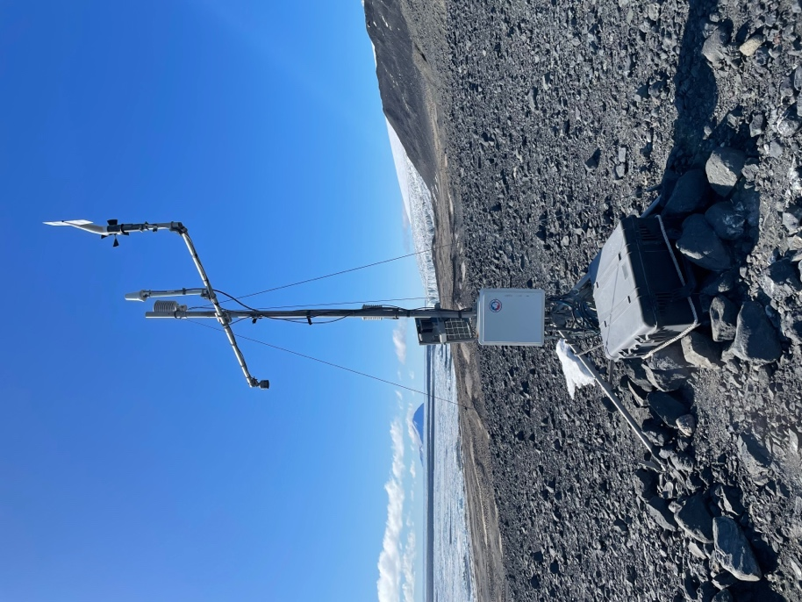
Inside enclosure. Cape Bird after.

2023-11-30: Otter to Gill (GIL) AWS
Purpose: Raise with 5’ tower

BBV: Jeff Amantea, Kai Ennis
Pax: Dave, Wenhua, Boonies: Freya Tagseth (cargo), Joe Colegrove (The Insulator)

0908: Depart WFD
1108: Arrive GIL

Conditions: Sunny, a bit windy and chilly

Instrument heights before (after):
Enclosure: 6” (61”)
Lower temperature: 15” (65”)
Boom (ADG): 56” (102”)
Relative humidity: 125” (148”)
Upper temperature: 125” (185”)
Wind: 155” (215”)

We raised with a 5’ tower section. The power system battery voltage and data from the station all looked good. Swapped out the CR1000 datacard with a 2 GB card. We did not bring the EarthScope GPS so did not get coordinates/elevation by those means.

CR1000 program running: GIL2017.CR1
Paros SN: 50972

InReach coordinates: -79.7889 / -178.5148

1535: Depart GIL
1654: Arrive WFD

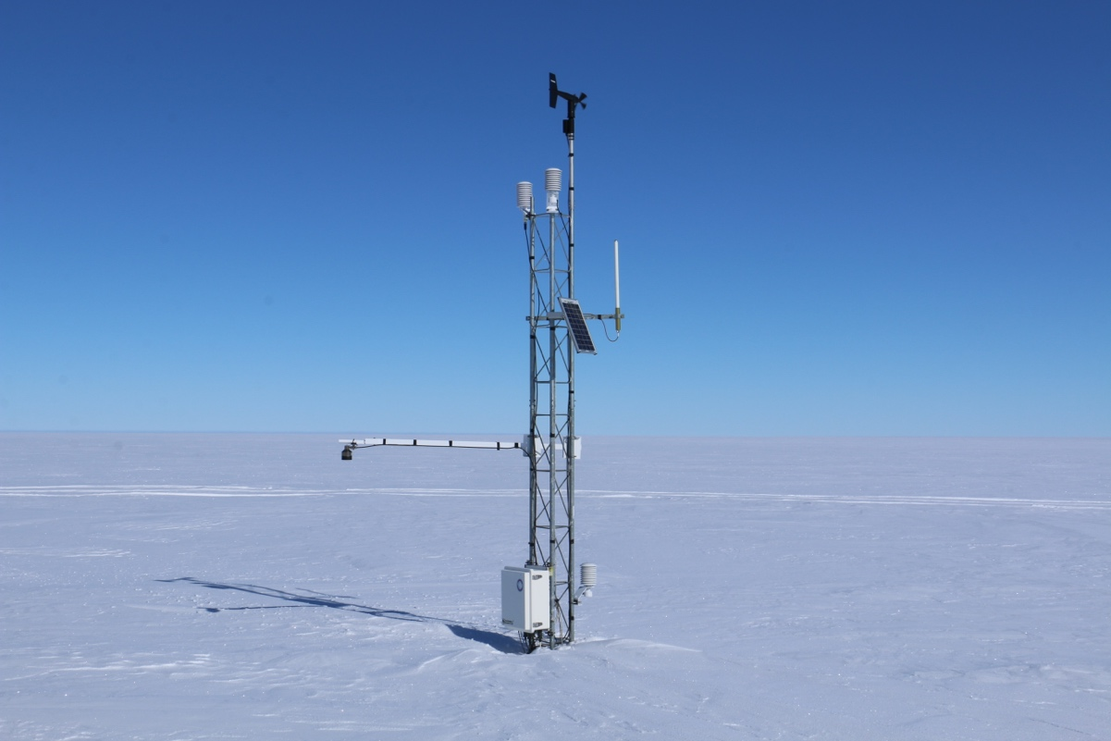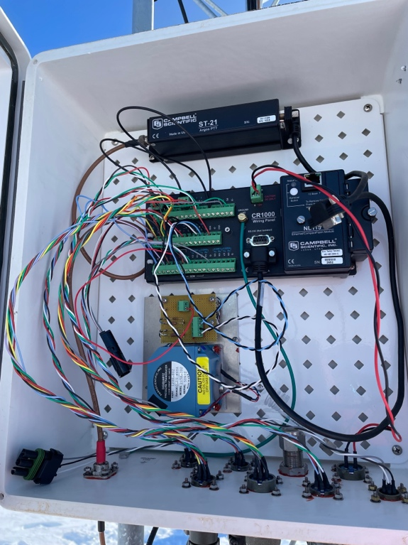
GIL upon arrival. Inside GIL enclosure.
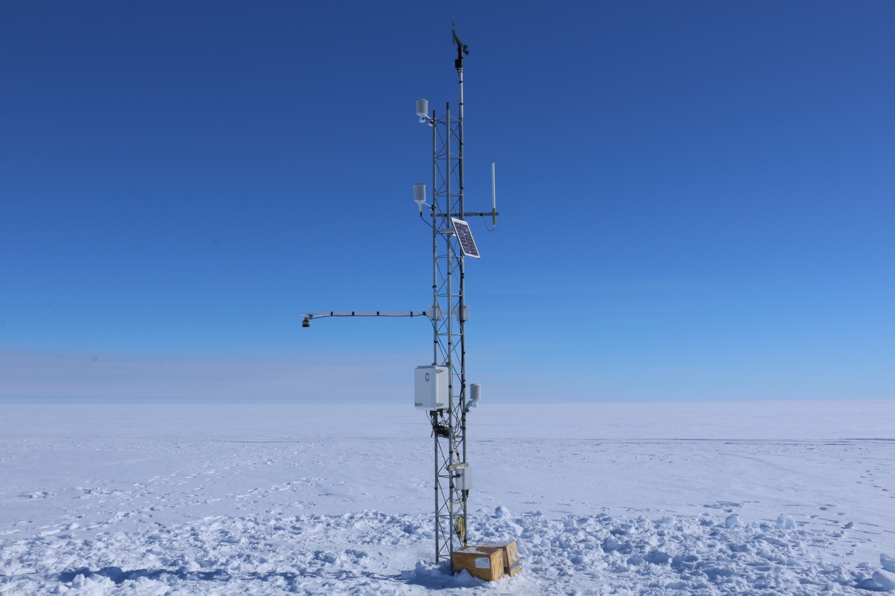
GIL after.

2023-11-30: NIWC visit Skomik (SKM) PCWS
Purpose: Remove Skomik enclosure

NIWC visited their AWS collocated at our Schwerdtfeger AWS/Skomik PCWS site. Per our request, they removed Skomik’s enclosure and returned it to us, since Skomik wasn’t transmitting reliably since its install in January 2022.

Skomik had PCWS board revision 2.1 installed. We swapped that with rev 2.2 with the hopes to reinstall the enclosure this current field season, but in lab testing we were unable to get it to send transmissions. The enclosure was sent back to Wisconsin for further troubleshooting.

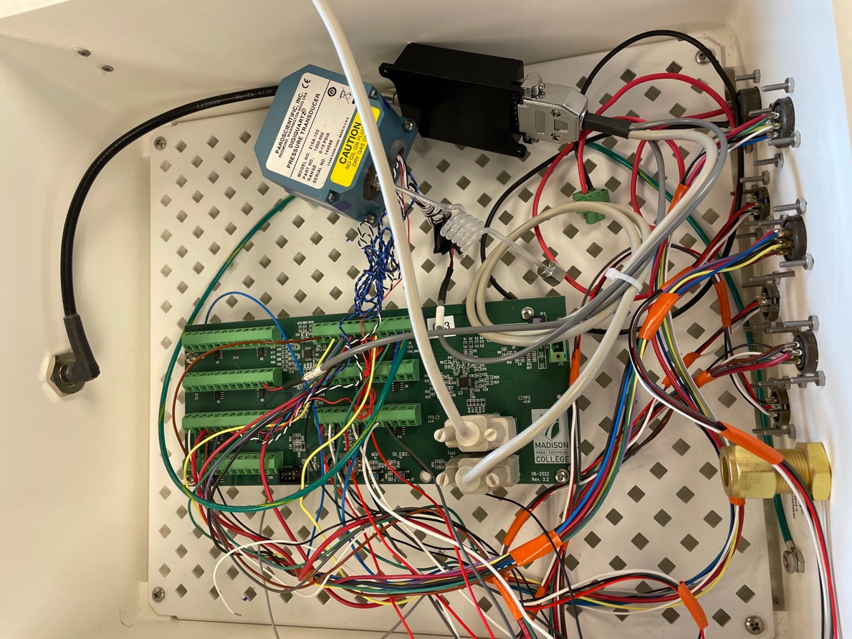
Skomik enclosure in the lab, with board rev 2.2 installed.

2023-12-01: Helo to Laurie II (LR2) AWS
Purpose: Swap batteries in power system

Pilot: George
Pax: Dave, Wenhua, Danni (janitor)

1356: Depart MCM
1429: Arrive LR2

Conditions: Windy and blowing snow, but warm

LR2 is an AWS2B.

We swapped both 100 A-hr batteries in the power system with two new 100 A-hr batteries. We didn’t measure instrument heights, but given we could see the top of the power system when we arrived, we estimate there was 14” of accumulation since it was last visited on 2 Dec 2022.

Therefore, the instrument heights are:
Enclosure: 61”
Relative humidity: 154”
Upper temperature: 146”
Wind: 174”
Solar panel: 119”

Coordinates from helo:
77º 23.671’ S / 170º 42.847’ E = 77.395º S / 170.714º E

1545: Depart LR2
1615: Arrive MCM

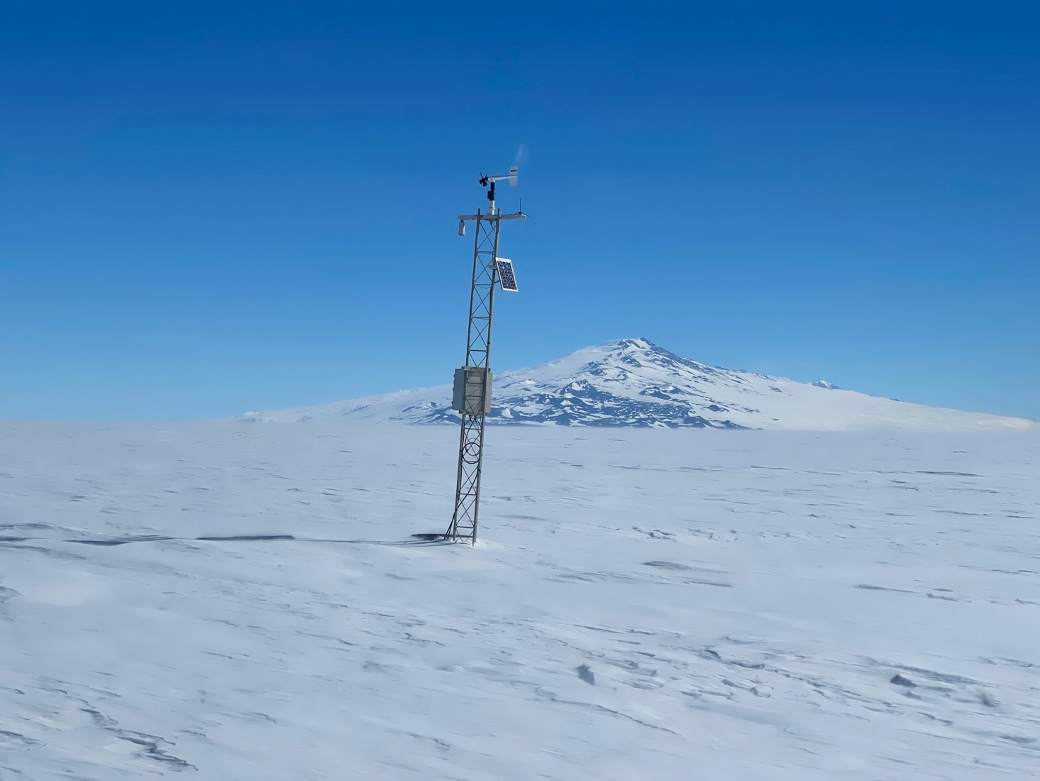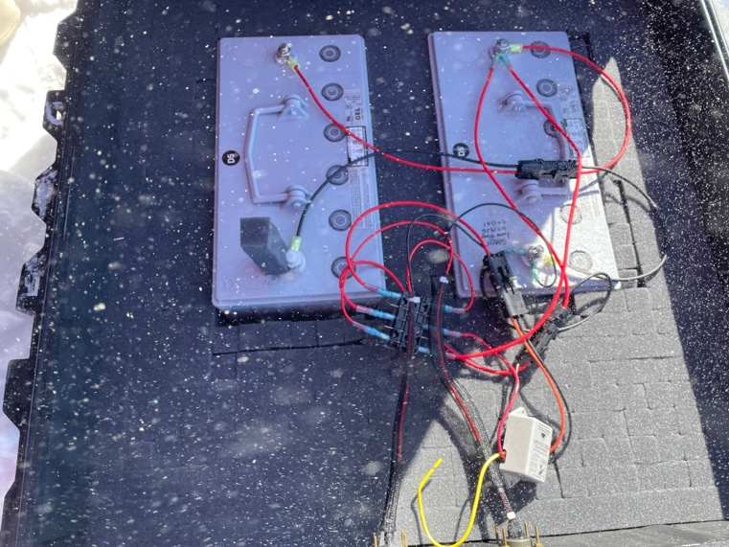
LR2 upon arrival. Inside power system.

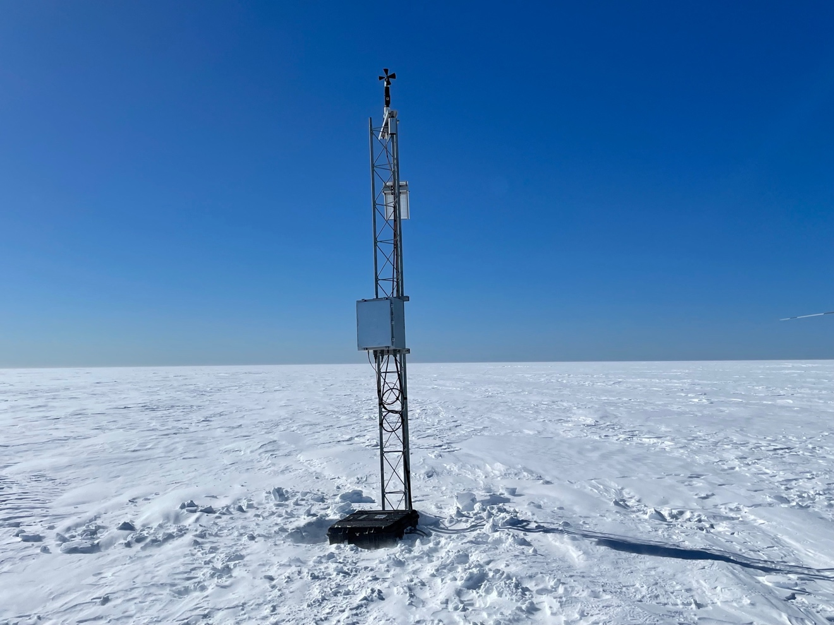
LR2 after.

2023-12-02: Helo to Windless Bight (WDB) AWS
Purpose: Raise station

Pilot: George
Pax: Dave, Wenhua, Nico (sous chef)

0824: Depart McMurdo
0835: Arrive WDB

Conditions: Sunny with minimal wind

Instrument heights before (after):
Lower temperature: 14” (61”)
Boom (with ADG and pyranometer): 39” (75”)
Enclosure: 57” (86”)
Relative humidity: 130” (140”)
Upper temperature: 130” (185”)
Wind: 160” (215”)

Raised the station with a 7’ tower section. It was difficult to install, needed to use a ratchet strap, and then lots of wiggling, to get the section on. We also bug up the power system (buried about 5’) and brought it to the surface.

EarthScope GPS coordinates and elevation:
-77.7317 / 167.6633
Elevation: 39.4 m

1330: Depart WDB
1341: Arrive McMurdo

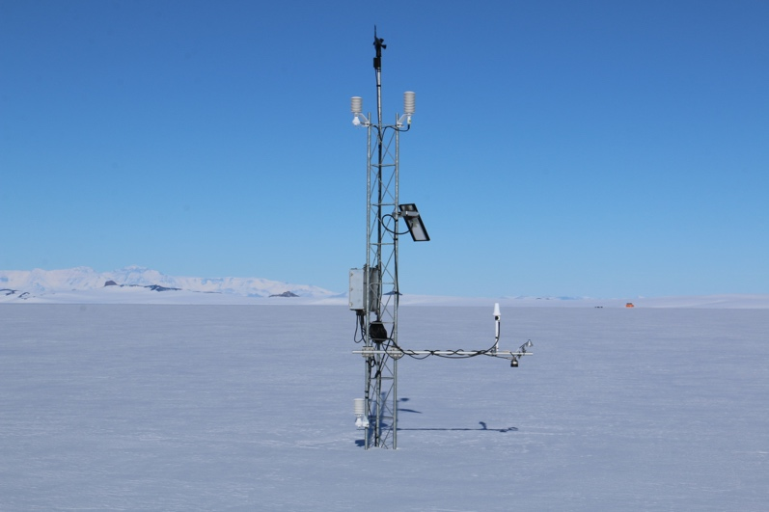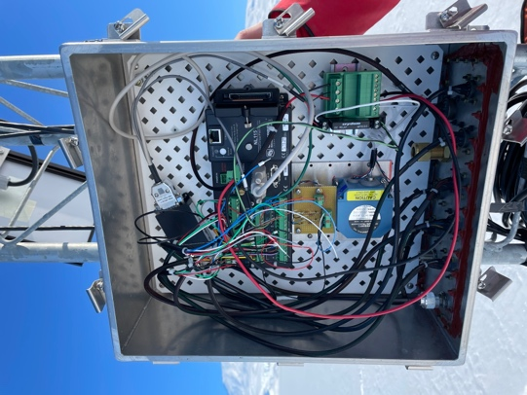
WDB upon arrival. Inside WDB enclosure.

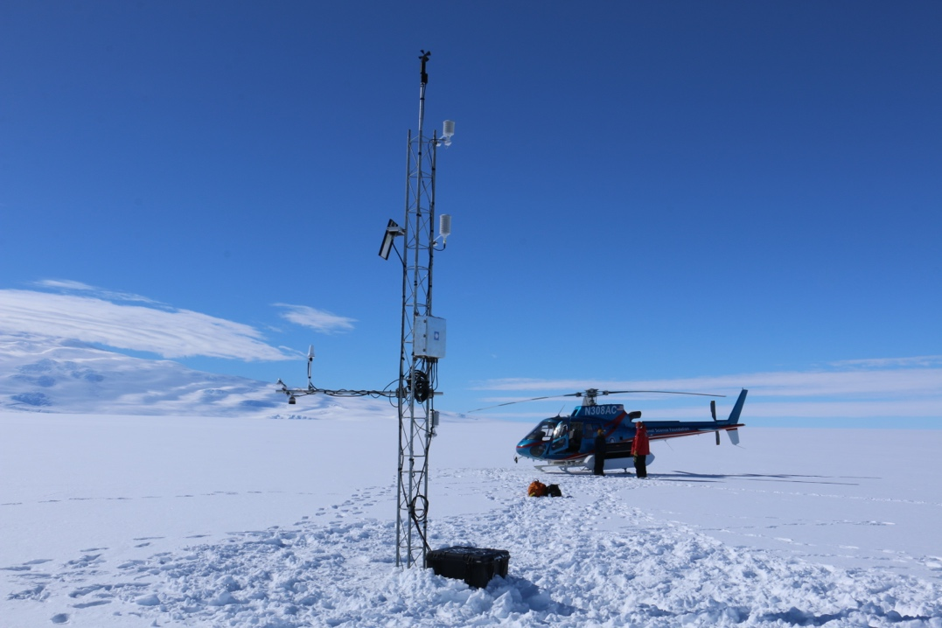
WDB after.

2023-12-01: Otter to Emilia (EML) AWS
Purpose: Swap enclosure

BBV: Jeff, Kai
Pax: Dave, Wenhua, Tom (water treatment), Tweedy

1154: Depart WFD
1238: Arrive EML

Conditions: Sunny, a bit windy but fairly warm

Instrument heights before (after):
Enclosure: 55” (61”)

We swapped the AWS2B enclosure and electronics for a CR1000 enclosure. The new program running is emilia.CR1. The new Paroscientific pressure sensor has SN 50266. There is a 1GB datacard in this CR1000.

The power system cable plug did not match the plug on the new enclosure, so we removed the power plug on the enclosure, cut the power cable, and direct-wired the power to the datalogger. We sealed the hole with putty. After the fact, we realized we could have used the port hole on the enclosure.

EarthScope GPS coordinates/elevation:
-78.3692 / 173.2297
Elevation: 50.5 m

1457: Depart EML
1533: Arrive WFD

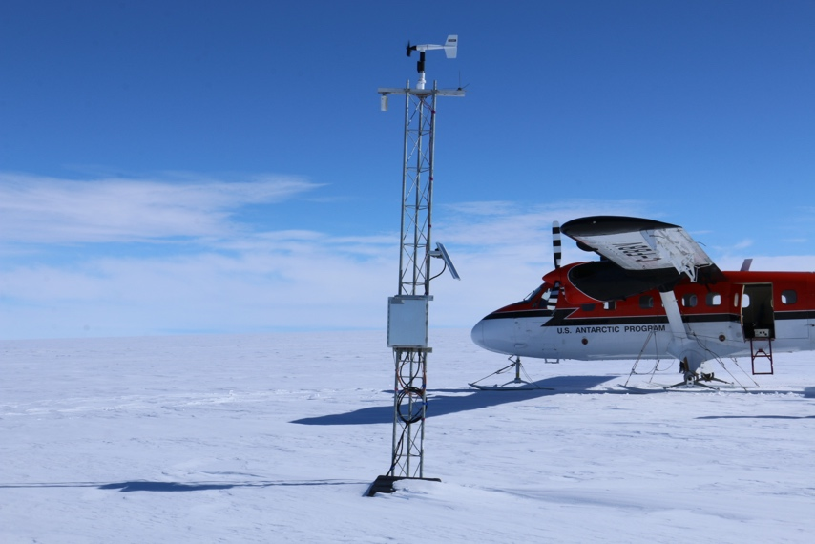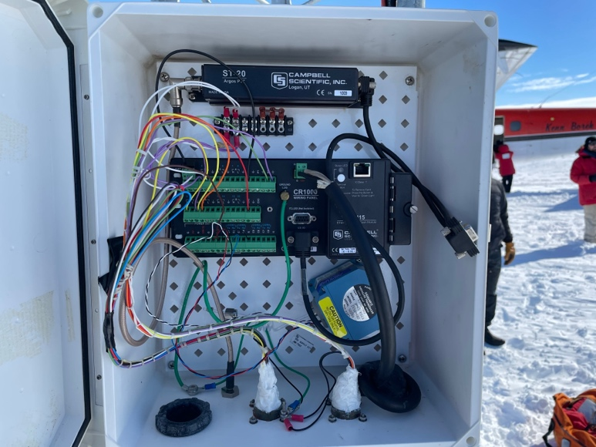
EML upon arrival. Inside new enclosure, showing direct-wired power.
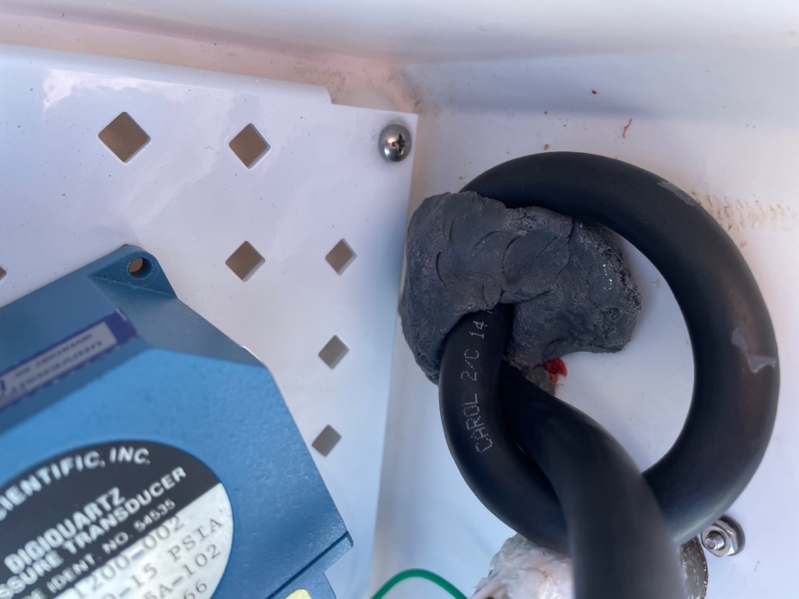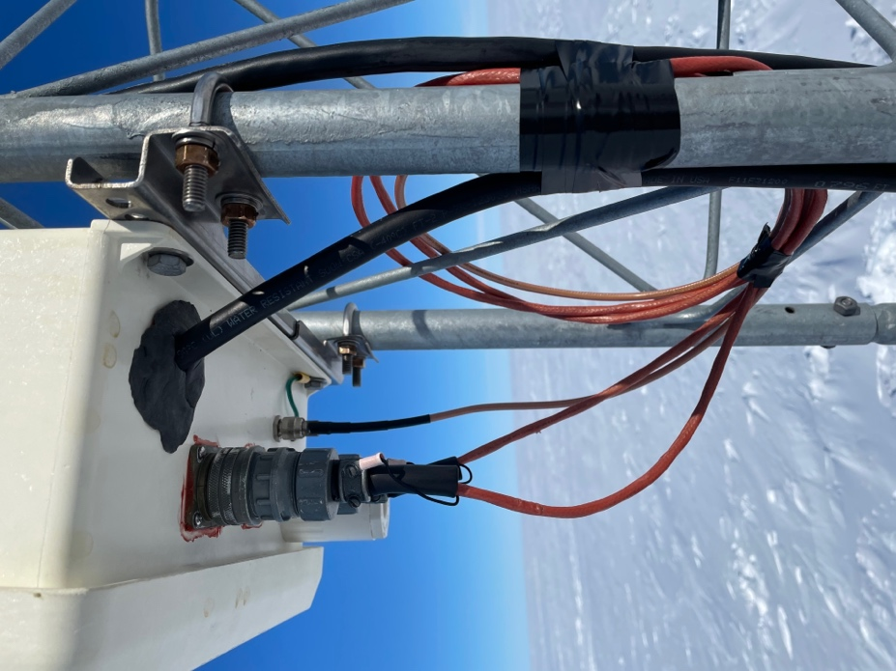
Power cable w/ putty, inside enclosure. Bottom of enclosure.

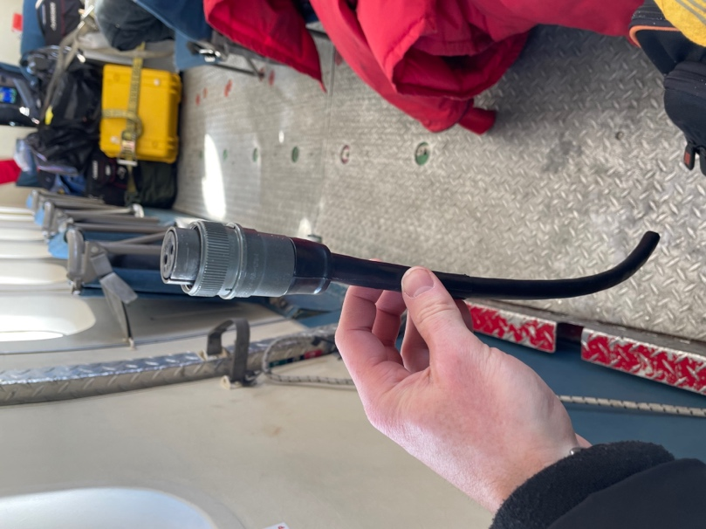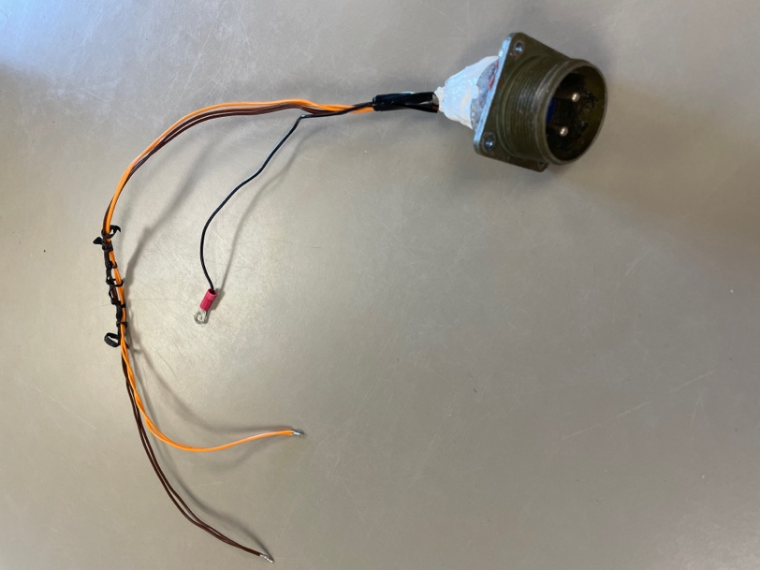
Power cable plug we cut. Power plug from the enclosure we removed.

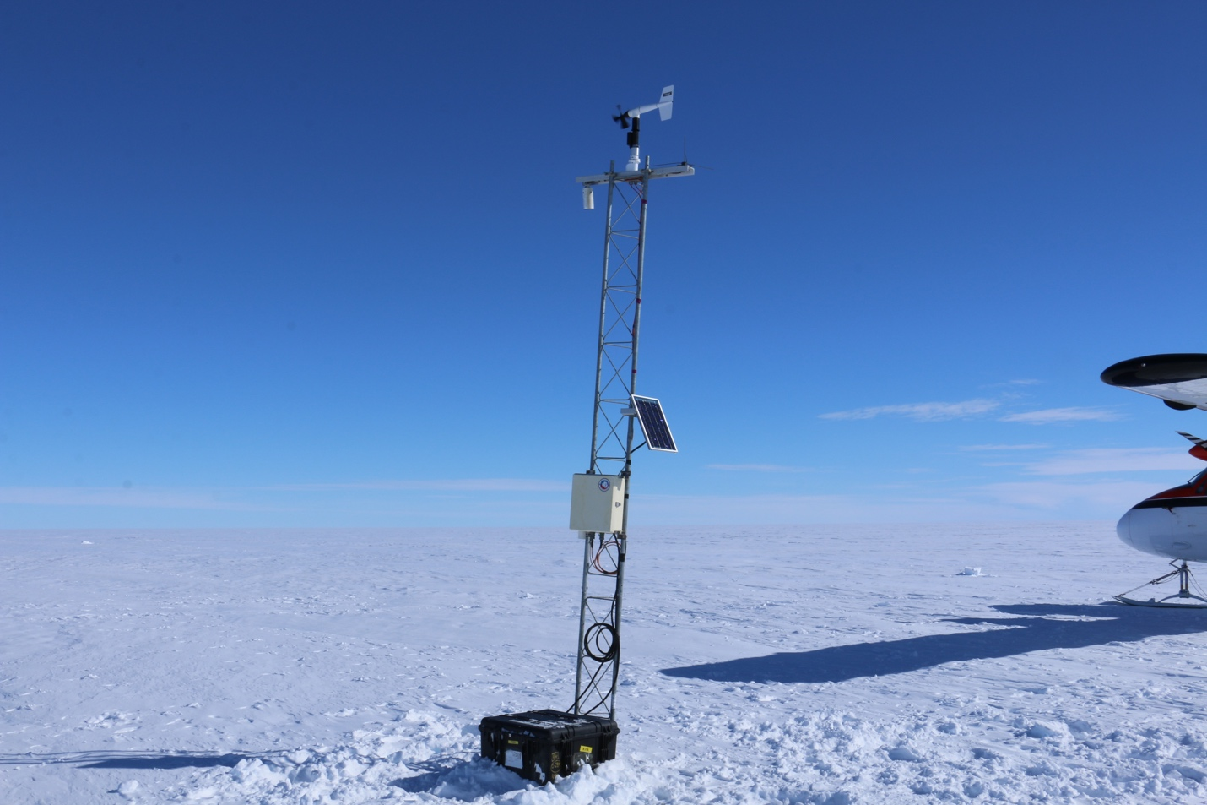
Emilia after.

2023-12-07: Otter to Sabrina (SAB) AWS
Purpose: Raise instruments and power system; swap wind, RH, ADG

BBV: Jeff, Kai
Pax: Dave, Wenhua, Chance (Crary electrician), Daniel (Parsons Construction electrician)

0915: Depart WFD
1132: Arrive Holland Range fuel cache
1223: Depart Holland Range fuel cache
1339: Arrive SAB

Conditions: sunny, light breeze

Instrument heights before (after):
Lower temperature: 40” (57”)
Boom (with ADG and pyranometer): 58” (92”)
Enclosure: 71” (74”)
Relative humidity: 148” (131”)
Upper temperature: 168” (168”)
Wind: 198” (198”)

There wasn’t as much accumulation as anticipated, so we did not add a new tower section and just raised the instrumentation and dug up the power system. (Also, we were only given 2.5 hours of ground time, so good that we didn’t need to add a tower section.) We replaced the wind monitor, relative humidity HMP155A, and ADG since the wind was broken, the RH was reporting low values, and the ADG wasn’t reporting data. We swapped the data card with a 2 GB datacard.

EarthScope coordinates and elevation:
-84.2314 / -170.3859
Elevation: 85.593 m

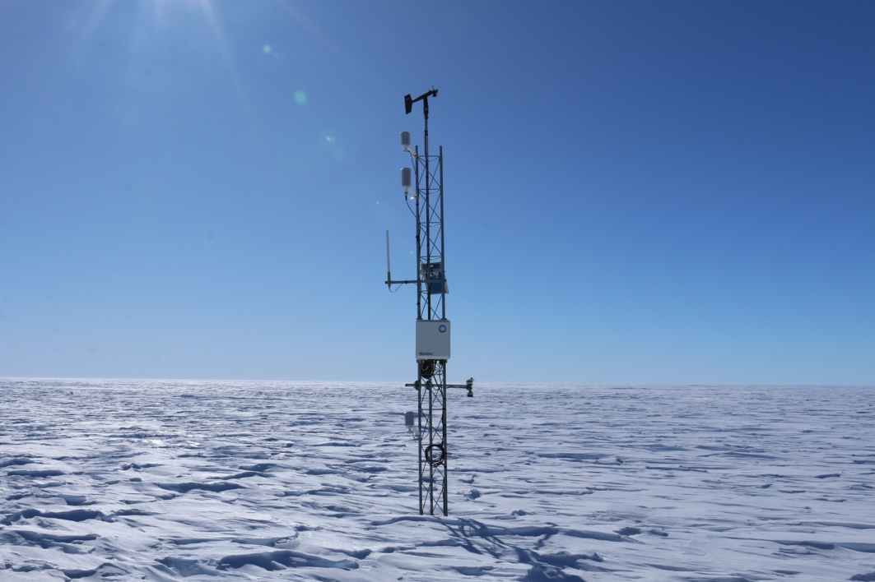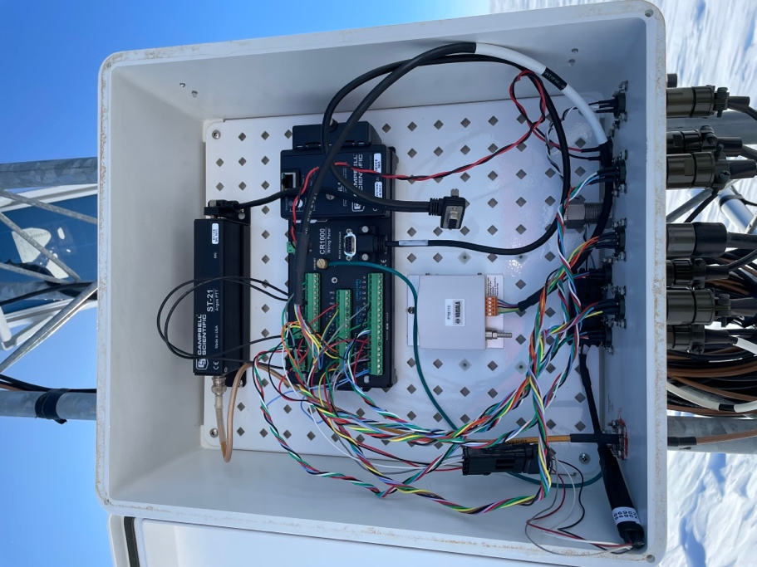
Sabrina upon arrival. Inside Sabrina enclosure.

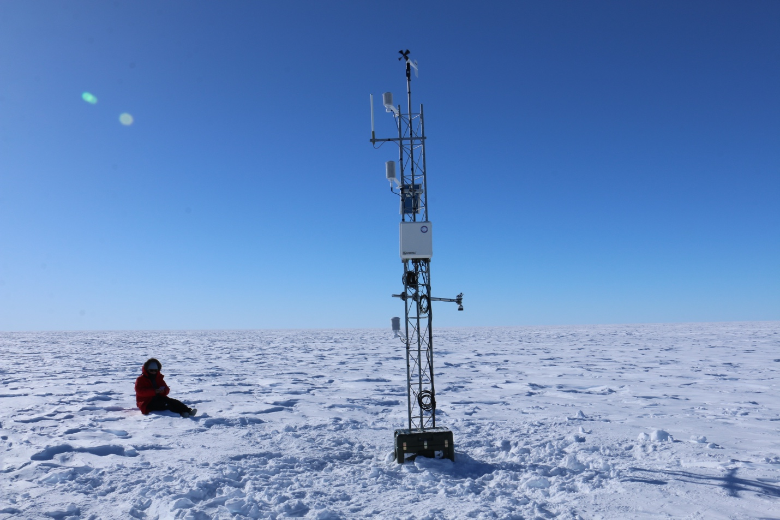
Sabrina after.

2023-12-08: Otter to Alexander Tall Tower! (BAT) AWS
Purpose: Rigger checkup

Pax: Riggers: Gabriel Menkhus, Geoff Delaune, Will Jasinevicius, Zac Schroeder, Jess Banks; EarthScope: Erika Schreiber

Paraphrased from Gabe about the riggers’ visit:
The tower itself is looking good.

The top wind monitor is busted. He thinks this was due to insufficiently securing it last season after they moved up all instrumentation, so it eventually backthreaded off its mount and came loose. It was found dangling off its mount, with the nose cone/prop on the ground. They unwired and removed the cable from the black wiring box, taped all ends of the wire, and taped the cable to the tower. They didn’t find any problems with the cable/wiring.

He said the lowest cup anemometer was pretty sticky and needs a strong wind to start spinning.

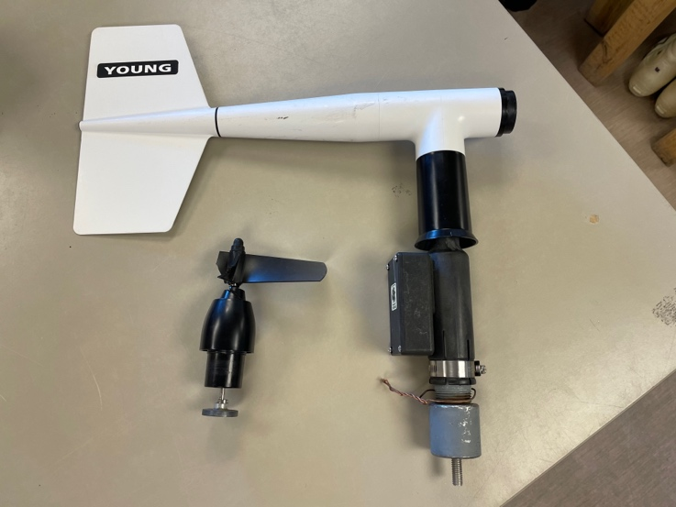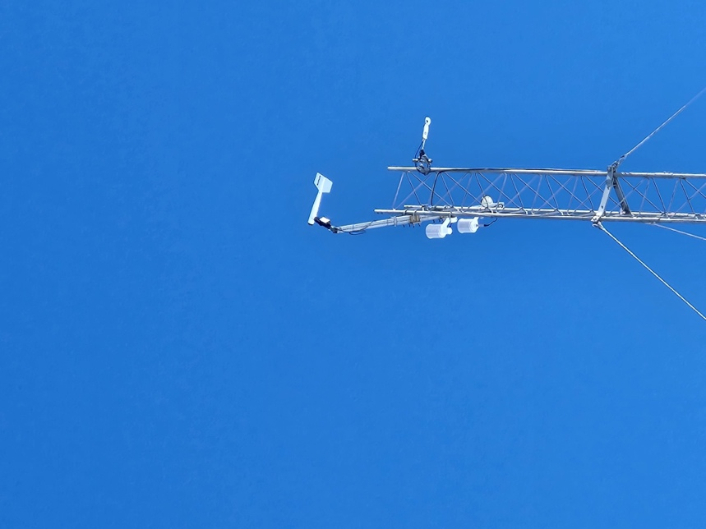
Recovered wind monitor installed at 30 m. 30 m wind monitor upon arrival.

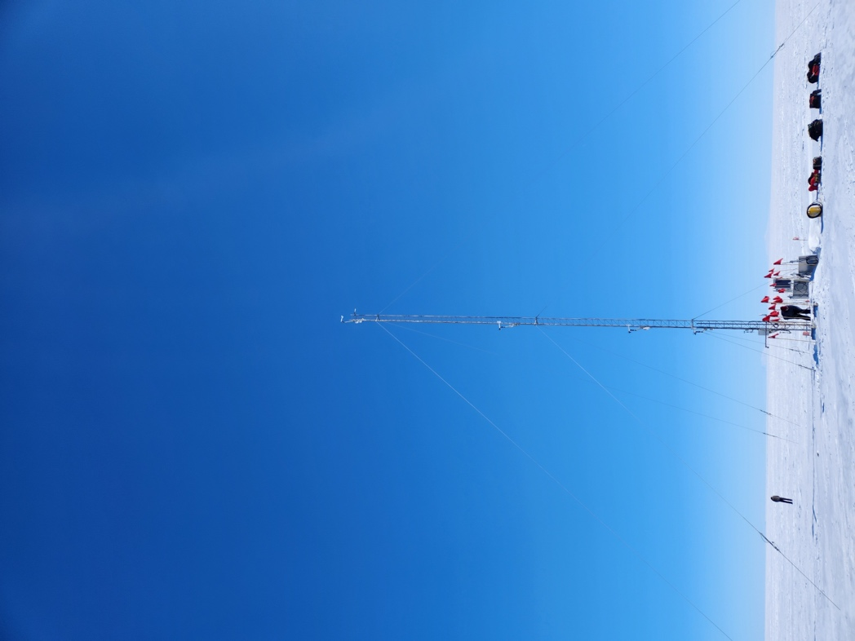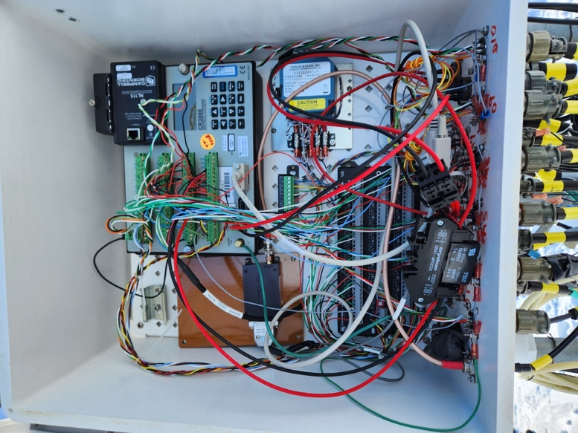
Tall Tower! upon arrival. Inside enclosure.

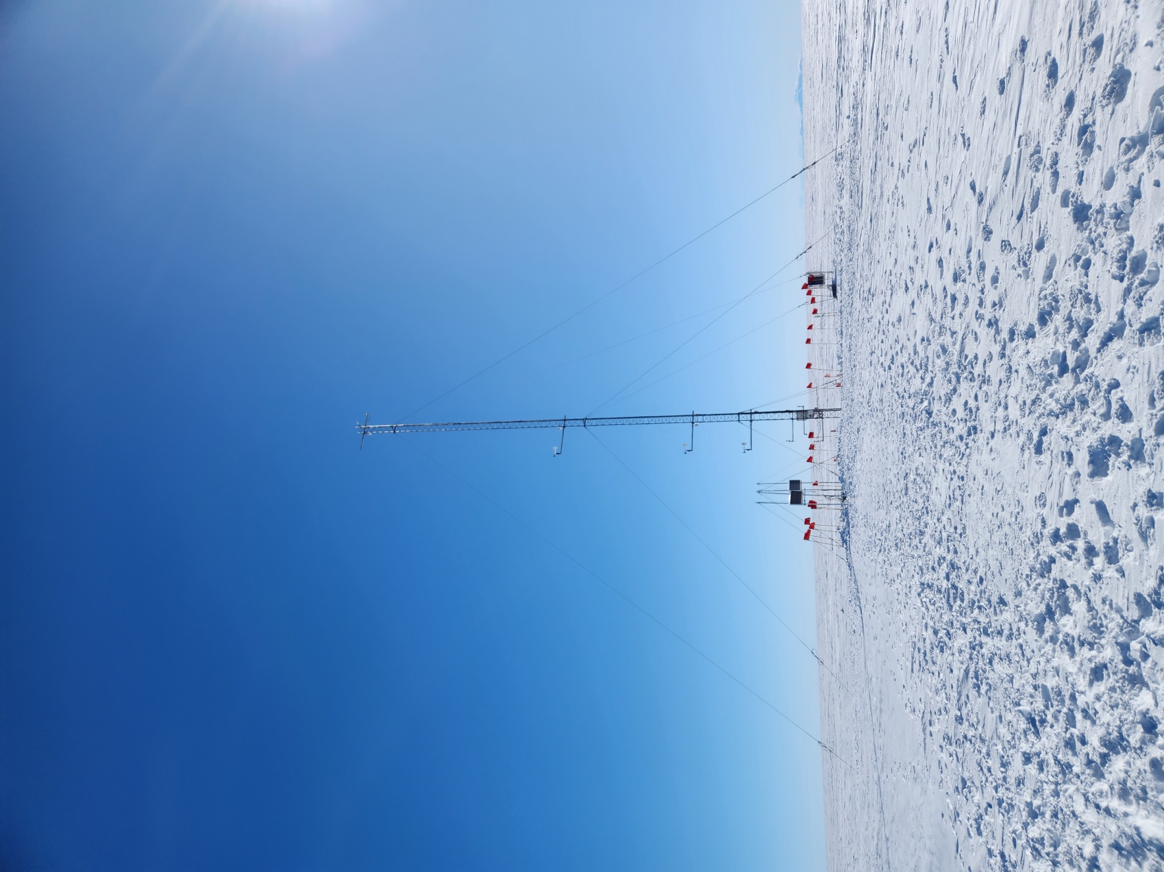
Tall Tower! after.

2023-12-11: Mattracks to Phoenix (PHX), Willie Field (WFD), and Sarah (SRH)
Purpose: PHX swap batteries in power system, WFD & SRH remove for future relocation. Also troubleshoot WFD transmission issues.

Pax: Dave, Wenhua

0945: Depart McMurdo
1040: Arrive PHX

Conditions: Sunny and warm

PHX stopped transmitting in August 2023 (end of winter) so it was suspected that the power system batteries needed to be replaced. We discovered that there were only two 100-Ahr batteries in the power system, which is generally insufficient to power an Iridium-transmitting AWS. We brought three new 100-Ahr batteries, but since there were only two preexisting batteries, we could only wire in two of the three new ones. We left the third new battery in the power system and would return another day with the wires to connect it to the system.

We dug up the power system to the surface. It was only buried a few feet, but there was a thick layer of ice around it that took a while to chip away. Also, one of the Pelican case latches broke when opening the power system. Doesn’t seem detrimental, but something to note.

We swapped the 2 GB datacard with a 256 MB datacard. The ADG is not working. We did not replace it.

Instrument heights before (after):
Enclosure: 32” (67”)
Lower temperature: 39” (39”)
Boom (with ADG and solar radiation): 54” (54”)
Relative humidity: 105” (105”)
Upper temperature: 128” (128”)
Wind: 158” (158”)

EarthScope GPS coordinates and elevation:
-77.9479 / 166.7445
Elevation: 9.505 m
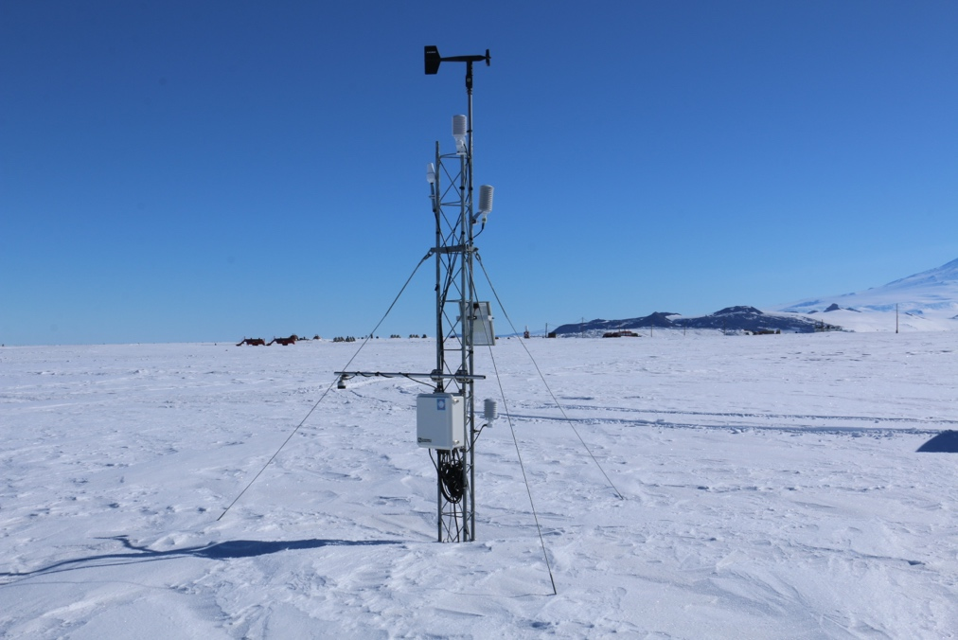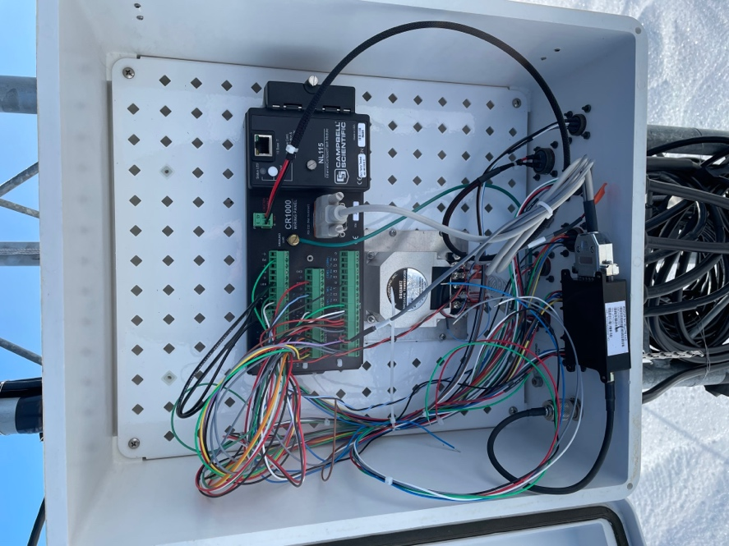
PHX upon arrival. Inside PHX enclosure.

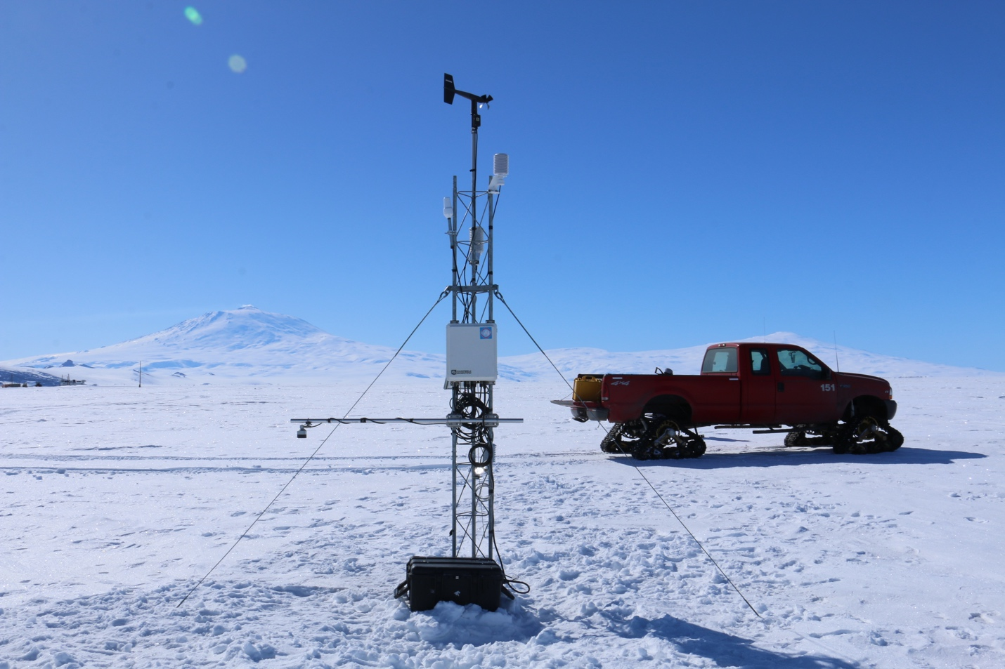
PHX after.

1435: Depart PHX
1525: Arrive WFD/SRH

We couldn’t park right next to WFD and SRH because the fuel line was in the way. Had to park ~300 feet from the sites. WFD datalogger was on, modem was connected, and the three batteries in the power system were reading proper voltages, so it’s unclear why WFD stopped transmitting. After the fact, in the lab, we discovered there is a problem with the Iridium NAL 9602 modem where it won’t transmit any data.

WFD instrument heights:
Enclosure: 25”
Lower temperature: 51”
Upper temperature: 79”
Wind: 108”

We removed all WFD and SRH instrumentation and power systems. We tried removing the tower sections but were unable to. The plan is to reinstall both WFD and SRH just off the road to Willie Field.

1835: Depart WFD
1915: Arrive Crary

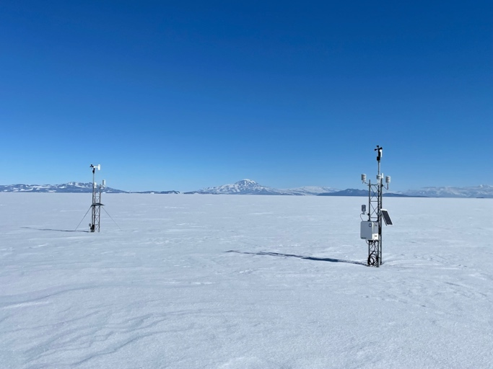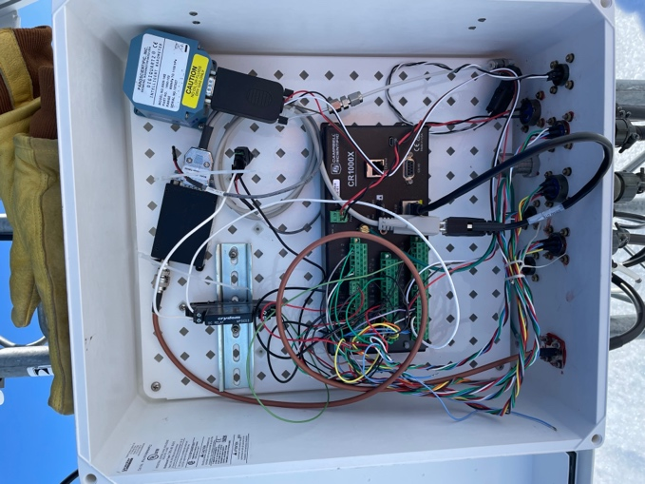
SRH (left) and WFD (right) upon arrival. Inside WFD enclosure.

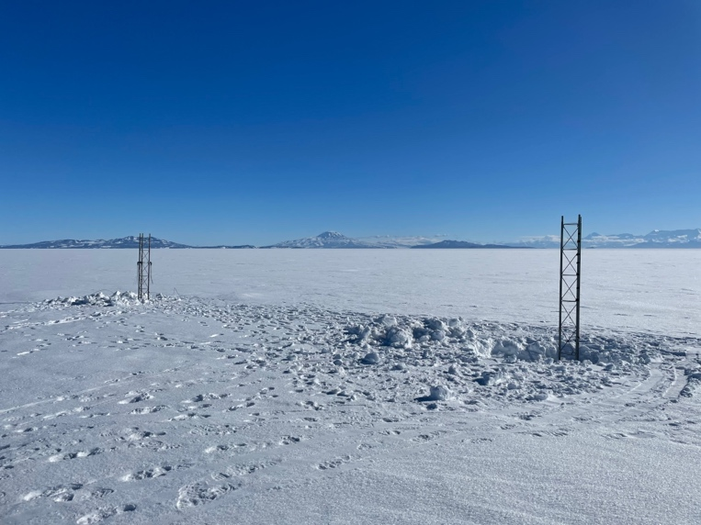
The towers that we left at the site.

2023-12-12: Mattracks to Phoenix (PHX) AWS
Purpose: Wire in 3rd battery in power system

Pax: Dave, Wenhua

0817: Depart McMurdo
0919: Arrive PHX

Wired in the third battery and confirmed transmissions with Lee back home.

0925: Leave PHX AWS
0956: Depart PHX airfield
1057: Arrive Crary

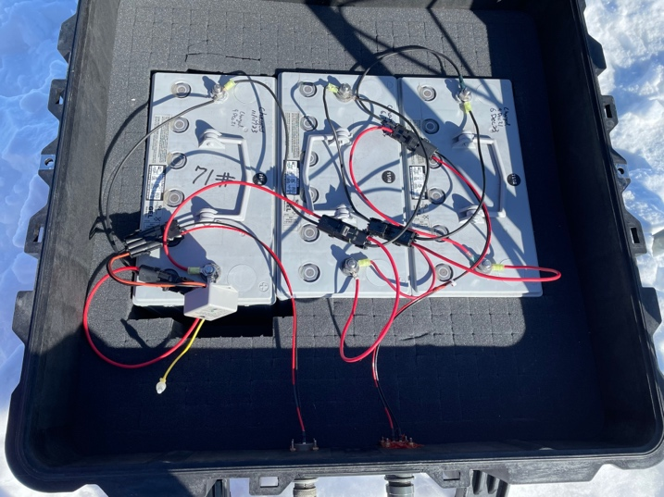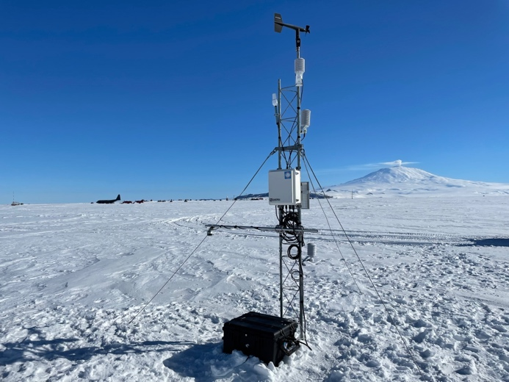
PHX power system. PHX after.

2023-12-13: Kominko-Slade (KMS) AWS
Purpose: Paul Summers, TJ Young, and others at WAIS offered to remove instrumentation for us (since we weren’t able to go to WAIS) and return to McMurdo. Instrumentation to be replaced in future field season.

From Paul Summers, (part of Thwaites project TIME (Thwaites Interdisciplinary Margin Evolution)):
“We were able to get all the sensors off the tower above and including the wind turbine for generating power. We unfortunately had to cut the cable for the turbine, but everything else was non-destructively removed from the tower.”

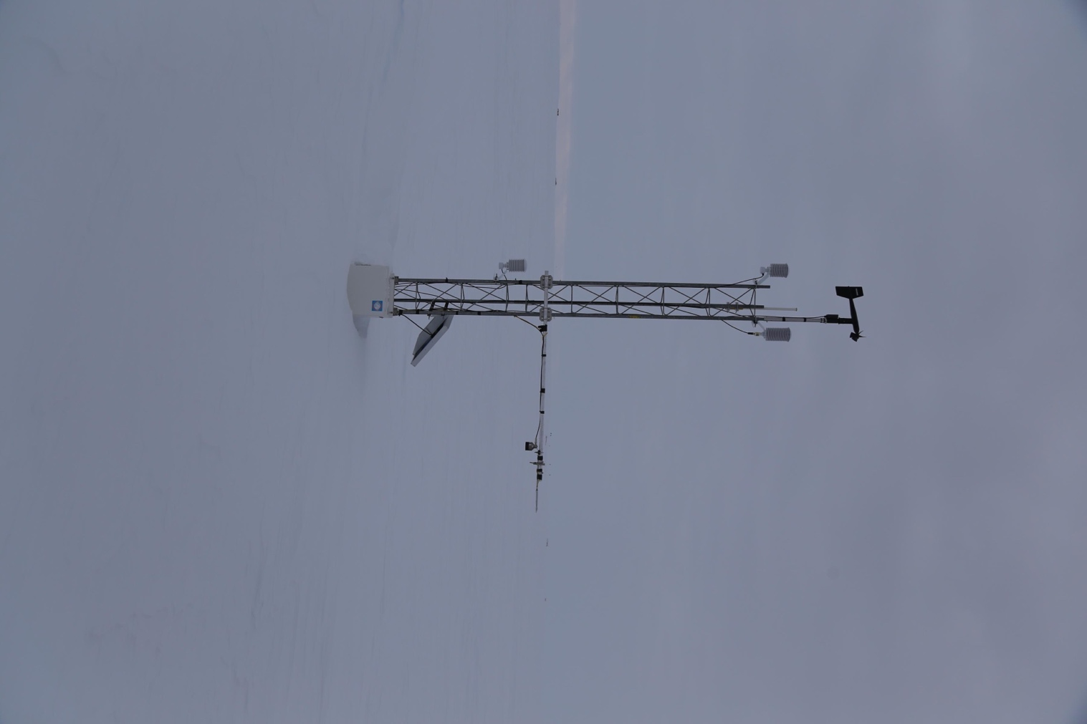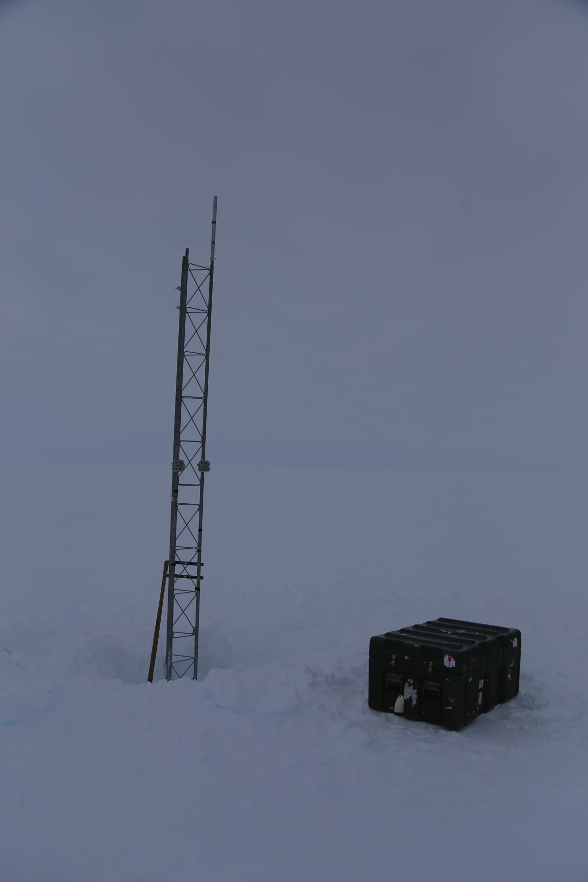
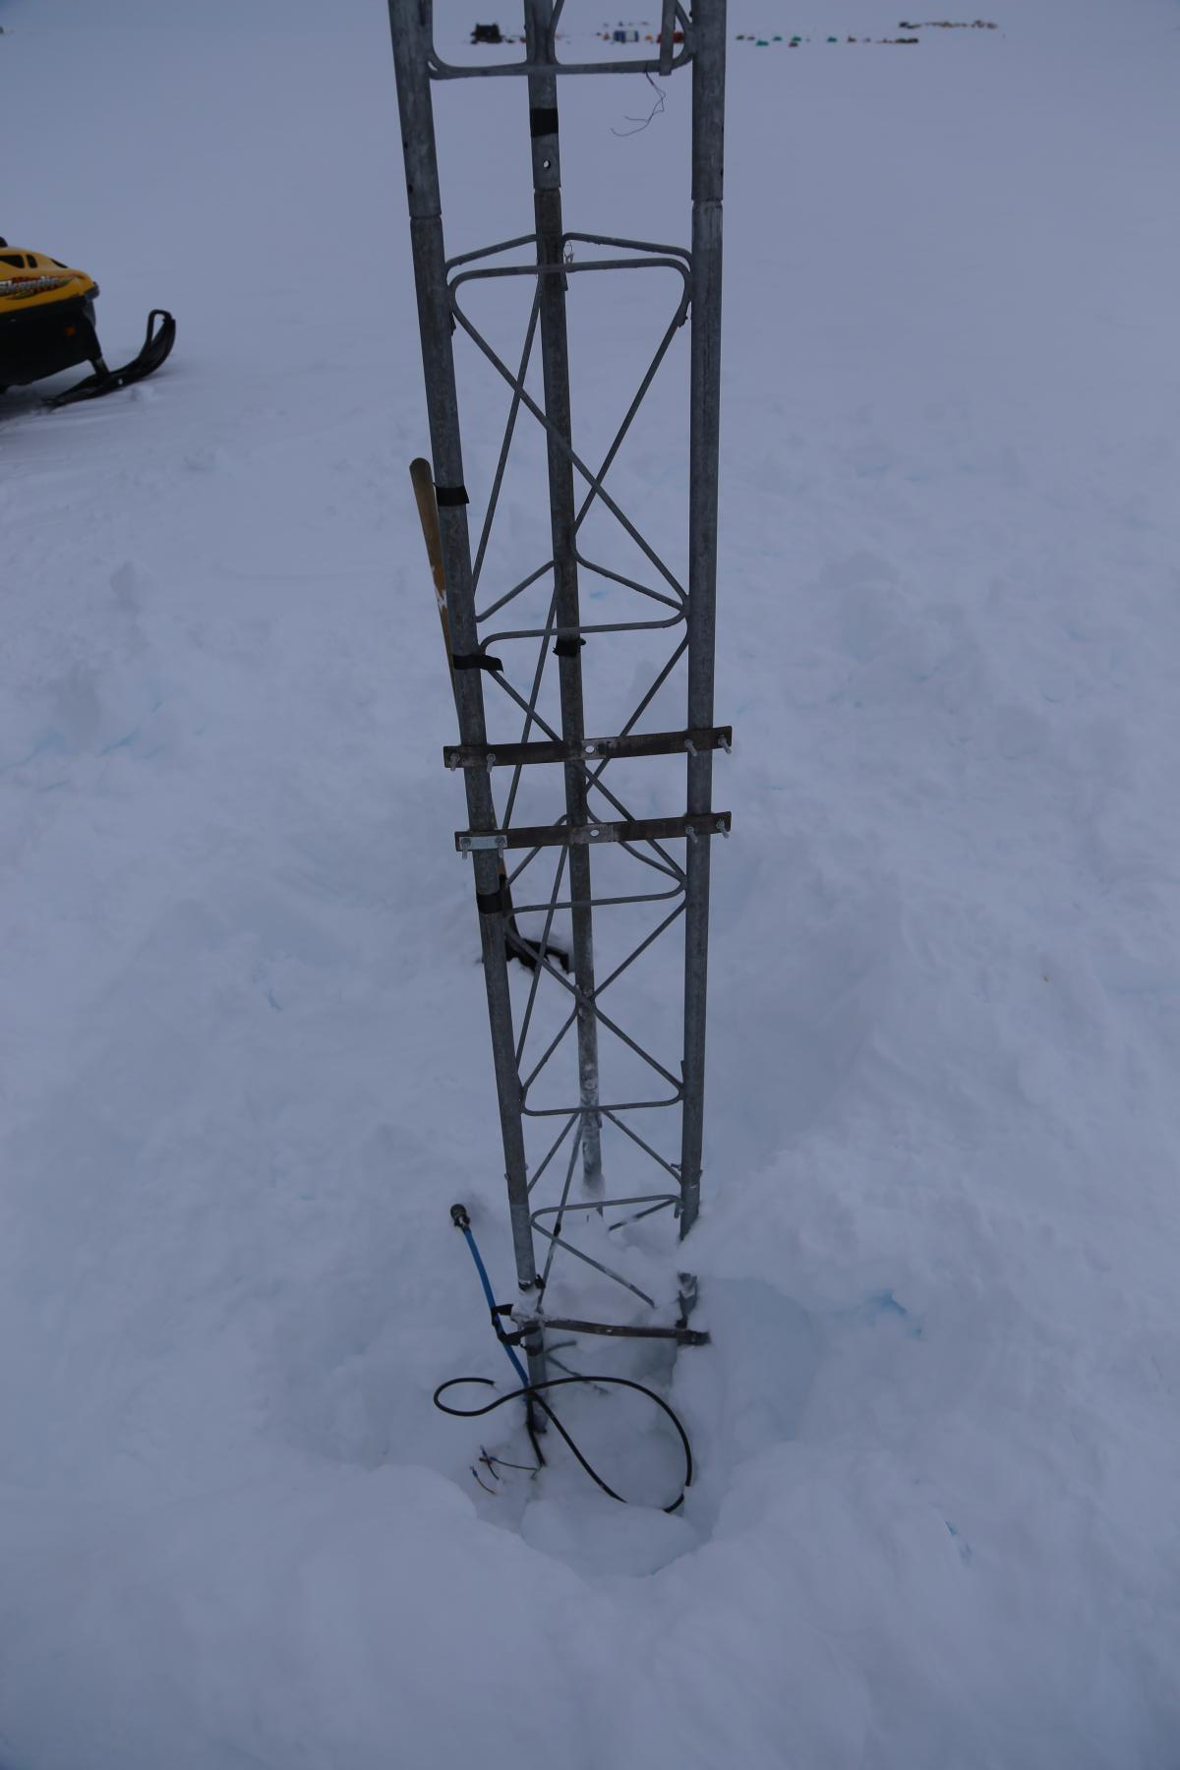

2023-12-19: Otter to Lettau (LET) AWS
Purpose: Raise the station with a 7’ tower section; replace power system, wind monitor, and ADG

KBG: Mike Knox, Matt Mawdsley
Pax: Dave, Wenhua, James McKamey (Crary IT), Mahlon Cleveland (firefighter), Le Roux Fincham-Putter (Parsons construction)

0909: Depart WFD
1109: Arrive S+200 fuel cache
1143: Depart S+200 fuel cache
1229: Arrive LET

CR1000 program running: Lettau.CR1

EarthScope GPS coordinates and elevation:
-82.4420 / -174.6800
Elev: 39.377 m

Instrument heights before (after):
Lower temperature: 9 (61”)
Enclosure: buried (99”)
Boom (with ADG and pyranometer): 27” (77”)
Relative humidity: 0” (134”)
Upper temperature: 83” (174”)
Wind: fell off (204”)

The pilots warned us that they noticed crevassing in the area and cautioned us not to walk outside the circled area that they taxied around the site. We should be sure to monitor surface conditions prior to future field visits.

Upon arrival, it was discovered the wind monitor had fallen off its mount and was broken and on the surface. We raised the station with a 7’ tower section, which was extremely difficult to install as the legs of the new and existing tower sections didn’t line up properly. With warping, wiggling, and Vaseline, the new tower section finally fit.

Due to ground time limitations and how buried the AWS was, the old power system was unrecoverable, so a new one with 2 100-Ahr batteries (along with a new solar panel) was installed. A new wind monitor was installed (the one that was previously installed at Willie Field), and a new ADG sensor was installed since the existing one wasn’t outputting data. We swapped the datacard with a 2 GB datacard.

1613: Depart LET
1833: Arrive WFD
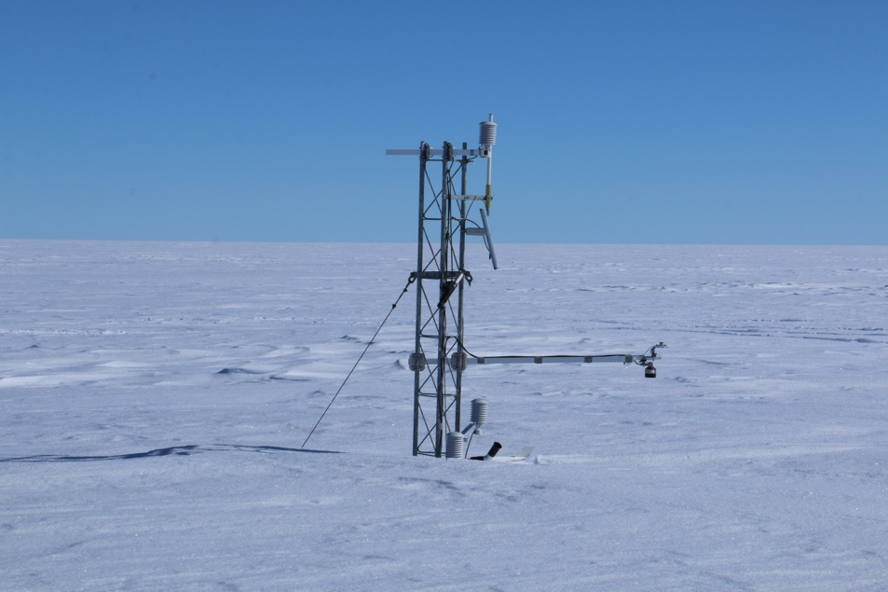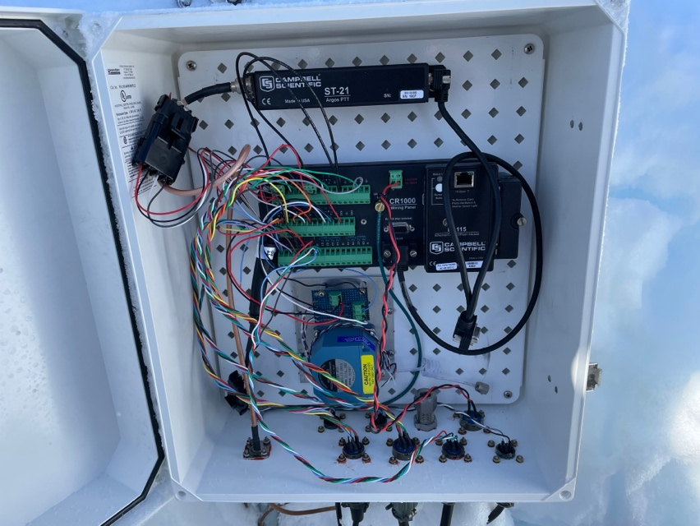
Lettau upon arrival. Inside Lettau enclosure.

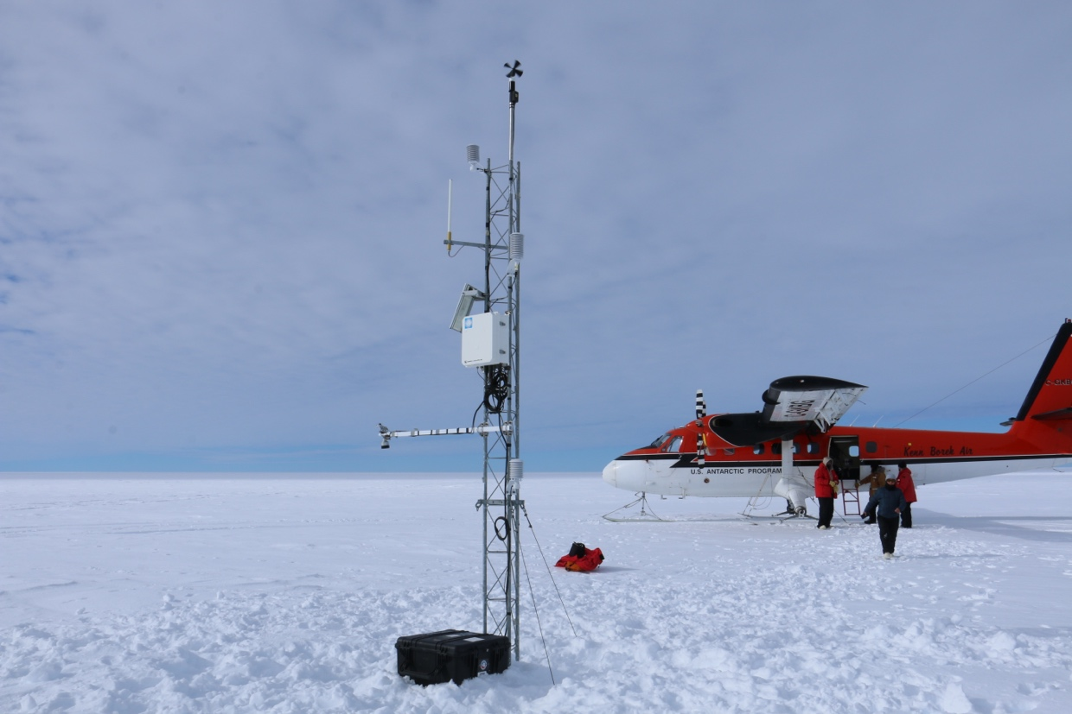
Lettau after.

2024-01-04: Otter to Emma (EMA) AWS
Purpose: Remove station

KBG: Mike, Matt
Pax: Dave, Wenhua, Amanda Bozzi (Galley supervisor), Dillon Hoxit (light vehicle mechanic)

0851: Depart WFD
1100: Arrive S+200 fuel cache
1139: Depart S+200 fuel cache
1251: Arrive EMA

CR1000 program running: 14633.CR1

EarthScope GPS coordinates and elevation:
-83.9835 / -175.2097
Elevation: 78.248 m

Instrument heights:
Lower temperature: 5”
Enclosure: 20”
Boom (with ADG and pyranometer): 52”
Relative humidity: 55”
Upper temperature: 115”
Wind: 145”

We removed all instrumentation, both power system cases, the top two tower sections, and all three guy chains (the ropes and deadmen/anchors were unrecoverable).

1518: Depart EMA
1747: Arrive WFD

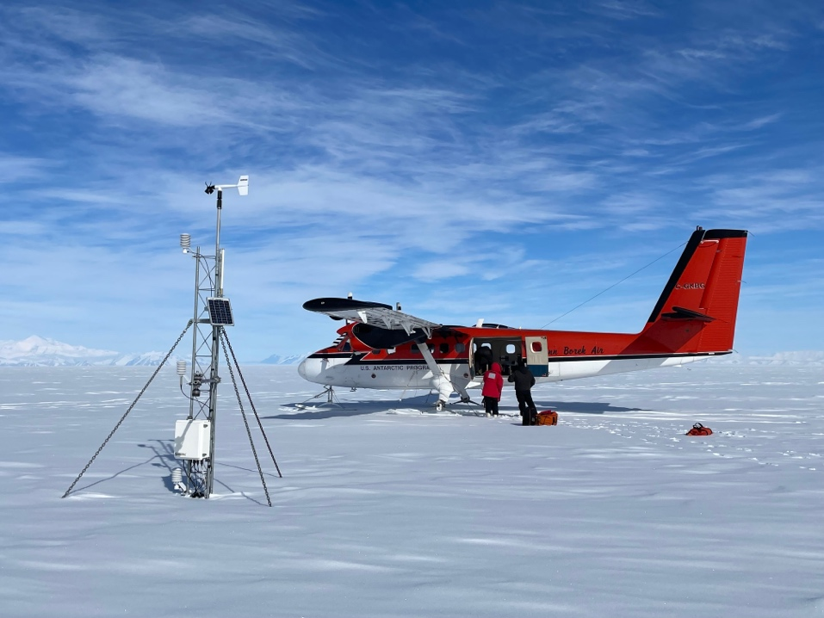
Emma upon arrival.

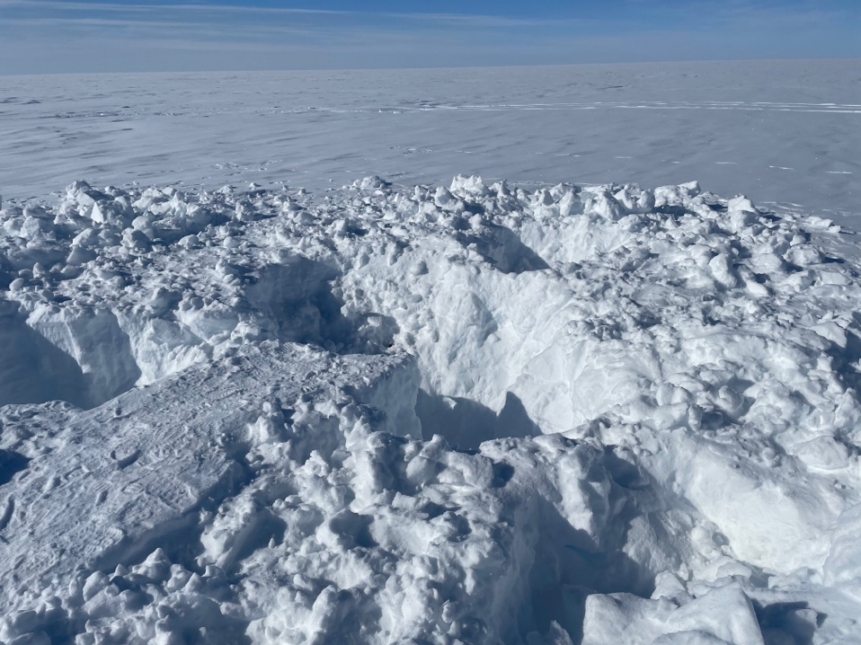
The aftermath.

