# | Correct Answer | Comments
1 | A: Wind
2 | FALSE
3 | B: Lightning heating the air | Lightning is over 50,000 deg. F. The rapid heating and cooling of the air essentially creates a sonic boom
4 | D: North Pole | Bonus: The northern hemisphere is tilted so far away from the Sun that the circle of illumination never reaches the north pole
5 | C. Galveston, TX
6 | ***Disaster Slide*** | ***Disaster Slide*** Team loses 10 mph and does not move
7 | B: Flash Flood | The heavy rain isn’t moving anywhere and therefore causes one area to receive high amounts of rainfall
8 | C: Lenticular | These are lens-shaped clouds and have been mistaken for UFOs.  If correct: +15 mph and move ahead; if incorrect: -0 mph and don’t move (see figure A)
9 | B: Ice, liquid, vapor
10 | A: True | Average U.S. deaths per year: 58
11 | B: Front
12 | B: Barometer
13 | A: Humidity | Bonus Acceptable answers: mixing ratio or vapor pressure
14 | FALSE | Right on the equator… wind is virtually non-existent
15 | A: | Earth rotates from west to east
16 | B: | Along the equator from East to West
17 | A: From West to East | Westerlies describes where the wind is coming from
18 | B: West | Easterlies describes where the wind is coming from
19 | D: Alaska | Recent research suggests that the aurora is caused by radiation, which is emitted as light from atoms in the upper atmosphere as they are hit by swiftly moving electrons and protons. If correct: +15 mph and move ahead; if incorrect: -0 mph and don’t move (see figure B)
20 | B: Below 32F | The key word here is BELOW
21 | A: | Many coastal cities would be under water
22 | D: South Africa | While South Africa is close to the south pole, Christmas occurs during their summer season
23 | C: Snow | Bonus Answer: Albedo… brighter surfaces reflect more energy (have a higher albedo) back into space
24 | D: The Sun
25 | ***Disaster Slide*** | ***Disaster Slide*** Team loses 10 mph and does not move
26 | A: Storm surge | Storm surge would occur with a hurricane
27 | C: 27,000 C
28 | ***Disaster Slide*** | ***Disaster Slide*** Team loses 10 mph and does not move
29 | B: Tornadoes
30 | A: Florida
31 | FALSE | Remember, the tilt of the earth is the reason for the season, not the Earth’s distance from the Sun. Early January marks the Perihelion (when Earth is closest to the Sun) and Early July marks the Aphelion (when Earth is farthest from the Sun)
32 | C: NOAA
33 | FALSE | Latitude has more of an effect on temperatures (gradient of hot to cold)
34 | B: | National Oceanic & Atmospheric Administration
35 | C: Silver Iodide | If correct: +15 and move ahead; if incorrect: -0 and don’t move
36 | B: Nitrogen | Nitrogen: 78%, Oxygen: 21%, other: 1%
37 | A: Relative humidity
38 | B: Dew Point
39 | B: Saturated
40 | ***Disaster Slide*** | ***Disaster Slide*** Team loses 10 mph and does not move
41 | D: Seismometer | Seismometers are used for Earthquakes
42 | C: Water Vapor | We need the greenhouse effect to keep us warm and water vapor is the primary greenhouse gas. The excess addition of other gasses is the problem.
43 | C: 74 mph | Bonus answer: Saffir-Simpson
44 | C: 22,000 miles | If correct: +15 mph and move ahead; if incorrect: -0 and don’t move. (See figure C)
45 | TRUE | The windward side of the Rockies would be the west side. The Leeward side would be the east side. Moisture is released (causing more precip.) on the west side as air has to rise to move over the mountains. This creates a “rain shadow” on the east side, hence desert terrain.
46 | D: Kelvin | Bonus: Absolute zero is the coldest temperature theoretically possible. It cannot be reached by artificial or natural means. At absolute zero molecular energy is minimal.
47 | A or B | Fish are living (BIO) and live in the water (Hydro)
48 | FALSE | 90 percent of the molecular weight of the atmosphere is within 10 miles of the Earth’s surface, even though the atmosphere extends almost 400 miles from Earth’s surface.

Figure A: Lenticular Clouds
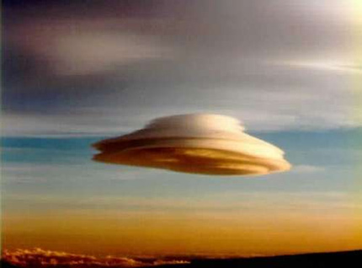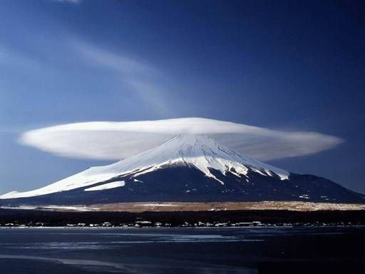

Figure B: Aurora Borealis in Alaska
Figure C: Geostationary Satellites

