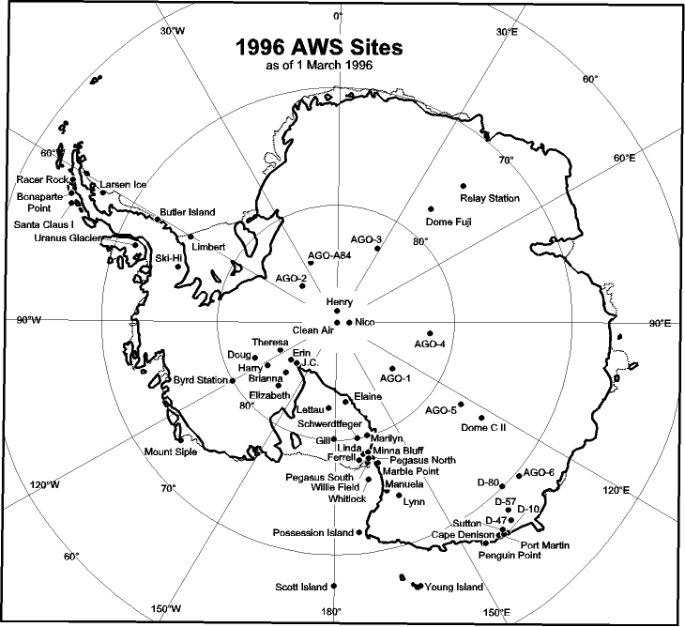

Antarctic Automatic Weather Station Data
for the calendar year
1996

by

Linda M. Keller
George A. Weidner
Charles R. Stearns
Matthew T. Whittaker
Robert E. Holmes

Space Science and Engineering Center
University of Wisconsin
1225 W. Dayton St.
Madison, Wisconsin
February 1998

Antarctic Automatic Weather Station Data

for the calendar year

1996

by

Linda M. Keller

George A. Weidner

Charles R. Stearns

Matthew T. Whittaker

Robert E. Holmes

Space Science and Engineering Center
University of Wisconsin
1225 W. Dayton St.
Madison, Wisconsin
February 1998

TABLE OF CONTENTS

Page

1. Introduction......................................................................................................................................... 1

2. Data Transmission............................................................................................................................. 1

3. AWS Identification and Location...................................................................................................... 1

4. AWS Data Summaries...................................................................................................................... 8

4.1 Monthly Data Summaries............................................................................................................. 8 D-10............................................................................................................................................. 9
D-47............................................................................................................................................. 9
D-57............................................................................................................................................. 9
D-80............................................................................................................................................. 9
Dome C II.................................................................................................................................... 9
Port Martin................................................................................................................................ 10
Cape Denison........................................................................................................................... 10
Penguin Point........................................................................................................................... 10
Sutton........................................................................................................................................ 11
Cape Webb............................................................................................................................... 11
Byrd Station.............................................................................................................................. 11
Mount Siple............................................................................................................................... 12
Harry......................................................................................................................................... 12
J.C. ............................................................................................................................................ 12
Theresa..................................................................................................................................... 13
Doug.......................................................................................................................................... 13
Brianna...................................................................................................................................... 13
Elizabeth................................................................................................................................... 14
Erin............................................................................................................................................ 14
Marble Point.............................................................................................................................. 14
Ferrell........................................................................................................................................ 15
Pegasus North.......................................................................................................................... 15
Pegasus South......................................................................................................................... 15
Minna Bluff................................................................................................................................ 16
Linda.......................................................................................................................................... 16
Willie Field................................................................................................................................. 16
Whitlock..................................................................................................................................... 17
Young Island............................................................................................................................. 17
Possession Island.................................................................................................................... 17
Marilyn....................................................................................................................................... 18
Schwerdtfeger.......................................................................................................................... 18
Gill............................................................................................................................................. 18
Lettau........................................................................................................................................ 19
Elaine........................................................................................................................................ 19
Manuela...................................................................................................................................... 19
Lynn........................................................................................................................................... 20
Larsen Ice Shelf....................................................................................................................... 20
Butler Island.............................................................................................................................. 20
Uranus Glacier.......................................................................................................................... 21
Racer Rock................................................................................................................................ 21
Bonaparte Point........................................................................................................................ 21
Ski-Hi......................................................................................................................................... 21
Santa Claus Island................................................................................................................... 22
Limbert..................................................................................................................................... 22
AGO-A84................................................................................................................................... 22
Clean Air (South Pole)............................................................................................................. 23
Nico........................................................................................................................................... 23
Henry........................................................................................................................................ 23
Relay Station............................................................................................................................ 24
Dome Fuji................................................................................................................................. 24

4.2 Three Hourly Data Summaries................................................................................................. 25

5. AWS Calibration................................................................................................................................. 26

5.1. Temperature............................................................................................................................... 26
5.2. Pressure...................................................................................................................................... 26
5.3. Wind Direction and Speed........................................................................................................ 26
5.4. Relative Humidity....................................................................................................................... 27
5.5. Vertical Air Temperature Difference........................................................................................ 27

6. AWS Operations Summary for 1996................................................................................................ 27

6.1. AWS Performance..................................................................................................................... 27
6.2. AWS Antarctic Field Activities.................................................................................................. 30

7. Global Telecommunications System................................................................................................ 32

8. Data and Field Report Availability.................................................................................................... 32

9. Acknowledgments............................................................................................................................. 34

1. INTRODUCTION

A network of automatic weather station (AWS) units is deployed to collect Antarctic surface weather observations in support of specific meteorological research projects as well as operational activities at McMurdo. The 1996 network consisted of 51 installed AWS units providing observations on the Ross Ice Shelf, east of the Transantarctic Mountains and north of McMurdo to the Adelie Coast, along the Antarctic Peninsula and climatological locations such as the South Pole. Each unit measures air temperature, wind speed, and wind direction normally at the top of the unit's tower at a nominal height of three meters and air pressure at the electronics enclosure (Figure 1). Some AWS units also measure the relative humidity at three meters and vertical air temperature difference between 0.5 and 3 meters. Measurement heights relative to the actual surface at the site are nominal due to snow accumulation around the AWS unit.

2. DATA TRANSMISSION

The transmitted AWS data are received and stored by the ARGOS data collection system on the NOAA series of polar orbiting satellites. The data are retransmitted by the satellite for reception by a local user terminal (LUT) as at McMurdo, Antarctica. The data are processed into scientific units and are available for local use. The complete data set is received daily at Madison, Wisconsin, from Service ARGOS, Toulouse, France, for processing and distribution to the users.

3. AWS IDENTIFICATION AND LOCATION

Site location is defined by the latitude and longitude which is determined by various methods: sun shots, angles to geographical features, aircraft data, ice breaker data, the platform location system of Service ARGOS, and the Global Positioning System. AWS elevation is obtained by barometry and should be correct to within +/- 5 meters. Site names were introduced for convenience. Table 3.1 lists the site name, ARGOS identification number, latitude, longitude, elevation, start date for the site, and the World Meteorological Organization (WMO) number for the site. Figures 2, 3, 4, and 5 show the locations of the AWS units in the Antarctic for 1996.

The ARGOS identification number (ID) is used to identify the data sets distributed to the users. AWS units are sometimes moved from one location to another, and as a result, the ID at a given site may change from year to year. Table 3.2 lists the site name with the ARGOS ID, the site start date, and the ID start and stop dates.

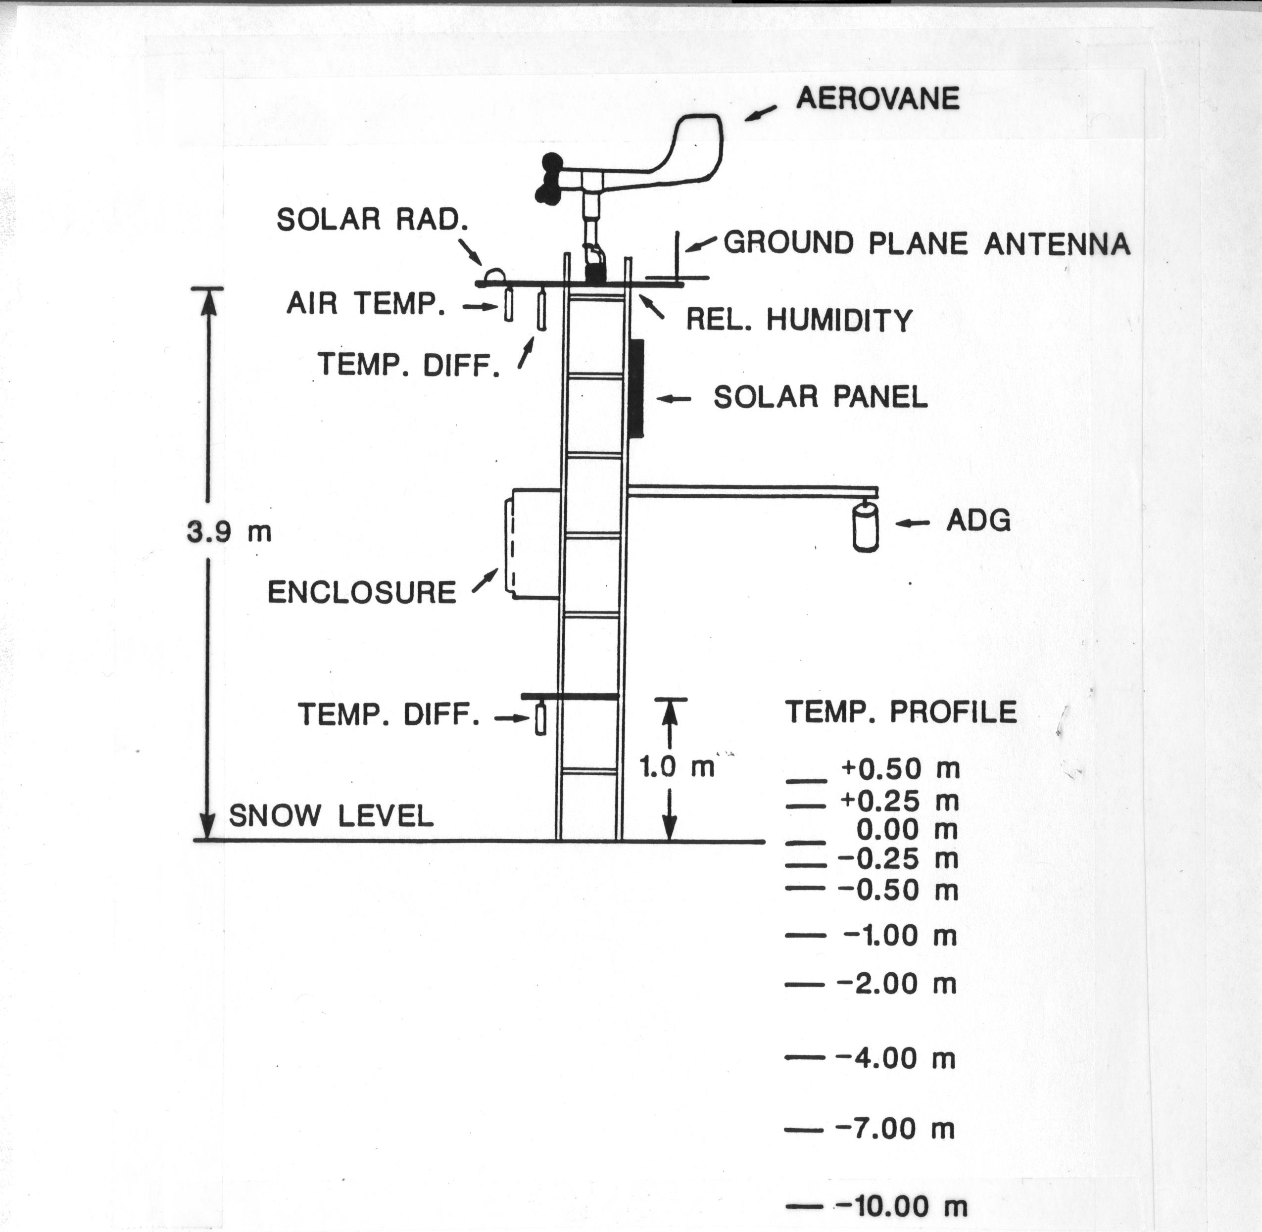
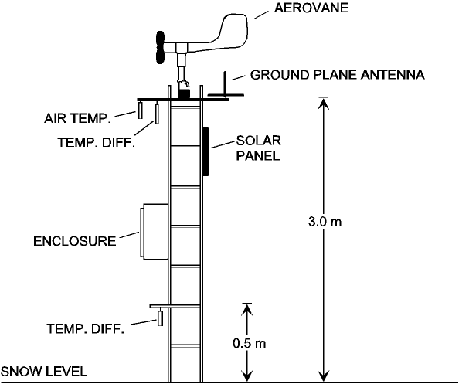

Figure 1. Layout of the AWS unit used in the Antarctic. The installed AWS unit has a 3-meter tower with a horizontal boom supporting the antenna, aerovane for measuring wind speed and direction, air temperature resistance thermometer, upper thermopile for measuring vertical air temperature difference, and the relative humidity sensor. The electronics enclosure is mounted at the mid point of the tower. The gel cell batteries are placed at the tower base. The solar panel, located near the tower top, faces north.
Table 3.1
AWS site name, geographic location and elevation, site start date, and WMO number for 1996.

Site name ARGOS ID Lat. (Deg) Long. (Deg) Elev. (m) Site Start Date WMO No.

Adelie Land
D-10 #8919 66.71ºS 139.83ºE 243 08 Jan 80 89832
D-47 #8986 67.40ºS 138.73ºE 1560 24 Jan 83 89834
D-57 #21360 68.20ºS 137.54ºE 2105 16 Jan 81
D-80 #8916 70.04ºS 134.88ºE 2500 14 Jan 83 89836
Dome C 8904 74.50ºS 123.00ºE 3280 05 Feb 80 89828
Dome C II 8989 75.12ºS 123.37ºE 3250 12 Dec 95 89828
Port Martin 8930 66.82ºS 141.40ºE 39 19 Jan 90
Cape Denison 8907 67.01ºS 142.66ºE 31 20 Jan 90
Penguin Point 8929 67.62ºS 146.18ºE 30 24 Dec 92 89847
Sutton 8939 67.08ºS 141.37ºE 871 26 Dec 94
Cape Webb 8933 67.93ºS 146.82ºE 37 28 Dec 94

West Antarctica
Byrd Station 8903 80.00ºS 119.40ºW 1530 05 Feb 80 89324
Mount Siple 8981 73.20ºS 127.05ºW 230 20 Feb 92 89327
Harry 21355 83.00ºS 121.39ºW 945 29 Nov 94
J.C. 21357 85.07ºS 135.52ºW 549 29 Nov 94
Theresa 21358 84.60ºS 115.81ºW 1463 29 Nov 94 89314
Doug 21359 82.32ºS 113.24ºW 1433 29 Nov 94
Brianna 21362 83.89ºS 134.15ºW 549 30 Nov 94
Elizabeth #21361 82.61ºS 137.08ºW 549 30 Nov 94 89332
Erin #21363 84.90ºS 128.81ºW 1006 29 Nov 94

Ross Island Region
Marble Point 8906 77.44ºS 163.69ºE 120 05 Feb 80 89866
Ferrell 8934 77.93ºS 170.82ºE 45 10 Dec 80 89872
Pegasus North 8927 77.95ºS 166.51ºE 10 23 Jan 90 89667
Pegasus South 8937 77.99ºS 166.58ºE 10 14 Jan 91
Minna Bluff 8988 78.55ºS 166.66ºE 920 22 Jan 91 89768
Linda #8909 78.48ºS 168.38ºE 50 21 Jan 91 89769
Willie Field 8901 77.87ºS 167.02ºE 20 25 Jan 92

Ocean Islands
Whitlock 8921 76.14ºS 168.39ºE 274 23 Jan 82 89865
Scott Island 8983 67.37ºS 179.97ºW 30 25 Dec 87 89371
Young Island 8980 66.23ºS 162.28ºE 30 01 Jan 91 89660
Possession Is. 8984 71.89ºS 171.21ºE 30 29 Dec 92 89879

Ross Ice Shelf
Marilyn 8931 79.95ºS 165.13ºE 75 16 Jan 84 89869
Schwerdtfeger 8913 79.90ºS 169.97ºE 60 24 Jan 85 89868
Gill 8911 79.99ºS 178.61ºW 55 24 Jan 85 89376
Lettau 8908 82.52ºS 174.45ºW 55 29 Jan 86 89377
Elaine 8900 83.13ºS 174.17ºE 60 28 Jan 86 89873

Reeves Glacier
Manuela 8905 74.95ºS 163.69ºE 80 06 Feb 84 89864
Lynn 8935 74.21ºS 160.41ºE 1772 19 Jan 88 89860

Antarctic Peninsula
Larsen Ice 8926 66.95ºS 60.91ºW 17 21 Oct 85 89262
Butler Island 8902 72.21ºS 60.17ºW 91 01 Mar 86 89266
Uranus Glac. 8920 71.43ºS 68.93ºW 780 06 Mar 86 89264
Racer Rock 8947 64.07ºS 61.61ºW 17 15 Oct 89 89261
Bonaparte Pt. 8912 64.78ºS 64.07ºW 8 05 Jan 92 89269
Recovery Glcr. 8932 80.82ºS 22.26ºW 1220 18 Jan 94
Ski-Hi 8917 74.98ºS 70.77ºW 1395 21 Feb 94 89272
Santa Claus Is 8910 64.96ºS 65.67ºW 25 10 Dec 94
Limbert 8925 75.42ºS 59.95ºW 40 30 Nov 95 89257
AGO-A84* 8932 84.36ºS 23.86ºW 2103 09 Jan 96

High Polar Plateau
Clean Air 8987 90.00ºS 2835 29 Jan 86 89208
Nico 8924 89.00ºS 89.67ºE 2935 26 Jan 93 89799
Henry 8985 89.01ºS 1.30ºW 2755 26 Jan 93 89108
Relay Station 8918 74.02ºS 43.06ºE 3353 01 Feb 95 89744
Dome Fuji 8982 77.31ºS 39.70ºE 3810 08 Feb 95 89734

# New ARGOS ID for 1996 at the site; *New location for 1996

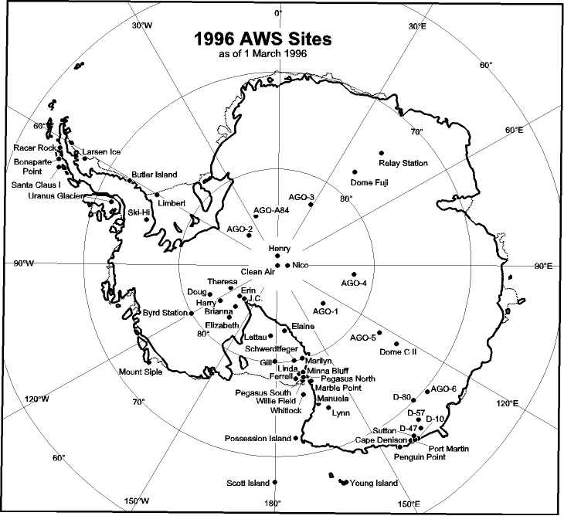

Figure 2. Antarctic automatic weather station locations during 1996 identified by the site name. Area around Ross Island is shown in Figure 3. Adelie Coast area is shown in Figure 4.

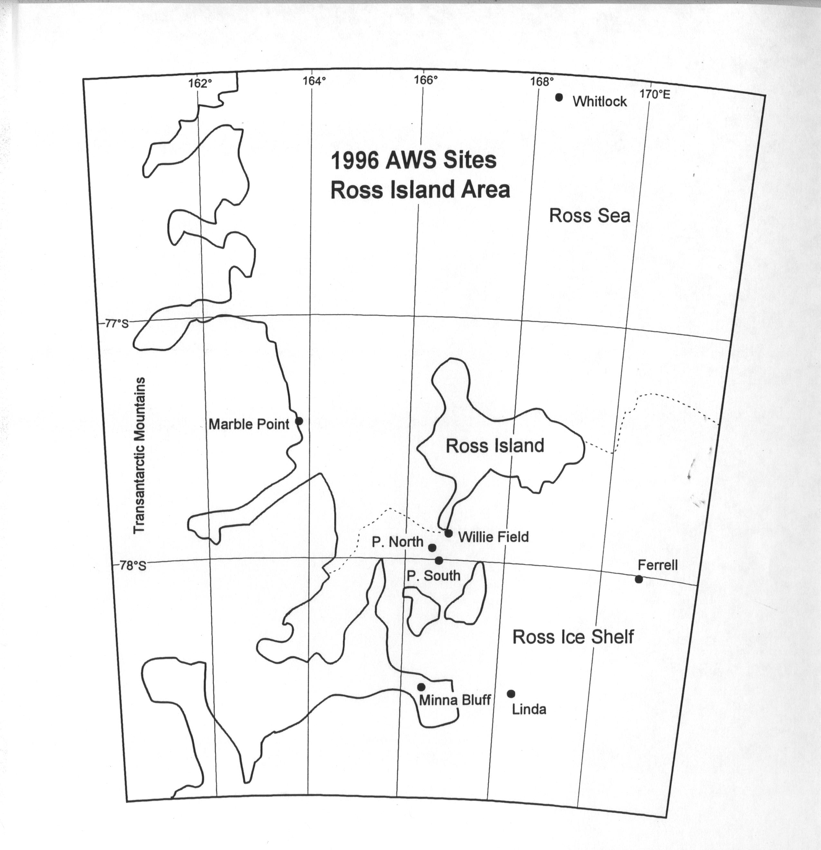

Figure 3. Location of Antarctic automatic weather stations in the vicinity of Ross Island, Antarctica during 1996.
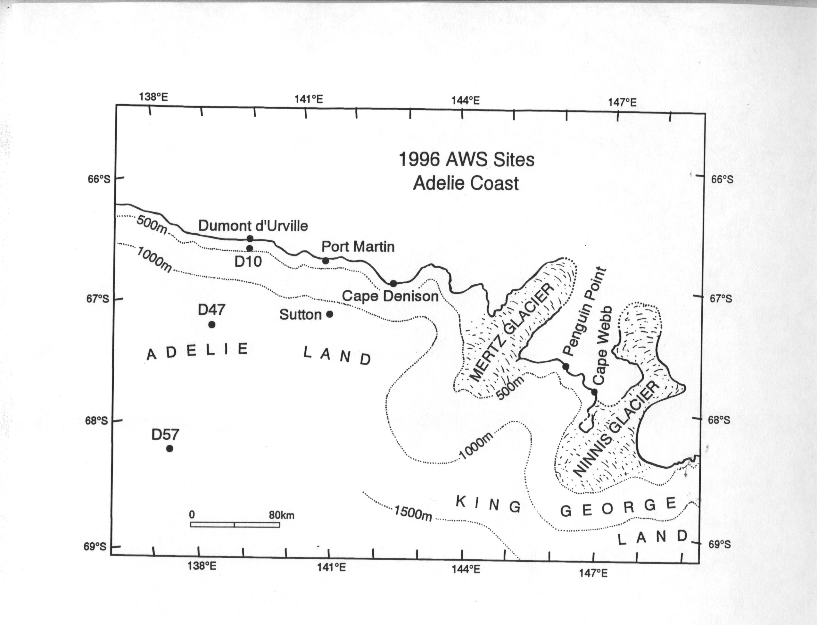

Figure 4. Location of Antarctic automatic weather stations on the Adelie Coast during 1996.
Table 3.2
1996 Antarctic AWS site name, ARGOS identification number (ID), site start date, ID start date, and ID stop date if occurring in 1995.
Site | ARGOS ID | Site Start Date | ID Start Date | ID Stop Date
D-10 | 21364 | 08 Jan 80 | 25 Dec 95 | 21 Jan 96
 | 8919 |  | 21 Jan 96
D-47 | 8986 | 24 Jan 83 | 11 Feb 96
D-57 | 21360 | 16 Jan 81 | 08 Feb 96
D-80 | 8919 | 14 Jan 83 | 12 Dec 85 | 24 Jan 96
 | 8916 |  | 24 Jan 96
Dome C | 8904 | 05 Feb 80 | 05 Feb 80 | 02 Jan 96
Dome C II | 8989 | 12 Dec 95 | 12 Dec 95
Port Martin | 8930 | 19 Jan 90 | 23 Dec 92
Cape Denison | 8907 | 20 Jan 90 | 27 Dec 94
Penguin Point | 8929 | 24 Dec 92 | 24 Dec 92
Sutton | 8939 | 26 Dec 94 | 26 Dec 94
Cape Webb | 8933 | 28 Dec 94 | 28 Dec 94
Byrd Station | 8903 | 05 Feb 80 | 05 Feb 80
Mount Siple | 8981 | 20 Feb 92 | 20 Feb 92
Brianna | 21362 | 30 Nov 94 | 30 Nov 94
Elizabeth | 21356 | 30 Nov 94 | 30 Nov 94 | 17 Jan 96
 | 21361 |  | 17 Jan 96
J.C. | 21357 | 29 Nov 94 | 29 Nov 94
Erin | 21361 | 29 Nov 94 | 29 Nov 94 | 18 Jan 96
 | 21363 |  | 18 Jan 96
Harry | 21355 | 29 Nov 94 | 29 Nov 94
Theresa | 21358 | 29 Nov 94 | 29 Nov 94
Doug | 21359 | 29 Nov 94 | 29 Nov 94
Marble Point | 8906 | 05 Feb 80 | 05 Feb 80
Ferrell | 8934 | 10 Dec 80 | 10 Dec 80
Pegasus North | 8927 | 23 Jan 90 | 23 Jan 90
Pegasus South | 8937 | 14 Jan 91 | 14 Jan 91
Minna Bluff | 8988 | 22 Jan 91 | 12 Jan 94
Linda | 8909 | 21 Jan 91 | 24 Nov 95
Willie Field | 8901 | 25 Jan 92 | 25 Jan 92
Whitlock | 8921 | 23 Jan 82 | 23 Feb 94
Scott Island | 8983 | 25 Dec 87 | 27 Dec 92
Young Island | 8980 | 01 Jan 91 | 01 Jan 91
Possession Island | 8984 | 29 Dec 92 | 29 Dec 92
Marilyn | 8931 | 16 Jan 84 | 18 Jan 91
Schwerdtfeger | 8913 | 24 Jan 85 | 22 Jan 93
Gill | 8911 | 24 Jan 85 | 25 Jan 91
Elaine | 8900 | 28 Jan 86 | 23 Jan 93
Lettau | 8908 | 29 Jan 86 | 29 Jan 86
Manuela | 8905 | 06 Feb 84 | 15 Feb 87
Lynn | 8935 | 19 Jan 88 | 23 Jan 92
Larsen Ice Shelf | 8926 | 21 Oct 85 | 01 Jan 86
Butler Island | 8902 | 01 Mar 86 | 01 Mar 86
Uranus Glacier | 8920 | 06 Mar 86 | 24 Jan 92
Limbert | 8925 | 30 Nov 95 | 30 Nov 95
Racer Rock | 8947 | 15 Oct 89 | 08 Dec 91
Bonaparte Point | 8912 | 05 Jan 92 | 05 Jan 92
Recovery Glacier | 8932 | 18 Jan 94 | 18 Jan 94 | 09 Jan 96
AGO-A84 | 8932 | 09 Jan 96 | 09Jan 96
Ski-Hi | 8917 | 21 Feb 94 | 21 Feb 94
Santa Claus Island | 8910 | 10 Dec 94 | 10 Dec 94
Clean Air | 8987 | 29 Jan 86 | 25 Jan 94
Henry | 8985 | 26 Jan 93 | 26 Jan 93
Relay Station | 8918 | 01 Feb 95 | 01 Feb 95
Dome Fuji | 8982 | 08 Feb 95 | 08 Feb 95

4. AWS DATA SUMMARIES

The data received by the University of Wisconsin, Space Science and Engineering Center, contain all the information received by the ARGOS system including duplicate and erroneous transmissions. Invalid data are eliminated during a quality check, and the valid data are converted to scientific units producing the complete data set. Data selected at three hourly intervals, plus or minus one hour, produce a three hourly data set for each AWS unit month. Section 6.1, AWS Performance, provides some explanations for missing and invalid data.

Use of the 1996 Antarctic AWS data for publication should acknowledge the support of NSF-OPP Grant 9303569 and 9419128 or reference this publication.

4.1 Monthly Data Summaries

The monthly summaries consist of the monthly means, from the three hourly data set, and the extremes, from the complete data set. For monthly values to be included, 25% of the three hourly observations must be available. Months with 50-75% of data missing occur most often when a station is started or stopped in the middle of the month. This can cause a bias in the monthly mean, especially during seasons when parameters such as temperature change rapidly. Annual means are calculated only when twelve months of data are available. The data are presented in the same order as the sites listed in Table 3.1. Definitions of the monthly data summary headings are listed below.

Heading Definition

Mean air temperature, ºC. Mean value for the month.

Percent of monthly data missing. Ratio of the number of missing observations to the number of possible observations X 100.

Maximum air temperature, ºC. Maximum value for the month.
Minimum air temperature, ºC. Minimum value for the month.

Mean wind speed, m/s. Mean value for the month.

Percent of monthly data missing. Ratio of the number of missing observations to the number of possible observations X 100.

Resultant wind speed, dir/vv. Resultant speed and direction for the month.
Constancy. Ratio of the monthly resultant to the monthly mean wind speed.
Maximum wind speed, dir/vv. Maximum wind speed and direction for the month.

Mean air pressure, mb. Mean value for the month.

Percent of monthly data missing. Ratio of the number of missing observations to the number of possible observations X 100.

Maximum air pressure, mb. Maximum value for the month.
Minimum air pressure, mb. Minimum value for the month.

4.2 Three Hourly Data Summaries

The data set for each AWS unit for the month is scanned to pick out the nearest observation within one hour of the UTC hours 00, 03, 06, 09, 12, 15, 18, and 21 to produce the three hourly data set. If valid data are not available within the three hourly time interval, then the entry is left blank to indicate missing data. The means, standard deviations, resultant wind speed and direction, the distribution of temperature, and wind speed with wind direction are determined from the three hourly observations and are presented as a monthly summary at the bottom of each page. A wind direction value of zero indicates a wind speed less than 0.50 m s⁻¹. North is indicated by a value of 360 degrees. The maximum and minimum values are taken from the complete data set, not the three hourly data set. The appropriate monthly data from the three hourly data set are used for the monthly summaries presented in 4.1. In the presence of sunlight the air temperatures are questionable if the wind speed is less than 1 m s⁻¹. These summaries are available by anonymous FTP (see Section 8). If you are unable to access the Internet, we will send the information either on diskettes or paper. Please contact us for further information (the address is at end of Section 8).

5. AWS CALIBRATION

5.1. Temperature

The external and internal temperatures are calibrated using a 1000 ohm 0.05% resistor in place of the platinum resistance thermometers which are 1000 ohms resistance at 0ºC. Because the other resistances in the temperature circuit are known only to 1%, the temperature calibration will vary from one electronic unit to another. The correction factor determined from the calibration resistor is programmed into the read-only-memories for each unit. After the correction factors have been programmed into the AWS, a calibration box with 0.1% resistors is used in the field to check the temperature calibration.

5.2. Pressure

The atmospheric pressure transducer is a Parascientific model 215A digiquartz pressure gauge. The transducer frequency changes from a nominal 40 kHz at zero pressure to a nominal 36 kHz at 1000 hPa. The pressure resolution is approximately 0.05 hPa.
Paulin aneroid barometers calibrated against a mercury barometer of 10 mm bore are used to check the pressure gauge calibration. Comparisons are made between AWS units, a Parascientific Model 760-16B accurate to +/- 0.1 hPa, and with the mercury barometers at Scott Base, Antarctica. The calibrations should be within +/- 0.2 hPa. Two mercury barometers have been purchased for use at McMurdo, Antarctica but are not yet available.
The reference vacuum on the older pressure transducers can degrade with time with a maximum observed 4 hPa shift to lower pressure after ten years. Recalibration of each pressure transducer would be desirable when each unit is serviced.

5.3. Wind direction and Speed

The Belfort model 123 aerovane measures wind direction and speed. The aerovane rotates a potentiometer wiper, and the fraction of full scale of the potentiometer is measured. The wind direction is checked by positioning the aerovane to the cardinal directions relative to the boom supporting the aerovane. North or the potentiometer zero is towards the antenna on the boom and has a dead zone of 5º. During the field installation the boom is usually aligned along the north-south line as determined from the sun's azimuth, longitude, and Greenwich Mean Time. In some cases the 180º end of the boom may point in a direction other than south. At Manuela site, the 180º end of the boom points up the glacier and a correction is added to the data during processing. At Byrd site the wind is usually out of the north so the boom was rotated 120º and the correction added during the data processing. The wind speed is determined from the aerovane tachometer voltage output as 0.0472 volt per meter per second. The aerovane tachometers are spun at 1800 rpm with a load of 1071.5 ohms and the output should be 9.20 +/-0.05 vdc.

Three additional wind sensors were used with AWS units for 1996. These were the Vaisala anemometer model WAA-15, the R.M. Young wind monitor model 05103, and the Hydro-Tech WS-3 rotor anemometer. The Vaisala WAA-15 and the Hydro-Tech WS-3 were used as backup sensors for measuring wind speed in the Adelie Coast area. The WAA-15 is a 3-cup opto-electronic anemometer. When rotating, the anemometer produces a pulsed output that is proportional to the wind speed. Rated accuracy is +/- 2% up to 75 m/s. The pulsed output was input into one of the digital counter channels for 5 seconds. This resulted in a calibration value of .293 m/s/bit. The Hydro-Tech WS-3 is a disk rotor, 3 in. high and 12 in. overall diameter, with radial cups, and the threshold sensitivity is 3 mph. The anemometer utilizes a commercial dc tachometer generator. Output is 0 to +5 vdc (and 0 to 1 ma) over the desired full scale wind speed of 85 m/s. Accuracy is +/- 2%.
The R.M. Young monitor 05103 also used a 10000 ohm potentiometer so that the wind direction was recorded identically with the Belfort/Bendix aerovanes. The wind speed was from the range of 0 to 1.0 volt full scale corresponding to 50 m/s. Thus the calibration for wind speed was a nominal .195 m/s/bit for the R.M. Young with +/- 1% up to 50 m/s.

5.4. Relative Humidity

The Vaisala HMP-35A humidity sensor output voltage varies linearly with relative humidity (U). The sensor is calibrated by placing it over saturated salt solutions with known relative humidities at room temperature: sodium chloride (U=75%), and lithium chloride (U=12%) are used. In addition, a dry inert gas, forced past the sensor, gives a 0% U, and the sensor output can be zeroed. Then, the gain setting can be set directly using a salt solution with a high relative humidity, such as sodium chloride. The resolution of the humidity sensor is about 1% and the drift can be 2 to 3% per year in the field. The relative humidity data are not included on the summary pages but are included in the 3 hourly data sets.

5.5. Vertical Air Temperature Difference

Two junction thermocouples are used to measure the air temperature difference between 3 m and 0.5 m on the tower. The output is about 78 microvolts for 1.ºC temperature difference between the junctions at 0.0ºC, dropping to 60 microvolts at -80ºC. Zero output is adjusted to 0.4 volts, so that 0 to 1 volt corresponds to a -6ºC to +9ºC range of air temperature differences between 3 m and 0.5 m. The resolution is 0.05ºC. Calibration of the individual systems is done by applying known voltages to the amplifier input. The vertical temperature difference data are not included on the summary pages but are included in the 3 hourly data sets.

6. AWS OPERATIONS SUMMARY FOR 1996

6.1. AWS Performance

Fifty AWS units were installed at the start of 1996 and 51 were installed by the end of 1996. Based on the installation months the AWS units delivered 74% of the temperature data, 73% of the pressure data and 62% of the wind data during 1996. Complete data sets were received from 21 AWS units and 11 AWS units operated for the installed period. Eighteen AWS units were not received for one month or more during the year or stopped during the year.

The wind system has the poorest performance. If the wind speed is zero or the wind direction is constant for extended periods (days to months) then the data is considered invalid. The reason for this behavior is not known but is believed to be due to the build up of frost on the wind system. This usually occurs in the winter season and at several AWS sites. The wind speed is most frequently zero when the wind direction is constant. Another problem with the wind system involves the tachometer for measuring wind speed. The brushes on the Belfort aerovane quickly wear down and fill the gaps between the contacts with brush material, shorting out the tachometer output. As a result we do not know the calibration. The problem is in the construction of the tachometer, so we have begun to install a new wind system manufactured by R.M. Young. They are currently operating at Nico, Henry, Pegasus North, Minna Bluff, Willie Field, Ski-Hi, J.C., Theresa, Doug, Brianna, Elizabeth, Erin, D-47, D-57, and Bonaparte Point sites.

Site Performance

D-10 Station inadvertently removed and replaced with non-functioning station on
21 January.
D-47 Station installed 11 February. Station operated intermittently and then stopped 4 August due to low battery voltage. Temperature not functioning after early April.
D-57 Station installed 8 February. Station operated until 4 August when it stopped due to low battery voltage.
D-80 Station changed 24 January. Temperature and wind speed and direction were not reporting correctly starting in mid-February, and pressure was not reporting correctly in March. Station stopped in March due to low battery voltage.
Dome C Station stopped on 3 January due to low battery voltage.
Dome C II OK.
Port Martin Station transmitted sporadically from April to September due to low battery voltage. As battery recharged, more transmissions received. A Hydro-Tech anemometer was installed instead of delta-T sensor. Pressure corrected for high wind speed conditions.
Cape Denison Intermittent transmission in May. The Belfort aerovane failed beginning in March. A Hydro-Tech anemometer was installed instead of delta-T sensor. Pressure corrected for high wind speed conditions.
Penguin Point A Vaisala anemometer was installed instead of the delta-T sensor. Wind speed from the Vaisala anemometer was substituted for the Belfort aerovane wind speed from January through November since the aerovane wind speed was not functioning properly. Pressure corrected for high wind speed conditions.
Sutton Station started running 10 January. Station stopped 20 February and started again 31 March. Occasionally missing several days of data for the rest of the year. Station stopped for most of October. A Hydro-Tech anemometer was installed instead of delta-T sensor.
Cape Webb Aerovane not operating during the year. Station stopped from 17 April to 7 June and again the first half of July. A Hydro Tech anemometer was installed instead of the delta-T sensor.
Byrd Station stopped 11 April.
Mount Siple Pressure erratic in summer half of year. Site has a "dog house" AWS without wind speed and direction.

Harry Pressure erratic in summer half of year. Station operated erratically in May and July and stopped 26 July. Station resumed transmission 21 October and operated erratically in December.
J.C. Station resumed transmitting on 18 January after power was disconnected and reconnected. Wind speed and direction not functioning. Station stopped 2 May due to low battery voltage and resumed transmitting 17 October as battery recharges in the austral spring. No humidity sensor.
Theresa Station resumed transmitting on 18 January after power supply was disconnected and reconnected. Station operated sporadically from mid-May through September. Delta-T not functioning properly mid-February to mid-November.
Doug Pressure erratic from mid-May through November. Station stopped 26 November. Delta-T not functioning properly.
Brianna Station transmitted erratically from the end of July to the beginning of October due to low battery voltage.
Elizabeth Station resumed transmitting 15 February. Aerovane operated intermittently June through September. Station transmitted erratically after 14 November.
Erin Station replaced and began transmitting 18 January. Aerovane stopped functioning 6 April. Station stopped 17 July due to low battery voltage and resumed transmission in late September as battery recharged in the austral spring.
Marble Point OK.
Ferrell OK.
Pegasus North No pressure reports due to calibration problem. Relative humidity sensor not functioning properly.
Pegasus South Relative humidity sensor not functioning properly.
Minna Bluff OK.
Linda OK.
Willie Field OK.
Whitlock Intermittent wind data from April to November. Intermittent transmissions in
August and September due to low battery voltage.
Scott Island Sporadic transmissions. Station stopped 7 March due to low battery voltage. Site has a "dog house" AWS without wind speed and direction.
Young Island Another Adog house@ AWS without wind speed and direction installed 26 January. Station not functioning properly for three weeks in February.
Possession Island Transmissions were irregular in November and December. Site has a "dog house" AWS without wind speed and direction.
Marilyn OK.
Schwerdtfeger Station reinstalled 27 January. Relative humidity is erratic August-October.
Gill Aerovane operated intermittently during July-November. Delta-T not functioning properly the first part of January. Relative humidity not functioning properly the last part of January until the end of the year.

Lettau Station transmitted sporadically February-April and stopped 12 April. The station resumed transmitting 10 November
Elaine Aerovane did not function throughout the year. The delta-T sensor was not operating properly.
Manuela Aerovane was replaced on 4 February. Aerovane stopped again on 29 July.
Lynn Station stopped transmitting on 3 April and resumed on 30 April.
Larsen Ice Aerovane did not operate after June.
Butler Island Pressure corrected.
Uranus Glacier Station stopped 13 February and resumed transmission 3 December with one day of transmission on 31 October.
Racer Rock Intermittent data transmission, very sparse from last half of May through the
end of the year due to low battery voltage.
Bonaparte Point New batteries installed in January. Station resumed transmission 29 January, but the pressure was not functioning properly. Station stopped 11 July. New station electronics installed 23 December.
Recovery Glacier Station removed.
Ski-Hi Intermittent data transmissions.
Santa Claus Island Water temperature probe did not function due to a defective probe. Temperature began to malfunction in May. Aerovane did not operate during June and August -September. Station stopped 28 September due to low battery voltage. New station electronics and batteries were installed 25 December. Aerovane still not functioning.
Limbert No delta-T sensor. Aerovane “frozen” most of the time from the end of February through October.
AGO-A84 Station installed 9 January. Aerovane “frozen” most of the time from the end
of April through the beginning of November. Station stopped 16 July due
to low battery voltage and resumed transmission 18 September as battery recharged in the austral spring.
Clean Air Pressure jumped erratically March-October.
Nico Aerovane occasionally “frozen” during the winter months.
Henry Station stopped 12 September due to low battery voltage and resumed transmission 14 October as battery recharged in the austral spring.
Relay Station OK.
Dome Fuji Pressure not functioning correctly.

6.2 AWS Antarctic Field Activities

Field activities for 1996 began with the arrival of Charles Stearns, Greig Thompson and Jonathan Thom at McMurdo in early January to begin repair work in the Siple Coast and Ross Ice Shelf areas. On 16 January, Stearns, Thompson, and Thom left McMurdo Station for Up Stream Bravo. On 17 January, a Twin Otter flight was made to Elizabeth site and AWS 21356 was removed and replaced with new 21361 electronics. The antenna cable did not have the shield soldered to the TNC connector. The aerovane was replaced with a Bendix aerovane, and the antenna cable was replaced with one that had the shield soldered to the TNC connector.

On 18 January, a Twin Otter flight was made to J.C. site. The power supply was disconnected and then reconnected, and the unit began to cycle normally. The malfunctioning wind direction was not checked because of the high wind speed at the time of the site visit. The flight continued on to Erin site, where the antenna cable was replaced with one that had the shield soldered to the TNC connector, but the unit still did not transmit. Because of limited resources, the electronics were not replaced at that time, and the party returned to Up Stream Bravo. A Twin Otter flight was made to Theresa site. One battery box was not connected to the junction box. The power supply was disconnected and then reconnected, and the station began to cycle normally. A second flight to Erin site was then made and AWS 21361 was replaced with 21363. A Belfort aerovane was also installed. On 19 January, Stearns, Thom, and Thompson returned to McMurdo Station.

On 23 January, a Twin Otter flight was made to Marilyn site. The site was raised by clamping two 1.8 m Rohn tower sections to the exposed 2.0 m of Triex tower using two sets of mounting bars. Three nylon rope guys were added to the tower addition. Two boxes of three gel-cell batteries were installed as well as a new power junction box and a new solar panel. The boom is now 3.8 m above the snow surface. The 1/8 in diameter antenna was replaced with a 1/4 in diameter one. On 24 January, a Twin Otter flight was made to Gill site, and the site was raised in a similar fashion as that at Marilyn.

A Twin Otter flight was made to Schwerdtfeger site on 27 January, and AWS 8913 was installed. A Bendix aerovane was installed as well as 2 boxes of three gel-cell batteries and new battery cables.

Using parts from the AWS units returned from Up Stream Bravo, AWS units 8980 and 8983 were repaired. Crew members of the USCG Polar Star installed a dog house AWS 8980 at Young Island on 26 January. Dog house AWS 8983 was not installed at Scott Island because of fog. AWS 8983 was returned to Seattle for installation during the next field season.

On the Antarctic Peninsula, members of the Long Term Ecological Research group replaced the batteries at Bonaparte Point AWS site on 14 January and installed a sea-water temperature probe at Santa Claus Island AWS site on 13 February. The sea water temperature probe did not function properly due to inadequate instrument design and manufacture.
Members of Programma Nazionale di Ricerche in Antartide at Terra Nova Bay installed a Belfort aerovane at Manuela site on 4 February. The aerovane was delivered to them by the Polar Star on the refueling trip for the base.

Members of the Institut Francais pour la Recherche et la Technologie Polaires (IFRTP) removed AWS 8919 from D-80 and installed AWS 8916 in its place on 24 January. On 8 February, AWS 21360 was installed at D-57, and AWS 8986 was installed at D-47 on 11 February. Also, AWS 21364 was inadvertently removed from D-10 on 21 January. The replacement unit, AWS 8919, did not function.

In December, 1996 Tony Amos took the place of C.R. Stearns on the Polar Duke to repair the AWS units on Bonaparte Point and Santa Claus Island. At Bonaparte Point on 23 December, Amos replaced the AWS electronics, batteries, and boom. The electronic box connectors to the boom and junction box were replaced with connectors that are supposed to be capable of withstanding corrosion by salt water. The connections between the junction box and the batteries and solar panel were wired directly and the openings were plugged with modeling clay. The water temperature sensor was installed in the sea water at Bonaparte Point. The water temperature probe that was removed was severely damaged by the salt water and the action of the sea ice. At Santa Claus Island on 26 December the pipes protecting the water temperature probe were destroyed. In addition, the AWS tower was bent at the base but left in place. The replacements were similar to those at Bonaparte Point. The water temperature probe was left on the surface and not put into the water. A stop was made at Racer Rock. The AWS unit was operating intermittently but the equipment was not available to make the necessary repairs.

7. GLOBAL TELECOMMUNICATIONS SYSTEM

The data from 35 Antarctic AWS units were entered into the Global Telecommunications System (GTS) during 1995. The data are collected by Service ARGOS. As soon as the data are received, Service ARGOS processes them and sends them on to the National Weather Service which distributes the data to the GTS. The data headers are:

SMAA14 KARS YYGGgg
SIAA14 KARS YYGGgg
SNAA14 KARS YYGGgg

where S indicates surface, M is main observations (at 00, 06, 12, and 18 UT), I is intermediate observations (at 03, 09, 15, and 21 UT), and N is any other time. AA14 is for Antarctica, and KARS stands for the Landover receiving center (backup is LFPW for the center in Toulouse, France). YY indicates the day in the month, GG is the hour, and gg is the minutes. Table 3.1 contains the WMO # used by the GTS grouped according to their purpose and proximity where possible.

The University of Wisconsin-Madison is responsible for obtaining WMO numbers for AWS sites and for providing Service ARGOS with calibration information for processing the data. The main reason for getting the AWS data into the GTS is to make sure that the data are available in near real time for all organizations operating in Antarctica. Of all the meteorological data in the GTS received by the Australian Bureau of Meteorology at Hobart, Tasmania, the AWS units provided more surface meteorological data than all the manned stations.

8. DATA AVAILABILITY

The data from our Automatic Weather Stations are available by anonymous FTP. The IP number is 144.92.108.169 (ice.ssec.wisc.edu). The login is "anonymous" (do not use the quotation marks), and the password is your email address. Once you have logged in, change to the pub subdirectory. A listing of our station locations, names, and ARGOS ID numbers is located in the file "biglist" in this subdirectory. It is meant to serve as a guide to our stations as their ID numbers sometimes change. A complete guide for navigating the site may be found in the file Areadme.faq@.

Our three-hourly interval data for Antarctica are contained in the year subdirectories of pub/antrdr. The data have been corrected, i.e. an effort has been made to remove the bad data points. These data take longer to process, so the data for recent months are not available in this format. Within each of the year subdirectories of pub/antrdr, there are text files named "3hrlist??" (where ?? indicates the last two digits of the year). These files list what station's data are contained in which files. The file Areadme.updates@ in pub/antrdr contains information on updates and/or corrections to the data, and the file Areadme.3format@ contains file name construction information and format of the three-hourly data. The file "readme.mailinglist" contains information on joining a mailing list which distributes information on data updates and changes. To subscribe, send email to majordomo@ice.ssec.wisc.edu with the subject line left blank. In the message body, type Asubscribe three yourname@email.address@ (do no use quotation marks) and substitute your own email address for Ayourname@email.address@.
The directory pub/summary/monthly contains printable text files of the paper data summary sheets. The format of the files can be found in the file "readme.sum" while updates and corrections to the data are located in "readme.sumupdates". The data are located in year subdirectories of pub/summary/monthly.

For those users who need more current information, we have created 10 minute interval data for each station. These data are located in year subdirectories of pub/10min/rdr. The data have been calibrated for the individual station instruments, but no other corrections have been made. The data are generally available up to and including the last full month of the current year. The year subdirectories also contain a text file named "namelist??" (where ?? indicates the last two digits of the year in question). These files list what station's data are contained in which files.

Several important readme files are located in pub/10min/rdr. The file "readme.5digit" contains information on the Siple Coast stations which have a different station identification. The file "readme.format" contains information on filename construction of the data, as well as file content and is a must for those unfamiliar with the data. The file "readme.updates" contains important information on changes/additions to the data, and the file Areadme.mailinglist@ contains information on joining a mailing list to receive notification by email of data changes and updates. To subscribe, send email to majordomo@ice.ssec.wisc.edu with the subject line left blank. In the message body, type Asubscribe ant yourname@email.address@ (do no use quotation marks) and substitute your own email address for Ayourname@email.address@. If you would like to see a list of all available mailing lists, please send email to majordomo@ice.ssec.wisc.edu with the subject line blank. In the message body type Alist@.

Our site is available 24 hours a day, 7 days a week. If you have questions or problems, send email to aws@ice.ssec.wisc.edu. We can also be reached by phone at (608) 265-2209 or fax at (608) 263-6738.
By mail, please contact:

Linda M. Keller
University of Wisconsin
Dept. of Atmospheric and Oceanic Sciences
1225 W. Dayton St.
Madison, WI 53706
USA

9. ACKNOWLEDGMENTS

This work is supported by the National Science Foundation, Office of Polar Programs, Grants 9303569 and 9419128 under the management of Dr. Bernhard Lettau of the National Science Foundation. Expeditions Polaires Francaises installs and maintains the AWS units from the Adelie Coast to Dome C. The British Antarctic Survey maintains the AWS units on the east side of the Antarctic Peninsula and south of Adelaide Island.

