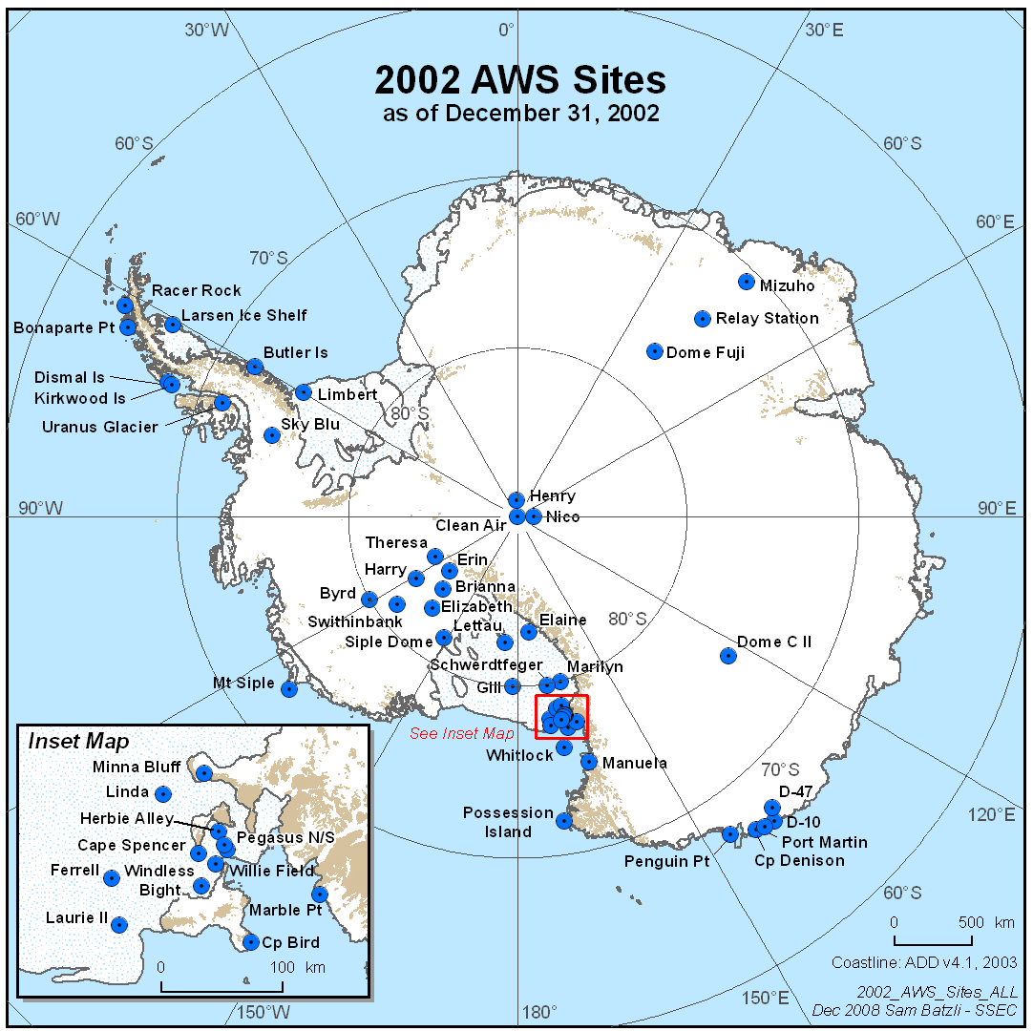

Antarctic Automatic Weather Station Data
for the calendar year 2002

by

Linda M. Keller
George A. Weidner
Charles R. Stearns
Jonathan E. Thom
Matthew A. Lazzara

Space Science and Engineering Center
University of Wisconsin
1225 W. Dayton St.
Madison, Wisconsin
December, 2008

Antarctic Automatic Weather Station Data

For The Calendar Year

2002

by

Linda M. Keller

George A. Weidner

Charles R. Stearns

Jonathan E. Thom

Matthew A. Lazzara

Space Science and Engineering Center

University of Wisconsin

1225 W. Dayton St.

Madison, Wisconsin

December, 2008

TABLE OF CONTENTS

Page

1. Introduction......................................................................................................................... 1

2. Data Transmission.............................................................................................................. 1

3. AWS Identification and Location......................................................................................... 1

4. AWS Data Summaries........................................................................................................ 10

4.1. Monthly Data Summaries.............................................................................................. 10
D-10.............................................................................................................................. 11
D-47.............................................................................................................................. 11
Dome C II..................................................................................................................... 11
Port Martin……………………………………………………………………………………. 12
Cape Denison………………………………………………………………………………… 12
Penguin Point............................................................................................................... 12
Byrd…………………………………………………………………………………………… 13
Mount Siple................................................................................................................... 13 Theresa........................................................................................................................ 13
Elizabeth....................................................................................................................... 13
Brianna………………………………………………………………………………………… 14
Harry…………………………………………………………………………………………… 14
Erin............................................................................................................................... 14
Siple Dome................................................................................................................... 15
Swithinbank................................................................................................................... 15
Marble Point.................................................................................................................. 15
Ferrell............................................................................................................................ 16
Pegasus North............................................................................................................... 16
Pegasus South.............................................................................................................. 16
Minna Bluff.................................................................................................................... 17
Linda............................................................................................................................. 17
Willie Field.................................................................................................................... 17
Windless Bight.............................................................................................................. 18
Herbie Alley…………………………………………………………………………………… 18
Cape Spencer………………………………………………………………………………… 18
Cape Bird....................................................................................................................... 19
Laurie II…….................................................................................................................. 19
Whitlock………………………………………………………………………………………. 19
Possession Island.......................................................................................................... 20
Manuela......................................................................................................................... 20
Marilyn........................................................................................................................... 20
Schwerdtfeger................................................................................................................ 21
Gill................................................................................................................................. 21
Lettau............................................................................................................................ 21
Elaine............................................................................................................................ 22
Larsen Ice Shelf............................................................................................................. 22
Butler Island................................................................................................................... 22
Uranus Glacier………………………………………………………………………………… 23
Limbert.......................................................................................................................... 23
Racer Rock.................................................................................................................... 23
Bonaparte Point............................................................................................................. 24
Sky-Blu............................................................................................................................ 24
Kirkwood Island............................................................................................................ 24
Dismal Island…………………………………………………………………………………. 25
Clean Air (South Pole)................................................................................................... 25
Henry............................................................................................................................. 25
Nico............................................................................................................................... 26
Relay Station................................................................................................................. 26
Dome Fuji……………………………………………………………………………………… 26
Mizuho…………………………………………………………………………………………. 27

4.2. Three Hourly Data Summaries....................................................................................... 28

5. AWS Calibration................................................................................................................. 28

5.1. Temperature................................................................................................................. 28
5.2. Pressure....................................................................................................................... 28
5.3. Wind Direction and Speed............................................................................................ 28
5.4. Relative Humidity......................................................................................................... 29
5.5. Vertical Air Temperature Difference.............................................................................. 29

6. AWS Operations Summary for 2001................................................................................... 29

6.1. AWS Performance........................................................................................................ 29
6.2. AWS Antarctic Field Activities....................................................................................... 31

7. Global Telecommunications System.................................................................................... 32

8. Data Availability................................................................................................................... 33

9. Acknowledgments................................................................................................................ 34

1. INTRODUCTION

Automatic weather station (AWS) units are deployed to collect Antarctic surface weather observations in support of specific meteorological research projects as well as operational activities in Antarctica. The 2002 network consisted of 52 installed AWS units providing observations on the Ross Ice Shelf, east of the Transantarctic Mountains and north of McMurdo to the Adelie Coast, along the Antarctic Peninsula, West Antarctica, East Antarctic, and climatological locations such as the South Pole. Each unit measures air temperature, wind speed, and wind direction at the top of the unit's tower at a nominal height of three meters and air pressure at the electronics enclosure (Figure 1). Some AWS units also measure the relative humidity at three meters and vertical air temperature difference between 0.5 and 3 meters. Measurement heights relative to the actual surface at the site are nominal due to snow accumulation around the AWS unit.

2. DATA TRANSMISSION

The transmitted AWS data are received and stored by the Data Collection System on the NOAA series of polar orbiting satellites. The data are retransmitted by the satellite for use in the High Resolution Picture Transmission (HRPT) broadcast at McMurdo, Antarctica. The data are processed into scientific units and are available for local use. The complete data set is received at the University of Wisconsin-Madison from CLS America (Service ARGOS), Largo, Maryland, for processing and distribution to the users.

3. AWS IDENTIFICATION AND LOCATION

Site location is defined by the latitude and longitude which is determined by various methods: sun shots, angles to geographical features, aircraft data, ice breaker data, the platform location system of CLS America (Service ARGOS), and the Global Positioning System. AWS elevation is obtained by barometry and Global Positioning System (GPS) and should be correct to within +/- 5 meters. Site names were introduced for convenience. Table 3.1 lists the site name, ARGOS identification number, latitude, longitude, elevation, start date for the site, and the World Meteorological Organization (WMO) number for the site. Figures 2, 3, 4, and 5 show the locations of the AWS units in the Antarctic for 2002.

The ARGOS identification number (ID) is used to identify the data sets distributed to the users. AWS units are sometimes moved from one location to another, and as a result, the ID at a given site may change from year to year. The site name does not change. Table 3.2 lists the site name with the ARGOS ID, the site start date, and the ID start and stop dates.

Figure 1. Layout of the AWS unit used in the Antarctic. The installed AWS unit has a 3-meter tower with a horizontal boom supporting the antenna, aerovane for measuring wind speed and direction, air temperature resistance thermometer, upper thermopile for measuring vertical air temperature difference, and the relative humidity sensor. The electronics enclosure is mounted at the midpoint of the tower. The gel cell batteries are placed at the tower base. The solar panel, located near the tower top, faces north. The Acoustic Depth Gauge (ADG) is installed on some of the AWS units to measure snow depth for precipitation studies.

Table 3.1
AWS site name, geographic location and elevation, site start date, and WMO number for 2002.
Site Name | ARGOS ID | Lat. (deg ) | Long. (deg) | Elev. (m) | Site Start Date | WMO No.
 |  |  | Adelie Land
D-10 | 8914 | 66.71ºS | 139.83ºE | 243 | 08 Jan 80 | 89832
D-47 | 8986 | 67.397ºS | 138.726ºE | 1560 | 24 Jan 83 | 89834
Dome C II | 8989 | 75.121ºS | 123.374ºE | 3250 | 12 Dec 95 | 89828
Port Martin | 8909 | 66.82ºS | 141.39ºE | 39 | 19 Jan 90
Cape Denison | 8988 | 67.009ºS | 142.664ºE | 31 | 20 Jan 90
Penguin Point | 8910 | 67.617ºS | 146.180ºE | 30 | 24 Dec 92 | 89847
 |  |  | West Antarctica
Byrd Station | 8903 | 80.007ºS | 119.404ºW | 1530 | 05 Feb 80 | 89324
Mount Siple | 8981 | 73.198ºS | 127.052ºW | 230 | 20 Feb 92 | 89327
Theresa | 21358 | 84.599ºS | 115.811ºW | 1463 | 29 Nov 94 | 89314
Elizabeth | 21361 | 82.607ºS | 137.078ºW | 519 | 30 Nov 94 | 89332
Brianna | #8931 | 83.889ºS | 134.154ºW | 525 | 30 Nov 94
Harry | 8900 | 83.003S | 121.393W | 945 | 29 Nov 94
Erin | 21363 | 84.904ºS | 128.828ºW | 990 | 29 Nov 94
Siple Dome | 8938 | 81.656ºS | 148.773ºW | 668 | 21 Jan 97 | 89345
Swithinbank | 21355 | 81.201ºS | 126.177ºW | 959 | 18 Jan 97
 |  |  | Ross Island Region
Marble Point | 8906 | 77.439ºS | 163.754ºE | 108 | 05 Feb 80 | 89866
Ferrell | 8929 | 77.910ºS | 170.817ºE | 45 | 10 Dec 80 | 89872
Pegasus North | 21357 | 77.952ºS | 166.500ºE | 8 | 23 Jan 90 | 89667
Pegasus South | 8937 | 77.99ºS | 166.576ºE | 10 | 14 Jan 91
Minna Bluff | 8935 | 78.554ºS | 166.691ºE | 895 | 22 Jan 91 | 89768
Linda | 8919 | 78.464ºS | 168.382ºE | 47 | 21 Jan 91 | 89769
Willie Field | 21364 | 77.865ºS | 167.017ºE | 40 | 25 Jan 92
Windless Bight | 8927 | 77.728ºS | 167.703ºE | 61 | 09 Dec 98
Herbie Alley | 8697 | 78.10ºS | 166.67ºE | 30 | 11 Jan 99
Cape Spencer | #8695 | 77.97ºS | 167.55ºE | 30 | 11 Jan 99
Cape Bird | 8901 | 77.224ºS | 166.440ºE | 42 | 28 Jan 99
Laurie II | 21360 | 77.549ºS | 170.817ºE | 30 | 01 Feb 00
 |  |  | Ocean Islands
Whitlock | 8907 | 76.144ºS | 168.392ºE | 274 | 01 Jan 82 | 89865
Possession Is. | 8984 | 71.891ºS | 171.210ºE | 30 | 29 Dec 92 | 89879
Manuela | 8905 | 74.946ºS | 163.687ºE | 78 | 06 Feb 84 | 89864
 |  |  | Ross Ice Shelf
Marilyn | 8934 | 79.954ºS | 165.130ºE | 75 | 16 Jan 84 | 89869
Schwerdtfeger | 8913 | 79.904ºS | 169.973ºE | 60 | 24 Jan 85 | 89868
Gill | 8911 | 79.985ºS | 178.611ºW | 55 | 24 Jan 85 | 89376
Lettau | 8908 | 82.518ºS | 174.452ºW | 55 | 29 Jan 86 | 89377
Elaine | 8915 | 83.134ºS | 174.169ºE | 60 | 28 Jan 86 | 89873

Site Name | ARGOS ID | Lat. (deg) | Long. (deg) | Elev. (m) | Site Start Date | WMO No.
 |  |  | Antarctic Peninsula
Larsen Ice | 8926 | 66.949ºS | 60.897ºW | 17 | 07 Feb 83 | 89262
Butler Island | 8902 | 72.207ºS | 60.160ºW | 91 | 01 Mar 86 | 89266
Uranus Glacier | 8920 | 71.43ºS | 68.93ºW | 780 | 06 Mar 86 | 89264
Limbert | 8925 | 75.422ºS | 59.851ºW | 40 | 30 Nov 95 | 89257
Racer Rock | 8947 | 64.067ºS | 61.613ºW | 17 | 15 Oct 89 | 89261
Bonaparte Pt. | 8923 | 64.778ºS | 64.067ºW | 8 | 05 Jan 92 | 89269
Sky-Blu | 8917 | 74.792ºS | 71.488ºW | 1556 | 07 Feb 99 | 89272
Kirkwood Island | 8930 | 68.340ºS | 69.007ºW | 30 | 26 May 01
Dismal Island | 8932 | 68.087ºS | 68.825ºW | 10 | 27 May 01
 |  |  | High Polar Plateau
Clean Air | 8987 | 90.00ºS |  | 2835 | 29 Jan 86 | 89208
Henry | 8985 | 89.011ºS | 1.025ºW | 2755 | 26 Jan 93 | 89108
Nico | 8924 | 89.000ºS | 89.669ºE | 2935 | 26 Jan 93 | 89799
Relay Station | 8918 | 74.017ºS | 43.062ºE | 3353 | 01 Feb 95 | 89744
Dome Fuji | 8904 | 77.31ºS | 39.70ºE | 3810 | 04 Feb 97 | 89734
Mizuho | 21359 | 70.70ºS | 44.29ºE | 2260 | 07 Oct 00

* New sites started during 2002
# New ARGOS ID for 2002 at the site

Figure 2. Antarctic automatic weather station locations during 2002 identified by the site name. Area around Ross Island is shown in Figure 3. Adelie Coast area is shown in Figure 4. Antarctic Peninsula is shown in Figure 5.
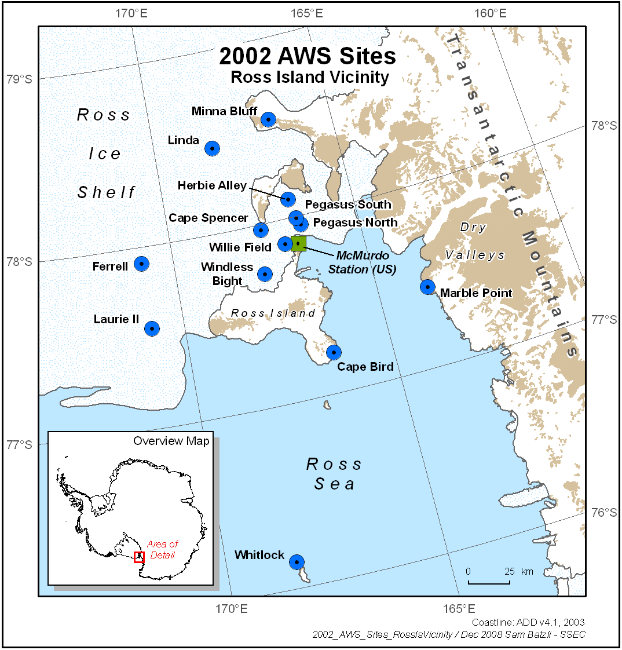

Figure 3. Location of Antarctic automatic weather stations in the vicinity of Ross Island, Antarctica during 2002.

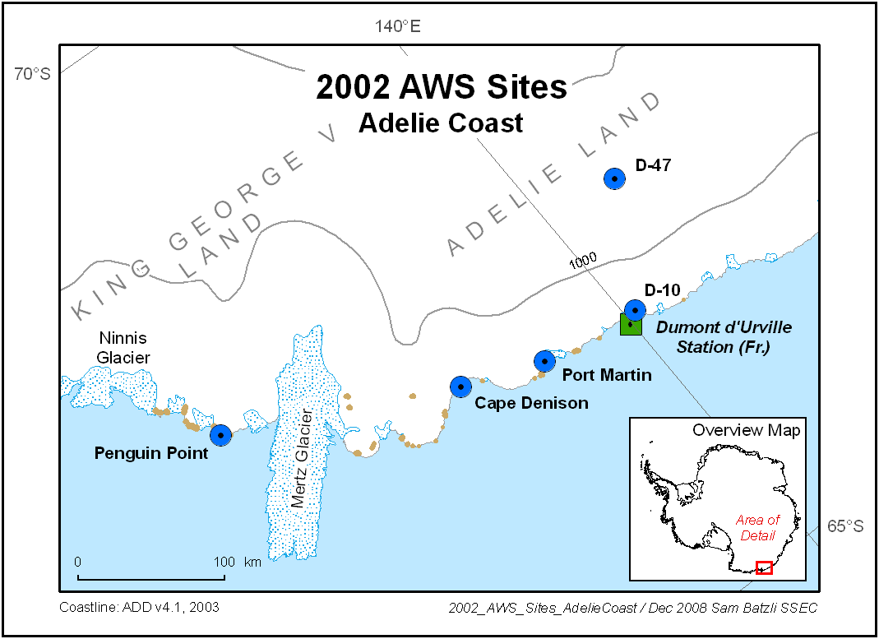

Figure 4. Location of Antarctic automatic weather stations along the Adelie Coast during 2002.

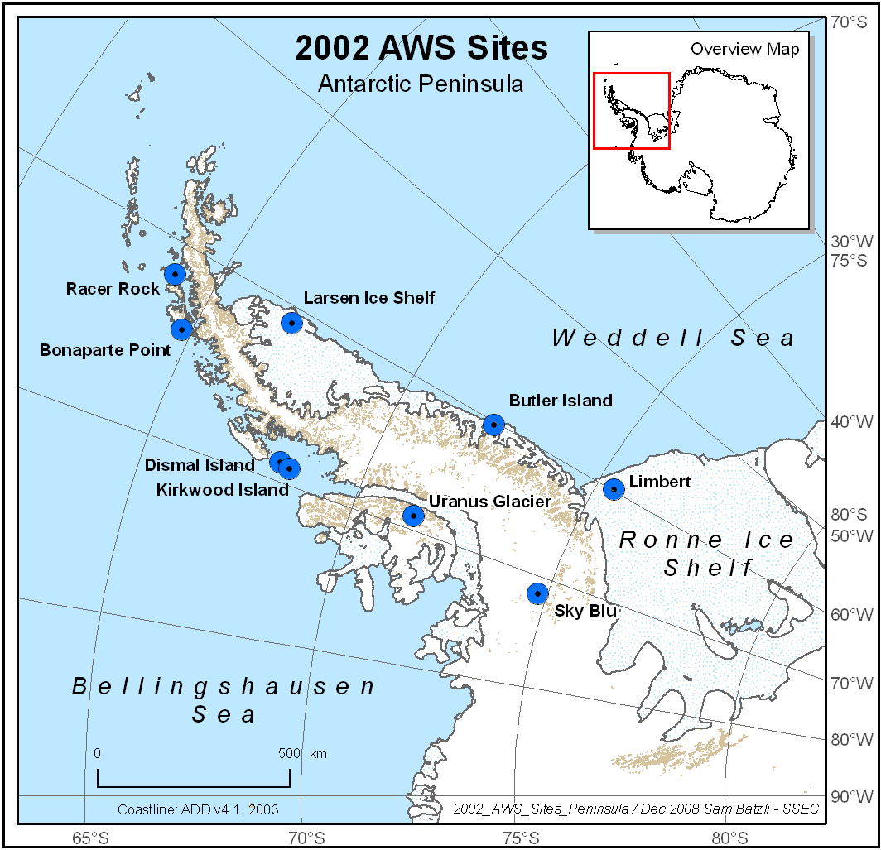

Figure 5. Location of Antarctic automatic weather stations along the Antarctic Peninsula during 2002.

Table 3.2
2002 Antarctic AWS site name, ARGOS identification number (ID), site start date, ID start date, and ID stop date if occurring in 2002.

Site | ARGOS ID | Site Start Date | ID Start Date | ID Stop Date
D-10 | 8914 | 08 Jan 80 | 28 Jan 98
D-47 | 8986 | 24 Nov 83 | 11 Feb 96
Dome C II | 8989 | 12 Dec 95 | 12 Dec 95
Port Martin | 8909 | 19 Jan 90 | 18 Dec 99
Cape Denison | 8988 | 20 Jan 90 | 17 Dec 99
Penguin Point | 8910 | 24 Dec 92 | 21 Dec 98
Byrd Station | 8903 | 05 Feb 80 | 05 Feb 80
Mount Siple | 8981 | 20 Feb 92 | 20 Feb 92
Theresa | 21358 | 29 Nov 94 | 29 Nov 94
Doug | 8922 | 29 Nov 94 | 20 Jan 97
Brianna | 21362 | 30 Nov 94 | 30 Nov 94 | 15 Jan 02
 | 8931 |  | 15 Jan 02
Harry | 8900 | 29 Nov 94 | 26 Jan 99
Elizabeth | 21361 | 30 Nov 94 | 17 Jan 96
Erin | 21363 | 29 Nov 94 | 18 Jan 96
Siple Dome | 8938 | 21 Jan 97 | 24 Jan 99
Swithinbank | 21356 | 18 Jan 97 | 18 Jan 97 | 13 Jan 02
 | 21355 |  | 13 Jan 02
Marble Point | 8906 | 05 Feb 80 | 05 Feb 80
Ferrell | 8929 | 10 Dec 80 | 09 Jan 01
Pegasus North | 21357 | 23 Jan 90 | 03 Feb 00
Pegasus South | 8937 | 14 Jan 91 | 14 Jan 91
Minna Bluff | 8935 | 22 Jan 91 | 25 Jan 99
Linda | 8919 | 21 Jan 91 | 15 Jan 98
Willie Field | 21364 | 25 Jan 92 | 29 Jan 01
Windless Bight | 8927 | 09 Dec 98 | 25 Jan 99
Herbie Alley | 8697 | 11 Jan 99 | 11 Jan 99
Cape Spencer | 8722 | 11 Jan 99 | 11 Jan 99 | 29 Jan 02
 | 8695 |  | 29 Jan 02
Cape Bird | 8901 | 28 Jan 99 | 28 Jan 99
Laurie II | 21360 | 01 Feb 00 | 16 Jan 01
Whitlock | 8907 | 01 Jan 82 | 07 Feb 01
Possession Island | 8984 | 29 Dec 92 | 29 Dec 92
Marilyn | 8934 | 16 Jan 84 | 30 Jan 01
Schwerdtfeger | 8913 | 24 Jan 85 | 22 Jan 93
Gill | 8911 | 24 Jan 85 | 25 Jan 91
Elaine | 8915 | 28 Jan 86 | 02 Jan 97
Lettau | 8908 | 29 Jan 86 | 29 Jan 86
Manuela | 8905 | 06 Feb 84 | 15 Feb 87
Larsen Ice Shelf | 8926 | 07 Feb 83 | 01 Jan 86
Butler Island | 8902 | 01 Mar 86 | 01 Mar 86
Uranus Glacier | 8920 | 06 Mar 86 | 06 Mar 86
Limbert | 8925 | 30 Nov 95 | 30 Nov 95
Racer Rock | 8947 | 15 Oct 89 | 08 Dec 91
Bonaparte Point | 8923 | 05 Jan 92 | 23 Dec 96
Sky-Blu | 8917 | 07 Feb 99 | 07 Feb 99
Kirkwood Is. | 8930 | 26 may 01 | 26 May 01
Dismal Is. | 8932 | 27 May 01 | 27 May 01
Clean Air | 8987 | 29 Jan 86 | 25 Jan 94
Henry | 8985 | 26 Jan 93 | 26 Jan 93
Nico | 8924 | 26 Jan 93 | 26 Jan 93
Relay Station | 8918 | 01 Feb 95 | 01 Feb 95
Dome Fuji | 8904 | 08 Feb 95 | 04 Feb 97
Mizuho | 21359 | 07 Oct 00 | 07 Oct 00

4. AWS DATA SUMMARIES

The data received by the University of Wisconsin, Space Science and Engineering Center, contain all the information received by the ARGOS system including duplicate and erroneous transmissions. Invalid data are eliminated during a quality check, and the valid data are converted to scientific units producing the complete data set. Data selected at three hourly intervals, plus or minus forty minutes, produce a three hourly data set for each AWS unit month. Section 6.1, AWS Performance, provides some explanations for missing and invalid data.

Use of the 2002 Antarctic AWS data for publication should acknowledge the support of NSF-OPP Grant 9726040 or reference this publication.

4.1. Monthly Data Summaries

The monthly summaries consist of the monthly means, from the three hourly data set, and the extremes, from the complete data set. For monthly values to be included, 25% of the three hourly observations must be available. Months with 50-75% of data missing occur most often when a station is started or stopped in the middle of the month. This can cause a bias in the monthly mean, especially during seasons when parameters such as temperature change rapidly. Annual means are calculated only when twelve months of data are available. The data are presented in the same order as the sites listed in Table 3.1. Definitions of the monthly data summary headings are listed below.

Heading Definition

Mean air temperature, ºC. Mean value for the month.

Percent of monthly data missing. Ratio of the number of missing observations to the number of
possible observations X 100.

Maximum air temperature, ºC. Maximum value for the month.
Minimum air temperature, ºC. Minimum value for the month.

Mean wind speed, m/s. Mean value for the month.

Percent of monthly data missing. Ratio of the number of missing observations to the number of
possible observations X 100.

Resultant wind speed, dir/vv. Resultant speed and direction for the month.
Constancy. Ratio of the monthly resultant to the monthly mean wind speed.

Maximum wind speed, dir/vv. Maximum wind speed and direction for the month.

Mean air pressure, mb. Mean value for the month.

Percent of monthly data missing Ratio of the number of missing observations to the number of
possible observations X 100.

Maximum air pressure, mb. Maximum value for the month.
Minimum air pressure, mb. Minimum value for the month.

Potential temperature, K Mean value for the month.

4.2. Three Hourly Data Summaries
After the data are received from Service ARGOS, ten minute interval data are created for each AWS unit. The data are calibrated for the individual station instruments, but no other corrections are made. This data set is created for those users who need fairly current information. These data are available by anonymous FTP (see Section 8).

The 10 minute data set for each AWS unit for the month is scanned to pick out the nearest observation within forty minutes of the UTC hours 00, 03, 06, 09, 12, 15, 18, and 21 to produce the three hourly data set. If valid data are not available within forty minutes of the three hourly time interval, then the entry is left blank to indicate missing data. The means, standard deviations, resultant wind speed and direction, the distribution of temperature, and wind speed with wind direction are determined from the three hourly observations and are presented as a monthly summary at the bottom of each page. A wind direction value of zero indicates a wind speed less than 0.50 m s⁻¹. North is indicated by a value of 360 degrees. The maximum and minimum values are taken from the complete 10 minute data set, not the three hourly data set. The appropriate monthly data from the three hourly data set are used for the monthly summaries presented in Section 4.1. In the presence of sunlight the air temperatures are questionable if the wind speed is less than 1 m s⁻¹. These summaries are available by anonymous FTP (see Section 8). If you are unable to access the Internet, we will send the information either on diskettes or paper. Please contact us for further information (the address is at end of Section 8).

5. AWS CALIBRATION

5.1. Temperature

The external and internal temperatures are calibrated using a 1000 ohm 0.05% resistor in place of the platinum resistance thermometers with 1000 ohms resistance at 0ºC. Because the other resistances in the temperature circuit are known only to 1%, the temperature calibration will vary from one electronic unit to another. The correction factor determined from the calibration resistor is programmed into the read-only-memories for each unit. After the correction factors have been programmed into the AWS, a calibration box with 0.1% resistors is used to check the temperature calibration.

5.2. Pressure

The atmospheric pressure transducer is a Parascientific model 215A Digiquartz® pressure gauge. The transducer frequency changes from a nominal 40 kHz at zero pressure to a nominal 36 kHz at 1000 hPa. The pressure resolution is about 0.05 hPa.
Paulin aneroid barometers calibrated against a mercury barometer of 10 mm bore are used to check the pressure gauge calibration. Comparisons are made between AWS units, a Parascientific Model 760-16B accurate to +/- 0.1 hPa, and with the mercury barometers at Scott Base, Antarctica. The calibrations should be within +/- 0.2 hPa.
The reference vacuum on the older pressure transducers can degrade with time with a maximum observed 4 hPa shift to lower pressure after fifteen years. Recalibration of each pressure transducer would be desirable when each unit is serviced.

5.3. Wind direction and Speed

The Belfort model 123 aerovane measures wind direction and speed. The aerovane rotates a potentiometer wiper, and the fraction of full scale of the potentiometer is measured. The wind direction is checked by positioning the aerovane to the cardinal directions relative to the boom supporting the aerovane. North or the potentiometer zero is towards the antenna on the boom and has a maximum dead zone of 3º. During the field installation, the boom is usually aligned along the north-south line as determined from the sun's azimuth, longitude, and Greenwich Mean Time. In some cases the 180º end of the boom may point in a direction other than south. At Manuela site, the 180º end of the boom points up the glacier and a correction is added to the data during processing. At Byrd site the wind is usually out of the north so the boom was rotated 120º and the correction added during the data processing. The wind speed is determined from the aerovane tachometer voltage output as 0.0472 volt per meter per second. The aerovane tachometers are spun at 1800 rpm with a load of 1071.5 ohms, and the output should be 9.20 +/-0.05 vdc.
Additional wind sensors were used with AWS units for 2000. These were the R.M. Young wind monitor model 05103 and the Hydro-Tech WS-3 anemometer with the WP-3 aerovane. The Hydro-Tech system was used for measuring wind speed in the Adelie Coast area. The Hydro-Tech WS-3 is a disk rotor, 3 in. high and 12 in. overall diameter, with radial cups, and the threshold sensitivity is 3 mph. The anemometer utilizes a commercial dc tachometer generator. Output is 0 to +5 vdc (and 0 to 1 ma) over the desired full scale wind speed of 85 m/s. Accuracy is +/- 2%.
The R.M. Young monitor 05103 also used a 10,000 ohm potentiometer with a 3º dead zone so that the wind direction was recorded identically with the Belfort/Bendix aerovanes. The wind speed was from the range of 0 to 1.0 volt full scale corresponding to 50 m/s. Thus the calibration for wind speed was a nominal .195 m/s/bit for the R.M. Young with +/- 1% up to 50 m/s.

5.4. Relative Humidity

The Vaisala HMP-35A/45A humidity sensor output voltage varies linearly with relative humidity (U). The sensor is calibrated by placing it over saturated salt solutions with known relative humidities at room temperature: sodium chloride (U=75%), and lithium chloride (U=12%) are used. In addition, a dry inert gas, forced past the sensor, gives a 0% U, and the sensor output can be zeroed. Then, the gain setting can be set directly using a salt solution with a high relative humidity, such as sodium chloride. The resolution of the humidity sensor is about 1% and the drift is 2 to 3% per year in the field. The relative humidity data are not included on the summary pages but are included in the 3 hourly data sets.

5.5. Vertical Air Temperature Difference

Two junction thermocouples are used to measure the air temperature difference between 3 m and 0.5 m on the tower. The output is about 78 microvolts for 1ºC temperature difference between the junctions at 0.0ºC, dropping to 60 microvolts at -80ºC. Zero output is adjusted to 0.4 volts, so that 0 to 1 volt corresponds to a -6ºC to +9ºC range of air temperature differences between 3 m and 0.5 m. The resolution is 0.05ºC. Calibration of the individual systems is done by applying known voltages to the amplifier input. The vertical temperature difference data are not included on the summary pages but are included in the 3 hourly data sets.

6. AWS OPERATIONS SUMMARY FOR 2002

6.1. AWS Performance

Forty-seven AWS units were installed at the start of 2002 and 51 were installed by the end of 2002. Based on the installation months the AWS units delivered 85% of the temperature data, 82% of the pressure data and 72% of the wind data during 2002. Complete data sets were received from 12 AWS units and 38 AWS units operated for the installed period. Eleven AWS units were not received for one month or more during the year or stopped during the year. Some of the stations were not received during the winter months due to low battery voltage.

The wind system has the poorest performance. If the wind speed is zero or the wind direction is constant for extended periods (days to months) then the data is considered invalid. The reason for this behavior is not known but is believed to be due to the build up of frost on the wind system. This usually occurs in the winter season and at several AWS sites. The wind speed is most frequently zero when the wind direction is constant.

Site Performance
D-10 The station transmitted erratically from July through the beginning of October. The relative humidity sensor and delta-T sensor were not functioning.
D-47 Temperature sensor not functioning. Station stopped transmitting 4 January and began again 27 February. Station transmitted erratically from April through early August with another break the first half of September. No relative humidity or delta-T sensors.
Dome C II OK.
Port Martin The aerovane was not functioning. No delta-T or extra high wind speed sensor. Pressure corrected for high wind speed conditions.
Cape Denison Station stopped transmitting 29 April and resumed 27 May. Several transmission gaps of a week or more in April, May, and September. Pressure corrected for high wind speed conditions.
Penguin Point The station stopped transmitting from 15 May to 21 June. Pressure corrected for high wind speed conditions.
Byrd Station transmitted from 3 to 8 October only.
Mount Siple Site has a "dog house" AWS without wind speed and direction. Pressure sensor not functioning correctly January and February.
Theresa Delta-T sensor buried.
Doug Aerovane not functioning in July. Relative humidity sensor not functioning. Station transmitted erratically in September and stopped transmitting on 8 October.
Elizabeth Aerovane "frozen" the last part of September.
Brianna The relative humidity sensor functioned erratically after June. The station stopped transmitting 3 November.
Harry The delta-T sensor is not functioning. The aerovane was "frozen" occasionally from June through November.
Erin The aerovane was "frozen" occasionally from May through July.
Siple Dome Aerovane “frozen” occasionally from April through November. Delta-T sensor not installed.
Swithinbank Station stopped transmitting 8 October. Delta-T sensor not functioning.
Marble Point OK.
Ferrell New station installed 10 January.
Pegasus North Station stopped transmitting on 25 January. Delta-T not functioning. Station resumed transmitting 4 November.
Pegasus South Station stopped transmitting on 6 May and resumed on 24 June. Relative humidity sensor not functioning. Aerovane “frozen” from June through October. Delta-T erratic all year.
Minna Bluff Station started transmitting 10 July. Delta-T sensor not functioning. Aerovane occasionally “frozen” July through November. Station stopped transmitting 13 December.
Linda Aerovane occasionally "frozen" April through October.
Willie Field Station replaced 29 January.
Windless Bight Station stopped transmitting 12 December due to low battery voltage.
Herbie Alley Pressure functioned erratically August, October, and November.
Cape Spencer Station stopped transmitting 25 December.
Cape Bird OK.
Laurie II Station replaced 17 January. Delta-T sensor not functioning. Aerovane occasionally "frozen" in September.
Whitlock Station replaced 7 February. Delta-T sensor not functioning. Aerovane “frozen” most of April and May and parts of June and July.
Possession Island Site has a "dog house" AWS without wind speed and direction.
Manuela Aerovane broken.
Marilyn Station replaced 30 January. Aerovane occasionally "frozen" May through November.
Schwerdtfeger Relative humidity sensor not functioning from mid February through November Aerovane “frozen” occasionally in July.
Gill Relative humidity sensor not functioning. Aerovane “frozen” occasionally in October.
Lettau Transmitting with many gaps in January, November, and December. Aerovane “frozen” occasionally from March through December.
Elaine OK.
Larsen Ice Shelf Aerovane “frozen” occasionally in July.
Butler Island Aerovane not functioning beginning of January and “frozen” occasionally from May through November. Pressure continues to need correction due to the failure of the precision time-based correction to the system clock.
Uranus Glacier Large gaps in transmission in March, November, and some of December.
Limbert Delta-T sensor not functioning. Aerovane not functioning. Station stopped transmitting in July and resumed in September due to low battery voltage.
Racer Rock Station transmitted erratically from the end of May to October due to low battery voltage. Station stopped transmitting 30 November.
Bonaparte Point Relative humidity and delta-T sensor not functioning. Aerovane not functioning January through May, July, and October through December. Pressure is too low and has been removed.
Sky Blu Aerovane “frozen” occasionally in September.
Kirkwood Island New station installed 21 May. Aerovane not functioning properly in May.
Dismal Island New station installed 22 May. Aerovane not functioning properly in May.
Clean Air Occasional problems with relative humidity sensor. Pressure functioning erratically February through November.
Henry Aerovane occasionally "frozen" June through September. Station stopped transmitting 20 September and resumed transmitting 30 October as the battery recharged in the austral spring.
Nico Aerovane occasionally "frozen" in August and September.
Relay Station OK.
Dome Fuji Repaired station installed on 22 December.
Mizuho No relative humidity or delta-T sensors. Occasional gaps in transmission during winter months.

6.2. AWS Antarctic Field Activities

McMurdo area

On 1 February, Ferrell site was visited by Jason Vandervest. A completely new station was installed (AWS 21355) with help from the Twin Otter crew. Later on 1 February, a new station site was establish near Cape Crozier (AWS 21364). This site will be called Laurie II.

On 3 February, Pegasus North and Pegasus South (AWS 8937) sites were visited by Dr. John Cassano and Jason Vandervest. AWS 8928 at Pegasus North was removed and a new station (AWS 21357) was installed. At Pegasus South the aerovane was replaced.

West Antarctica

Dr. John Cassano, Dr. Chris Shuman, and Jason Vandervest flew to Siple Dome on 15 January to conduct AWS field work in West Antarctica. GPS coordinates were recorded for Siple Dome (8938) site, and it was noted that the boom was not aligned with north. On 18 January, the team went to Brianna (21361) site. Two battery boxed and 1 battery cable were replaced, and GPS coordinates were recorded. The team moved on to Elizabeth (21361) site where two new battery boxes and cables were installed, and GPS coordinates were recorded. On 19 January, the team went to JC (21357) site. The site was anchored loosely, and the antenna was broken. They were unable to replace the antenna, so the entire site was removed. On to Erin (21363) site, the team recorded GPS coordinates. They installed 2 new battery boxes and cables, raised the lower delta T boom because the probe was covered with snow, and replaced the Bendix/Belfort aerovane. Finally, the team installed a new AWS (8936) at Noel/ITASE site. GPS coordinates were recorded.

Polar Plateau

Dr. John Cassano reinstalled the Clean Air AWS (8987) at the new site at South Pole station on 26 January.

Mizuho AWS unit (21359) was installed at Mizuho Station on 7 October by members of JARE.

Adelie Coast

Rob Flint met the USGS Polar Sea in Hobart for the trip along the Adelie Coast. On 18 December Rob Flint and Blake Moore went to Port Martin (8909). The solar panel had been smashed by an impact. Some of the connectors and the junction box were so corroded by salt that it was impossible to do any work. A return visit with better tools and equipment was made on 20 December. New batteries, solar panel and junction box were installed. Also on 18 December, Gerd Wendler and Drew Egressey went to Sutton (8939). The station was removed and returned to the ship.

On 19 December, Rob Flint and Rachel Smith went to Penguin Point. They replaced the batteries and tightened the guys. A visual inspection showed the station to be in good condition with no evidence of salt corrosion. On 20 December, Rob Flint and LCDR Jackson went to Cape Denison. The batteries were replaced, and no evidence of salt deposition was found on the station. Installation of Cape Webb was scrapped due to transportation problems.

Antarctic Peninsula

The British Antarctic Survey serviced several of the units on the Antarctic Peninsula. Limbert (8925) site had stopped transmitting. The batteries were charged, so the unit was moved to Rothera on 14 January for further testing. A fault was found on the CPU board, and the unit was replaced on 10 February. A new tower section was added, and the boom was replaced. Uranus Glacier (8920) was visited on 7 January. The tower was raised, three new guys and deadmen were placed, and two new batteries and the junction box were replaced. The unit was removed to Rothera on 19 January because the transmissions were garbled. The 50 MHz oscillator was retuned, and the unit replaced on 24 January.

AWS unit 8917 (Sky-Blu) was revisited on 8 and 9 February. The tower was raised by two sections. Larsen Ice (8926) site was also visited on 9 February. Two new batteries were added and the guys were tightened. On 11 February, Butler Island (8902) site was visited. The tower was raised and new battery boxes added. The wind propeller was loose, and there is evidence of salt corrosion at the site.

7. GLOBAL TELECOMMUNICATIONS SYSTEM

The data from 31 Antarctic AWS units were entered into the Global Telecommunications System (GTS) during 2000. The data are collected by Service ARGOS. As soon as the data are received, Service ARGOS processes them and sends them on to the National Weather Service which distributes the data to the GTS.The data headers are:

SMAA14 KARS YYGGgg
SIAA14 KARS YYGGgg
SNAA14 KARS YYGGgg

where S indicates surface, M is main observations (at 00, 06, 12, and 18 UT), I is intermediate observations (at 03, 09, 15, and 21 UT), and N is any other time. AA14 is for Antarctica, and KARS stands for the Largo receiving center (backup is LFPW for the center in Toulouse, France). YY indicates the day in the month, GG is the hour, and gg is the minutes. Table 3.1 contains the WMO identification number used by the GTS grouped according to their purpose and proximity where possible.

The University of Wisconsin-Madison is responsible for obtaining WMO numbers for AWS sites and for providing Service ARGOS with calibration information for processing the data. The main reason for getting the AWS data into the GTS is to make sure that the data are available in near real time for all organizations operating in Antarctica.

8. DATA AVAILABILITY

The data from our Automatic Weather Stations are available by anonymous FTP. The IP address and domain name are 128.104.109.33 (ice.ssec.wisc.edu). The login is "anonymous" (do not use the quotation marks), and the password is your email address. Once you have logged in, change to the pub/aws subdirectory. A listing of our station locations, names, and ARGOS ID numbers is located in the file "biglist" in this subdirectory. It is meant to serve as a guide to our stations as their ID numbers sometimes change. A complete guide for navigating the site may be found in the file “readme.faq”.

Our three-hourly interval data for Antarctica in ASCII text format are contained in the year subdirectories of pub/aws/antrdr. The data have been corrected, i.e. an effort has been made to remove the bad data points. These data take longer to process, so the data for recent months are not available in this format. Within each of the year subdirectories of pub/aws/antrdr, there are text files named "3hrlist??" (where ?? indicates the last two digits of the year). These files list what station's data are contained in which files. The files “readme.updates?” in pub/aws/antrdr contain information on updates and/or corrections to the data, and the file “readme.3format” contains file name construction information and format of the three-hourly data. The file “readme.mailinglist” contains information on joining a mailing list which distributes information on data updates and changes. To subscribe, send email to aws@ssec.wisc.edu requesting to be added to our mailing list.

The directory pub/aws/summary/monthly contains ASCII printable text files of the paper data summary sheets. The format of the files can be found in the file "readme.sum" while updates and corrections to the data are located in "readme.sumupdates". The data are located in year subdirectories of pub/summary/monthly.

For those users who need more current information, we have created 10 minute interval data in ASCII text format for each station. These data are located in year subdirectories of pub/aws/10min/rdr. The data have been calibrated for the individual station instruments, but no other corrections have been made. The data are generally available up to and including the last full month of this year. The year subdirectories also contain a text file named "namelist??" (where ?? indicates the last two digits of the year in question). These files list what station's data are contained in which files.

Several important readme files are located in pub/aws/10min/rdr. The file "readme.format" contains information on filename construction of the data, as well as well as file content and is a must for those unfamiliar with the data. The files "readme.updates?" contain important information on changes/additions to the data.

Our site is available 24 hours a day, 7 days a week. If you have questions or problems, send email to aws@ssec.wisc.edu. We can also be reached by phone at (608) 265-2209 or (608) 262-0436 or fax at (608) 262-5947.

By mail, please contact:

Linda M. Keller
University of Wisconsin
Department of Atmospheric and Oceanic Sciences
1225 W. Dayton St.
Madison, WI 53706
USA

9. ACKNOWLEDGMENTS

This work is supported by the National Science Foundation, Office of Polar Programs, Grant 9726040 under the management of Dr. Bernhard Lettau. Assistance from the following countries is gratefully acknowledged. Expeditions Polaires Francaises installs and maintains the AWS units from the Adelie Coast to Dome C II. The British Antarctic Survey maintains the AWS units on the east side of the Antarctic Peninsula and south of Adelaide Island. The Japanese Antarctic Research Expedition (JARE) installs and maintains the AWS units at Relay Station, Mizuho, and Dome Fuji.
Mary R. Albert Prof. Richard Alley Dr. I. Allison
U.S.A. CRREL The Pennsylvania State University Antarctic CRC
72 Lyme Road Earth Systems Science Center University of Tasmania
Hanover, NH 03755-1290 517 Deike Building Hobart, Tasmania 7001
University Park, PA 16802 AUSTRALIA
Dr. Sridhar Anandakrishnan Dr. Jean-Claude Andre Stefania Argentini
The Pennsylvania State University Centre National de Recherches Consiglio Nazionale Delle Ricerche
Earth Systems Science Center Meteorologiques IFA/CNR Via G. Galilei, c.p. 27
540 Deike Building 42 Avenue G. Coriolis 00044 Frascati (Roma)
University Park, PA 16802 F-31057 Toulouse Cedex ITALY
FRANCE
Dr. Gail Ashley Liana Bacigalupi Dr. Karen S. Baker
Rutgers University Library Scripps Institute of Oceanography
Dept. of Geological Sciences ENEA Progetto Antartide UCSD - A - 018
Piscataway, NJ 08854 Via Anguillarese, 301 La Jolla, CA 92093
00060 S. Maria di Galeria (Roma)
ITALY
Prof. Roger Bales Dr. L.A. Barrie Ian J. Barton
University of Arizona Atmospheric Environment Service CSIRO Marine Laboratories
Dept. of Hydrology & Water Resources 4905 Dufferin Street GPO Box 1538
Tuscon, AZ 85721 North York, Ontario Hobart, Tasmania 7001
M3H 5T4 AUSTRALIA
CANADA
Rabindra Basnyat Rob Bauer Ms. Judy Bausch
General Post Office NSIDC/CIRES Yerkes Observatory
P.O. Box #6644 University of Colorado P.O. Box 258
Kathmandu Boulder, CO 80309-0449 Williams Bay, WI 53191
NEPAL
Dr. John Bengston Prof. Charles R. Bentley Dr. Robert Bindshadler
NOAA/NMFS University of Wisconsin NASA
National Marine Mammal Lab. Geophys. & Polar Research Cen. Goddard Space Flight Center
7600 Sand Pt. Way N.E. 1215 W. Dayton St. Code 971
Seattle, WA 98115-0070 Madison, WI 53706 Greenbelt, MD 20771
Prof. Krzystztof Birkenmajer, Chrm. Dr. George Blaisdell Mr. Greg Bodeker
Com. On Polar Res., Polish Academy of National Science Foundation University of Natal
Sciences Office of Polar Programs Space Physics Research Instit.
Dept. of Dynamic Geology Room 755 King George V. Ave.
Instit. of Geological Sciences 4201 Wilson Blvd. Durban 4001
ul. Senacka 1-3 Arlington, VA 22230 SOUTH AFRICA
31-002 Krakow
POLAND
Dr. John Bolzan Dr. Scott Borg Irina I. Borzenkova
Ohio State University National Science Foundation State Hydrological Institute
Byrd Polar Research Center Office of Polar Programs 23 Second Line
1090 Carmack Road Room 755 199053, St. Petersburg
Columbus, OH 43210-1002 4201 Wilson Blvd. RUSSIA
Arlington, VA 22230
John W. Briggs, Engineer Dr. David Bromwich Neva Brown
Yerkes Observatory Ohio State University 30 Lantern Lane
373 West Geneva Street Byrd Polar Research Center Wrentham, MA 02093
Williams Bay, WI 53191-0258 1090 Carmack Road
Columbus, OH 43210-1002
Giancarlo Caimi Michael Carmody Prof. Azzio Caneva
Via S. Benelli 8 Raytheon Polar Services Universita di Genova
20151 7400 South Tuscon Way Stazione Geofisica
Milano Centennial, CO 80112-3938 12080 Roburent
ITALY Cuneo
ITALY
Captain, R/V Lawrence G. Gould Captain, R/V Nathaniel B. Palmer Dr. A.M. Carleton
c/o AGUNSA c/o AGUNSA Dept. of Geography
Deposito Franco Antarctico Deposito Franco Antarctico The Pennsylvania State University
Av. Independencia 772 Av. Independencia 772 0314 Walker Building
P.O. Box 60-D P.O. Box 60-D University Park, PA 16802
Punta Arenas Punta Arenas
CHILE CHILE
Prof. John Carroll I.F.S. Cavalacanti Art Cayette
University of California Depto Meteorologia, INPE SPAWAR System Center
Dept. LAWR Caixu Postal 515 P.O. Box 190022
Davis, CA 95616 12 200 Sao Jose dos Campos North Charleston, NC 29419-9022
Sao Paulo
BRAZIL
Roberto Cervellati Prof. Chen Liqi, Director Dr. TaeJin Choi
ENEA Pas Progetto Antarctide Chinese Antarctic Administration Korea Polar Research Institute, KORDI
S.S. Anguillarese 301 No. 1 Fuxingmenwai Street Songdo Techno Park, 7-50,
Roma Beijing Songdo-dong, Yeonsu-gu,
ITALY CHINA Incheon 406-840
KOREA
Pecheng Chu Dr. Josefino C. Comiso The Committee on Antarctic Research
Naval Postgrad. School, Code OC/CU NASA/Goddard Space Flight Center ul. Vavilova, 44
Dept. of Oceanography Code 971 Building 2
Monterey, CA 93943 Greenbelt, MD 20771 Moscow 117333
RUSSIA
Frederick E. Crory Dick Crouthamel CRREL-TL
US Army CRREL National Weather Service Dept. of the Army Corps of Engineers
72 Lyme Road Mail Code W/OM31 Hanover, NH 03755-1290
Hanover, NH 03755-1290 1325 E-W Highway
Silver Spring, MD 20910
W. Darnell Dr. Thomas DeFelice Rear Ar. Fernando M. Diegues, Sec.
NASA, Langley Research Center University of Wisconsin Comm. Interministerial para os Recursos do
Mail Stop 185 Dept. of Geoscience, Lapham Hall Mar (CIRM)
Hampton, VA 23665-5225 P.O. Box 413 Ministerio da Marinha
Milwaukee, WI 53201 40 ANDAR
70055 DF-Brasilia
BRAZIL
Debra Diemand Director Dr. David J. Drewry
CRREL-TL Cold And Arid Regions Vice-Chancellor
Dept. of the Army Corps of Engineers Environ. and Engineering Res. Institute University of Hull
Hanover, NH 03755-1290 Academia Sinica Cottingham Road
Lanzhou 730000 Hull, Yorksire HU6 7RX
CHINA UNITED KINGDOM
Mr. Michel Engler, Director Dr. Hiroyuki Enomoto Dr. Karl Erb
Expeditions Polaires Francaises Kitami Institute of Technology National Science Foundation
47 Ave. du Marechal Fayolle Koencho 165 Office of Polar Programs
75116 Paris Kitami, Hokkaido Room 755
FRANCE 090-8507 JAPAN 4201 Wilson Blvd.
Arlington, VA 22230
Jane Ferrigno Michel Fily Margaret Finger, Librarian
USGS National Center Lab. de Glaciologie et Geophys. de University of Melbourne
Mail Stop 927 L'Environnement Dept. of Meteorology
Reston, VA 22092 BP 96 Parkville, Victoria 3052
38402 Saint-Martin-d'Heres AUSTRALIA
FRANCE
Dr. Joan Fitzpatrick Dr. R.J. Flint Dr. Benson Fogle
Federal Center 185 Bear Gulch Road 7 Park Overlook Court
U.S. Geological Survey-Denver Woodside, CA 94062 Bethesda, MD 20817
P.O. Box 25046
Denver, CO 80225
Prof. Theodore D. Foster Andrew G. Fountain E. Imre Friedmann
Scripps Institute of Oceanography Dept. of Geology Polar Desert Research Center
Mail Code 0240 Portland State University Dept. of Biological Science (B-142)
University of California, San Diego P.O. Box 751 Florida State University
LaJolla, CA 92093-0240 Portland, OR 97207-0751 Tallahassee, FL 32306-2043
Prof. H. Fukunishi Gen. Ricardo Galarza Christophe Genthon
Tohoku University Uruguayan Antarctic Institute Lab. de Glaciol. et Geophys. de l'Env.
Upper Atmos. & Space Research Buenos Aires 350 54 Rue Moliere, DU BP 96
Laboratory Montevideo F-38402 Saint Martin d'Heres
Sendai 980-0845 URUGUAY Cedex
JAPAN FRANCE
Abbate Giulia Hector R. Godoy Goldthwait Polar Library
ENEA Casaccia Servicio Meteorologico National Byrd Polar Research Center
Italian Antarctic Project Depto Antarctico Ohio State University
Via Anguillarese 301 25 de Mayo 658 1090 Carmack Road
00100 Roma Capital Federal Columbus, OH 43210-1002
ITALY REPUBLICA ARGENTINA
Robert Grumbine Anselm Haanen Ritva Hanninen, Librarian
5200 Auth Rd., Room 204 IEIS Prog. Consultant, c/-DSIR Antarctic Finnish Meteorological Institute
W/NMC21 Orchard Road Box 503
Camp Springs, MD 20746 Christchurch International Airport SF-00101 Helsinki 10
P.O. Box 14-091, Christchurch FINLAND
NEW ZEALAND
Inger Hanssen-Bauer Ross Harp, Jr. Ralph Harvey
Norwegian Meteorological Institute P.O. Box 1717 Dept. Geological Sciences
P.O. Box 43 - Blindem Boulder, CO 80306 Case Western Reserve University
0313 Oslo 3 112 A.W. Smith
NORWAY 10900 Euclid Ave.
Cleveland, OH 44106-7216
G. Hernandez Dr. Roger Hewitt Dr. Austin Hogan
University of Washington Southwest Fisheries Center P.O. Box 21
Geophysics Program Antarctic Ecosys. Research Gr. Piermont, NH 03779-0021
AK-50 P.O. Box 271
Seattle, WA 98195 La Jolla, CA 92038
Hugh Hutchinson T.H. Jacka Dr. Stanley Jacobs
Bureau of Meteorology Antarctic CRC Columbia University
20 Ellerslie Rd. Box 252C Lamont Observatory
Hobart, TAS 7000 Hobart, Tasmania Palisades, NY 10964
AUSTRALIA AUSTRALIA 7001
Martin Jeffries Dr. Ken Jezek Prof. Jia Pengqun
National Science Foundation Ohio State University Polar Met. Lab., Acad. of Met. Sci.
Office of Polar Programs Byrd Polar Research Center State Meteorological Admin.
Room 755 1090 Carmack Road Baishiqiaolu No. 46, West Suburb
4201 Wilson Blvd. Columbus, OH 43210-1002 Beijing, 100081
Arlington, VA 22230 CHINA
P.D. Jones Dr. Takao Kameda Prof. Anders Karlqvist, Director
University of East Anglia Snow and Ice Research Laboratory Royal Swedish Academy of Science
Climate Research Unit Dept. of Civil & Environmental Engineering Polar Research Secretariat
Norwich NR4 7TJ Kitami Institute of Technology Box 50005
UNITED KINGDOM 165, Koencho, Kitami, 10405 Stockholm
Hokkaido 090-8507 SWEDEN
JAPAN
Stephen J. Katz Chris Kidd Dr. Tokio Kikuchi
Colorado School of Mines School of Geography Kochi University
Arthur Lakes Library/Serials University of Birmingham Dept. of Physics, Faculty of Sci.
Golden, CO 80401 Edgbaston, Birmingham 2-5-1, Akebono-cho
B15 2TT Kochi 780-8072
UNITED KINGDOM JAPAN
Dr. John C. King Akio Kitoh Dr. Yuji Kodama
British Antarctic Survey Meteorological Research Institute Hokkaido University
High Cross, Madingley Road Climate Research Division Institute of Low Temp. Science
Cambridge CB3 OET Tsukuba, Ibaraki 305-0052 Sapporo 060-0819
UNITED KINGDOM JAPAN JAPAN
Dr. K.Ya Kondratyev Dr. Els Kooij-Connally Prof. Dr. Christopher Kottmeier
The Russian Acad. Inst. for Lake Res. Library ECMWF Universitat Karlsruhe
Sevastyanov Str., 9 Shinfield Park Institut fur Meteorologie und
St. Petersburg, 196199 Reading, Berkshire RG2 9AX Klimaforschung
RUSSIA UNITED KINGDOM Kaiserstr. 12 (Physikhochhaus)
76128 Karlsruhe
GERMANY
Dr. Steve Kottmeier Prof. Dr. H. Kraus Arlin Krueger
Raytheon Polar Services Met. Institut der Universitat Bonn NASA/Goddard Space Flight Center
7400 South Tuscon Way D-5300 Bonn 1 Code 616
Centennial, CO 80112-3938 FRG Auf Dem Hugel 20 Greenbelt, MD 20771
GERMANY
Dr. B.L. Krutskikh Prof. M. Kuhn Dr. Ron Kwok
Arctic & Antarc. Research Institute Universitat Innsbruck Senior Research Scientist
St. Petersburg, 191104 Institut fur Met. & Geophysik Jet Propulsion Laboratory
RUSSIA Innrain 52 California Institute of Technology
A-6020 Innsbruck 4800 Oak Grove Dr.
AUSTRIA Pasadena, CA 91109
Dr. Victor Lagun Claude M. Laird Jouko Launiainen
Air-Sea Interaction Dept. University of Kansas Finnish Instit. of Marine Research
The Arctic & Antarc. Scientific Res. Instit. 2291 Irving Hill Drive P.O. Box 33
38 Bering Street Campus West 00931 Helsinki
199 397 St. Petersburg Lawrence, KS 66045 FINLAND
RUSSIAN FEDERATION
Anthony Lazzara Brig. Gen. Jorge E. Leal Bang Yong Lee
P.O. Box 72 Dir. Nacional del Antarctico Korea Ocean Research & Dev. Instit.
Morgan, VT 05853 Cerrito 1248 Polar Research Center
1010 Buenos Aires Ansan P.O. Box 29
ARGENTINA Seoul 425-600
SOUTH KOREA
Denyse Lemaire-Ronveaux Dr. Marc Lessard Librarian
Dept. des Sci. de la terre et de l'environ. Thayer School of Engineering Australian Antarctic Division
Faculte des Sciences Dartmouth College Channel Highway
CP 160 Ave F.D. Roosevelt, 50 8000 Cummings Kingston, Tasmania 7050
1050 Brussels Hanover, NH 03755-8000 AUSTRALIA
BELGIUM
Librarian Library Library
British Antarctic Survey Alfred Wegener Inst. fur Polar und Antarctica New Zealand
High Cross, Madingley Road Meeresforschung Private Bag 4745
Cambridge CB3 OET Forschungsstelle Potsdam Christchurch
UNITED KINGDOM Telegraphenberg A 43 NEW ZEALAND
14473 Potsdam
GERMANY
Library Library Library
Climatic Research Unit Finnish Inst. of Marine Research Instituto Antarctico Chileno
University of East Anglia Box 33 Luis Thayer Ojeda 814
Norwich NR4 7TJ SF 00931 Casilla 16521 Correo 9
UNITED KINGDOM Helsinki Santiago
FINLAND CHILE
Keith B. Mayer Library Library Library
Geophysical Institute/IARC National Inst. of Polar Research Tasmania/Antarctica Reg. Office
903 Koyukuk 9-10, Kaga 1-chome Bureau of Meteorology
Fairbanks, AK 99775 Itabashi-ku GPO Box 727G
Tokyo 173-8515 Hobart, Tasmania 7001
JAPAN AUSTRALIA
Dr. David Limbert Nancy Liston, Librarian Michael P. Lizotte
2 Topcliffe Way U.S. Army CRREL 800 Algoma Blvd.
Cambridge, CB1 4SH Attn: Library Oshkosh, WI 54901
UNITED KINGDOM 72 Lyme Road
Hanover, NH 03755-1290
Dr. C. Lorius Dr. Douglas H. Lowenthal Daren Lu
C.R.N.S., Lab. de Glaciol. et Geophys. de Desert Research Institute Institute of Atmospheric Physics
L'Environ. 2215 Raggio Parkway CAS
rue Moliere, BP 96 Reno, NV 89512-1095 Beijing 100029
38 402 Saint Martin D'Heres CHINA
Cedex
FRANCE
Dan Lubin Prof. Lu Longhua Kirk A. Maasch
National Science Foundation Polar Meteorology Research Lab. Quaternary Institute
Office of Polar Programs Acad. of Met. Sci., State Meteorological University of Maine
Room 755 Admin. 5711 Boardman Hall
4201 Wilson Blvd. Baishiqiaolu #46, West Suburb Orono, ME 04469-5711
Arlington, VA 22230 Beijing
CHINA 100081
Doug MacAyeal Sammantha Magsino, SOAR Dr. Pentti Malkki
Dept. of Geophysical Sciences Institute for Geophysics Finnish Instit. of Marine Research
5734 S. Ellis Ave. University of Texas at Austin P.O. Box 33
Chicago, IL 60637 4412 Spicewood Springs Road SF-00931 Helsinki
Bldg. 600 FINLAND
Austin, TX 78759-8500
Dr. M.J. Manton Dominique Marbouty Cristine Coutinho Marcial
Bureau of Meteorology Research Cen. European Cent. for Med Range Weather Sec. Da Com. Intermin., Para
GPO Box 1289K Forecasts Recursos do Mar.
Melbourne, Victoria 3001 Shinfield Park, Reading Min. da Marinha, SECIRM-40 ANDAR
AUSTRALIA Berkshire RG2 9AX Cep: 70055-Brasilia-D.F.
UNITED KINGDOM BRAZIL
Alberto Marenga Roberta Marinello Paul Mayewski
Polar Documentation Centre National Science Foundation Dept. of Geological Sciences
P.O. Box 14302 Office of Polar Programs University of Maine
00149 Roma, (Trullo) Room 755 5790 Bryand Global Sciences Center
ITALY 4201 Wilson Blvd. Orono, ME 04469-5790
Arlington, VA 22230
Viktor L. Mazo Joe McConnell Christopher P. McKay
Russian Academy of Sciences University of Arizona NASA, Solar Systems Explor. Branch
Institute of Geography Dept. of Hydrology and Water Resources Ames Research Center
29 Staromonetny Tucson, AZ 85721 Moffett Field, CA 94034
119017 Moscow
RUSSIA
Thomas K. Mefford Meteorology Department Library Meteorology Office
NOAA/CMDL The Pennsylvania State University McMurdo Station, Antarctica
325 Broadway 503 Walker Bldg. PSC 469 Box 700
R/CMDL1 University Park, PA 16802 APO AP 96599-5700
Boulder, CO 80305
Tony Meunier Dr. Peter Milne Al Mongeon
USGS MS 515 National Science Foundation National Weather Service
Reston, VA 20192 Office of Polar Programs WMO Representative
Room 755 W/OSO 242
4201 Wilson Blvd. 1325 East West Highway
Arlington, VA 22230 Silver Spring, MD 20910
Prof. Joseph M. Moran Dr. Richard E. Moritz E.M. Morris
UW-Green Bay University of Washington British Antarctic Survey
Dept. of Earth Science Polar Science Center High Cross, Madingley Road
Green Bay, WI 54311 1013 N.E. 40th Street Cambridge CB3 OET
Seattle, WA 98015 UNITED KINGDOM
Robert Morse Dr. Ellen Mosley-Thompson Mr. G.B. Mukherji, Director
UW-Madison Ohio State University Dept. of Ocean Development
Dept. of Physics Byrd Polar Research Center Block 12 C.G.O. Complex
Room 3406 Sterling Hall 1090 Carmack Road Lodi Road
475 N. Charter Street Columbus, OH 43210-1002 New Delhi 110003
Madison, WI 53706 INDIA
Prof. Frank J. Murcray John Nairn M.R. Nayak
University of Denver Bureau of Meteorology National Institute of Oceanography
Dept. of Physics Antarctic Met. Center Marine Instrumentation Div.
Denver, CO 80208-0202 Project Development Center N.I.O. Dona Paula
P.O. Box 1289K, Melbourne 3001 Goa-403 004
Victoria INDIA
AUSTRALIA
National Center for Atmospheric Research William Neff NOAA/MASC Library
NCAR Library - Serials NOAA/ERL/WPL, R/E/WP7 Acquisitions MC5
P.O. Box 3000 325 Broadway 325 Broadway
Boulder, CO 80307 Boulder, CO 80303 Boulder, CO 80303
NSF Representative NSF Representative Kathy Pagan
McMurdo Station New Zealand NASA/AMES
PSC 469 Box 700 PSC 467 Box 296 Mail Stop 245-5
APO AP 96599-5700 APO AP 96531-2000 Moffett Field, CA 94035
Dr. Julie Palais Prof. Thomas Parish Dr. Byong Kwon Park, Director
National Science Foundation University of Wyoming Korea Ocean Res. & Dev. Institute
Office of Polar Programs Dept. of Atmospheric Sciences An San P.O. Box 29
Room 755 P.O. Box 3038, Univ. Station Seoul 425-600
4201 Wilson Blvd. Laramie, WY 82071 SOUTH KOREA
Arlington, VA 22230
Dr. Andrea Pellegrini Dr. Polly Penhale Polar Research Center
PAS/Progetto Antarctide National Science Foundation Korean Ocean Research and Dev. Inst.
ENEA-Casaccia Office of Polar Programs Ansan P.O. Box 29
C.P. 2400 Room 755 Seoul 425-600
00100 Roma A.D. 4201 Wilson Blvd. SOUTH KOREA
ITALY Arlington, VA 22230
Michael Pook Joseph Prejs Dr. Tony Press, Director
Antarctic CRC 1501 S. Clifton Ave. Antarctic Division
GPO Box 252-80 Bloomington, IN 47401-6649 Channel Highway
Hobart, Tasmania 7001 Kingston, Tasmania 7050
AUSTRALIA AUSTRALIA
Linda Preston, Librarian Rajmund Przybylak Dominique Raynaud
Federal Bldg.-Library Nicholas Copernicus University Laboratoire de Glaciol. et Geophys. de
Nat. Climatic Data Center/NOAA Dept. of Climatology l'Environ.
Asheville, NC 28801-2696 ul. Danielwskiego 6 BP 96 38402 St. Martin d'Heres
87-100 Torun Cedex
POLAND FRANCE
Margaret N. Rees Ms. Winifred Reuning Dr. David Reusch
University of Nevada National Science Foundation Earth and Environmental Systems Institute
Dept. of Geophysics Office of Polar Programs 517 Deike Building
Las Vegas, NV 89154 Room 755 Pennsylvania State University
4201 Wilson Blvd. University Park, PA 16802
Arlington, VA 22230
Dr. Carlos A. Rinaldi, Director Dr. Ted J. Rosenburg Dr. Thomas F. Ross
Instituto Antarctico University of Maryland NOAA/NCDC
Cerrito 1248 Inst. for Phys. Sci. & Tech. National Climatic Data Center
1010 Buenos Aires College Park, MD 20742 Room 121
ARGENTINA Federal Building
Asheville, NC 28801-2696
Comodoro Enrique Saavedra V.K. Saxena Akhil Saxena, Section Officer
Servicio Meteorologico Nacional North Carolina State University Government of India
25 de Mayo 658 Dept. of Marine, Earth & Atmos. Science Dept. of Ocean Development
1002 Buenos Aires Box 8208 Mahasagar Bhavan, Block-12
REPUBLICA ARGENTINA Raleigh, NC 27695-8208 CGO Complex, Lodi Road
New Delhi 110003
INDIA
Ted Scambos Greg Scharfen Guy Schayes
National Snow and Ice Data Center National Snow and Ice Data Center UCL-Institut d'Astron. et de Geophys.
University of Colorado University of Colorado Chemin du Cyclotron 2
Campus Box 449 Campus Box 449 B-1348 Louvain-La-Neuve
Boulder, CO 80309-0449 Boulder, CO 80309-0449 BELGIUM
Thomas W. Schmidlin Schwerdtfeger Library Science & Technology Corp.
Kent State University Space Science and Engineering Center 101 Research Drive
Dept. of Geography 1225 W. Dayton St., Room-317 Hampton, VA 23666
Kent, OH 44242 Madison, WI 53706 ATTN: C.A. Keen
Science Library Science Library Science Library
Amundsen-Scott South Pole Station, Crary Laboratory Palmer Station, Antarctica
Antarctica McMurdo Station, Antarctica c/o Supervisor, Lab Operations
c/o Inland Stations Manager c/o Laboratory Manager 61 Inverness Dr. East, Suite 300
7400 South Tuscon Way 61 Inverness Dr. East, Suite 300 Englewood, CO 80112
Centennial, CO 80112-3938 Englewood, CO 80112
Service Central d'Explication Meteorologia Dr. Alberto Setzer Jonathan Shanklin
Division Climatologie Instituto de Pesquisas Espaciais British Antarctic Survey
2, Division Rapp Dept. de Meteorologia e Oceanografia High Cross, Madingley Road
75340 Paris Cedex 07 Caixa Postal 515 Cambridge CB3 OET
FRANCE 12201-Sao Jose dos Campos-SP UNITED KINGDOM
BRAZIL
Dr. Hayley Shen Dr. Madan L. Shrestha, Dir. General Dr. Christopher A. Shuman
Dept. of Civil and Environmental Dept. of Hydrology & Meteorology NASA/GFSC
Engineering P.O. Box No. 406 Code 971
Clarkson University Babarmahal, Kathmandu Greenbelt, MD 20771
Potsdam, NY 13699-5710 NEPAL
August L. Shumbera Prof. Ian Simmonds Prof. Raymond Smith
Federal Building School of Earth Sciences University of CA-Santa Barbara
National Climatic Data Center University of Melbourne Computer Systems Laboratory
Asheville, NC 28801 Parkville, Victoria Santa Barbara, CA 93106
AUSTRALIA 3052
Dr. Philip M. Solomon Dr. Susan Solomon Dr. Roland Souchez
SUNY Stoneybrook NOAA DSRC Faculte des Sciences
Dept. of Physics 325 Broadway Dept. des Sci. de la terre et de l'environ.
Stoneybrook, NY 11794 Boulder, CO 80305 CP 160 Ave. F.D. Roosevelt, 50
1050 Brussels
BELGIUM
South Pole Station Todd Sowers Sharon Stammerjohn
PSC 468 Box 400 University of Rhode Island Institute for Computational Earth System
APO AP 96598-5400 URI/GSO S. Ferry Road Science
Narragansett, RI 02882-1197 UCSD
Sanata Barbara, CA 93106-3060
Station Manager Mr. Brian Stone Towanda Street
Palmer Station, Antarctica National Science Foundation National Ice Center
c/o AGUNSA Office of Polar Programs FOB#4, Room 2301
Deposito Franco Antarctico Room 755 4251 Suitland Rd.
Av. Independencia 772, P.O. Box 60-D 4201 Wilson Blvd. Washington, DC 20395
Punta Arenas Arlington, VA 22230
CHILE
Dr. N.A. Streten Dr. A.P. Sturman Mike Scheuermann
Bureau of Meteorology University of Canterbury National Science Foundation
Box 1289 K, Melbourne 3000 Dept. of Geography Office of Polar Programs
Victoria Christchurch 1 Room 755
AUSTRALIA NEW ZEALAND 4201 Wilson Blvd.
Arlington, VA 22230
Swedish Polar Research Secretariat, Dr. Charles Swithinbank Prof. Masaki Takematsu
Library Home End Fulbourn Kyushu University
Box 50005 Cambridge CB1 5BS Res. Inst. for Applied Mechanics
S10405 Stockholm UNITED KINGDOM Kasuga 816
SWEDEN JAPAN
Tasmanian/Antarctic Reg. Office Dr. Kendall Taylor Dr. Calvin Teague
Bureau of Meteorology Desert Research Institute Center for Radar Astronomy
Hobart P.O. Box 60220 Dept. of Electrical Engineering
AUSTRALIA 5625 Fox Ave. Stanford University
Reno, NV 89506-0220 Stanford, CA 94305
Martha B. Thayer Geza T. Thuronyi Dr. Brian A. Tinsley, MSF022
NOAA Library Library of Congress University of Texas-Dallas
7600 Sand Point Way NE Bldg. 3 Science & Technology Division Box 830688
Bin C-15700 Washington, D.C. 20540 Richardson, TX 75083-0688
Seattle, WA 98115
Dr. Adrian Tuck John Turner Dr. Rein Vaikmae
R/E/ALG British Antarctic Survey Estonian Academy of Science
NOAA/Aeronomy Lab High Cross, Madingley Road Institute of Geology
325 Broadway Cambridge CB3 OET 7 Estonia Puiestee
Boulder, CO 80303 UNITED KINGDOM 200101 Tallinn
ESTONIA
Luca Valenziano Rodolfo del Valle Michiel van den Broeke
CNR-TESRE Instituto Antarctico Argentino IMAU
via P. Gobetti 101 Cerrito 1248-1010 P.O. Box 80005
I-40129 Buenos Aires 3508 TA Utrecht
Bologna ARGENTINA THE NETHERLANDS
ITALY
Dr. Harry van Loon Michael Van Woert E.D. Waddington
NCAR National Science Foundation University of Washington
P.O. Box 3000 Office of Polar Programs Geophysics AK-50
Boulder, CO 80307 Room 755 Seattle, WA 98195-1650
4201 Wilson Blvd.
Arlington, VA 22230
Von Walden John E. Walsh Stephen G. Warren
Dept. of Geography University of Illinois University of Washington
University of Idaho Dept. of Atmospheric Sciences Dept. of Atmospheric Sciences
McClure Building, Room 203 1101 W. Springfield Ave. AK-40
Moscow, ID 83844-3021 Urbana, IL 61801 Seattle, WA 98195
Dr. Gunter Weller Dr. Gerd Wendler Prof. G. Wojcik
University of Alaska University of Alaska Nicholas Copernicus University
Geophysical Institute P.O. Box 757320 Inst. Of Geography, Dept. of Climatology
903 Koyukuk Ave. Fairbanks, AK 99775-7320 ul. Danielewskiego 6
Fairbanks, AK 99701 87-100 Torun
POLAND
Dr. Anthony Worby World Data Center-A World Data Center-A
GPO Box 252-80 Glaciology (Snow and Ice) Marine Geology & Geophysics
Hobart, Tasmania 7001 CIRES/University of Colorado NOAA, E/GC3
AUSTRALIA Boulder, CO 80309 325 Broadway
Boulder, CO 80303
World Data Center-A: Meteorology World Data Center-A: Oceanography Steven Worley (2)
NOAA, E/CC NOAA, E/OC53 NCAR/SCD
Federal Building Silver Spring, MD 20910-3282 P.O. Box 3000
Asheville, NC 28801 Boulder, CO 80307
Mrs. Xu Pei-Min Dr.Takashi Yamanouchi Hengchun Ye
Polar Information Data Center National Instit. of Polar Research California State University, Los Angeles
Polar Res. Institute of China 1-9-10 Kaga, Itabashi-ku Dept. of Geography and Urban Analysis
Jinqiao Road, Pudong 451 Tokyo, 173-8515 Los Angeles, CA 90032-8222
Shanghai 200129 JAPAN
CHINA
Zhang Yinsheng Dr. I.A. Zotikov Dr. Mario Zucchelli, Manager
Cold And Arid Regions Russian Academy of Sciences Antarctic Project, ENEA PAS
Environ. and Engineering Res. Institute Institute of Geography C.R.E. CASACCIA P.O. Box 2400
Academia Sinica 29 Staromonetny Via Anguillarese, 301
Lanzhou 730000 Moscow, 119017 00100 Roma A.D.
CHINA RUSSIA ITALY
Dr. H.J. Zwally
NASA/Goddard Space Flight Center
Code 971
Greenbelt, MD 20771

