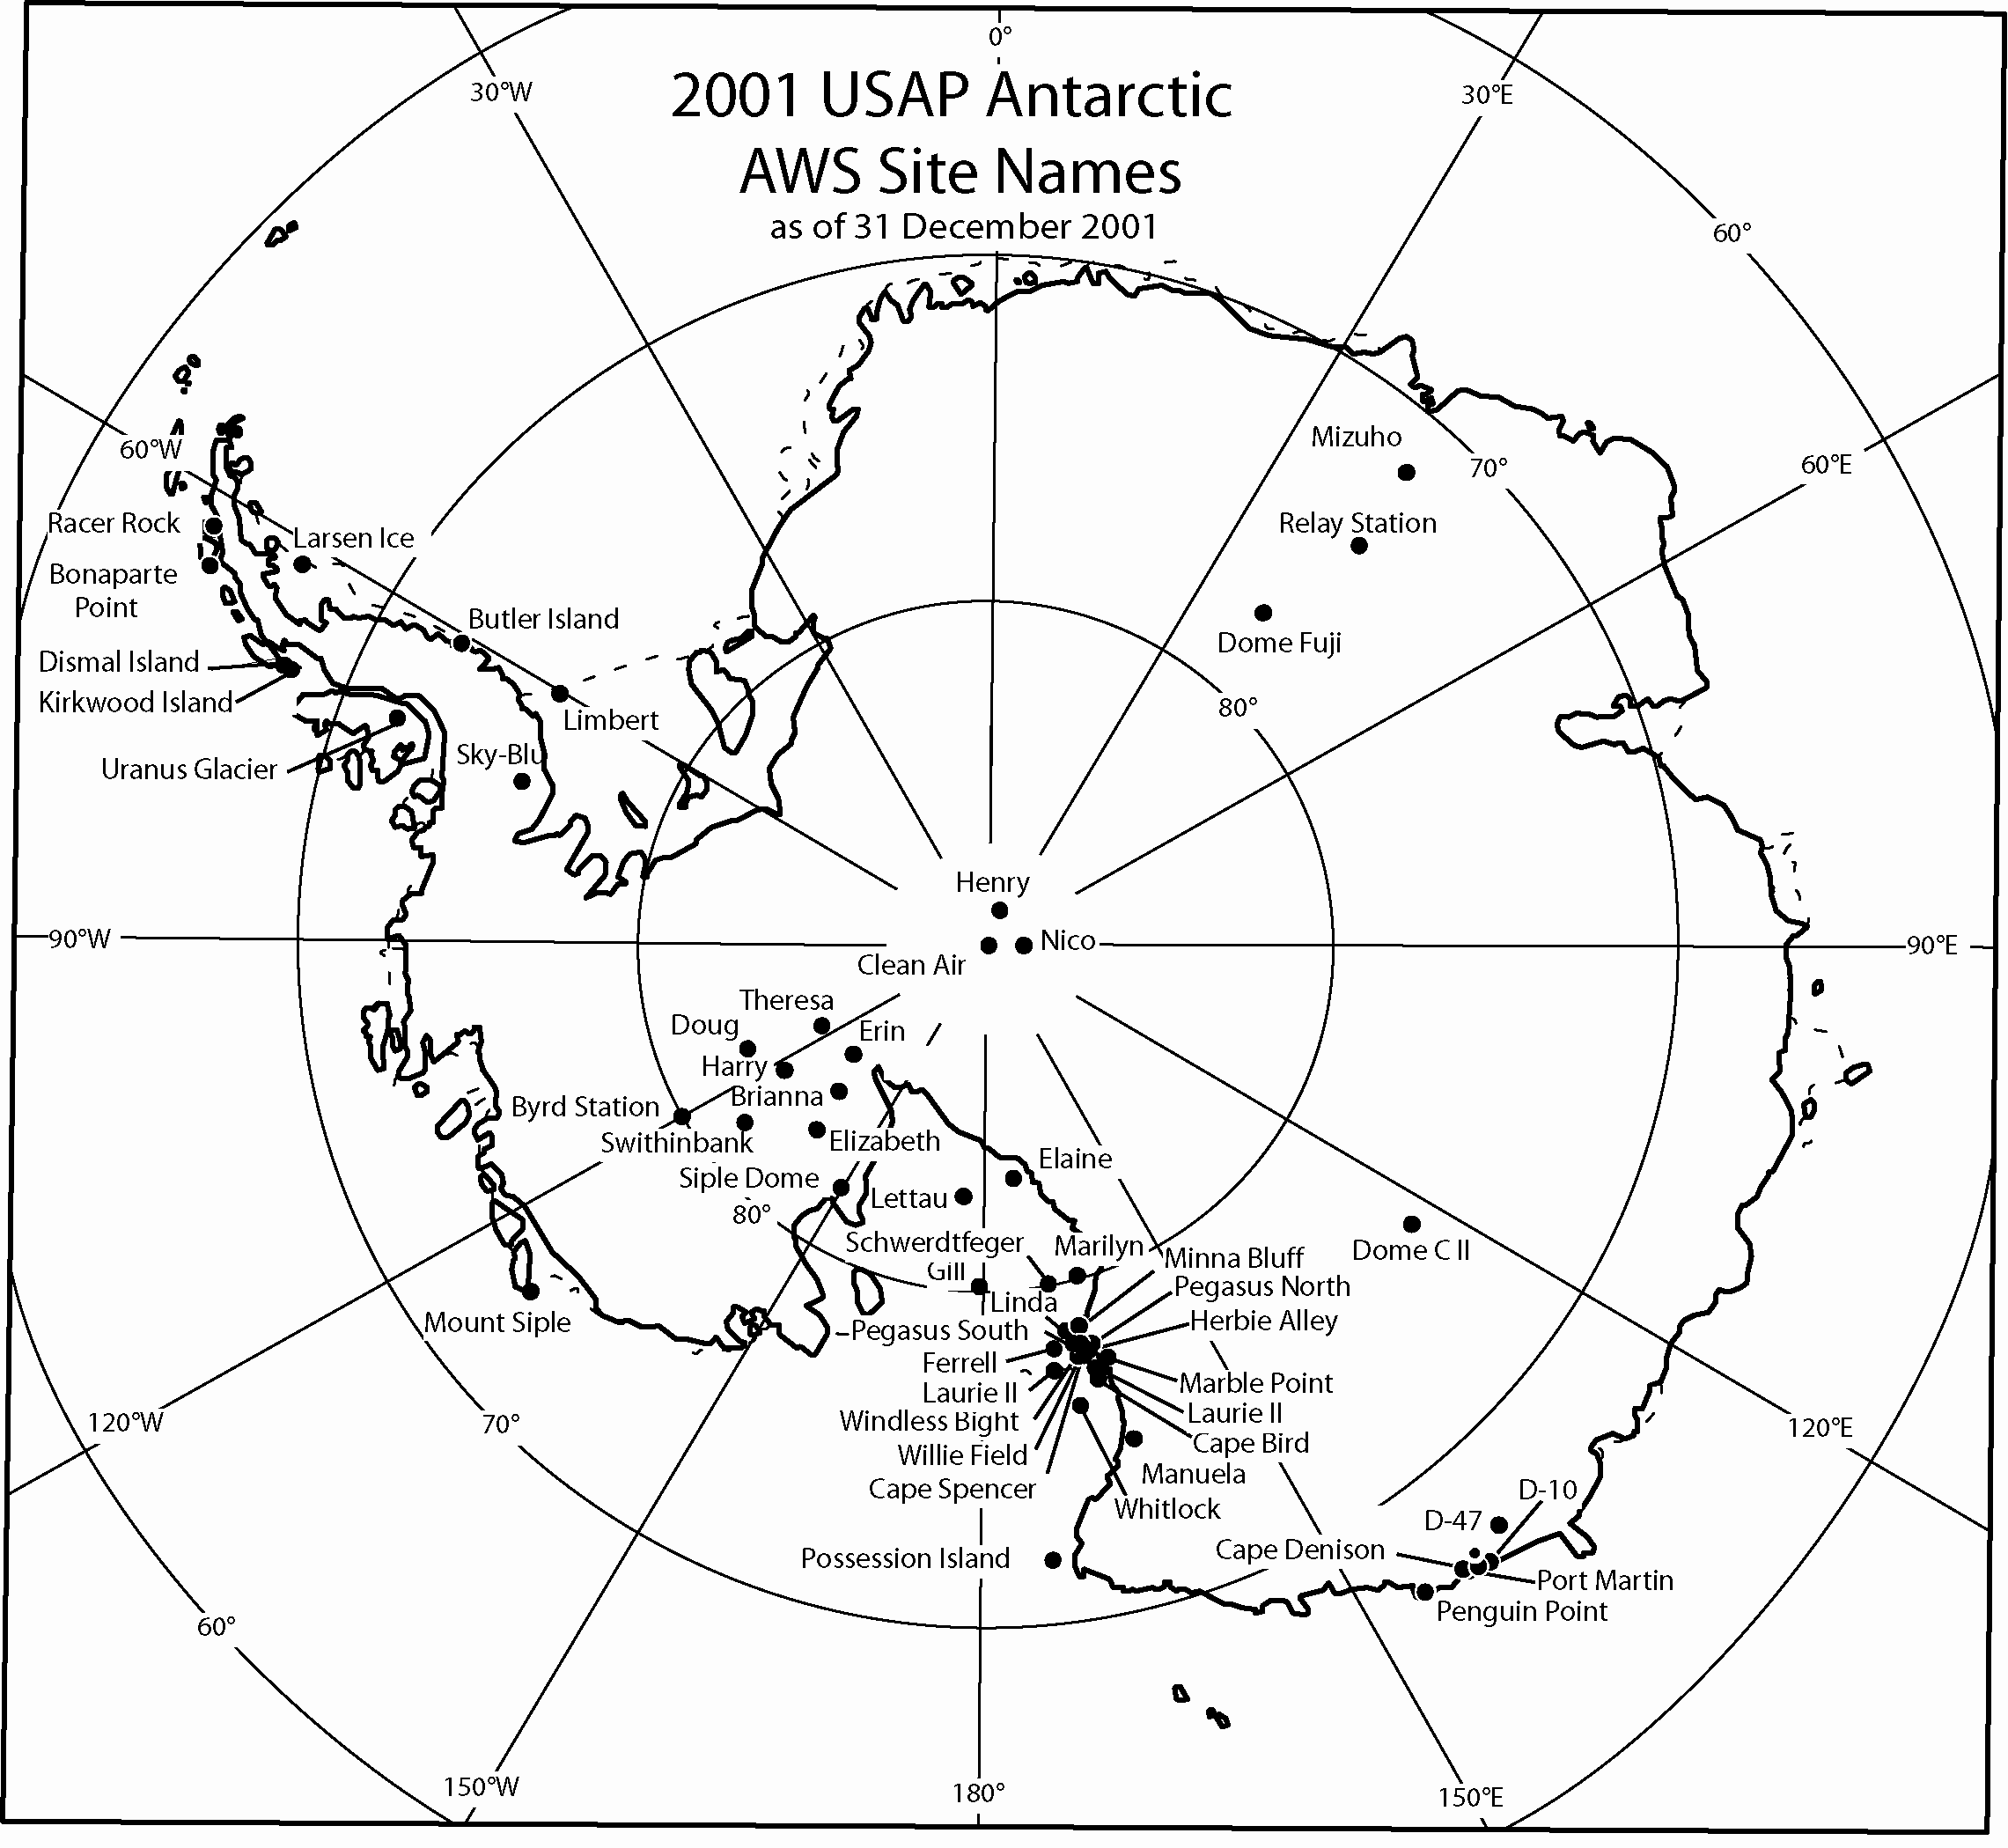

Antarctic Automatic Weather Station Data
for the calendar year 2001

by

Linda M. Keller
George A. Weidner
Charles R. Stearns
Jonathan E. Thom
Matthew A. Lazzara

Space Science and Engineering Center
University of Wisconsin
1225 W. Dayton St.
Madison, Wisconsin
February, 2007

Antarctic Automatic Weather Station Data

For The Calendar Year

2001

by

Linda M. Keller

George A. Weidner

Charles R. Stearns

Jonathan E. Thom

Matthew A. Lazzara

Space Science and Engineering Center

University of Wisconsin

1225 W. Dayton St.

Madison, Wisconsin

February, 2007

TABLE OF CONTENTS

Page

1. Introduction......................................................................................................................... 1

2. Data Transmission.............................................................................................................. 1

3. AWS Identification and Location......................................................................................... 1

4. AWS Data Summaries........................................................................................................ 9

4.1. Monthly Data Summaries.............................................................................................. 9
D-10.............................................................................................................................. 10
D-47.............................................................................................................................. 10
Dome C II..................................................................................................................... 10
Port Martin……………………………………………………………………………………. 11
Cape Denison………………………………………………………………………………… 11
Penguin Point............................................................................................................... 11
Mount Siple................................................................................................................... 12 Theresa........................................................................................................................ 12
Doug............................................................................................................................. 12
Elizabeth....................................................................................................................... 13
Brianna………………………………………………………………………………………… 13
Harry…………………………………………………………………………………………… 13
Erin............................................................................................................................... 14
Siple Dome................................................................................................................... 14
Swithinbank................................................................................................................... 14
Marble Point.................................................................................................................. 15
Ferrell............................................................................................................................ 15
Pegasus North............................................................................................................... 15
Pegasus South.............................................................................................................. 16
Minna Bluff.................................................................................................................... 16
Linda............................................................................................................................. 16
Willie Field.................................................................................................................... 17
Windless Bight.............................................................................................................. 17
Herbie Alley…………………………………………………………………………………… 17
Cape Spencer………………………………………………………………………………… 18
Cape Bird....................................................................................................................... 18
Laurie II……................................................................................................................... 18
Whitlock……………………………………………………………………………………….. 19
Possession Island.......................................................................................................... 19
Manuela......................................................................................................................... 19
Marilyn........................................................................................................................... 20
Schwerdtfeger................................................................................................................ 20
Gill................................................................................................................................. 20
Lettau............................................................................................................................ 21
Elaine............................................................................................................................ 21
Larsen Ice Shelf............................................................................................................. 21
Butler Island................................................................................................................... 22
Uranus Glacier………………………………………………………………………………… 22
Limbert.......................................................................................................................... 22
Racer Rock.................................................................................................................... 23
Bonaparte Point............................................................................................................. 23
Sky-Blu........................................................................................................................... 23
Kirkwood Island……………………………………………………………………………….. 24
Dismal Island................................................................................................................. 24
Clean Air (South Pole)................................................................................................... 24
Henry............................................................................................................................. 25
Nico............................................................................................................................... 25
Relay Station................................................................................................................. 25
Dome Fuji……………………………………………………………………………………… 26
Mizuho…………………………………………………………………………………………. 26

4.2. Three Hourly Data Summaries....................................................................................... 27

5. AWS Calibration................................................................................................................. 27

5.1. Temperature................................................................................................................. 27
5.2. Pressure....................................................................................................................... 27
5.3. Wind Direction and Speed............................................................................................ 27
5.4. Relative Humidity......................................................................................................... 28
5.5. Vertical Air Temperature Difference.............................................................................. 28

6. AWS Operations Summary for 2001................................................................................... 28

6.1. AWS Performance........................................................................................................ 28
6.2. AWS Antarctic Field Activities....................................................................................... 30

7. Global Telecommunications System.................................................................................... 31

8. Data Availability................................................................................................................... 31

9. Acknowledgments................................................................................................................ 32

1. INTRODUCTION

A network of automatic weather station (AWS) units is deployed to collect Antarctic surface weather observations in support of specific meteorological research projects as well as operational activities in Antarctica. The 2001 network consisted of 52 installed AWS units providing observations on the Ross Ice Shelf, east of the Transantarctic Mountains and north of McMurdo to the Adelie Coast, along the Antarctic Peninsula, West Antarctica, and climatological locations such as the South Pole. Each unit measures air temperature, wind speed, and wind direction at the top of the unit's tower at a nominal height of three meters and air pressure at the electronics enclosure (Figure 1). Some AWS units also measure the relative humidity at three meters and vertical air temperature difference between 0.5 and 3 meters. Measurement heights relative to the actual surface at the site are nominal due to snow accumulation around the AWS unit.

2. DATA TRANSMISSION

The transmitted AWS data are received and stored by the Data Collection System on the NOAA series of polar orbiting satellites. The data are retransmitted by the satellite for use in the High Resolution Picture Transmission (HRPT) broadcast at McMurdo, Antarctica. The data are also received with the Global Area Coverage (GAC) data collected at the Space Science and Engineering Center, University of Wisconsin-Madison. The data are processed into scientific units and are available for local use. The complete data set is received at the University of Wisconsin-Madison from CLS America (Service ARGOS), Largo, Maryland, for processing and distribution to the users.

3. AWS IDENTIFICATION AND LOCATION

Site location is defined by the latitude and longitude which is determined by various methods: sun shots, angles to geographical features, aircraft data, ice breaker data, the platform location system of CLS America (Service ARGOS), and the Global Positioning System. AWS elevation is obtained by barometry and UNAVCO Global Positioning System (GPS) and should be correct to within +/- 5 meters. Site names were introduced for convenience. Table 3.1 lists the site name, ARGOS identification number, latitude, longitude, elevation, start date for the site, and the World Meteorological Organization (WMO) number for the site. Figures 2, 3, and 4 show the locations of the AWS units in the Antarctic for 2001.

The ARGOS identification number (ID) is used to identify the data sets distributed to the users. AWS units are sometimes moved from one location to another, and as a result, the ID at a given site may change from year to year. The site name does not change. Table 3.2 lists the site name with the ARGOS ID, the site start date, and the ID start and stop dates.

Figure 1. Layout of the AWS unit used in the Antarctic. The installed AWS unit has a 3-meter tower with a horizontal boom supporting the antenna, aerovane for measuring wind speed and direction, air temperature resistance thermometer, upper thermopile for measuring vertical air temperature difference, and the relative humidity sensor. The electronics enclosure is mounted at the midpoint of the tower. The gel cell batteries are placed at the tower base. The solar panel, located near the tower top, faces north. The Acoustic Depth Gauge (ADG) is installed on some of the AWS units to measure snow depth for precipitation studies.

Table 3.1
AWS site name, geographic location and elevation, site start date, and WMO number for 2001.
Site Name | ARGOS ID | Lat. (deg ) | Long. (deg) | Elev. (m) | Site Start Date | WMO No.
 |  |  | Adelie Land
D-10 | 8914 | 66.71ºS | 139.83ºE | 243 | 08 Jan 80 | 89832
D-47 | 8986 | 67.397ºS | 138.726ºE | 1560 | 24 Jan 83 | 89834
Dome C II | 8989 | 75.121ºS | 123.374ºE | 3250 | 12 Dec 95 | 89828
Port Martin | 8909 | 66.82ºS | 141.39ºE | 39 | 19 Jan 90
Cape Denison | 8988 | 67.009ºS | 142.664ºE | 31 | 20 Jan 90
Penguin Point | 8910 | 67.617ºS | 146.180ºE | 30 | 24 Dec 92 | 89847
 |  |  | West Antarctica
Byrd Station | 8903 | 80.007ºS | 119.404ºW | 1530 | 05 Feb 80 | 89324
Mount Siple | 8981 | 73.198ºS | 127.052ºW | 230 | 20 Feb 92 | 89327
Theresa | 21358 | 84.599ºS | 115.811ºW | 1463 | 29 Nov 94 | 89314
Doug | 8922 | 82.315ºS | 113.240ºW | 1433 | 29 Nov 94
Elizabeth | 21361 | 82.607ºS | 137.078ºW | 519 | 30 Nov 94 | 89332
Brianna | 21362 | 83.889ºS | 134.154ºW | 526 | 30 Nov 94
Harry | 8900 | 83.003S | 121.393W | 945 | 29 Nov 94 | 89329
Erin | 21363 | 84.904ºS | 128.828ºW | 990 | 29 Nov 94
Siple Dome | 8938 | 81.656ºS | 148.773ºW | 668 | 21 Jan 97 | 89345
Swithinbank | 21356 | 81.20ºS | 126.174ºW | 945 | 18 Jan 97
 |  |  | Ross Island Region
Marble Point | 8906 | 77.439ºS | 163.754ºE | 108 | 05 Feb 80 | 89866
Ferrell | #8929 | 77.910ºS | 170.817ºE | 45 | 10 Dec 80 | 89872
Pegasus North | 21357 | 77.952ºS | 166.500ºE | 8 | 23 Jan 90 | 89667
Pegasus South | 8937 | 77.99ºS | 166.576ºE | 10 | 14 Jan 91
Minna Bluff | 8935 | 78.554ºS | 166.691ºE | 895 | 22 Jan 91 | 89768
Linda | 8919 | 78.464ºS | 168.382ºE | 47 | 21 Jan 91 | 89769
Willie Field | #21364 | 77.865ºS | 167.017ºE | 40 | 25 Jan 92
Windless Bight | 8927 | 77.728ºS | 167.703ºE | 61 | 09 Dec 98
Herbie Alley | 8697 | 78.10ºS | 166.67ºE | 30 | 11 Jan 99
Cape Spencer | 8722 | 77.97ºS | 167.55ºE | 30 | 11 Jan 99
Cape Bird | 8901 | 77.224ºS | 166.440ºE | 42 | 28 Jan 99
Laurie II* | #21360 | 77.549ºS | 170.817ºE | 30 | 01 Feb 00
 |  |  | Ocean Islands
Whitlock | #8907 | 76.144ºS | 168.392ºE | 274 | 01 Jan 82 | 89865
Possession Is. | 8984 | 71.891ºS | 171.210ºE | 30 | 29 Dec 92 | 89879
Manuela | 8905 | 74.946ºS | 163.687ºE | 78 | 06 Feb 84 | 89864
 |  |  | Ross Ice Shelf
Marilyn | #8934 | 79.954ºS | 165.130ºE | 75 | 16 Jan 84 | 89869
Schwerdtfeger | 8913 | 79.904ºS | 169.973ºE | 60 | 24 Jan 85 | 89868
Gill | 8911 | 79.985ºS | 178.611ºW | 55 | 24 Jan 85 | 89376
Lettau | 8908 | 82.518ºS | 174.452ºW | 55 | 29 Jan 86 | 89377
Elaine | 8915 | 83.134ºS | 174.169ºE | 60 | 28 Jan 86 | 89873

Site Name | ARGOS ID | Lat. (deg) | Long. (deg) | Elev. (m) | Site Start Date | WMO No.
 |  |  | Antarctic Peninsula
Larsen Ice | 8926 | 66.949ºS | 60.897ºW | 17 | 07 Feb 83 | 89262
Butler Island | 8902 | 72.207ºS | 60.160ºW | 91 | 01 Mar 86 | 89266
Uranus Glacier | 8920 | 71.43ºS | 68.93ºW | 780 | 06 Mar 86 | 89264
Limbert | 8925 | 75.422ºS | 59.851ºW | 40 | 30 Nov 95 | 89257
Racer Rock | 8947 | 64.067ºS | 61.613ºW | 17 | 15 Oct 89 | 89261
Bonaparte Pt. | 8923 | 64.778ºS | 64.067ºW | 8 | 05 Jan 92 | 89269
Sky-Blu | 8917 | 74.972ºS | 71.488ºW | 1510 | 07 Feb 99 | 89272
Kirkwood Island* | #8930 | 68.340ºS | 69.007ºW | 30 | 26 May 01
Dismal Island* | #8932 | 68.087ºS | 68.825ºW | 10 | 27 May 01
 |  |  | High Polar Plateau
Clean Air | 8987 | 90.00ºS |  | 2835 | 29 Jan 86 | 89208
Henry | 8985 | 89.011ºS | 1.025ºW | 2755 | 26 Jan 93 | 89108
Nico | 8924 | 89.00ºS | 89.669ºE | 2935 | 26 Jan 93 | 89799
Relay Station | 8918 | 74.017ºS | 43.062ºE | 3353 | 01 Feb 95 | 89744
Dome Fuji | #8904 | 77.31ºS | 39.70ºE | 3810 | 08 Feb 95 | 89734
Mizuho | 21359 | 70.70ºS | 44.29ºE | 2260 | 07 Oct 00

* New sites started during 2001
# New ARGOS ID for 2001 at the site

Figure 2. Antarctic automatic weather station locations during 2001 identified by the site name. Area around Ross Island is shown in Figure 3. Adelie Coast area is shown in Figure 4.
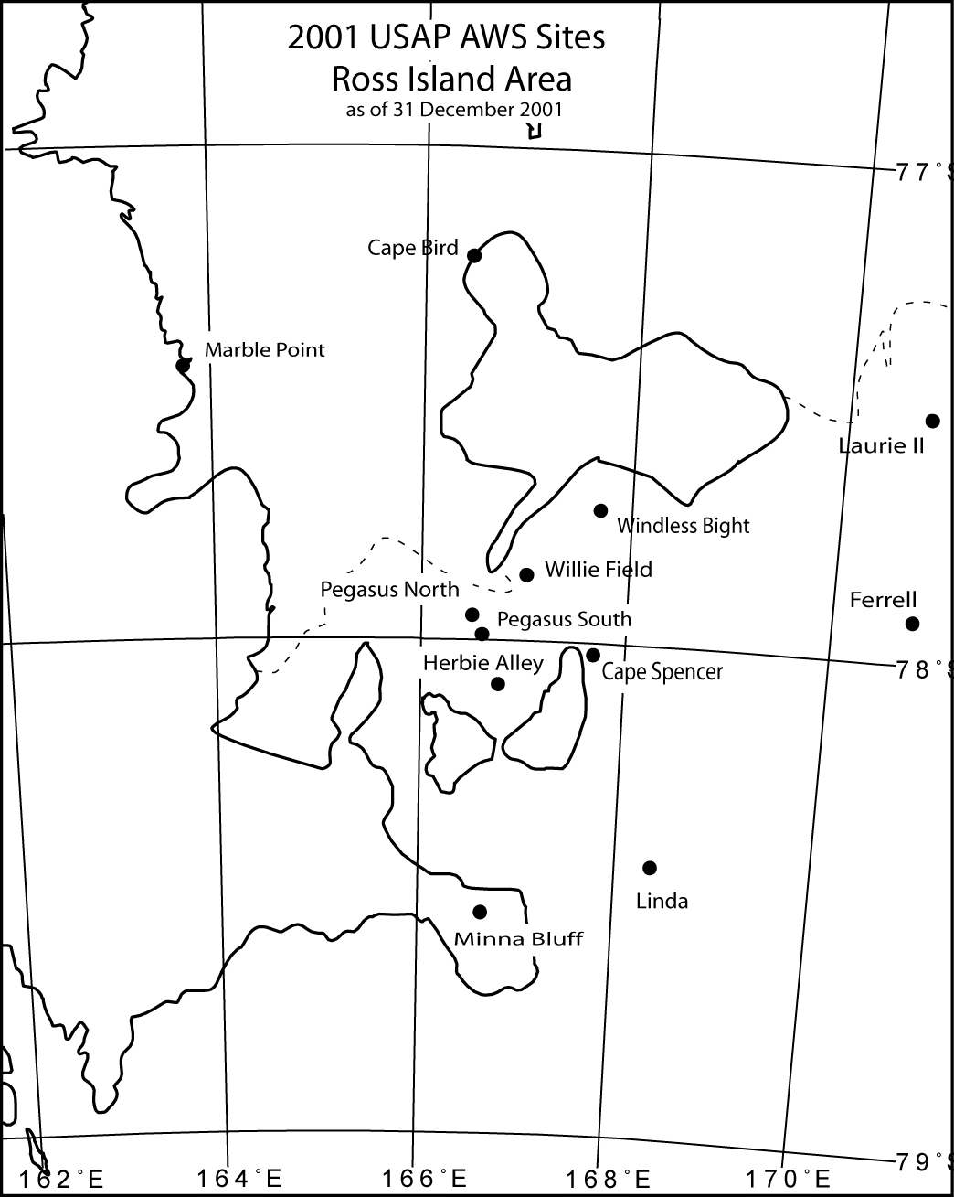

Figure 3. Location of Antarctic automatic weather stations in the vicinity of Ross Island, Antarctica during 2001.

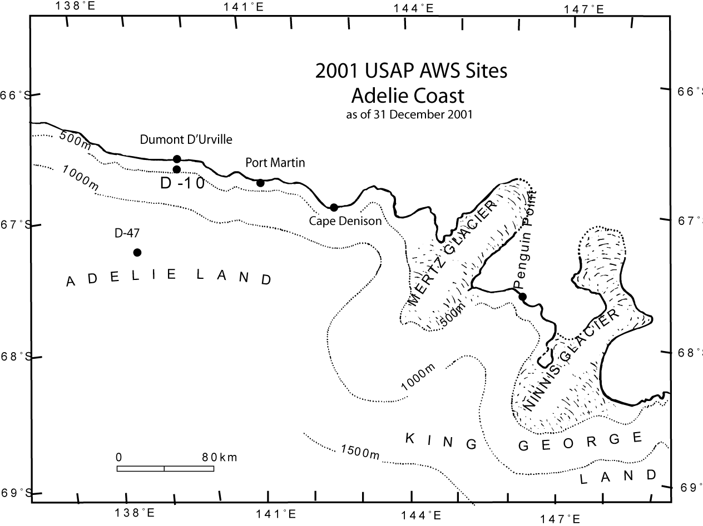

Figure 4. Location of Antarctic automatic weather stations along the Adelie Coast during 2001.

Table 3.2
2001 Antarctic AWS site name, ARGOS identification number (ID), site start date, ID start date, and ID stop date if occurring in 2001.

Site | ARGOS ID | Site Start Date | ID Start Date | ID Stop Date
D-10 | 8914 | 08 Jan 80 | 28 Jan 98
D-47 | 8986 | 24 Nov 83 | 11 Feb 96
Dome C II | 8989 | 12 Dec 95 | 12 Dec 95
Port Martin | 8909 | 19 Jan 90 | 18 Dec 99 | 18 Dec 00
Cape Denison | 8988 | 20 Jan 90 | 17 Dec 99
Penguin Point | 8910 | 24 Dec 92 | 21 Dec 98
Byrd Station | 8903 | 05 Feb 80 | 05 Feb 80
Mount Siple | 8981 | 20 Feb 92 | 20 Feb 92
Theresa | 21358 | 29 Nov 94 | 29 Nov 94
Doug | 8922 | 29 Nov 94 | 20 Jan 97
Brianna | 21362 | 30 Nov 94 | 30 Nov 94
Harry | 8900 | 29 Nov 94 | 26 Jan 99
Elizabeth | 21361 | 30 Nov 94 | 17 Jan 96
Erin | 21363 | 29 Nov 94 | 18 Jan 96
Siple Dome | 8938 | 21 Jan 97 | 24 Jan 99
Swithinbank | 21356 | 18 Jan 97 | 18 Jan 97
Marble Point | 8906 | 05 Feb 80 | 05 Feb 80
Ferrell | 21355 | 10 Dec 80 | 01 Feb 00 | 09 Jan 01
 | 8929 |  | 09 Jan 01
Pegasus North | 21357 | 23 Jan 90 | 03 Feb 00
Pegasus South | 8937 | 14 Jan 91 | 14 Jan 91
Minna Bluff | 8935 | 22 Jan 91 | 25 Jan 99
Linda | 8919 | 21 Jan 91 | 15 Jan 98
Willie Field | 8929 | 25 Jan 92 | 16 Jan 99 | 29 Jan 01
 | 21364 |  | 29 Jan 01
Windless Bight | 8927 | 09 Dec 98 | 25 Jan 99
Herbie Alley | 8697 | 11 Jan 99 | 11 Jan 99
Cape Spencer | 8722 | 11 Jan 99 | 11 Jan 99
Cape Bird | 8901 | 28 Jan 99 | 28 Jan 99
Laurie II | 21364 | 01 Feb 00 | 01 Feb 00 | 16 Jan 01
 | 21360 |  | 16 Jan 01
Whitlock | 8907 | 01 Jan 82 | 07 Feb 01
Possession Island | 8984 | 29 Dec 92 | 29 Dec 92
Marilyn | 8931 | 16 Jan 84 | 18 Jan 91 | 30 Jan 01
 | 8934 |  | 30 Jan 01
Schwerdtfeger | 8913 | 24 Jan 85 | 22 Jan 93
Gill | 8911 | 24 Jan 85 | 25 Jan 91
Elaine | 8915 | 28 Jan 86 | 02 Jan 97
Lettau | 8908 | 29 Jan 86 | 29 Jan 86
Manuela | 8905 | 06 Feb 84 | 15 Feb 87
Larsen Ice Shelf | 8926 | 07 Feb 83 | 01 Jan 86
Butler Island | 8902 | 01 Mar 86 | 01 Mar 86
Uranus Glacier | 8920 | 06 Mar 86 | 06 Mar 86
Limbert | 8925 | 30 Nov 95 | 30 Nov 95
Racer Rock | 8947 | 15 Oct 89 | 08 Dec 91
Bonaparte Point | 8923 | 05 Jan 92 | 23 Dec 96
Sky-Blu | 8917 | 07 Feb 99 | 07 Feb 99
Kirkwood Is. | 8930 | 26 may 01 | 26 May 01
Dismal Is. | 8932 | 27 May 01 | 27 May 01
Clean Air | 8987 | 29 Jan 86 | 25 Jan 94
Henry | 8985 | 26 Jan 93 | 26 Jan 93
Nico | 8924 | 26 Jan 93 | 26 Jan 93
Relay Station | 8918 | 01 Feb 95 | 01 Feb 95
Dome Fuji | 8904 | 08 Feb 95 | 04 Feb 97
Mizuho | 21359 | 07 Oct 00 | 07 Oct 00

4. AWS DATA SUMMARIES

The data received by the University of Wisconsin, Space Science and Engineering Center, contain all the information received by the ARGOS system including duplicate and erroneous transmissions. Invalid data are eliminated during a quality check, and the valid data are converted to scientific units producing the complete data set. Data selected at three hourly intervals, plus or minus forty minutes, produce a three hourly data set for each AWS unit month. Section 6.1, AWS Performance, provides some explanations for missing and invalid data.

Use of the 2001 Antarctic AWS data for publication should acknowledge the support of NSF-OPP Grants `0088058 and 0338147 or reference this publication.

4.1. Monthly Data Summaries

The monthly summaries consist of the monthly means, from the three hourly data set, and the extremes, from the complete data set. For monthly values to be included, 25% of the three hourly observations must be available. Months with 50-75% of data missing occur most often when a station is started or stopped in the middle of the month. This can cause a bias in the monthly mean, especially during seasons when parameters such as temperature change rapidly. Annual means are calculated only when twelve months of data are available. The data are presented in the same order as the sites listed in Table 3.1. Definitions of the monthly data summary headings are listed below.

Heading Definition

Mean air temperature, ºC. Mean value for the month.

Percent of monthly data missing. Ratio of the number of missing observations to the number of
possible observations X 100.

Maximum air temperature, ºC. Maximum value for the month.
Minimum air temperature, ºC. Minimum value for the month.

Mean wind speed, m/s. Mean value for the month.

Percent of monthly data missing. Ratio of the number of missing observations to the number of
possible observations X 100.

Resultant wind speed, dir/vv. Resultant speed and direction for the month.
Constancy. Ratio of the monthly resultant to the monthly mean wind speed.

Maximum wind speed, dir/vv. Maximum wind speed and direction for the month.

Mean air pressure, mb. Mean value for the month.

Percent of monthly data missing. Ratio of the number of missing observations to the number of
possible observations X 100.

Maximum air pressure, mb. Maximum value for the month.
Minimum air pressure, mb. Minimum value for the month.

Potential temperature, K Mean value for the month.
4.2. Three Hourly Data Summaries
After the data are received from Service ARGOS, ten minute interval data are created for each AWS unit. The data are calibrated for the individual station instruments, but no other corrections are made. This data set is created for those users who need fairly current information. These data are available by anonymous FTP (see Section 8).

The 10 minute data set for each AWS unit for the month is scanned to pick out the nearest observation within forty minutes of the UTC hours 00, 03, 06, 09, 12, 15, 18, and 21 to produce the three hourly data set. If valid data are not available within forty minutes of the three hourly time interval, then the entry is left blank to indicate missing data. The means, standard deviations, resultant wind speed and direction, the distribution of temperature, and wind speed with wind direction are determined from the three hourly observations and are presented as a monthly summary at the bottom of each page. A wind direction value of zero indicates a wind speed less than 0.50 m s⁻¹. North is indicated by a value of 360 degrees. The maximum and minimum values are taken from the complete 10 minute data set, not the three hourly data set. The appropriate monthly data from the three hourly data set are used for the monthly summaries presented in Section 4.1. In the presence of sunlight the air temperatures are questionable if the wind speed is less than 1 m s⁻¹. These summaries are available by anonymous FTP (see Section 8). If you are unable to access the Internet, we will send the information either on diskettes or paper. Please contact us for further information (the address is at end of Section 8).

5. AWS CALIBRATION

5.1. Temperature

The external and internal temperatures are calibrated using a 1000 ohm 0.05% resistor in place of the platinum resistance thermometers with 1000 ohms resistance at 0ºC. Because the other resistances in the temperature circuit are known only to 1%, the temperature calibration will vary from one electronic unit to another. The correction factor determined from the calibration resistor is programmed into the read-only-memories for each unit. After the correction factors have been programmed into the AWS, a calibration box with 0.1% resistors is used to check the temperature calibration.

5.2. Pressure

In 2001 pressure calibration was performed by using a Paroscientific portable pressure standard model 760-16B. It has a 0.0001% resolution (<1 microbar resolution) with a ±0.08 hPa or better accuracy and a 0.1 hPa/year or better stability over the pressure range of 500 hPa to 1100 hPa. There is ISO 9001:2000 compliance and is a NIST traceable standard.
Comparisons are made between AWS units and with the mercury barometers in the Crary Laboratory at McMurdo, Antarctica. The calibrations should be within +/- 0.2 hPa.
The reference vacuum on the older pressure transducers can degrade with time with a maximum observed 4 hPa shift to lower pressure after fifteen years. Recalibration of each pressure transducer would be desirable when each unit is serviced.

5.3. Wind direction and Speed

The Belfort model 123 aerovane measures wind direction and speed. The aerovane rotates a potentiometer wiper, and the fraction of full scale of the potentiometer is measured. The wind direction is checked by positioning the aerovane to the cardinal directions relative to the boom supporting the aerovane. North or the potentiometer zero is towards the antenna on the boom and has a maximum dead zone of 3º. During the field installation, the boom is usually aligned along the north-south line as determined from the sun's azimuth, longitude, and Greenwich Mean Time. In some cases the 180º end of the boom may point in a direction other than south. At Manuela site, the 180º end of the boom points up the glacier and a correction is added to the data during processing. At Byrd site the wind is usually out of the north so the boom was rotated 120º and the correction added during the data processing. The wind speed is determined from the aerovane tachometer voltage output as 0.0472 volt per meter per second. The aerovane tachometers are spun at 1800 rpm with a load of 1071.5 ohms, and the output should be 9.20 +/-0.05 vdc.
Additional wind sensors were used with AWS units for 2001. These were the R.M. Young wind monitor model 05103 and the Hydro-Tech WS-3 anemometer with the WP-3 aerovane. The Hydro-Tech system was used for measuring wind speed in the Adelie Coast area. The Hydro-Tech WS-3 is a disk rotor, 3 in. high and 12 in. overall diameter, with radial cups, and the threshold sensitivity is 3 mph. The anemometer utilizes a commercial dc tachometer generator. Output is 0 to +5 vdc (and 0 to 1 ma) over the desired full scale wind speed of 85 m/s. Accuracy is +/- 2%.
The R.M. Young monitor 05103 also used a 10,000 ohm potentiometer with a 3º dead zone so that the wind direction was recorded identically with the Belfort/Bendix aerovanes. The wind speed was from the range of 0 to 1.0 volt full scale corresponding to 50 m/s. Thus the calibration for wind speed was a nominal .195 m/s/bit for the R.M. Young with +/- 1% up to 50 m/s.

5.4. Relative Humidity

The Vaisala HMP-35A/45A humidity sensor output voltage varies linearly with relative humidity (U). The sensor is calibrated by placing it over saturated salt solutions with known relative humidities at room temperature: sodium chloride (U=75%), and lithium chloride (U=12%) are used. In addition, a dry inert gas, forced past the sensor, gives a 0% U, and the sensor output can be zeroed. Then, the gain setting can be set directly using a salt solution with a high relative humidity, such as sodium chloride. The resolution of the humidity sensor is about 1% and the drift is 2 to 3% per year in the field. The relative humidity data are not included on the summary pages but are included in the 3 hourly data sets.

5.5. Vertical Air Temperature Difference

Two junction thermocouples are used to measure the air temperature difference between 3 m and 0.5 m on the tower. The output is about 78 microvolts for 1ºC temperature difference between the junctions at 0.0ºC, dropping to 60 microvolts at -80ºC. Zero output is adjusted to 0.4 volts, so that 0 to 1 volt corresponds to a -6ºC to +9ºC range of air temperature differences between 3 m and 0.5 m. The resolution is 0.05ºC. Calibration of the individual systems is done by applying known voltages to the amplifier input. The vertical temperature difference data are not included on the summary pages but are included in the 3 hourly data sets.

6. AWS OPERATIONS SUMMARY FOR 2001

6.1. AWS Performance

Forty-eight AWS units were installed at the start of 2001 and 51 were installed by the end of 2001. Based on the installation months the AWS units delivered 91% of the temperature data, 88% of the pressure data and 82% of the wind data during 2001. Complete data sets were received from 5 AWS units and 40 AWS units operated for the installed period. Seven AWS units were not received for one month or more during the year or stopped during the year. Some of the stations were not received during the winter months due to low battery voltage.

The wind system has the poorest performance. If the wind speed is zero or the wind direction is constant for extended periods (days to months) then the data is considered invalid. The reason for this behavior is not known but is believed to be due to the build up of frost on the wind system. This usually occurs in the winter season and at several AWS sites. The wind speed is most frequently zero when the wind direction is constant.

Site Performance
D-10 The station transmitted erratically from July through the beginning of October. The relative humidity sensor and delta-T sensor were not functioning.
D-47 Temperature sensor not functioning. Station stopped transmitting 4 January and began again 27 February. Station transmitted erratically from April through early August with another break the first half of September. No relative humidity or delta-T sensors.
Dome C II OK.
Port Martin The aerovane was not functioning. No delta-T or extra high wind speed sensor. Pressure corrected for high wind speed conditions.
Cape Denison Station stopped transmitting 29 April and resumed 27 May. Several transmission gaps of a week or more in April, May, and September. Pressure corrected for high wind speed conditions.
Penguin Point The station stopped transmitting from 15 May to 21 June. Pressure corrected for high wind speed conditions.
Byrd Station transmitted from 3 to 8 October only.
Mount Siple Site has a "dog house" AWS without wind speed and direction. Pressure sensor not functioning correctly January and February.
Theresa Delta-T sensor buried.
Doug Aerovane not functioning in July. Relative humidity sensor not functioning. Station transmitted erratically in September and stopped transmitting on 8 October.
Elizabeth Aerovane "frozen" the last part of September.
Brianna The relative humidity sensor functioned erratically after June. The station stopped transmitting 3 November.
Harry The delta-T sensor is not functioning. The aerovane was "frozen" occasionally from June through November.
Erin The aerovane was "frozen" occasionally from May through July.
Siple Dome Aerovane “frozen” occasionally from April through November. Delta-T sensor not installed.
Swithinbank Station stopped transmitting 8 October. Delta-T sensor not functioning.
Marble Point OK.
Ferrell New station installed 10 January.
Pegasus North Station stopped transmitting on 25 January. Delta-T not functioning. Station resumed transmitting 4 November.
Pegasus South Station stopped transmitting on 6 May and resumed on 24 June. Relative humidity sensor not functioning. Aerovane “frozen” from June through October. Delta-T erratic all year.
Minna Bluff Station started transmitting 10 July. Delta-T sensor not functioning. Aerovane occasionally “frozen” July through November. Station stopped transmitting 13 December.
Linda Aerovane occasionally "frozen" April through October.
Willie Field Station replaced 29 January.
Windless Bight Station stopped transmitting 12 December due to low battery voltage.
Herbie Alley Pressure functioned erratically August, October, and November.
Cape Spencer Station stopped transmitting 25 December.
Cape Bird OK.
Laurie II Station replaced 17 January. Delta-T sensor not functioning. Aerovane occasionally "frozen" in September.
Whitlock Station replaced 7 February. Delta-T sensor not functioning. Aerovane “frozen” most of April and May and parts of June and July.
Possession Island Site has a "dog house" AWS without wind speed and direction.
Manuela Aerovane broken.
Marilyn Station replaced 30 January. Aerovane occasionally "frozen" May through November.
Schwerdtfeger Relative humidity sensor not functioning from mid February through November Aerovane “frozen” occasionally in July.
Gill Relative humidity sensor not functioning. Aerovane “frozen” occasionally in October
Lettau Transmitting with many gaps in January, November, and December. Aerovane “frozen” occasionally from March through December.
Elaine OK.
Larsen Ice Shelf Aerovane “frozen” occasionally in July.
Butler Island Aerovane not functioning beginning of January and “frozen” occasionally from May through November. Pressure continues to need correction due to the failure of the precision time-based correction to the system clock.
Uranus Glacier Large gaps in transmission in March, November, and some of December.
Limbert Delta-T sensor not functioning. Aerovane not functioning. Station stopped transmitting in July and resumed in September due to low battery voltage.
Racer Rock Station transmitted erratically from the end of May to October due to low battery voltage. Station stopped transmitting 30 November.
Bonaparte Point Relative humidity and delta-T sensor not functioning. Aerovane not functioning January through May, July, and October through December. Pressure is too low and has been removed.
Sky Blu Aerovane “frozen” occasionally in September.
Kirkwood Island New station installed 21 May. Aerovane not functioning properly in May.
Dismal Island New station installed 22 May. Aerovane not functioning properly in May.
Clean Air Occasional problems with relative humidity sensor. Pressure functioning erratically February through November.
Henry Aerovane occasionally "frozen" June through September. Station stopped transmitting 20 September and resumed transmitting 30 October as the battery recharged in the austral spring.
Nico Aerovane occasionally "frozen" in August and September.
Relay Station OK.
Dome Fuji Repaired station installed on 22 December.
Mizuho No relative humidity or delta-T sensors. Occasional gaps in transmission during winter months.

6.2. AWS Antarctic Field Activities

McMurdo area

Pegasus North (8927) was visited on 7 January by Jonathan Thom, Rob Flint, and Ernie Mastroianni. The station was operating nominally, but the RPSC airfield manager requested that the station be relocated. The old location was directly in the middle of the approach apron for the runway. The station was removed, and the following day another station (8927) was installed about 1 mile southeast of the old location. On 9 January, Ferrell (21355) site was visited by Jonathan Thom and Rob Flint. The station and boom were removed and replaced with 8929. On 16 January, Laurie II (21364) was visited by Jonathan Thom. The station was replaced with 21360. Willie Field (8929) site was visited by Jonathan Thom, Doug MacAyeal, and Andy Bliss on 29 January. The AWS had been removed earlier to provide a station for Ferrell site. AWS 21364 was installed and the station was raised. An R.M. Young wind monitor was also installed. On 30 January, Marilyn (8931) site was visited by Jonathan Thom, Andy Bliss, and Ben Kerman.The station was raised, a new AWS enclosure (8934) was installed, and 2 boxes of batteries were connected. The boom is 60 degrees off north in a counterclockwise direction.

On 7 February, Whitlock site was visited on Franklin Island by USCGC Polar Sea. MST3 David Otani oversaw the replacement of the AWS enclosure. The AWS unit is now 8907. The Polar Sea went on to Manuela (8905) site to fix the aerovane but were unable to spot the station. The helicopter had problems so another attempt was not made.

West Antarctica

No operations for 2001 due to limited resources of time and AWS.

Polar Plateau

Dome Fuji (8904) was reinstalled 22 December by members of JARE.

Adelie Coast

No field work due to lack of resources.

Antarctic Peninsula

The Southern Ocean GLOBEC group installed Kirkwood Island (8930) AWS unit on 26 May and Dismal Island AWS unit on 27 May. The Palmer Station Science Technician, John Booth, attempted to repair the Bonaparte Point AWS unit (8923) on 12 May.

7. GLOBAL TELECOMMUNICATIONS SYSTEM

The data from 35 Antarctic AWS units were entered into the Global Telecommunications System (GTS) during 2001. The data are collected by CLS America (Service ARGOS). As soon as the data are received, CLS America (Service ARGOS) processes them and sends them on to the National Weather Service which distributes the data to the GTS.The data headers are:

SMAA14 KARS YYGGgg
SIAA14 KARS YYGGgg
SNAA14 KARS YYGGgg

where S indicates surface, M is main observations (at 00, 06, 12, and 18 UT), I is intermediate observations (at 03, 09, 15, and 21 UT), and N is any other time. AA14 is for Antarctica, and KARS stands for the Largo receiving center (backup is LFPW for the center in Toulouse, France). YY indicates the day in the month, GG is the hour, and gg is the minutes. Table 3.1 contains the WMO identification number used by the GTS grouped according to their purpose and proximity where possible.

The University of Wisconsin-Madison is responsible for obtaining WMO numbers for AWS sites and for providing CLS America (Service ARGOS) with calibration information for processing the data. The main reason for getting the AWS data into the GTS is to make sure that the data are available in near real time for all organizations operating in Antarctica and for numerical weather prediction models.

8. DATA AVAILABILITY

The data from our Automatic Weather Stations are available by anonymous FTP. The IP address and domain name are 128.104.109.33 (ice.ssec.wisc.edu). The login is "anonymous" (do not use the quotation marks), and the password is your email address. Once you have logged in, change to the pub/aws subdirectory. A listing of our station locations, names, and ARGOS ID numbers is located in the file "biglist" in this subdirectory. It is meant to serve as a guide to our stations as their ID numbers sometimes change. A complete guide for navigating the site may be found in the file “readme.faq”.

Our three-hourly interval data for Antarctica in ASCII text format are contained in the year subdirectories of pub/aws/antrdr. The data have been corrected, i.e. an effort has been made to remove the bad data points. These data take longer to process, so the data for recent months are not available in this format. Within each of the year subdirectories of pub/aws/antrdr, there are text files named "3hrlist??" (where ?? indicates the last two digits of the year). These files list what station's data are contained in which files. The files “readme.updates?” in pub/aws/antrdr contain information on updates and/or corrections to the data, and the file “readme.3format” contains file name construction information and format of the three-hourly data. The file “readme.mailinglist” contains information on joining a mailing list which distributes information on data updates and changes. To subscribe, send email to aws@ssec.wisc.edu requesting to be added to our mailing list.

The directory pub/aws/summary/monthly contains ASCII printable text files of the paper data summary sheets. The format of the files can be found in the file "readme.sum" while updates and corrections to the data are located in "readme.sumupdates". The data are located in year subdirectories of pub/summary/monthly.

For those users who need more current information, we have created 10 minute interval data in ASCII text format for each station. These data are located in year subdirectories of pub/aws/10min/rdr. The data have been calibrated for the individual station instruments, but no other corrections have been made. The data are generally available up to and including the last full month of this year. The year subdirectories also contain a text file named "namelist??" (where ?? indicates the last two digits of the year in question). These files list what station's data are contained in which files.

Several important readme files are located in pub/aws/10min/rdr. The file "readme.format" contains information on filename construction of the data, as well as well as file content and is a must for those unfamiliar with the data. The files "readme.updates?" contain important information on changes/additions to the data.

Our site is available 24 hours a day, 7 days a week. If you have questions or problems, send email to aws@ssec.wisc.edu. We can also be reached by phone at (608) 265-2209 or (608) 265-4816 or fax at (608) 262-5947.

By mail, please contact:

Linda M. Keller
University of Wisconsin
Department of Atmospheric and Oceanic Sciences
1225 W. Dayton St.
Madison, WI 53706
USA

or

Shelley Knuth
University of Wisconsin
Space Science and Engineering Center
1225 W. Dayton St.
Madison, WI 53706
USA

9. ACKNOWLEDGMENTS

This work is supported by the National Science Foundation, Office of Polar Programs, Grants 0088058 and 0338147 under the management of Dr. Bernhard Lettau. Assistance from the following countries is gratefully acknowledged. Expeditions Polaires Francaises installs and maintains the AWS units from the Adelie Coast to Dome C II. The British Antarctic Survey maintains the AWS units on the east side of the Antarctic Peninsula and south of Adelaide Island. The Japanese Antarctic Research Expedition (JARE) installs and maintains the AWS units at Relay Station, Mizuho, and Dome Fuji.

Dr. S.P. Adhikary, Dir. General Mary R. Albert Prof. Richard Alley
Dept. of Hydrology & Meteorology U.S.A. CRREL The Pennsylvania State University
P.O. Box No. 406 72 Lyme Road Earth Systems Science Center
Babarmahal, Kathmandu Hanover, NH 03755-1290 306 Deike Building
NEPAL University Park, PA 16802
Dr. I. Allison Dr. Sridhar Anandakrishnan Dr. Jean-Claude Andre
Antarctic CRC The Pennsylvania State University Centre National de Recherches
University of Tasmania Earth Systems Science Center Meteorologiques
Hobart, Tasmania 7001 540 Deike Building 42 Avenue G. Coriolis
AUSTRALIA University Park, PA 16802 F-31057 Toulouse Cedex
FRANCE
Dr. Gail Ashley Liana Bacigalupi Dr. Karen S. Baker
Rutgers University Library Scripps Institute of Oceanography
Dept. of Geological Sciences ENEA Progetto Antartide UCSD - A - 018
Piscataway, NJ 08854 Via Anguillarese, 301 La Jolla, CA 92093
00060 S. Maria di Galeria (Roma)
ITALY
Prof. Roger Bales Dr. L.A. Barrie Ian J. Barton
University of Arizona Atmospheric Environment Service CSIRO Marine Laboratories
Dept. of Hydrology & Water Resources 4905 Dufferin Street GPO Box 1538
Tuscon, AZ 85721 North York, Ontario Hobart, Tasmania 7001
M3H 5T4 AUSTRALIA
CANADA
Rabindra Basnyat Rob Bauer Ms. Judy Bausch
General Post Office NSIDC/CIRES Yerkes Observatory
P.O. Box #6644 University of Colorado P.O. Box 258
Kathmandu Boulder, CO 80309-0449 Williams Bay, WI 53191
NEPAL
Dr. John Bengston Prof. Charles R. Bentley Biblioteca Y Centro de Documentacion
NOAA/NMFS University of Wisconsin Dir. Meteorologica de Chile
National Marine Mammal Lab. Geophys. & Polar Research Cen. Casilla 717
7600 Sand Pt. Way N.E. 1215 W. Dayton St. Santiago
Seattle, WA 98115-0070 Madison, WI 53706 CHILE
Dr. Robert Bindshadler Prof. Krzystztof Birkenmajer, Chrm. Dr. George Blaisdell
NASA Com. On Polar Res., Polish Academy of National Science Foundation
Goddard Space Flight Center Sciences Office of Polar Programs
Code 971 Dept. of Dynamic Geology Room 755
Greenbelt, MD 20771 Instit. of Geological Sciences 4201 Wilson Blvd.
ul. Senacka 1-3 31-002 Krakow Arlingtion, VA 22230
POLAND
Mr. Greg Bodeker Dr. John Bolzan Dr. Scott Borg
University of Natal Ohio State University National Science Foundation
Space Physics Research Instit. Byrd Polar Research Center Office of Polar Programs
King George V. Ave. 1090 Carmack Road Room 755
Durban 4001 Columbus, OH 43210-1002 4201 Wilson Blvd.
SOUTH AFRICA Arlington, VA 22230
Irina I. Borzenkova Prof. David Braaten John W. Briggs, Engineer
State Hydrological Institute University of Kansas Yerkes Observatory
23 Second Line Dept. of Physics and Astronomy 373 West Geneva Street
199053, St. Petersburg Lawrence, KS 66045 Williams Bay, WI 53191-0258
RUSSIA
Dr. David Bromwich Neva Brown Giancarlo Caimi
Ohio State University 30 Lantern Lane Via S. Benelli 8
Byrd Polar Research Center Wrentham, MA 02093 20151
1090 Carmack Road Milano
Columbus, OH 43210-1002 ITALY
Prof. Azzio Caneva Captain, R/V Lawrence G. Gould Captain, R/V Nathaniel B. Palmer
Universita di Genova c/o AGUNSA c/o AGUNSA
Stazione Geofisica Deposito Franco Antarctico Deposito Franco Antarctico
12080 Roburent Av. Independencia 772 Av. Independencia 772
Cuneo P.O. Box 60-D Punta Arenas P.O. Box 60-D Punta Arenas
ITALY CHILE CHILE
Dr. A.M. Carleton Prof. John Carroll I.F.S. Cavalacanti
Dept. of Geography University of California Depto Meteorologia, INPE
The Pennsylvania State University Dept. LAWR Caixu Postal 515
0314 Walker Building Davis, CA 95616 12 200 Sao Jose dos Campos
University Park, PA 16802 Sao Paulo
BRAZIL
Art Cayette Roberto Cervellati Prof. Chen Liqi, Director
SPAWAR System Center ENEA Pas Progetto Antarctide Chinese Antarctic Administration
P.O. Box 190022 S.S. Anguillarese 301 No. 1 Fuxingmenwai Street
North Charleston, NC 29419-9022 Roma Beijing
ITALY CHINA
Dr. K.Y. Chen Mr. Erick Chiang Pecheng Chu
University of Florida National Science Foundation Naval Postgrad. School, Code OC/CU
Dept. of Astronomy Office of Polar Programs Dept. of Oceanography
211 Space Sci. Research Building Room 755 Monterey, CA 93943
Gainesville, FL 32611 4201 Wilson Blvd.
Arlington, VA 22230
Dr. Josefino C. Comiso The Committee on Antarctic Research Richard Cram
NASA/Goddard Space Flight Center ul. Vavilova, 44 Federal Building
Code 971 Building 2 National Climatic Data Center
Greenbelt, MD 20771 Moscow 117333 Asheville, NC 28801
RUSSIA
Frederick E. Crory Dick Crouthamel CRREL-TL
US Army CRREL National Weather Service Dept. of the Army Corps of Engineers
72 Lyme Road Mail Code W/OM31 Hanover, NH 03755-1290
Hanover, NH 03755-1290 1325 E-W Highway
Silver Spring, MD 20910
W. Darnell Dr. Thomas DeFelice Rear Ar. Fernando M. Diegues, Sec.
NASA, Langley Research Center University of Wisconsin Comm. Interministerial para os Recursos
Mail Stop 185 Dept. of Geoscience, Lapham Hall do Mar (CIRM)
Hampton, VA 23665-5225 P.O. Box 413 Ministerio da Marinha
Milwaukee, WI 53201 40 ANDAR
70055 DF-Brasilia
BRAZIL
Debra Diemand Director Dr. David J. Drewry
CRREL-TL Cold And Arid Regions Vice-Chancellor
Dept. of the Army Corps of Engineers Environ. and Engineering Res. Institute University of Hull
Hanover, NH 03755-1290 Academia Sinica Cottingham Road
Lanzhou 730000 Hull, Yorksire HU6 7RX
CHINA UNITED KINGDOM
Mr. Michel Engler, Director Dr. Hiroyuki Enomoto Dr. Karl Erb
Expeditions Polaires Francaises Kitami Institute of Technology National Science Foundation
47 Ave. du Marechal Fayolle Koencho 165 Office of Polar Programs
75116 Paris Kitami, Hokkaido Room 755
FRANCE 090-8507 JAPAN 4201 Wilson Blvd.
Arlington, VA 22230
Edelberto R. Farias, Director Jane Ferrigno Michel Fily
Dir. Meteorologica de Chile USGS National Center Lab. de Glaciologie et Geophys. de
Casilla 717-STGO Mail Stop 927 L'Environnement
CHILE Reston, VA 22092 BP 96
38402 Saint-Martin-d'Heres
FRANCE
Margaret Finger, Librarian Dr. Joan Fitzpatrick Dr. Joseph Fletcher
University of Melbourne Federal Center NOAA/ERL R/E
Dept. of Meteorology U.S. Geological Survey-Denver 325 Broadway
Parkville, Victoria 3052 P.O. Box 25046 Boulder, CO 80303
AUSTRALIA Denver, CO 80225
Dr. R.J. Flint Dr. Benson Fogle Prof. Theodore D. Foster
185 Bear Gulch Road 7 Park Overlook Court Scripps Institute of Oceanography
Woodside, CA 94062 Bethesda, MD 20817 Mail Code 0240
University of California, San Diego
LaJolla, CA 92093-0240
Andrew G. Fountain E. Imre Friedmann Prof. H. Fukunishi
Dept. of Geology Polar Desert Research Center Tohoku University
Portland State University Dept. of Biological Science (B-142) Upper Atmos. & Space Research
P.O. Box 751 Florida State University Sendai 980-0845
Portland, OR 97207-0751 Tallahassee, FL 32306-2043 JAPAN
Gen. Ricardo Galarza Christophe Genthon Abbate Giulia
Uruguayan Antarctic Institute Lab. de Glaciol. et Geophys. de l'Env. ENEA Casaccia
Buenos Aires 350 54 Rue Moliere, DU BP 96 Italian Antarctic Project
Montevideo F-38402 Saint Martin d'Heres Via Anguillarese 301
URUGUAY Cedex 00100 Roma
FRANCE ITALY
Hector R. Godoy Goldthwait Polar Library Robert Grumbine
Servicio Meteorologico National Byrd Polar Research Center 5200 Auth Rd., Room 204
Depto Antarctico Ohio State University W/NMC21
25 de Mayo 658 1090 Carmack Road Camp Springs, MD 20746
Capital Federal Columbus, OH 43210-1002
REPUBLICA ARGENTINA
Anselm Haanen Ritva Hanninen, Librarian Inger Hanssen-Bauer
IEIS Prog. Consultant, c/-DSIR Antarctic Finnish Meteorological Institute Norwegian Meteorological Institute
Orchard Road Box 503 P.O. Box 43 - Blindem
Christchurch International Airport SF-00101 Helsinki 10 0313 Oslo 3
P.O. Box 14-091, Christchurch FINLAND NORWAY
NEW ZEALAND
Ross Harp, Jr. Ralph Harvey G. Hernandez
P.O. Box 1717 Dept. Geological Sciences University of Washington
Boulder, CO 80306 Case Western Reserve University Geophysics Program
112 A.W. Smith AK-50
10900 Euclid Ave. Seattle, WA 98195
Cleveland, OH 44106-7216
Dr. Roger Hewitt Ms. Kathie Hill Dr. Austin Hogan
Southwest Fisheries Center Raytheon Polar Services P.O. Box 21
Antarctic Ecosys. Research Gr. 7400 South Tuscon Way Piermont, NH 03779-0021
P.O. Box 271 Centennial, CO 80112-3938
La Jolla, CA 92038
Hugh Hutchinson Lloyd E. Irwin T.H. Jacka
Bureau of Meteorology NOAA, NWS Antarctic CRC
20 Ellerslie Rd. SSMC2, Station 5118 Box 252C
Hobart, TAS 7000 1325 East-West Highway Hobart, Tasmania
AUSTRALIA Silver Spring, MD 20910 AUSTRALIA 7001
Dr. Stanley Jacobs Martin Jeffries Dr. Ken Jezek
Columbia University University of Alaska Ohio State University
Lamont Observatory Geophysical Institute Byrd Polar Research Center
Palisades, NY 10964 903 Koyukuk Ave. 1090 Carmack Road
Fairbanks, AK 99705-7320 Columbus, OH 43210-1002
Prof. Jia Pengqun P.D. Jones Prof. Anders Karlqvist, Director
Polar Met. Lab., Acad. of Met. Sci. University of East Anglia Royal Swedish Academy of Science
State Meteorological Admin. Climate Research Unit Polar Research Secretariat
Baishiqiaolu No. 46, West Suburb Norwich NR4 7TJ Box 50005
Beijing, 100081 UNITED KINGDOM 10405 Stockholm
CHINA SWEDEN
Stephen J. Katz Chris Kidd Dr. Tokio Kikuchi
Colorado School of Mines School of Geography Kochi University
Arthur Lakes Library/Serials University of Birmingham Dept. of Physics, Faculty of Sci.
Golden, CO 80401 Edgbaston, Birmingham 2-5-1, Akebono-cho
B15 2TT Kochi 780-8072
UNITED KINGDOM JAPAN
Dr. John C. King Akio Kitoh Dr. Yuji Kodama
British Antarctic Survey Meteorological Research Institute Hokkaido University
High Cross, Madingley Road Climate Research Division Institute of Low Temp. Science
Cambridge CB3 OET Tsukuba, Ibaraki 305-0052 Sapporo 060-0819
UNITED KINGDOM JAPAN JAPAN
Dr. K.Ya Kondratyev Dr. Els Kooij-Connally Prof. Dr. Christopher Kottmeier
The USSR Acad. Inst. for Lake Res. Library ECMWF Universitat Karlsruhe
Sevastyanov Str., 9 Shinfield Park Institut fur Meteorologie und
St. Petersburg, 196199 Reading, Berkshire RG2 9AX Kaiserstr. 12 (Physikhochhaus)
RUSSIA UNITED KINGDOM 76128 Karlsruhe
GERMANY
Dr. Steve Kottmeier Prof. Dr. H. Kraus Dr. Monica Kristensen
Raytheon Polar Services Met. Institut der Universitat Bonn Norwegian Meteorological Institute
7400 South Tuscon Way D-5300 Bonn 1 Postboks Box 43 Blindem
Centennial, CO 80112-3938 FRG Auf Dem Hugel 20 0313 Oslo 3
GERMANY NORWAY
Arlin Krueger Dr. B.L. Krutskikh Prof. M. Kuhn
NASA/Goddard Space Flight Center Arctic & Antarc. Research Institute Universitat Innsbruck
Code 616 St. Petersburg, 191104 Institut fur Met. & Geophysik
Greenbelt, MD 20771 RUSSIA Innrain 52
A-6020 Innsbruck
AUSTRIA
Dr. Ron Kwok Dr. Victor Lagun Claude M. Laird
Senior Research Scientist Air-Sea Interaction Dept. University of Kansas
Jet Propulsion Laboratory The Arctic & Antarc. Scientific Res. Instit. 2291 Irving Hill Drive
California Institute of Technology 38 Bering Street Campus West
4800 Oak Grove Dr. 199 397 St. Petersburg Lawrence, KS 66045
Pasadena, CA 91109 RUSSIAN FEDERATION
Jouko Launiainen Anthony Lazzara Brig. Gen. Jorge E. Leal
Finnish Instit. of Marine Research 110 Cherry Street Dir. Nacional del Antarctico
P.O. Box 33 Wrentham, MA 02093 Cerrito 1248
00931 Helsinki 1010 Buenos Aires
FINLAND ARGENTINA
Bang Yong Lee Denyse Lemaire-Ronveaux Dr. Marc Lessard
Korea Ocean Research & Dev. Instit. Dept. des Sci. de la terre et de l'environ. Thayer School of Engineering
Polar Research Center Faculte des Sciences Dartmouth College
Ansan P.O. Box 29 CP 160 Ave F.D. Roosevelt, 50 8000 Cummings
Seoul 425-600 1050 Brussels Hanover, NH 03755-8000
SOUTH KOREA BELGIUM
Dr. Bernhard Lettau Librarian Librarian
National Science Foundation Australian Antarctic Division British Antarctic Survey
Office of Polar Programs Channel Highway High Cross, Madingley Road
Room 755 Kingston, Tasmania 7050 Cambridge CB3 OET
4201 Wilson Blvd. Arlington, VA 22230 AUSTRALIA UNITED KINGDOM
Library Library Library
Alfred Wegener Inst. fur Polar und Antarctica New Zealand Climatic Research Unit
Meeresforschung Private Bag 4745 University of East Anglia
Forschungsstelle Potsdam Christchurch Norwich NR4 7TJ
Telegraphenberg A 43 NEW ZEALAND UNITED KINGDOM
14473 Potsdam
GERMANY
Library Keith B. Mather Library Library
Finnish Inst. of Marine Research Geophysical Institute/IARC National Inst. of Polar Research
Box 33 903 Koyukuk 9-10, Kaga 1-chome
SF 00931 Fairbanks, AK 99775 Itabashi-ku
Helsinki Tokyo 173-8515
FINLAND JAPAN
Library Dr. David Limbert Nancy Liston, Librarian
Tasmania/Antarctica Reg. Office 2 Topcliffe Way U.S. Army CRREL
Bureau of Meteorology Cambridge, CB1 4SH Attn: Library
GPO Box 727G UNITED KINGDOM 72 Lyme Road
Hobart, Tasmania 7001 Hanover, NH 03755-1290
AUSTRALIA
Michael P. Lizotte Dr. C. Lorius Dr. Douglas H. Lowenthal
800 Algoma Blvd. C.R.N.S., Lab. de Glaciol. et Geophys. de Desert Research Institute
Oshkosh, WI 54901 L'Environ. 2215 Raggio Parkway
rue Moliere, BP 96 Reno, NV 89512-1095
38 402 Saint Martin D'Heres
Cedex
FRANCE
Prof. Lu Longhua Daren Lu Dan Lubin
Polar Meteorology Research Lab. Institute of Atmospheric Physics UCSD/SIO
Acad. of Met. Sci., State Meteorological CAS La Jolla, CA 92093-0221
Admin. Beijing 100029
Baishiqiaolu #46, West Suburb CHINA
Beijing
CHINA 100081
Kirk A. Maasch Doug MacAyeal Sammantha Magsino, SOAR
Quaternary Institute Dept. of Geophysical Sciences Institute for Geophysics
University of Maine 5734 S. Ellis Ave. University of Texas at Austin
5711 Boardman Hall Chicago, IL 60637 4412 Spicewood Springs Road
Orono, ME 04469-5711 Bldg. 600
Austin, TX 78759-8500
Dr. Pentti Malkki Dr. M.J. Manton Dominique Marbouty
Finnish Instit. of Marine Research Bureau of Meteorology Research Cen. European Cent. for Med Range Weather
P.O. Box 33 GPO Box 1289K Forecasts
SF-00931 Helsinki Melbourne, Victoria 3001 Shinfield Park, Reading
FINLAND AUSTRALIA Berkshire RG2 9AX
UNITED KINGDOM
Cristine Coutinho Marcial Alberto Marenga Roberta Marinello
Sec. Da Com. Intermin., Para Recursos do Polar Documentation Centre National Science Foundation
Mar. P.O. Box 14302 Office of Polar Programs
Min. da Marinha, SECIRM-40 ANDAR 00149 Roma, (Trullo) Room 755
Cep: 70055-Brasilia-D.F. ITALY 4201 Wilson Blvd.
BRAZIL Arlington, VA 22230
Paul Mayewski Viktor L. Mazo Thomas McIntyre
Dept. of Geological Sciences USSR Academy of Sciences F/PR, NOAA, NMFS
University of Maine Institute of Geography 1335 East West Highway
5790 Bryand Global Sciences Center 29 Staromonetny Silver Spring, MD 20910
Orono, ME 04469-5790 109017 Moscow
RUSSIA
Christopher P. McKay Thomas K. Mefford Meteorology Department Library
NASA, Solar Systems Explor. Branch NOAA/CMDL The Pennsylvania State University
Ames Research Center 325 Broadway 503 Walker Bldg.
Moffett Field, CA 94034 R/CMDL1 University Park, PA 16802
Boulder, CO 80305
Meteorology Office Tony Meunier Dr. Kingtse C. Mo
McMurdo Station, Antarctica USGS MS 515 NOAA/NWS
PSC 469 Box 700 Reston, VA 20192 Nat. Meteorological Center
APO AP 96599-5700 Washington, D.C. 20233
Al Mongeon Prof. Joseph M. Moran Dr. Richard E. Moritz
National Weather Service UW-Green Bay University of Washington
WMO Representative Dept. of Earth Science Polar Science Center
W/OSO 242 Green Bay, WI 54311 1013 N.E. 40th Street
1325 East West Highway Seattle, WA 98015
Silver Spring, MD 20910
E.M. Morris Robert Morse Dr. Ellen Mosley-Thompson
British Antarctic Survey UW-Madison Ohio State University
High Cross, Madingley Road Dept. of Physics Byrd Polar Research Center
Cambridge CB3 OET Room 3406 Sterling Hall 1090 Carmack Road
UNITED KINGDOM 475 N. Charter Street Columbus, OH 43210-1002
Madison, WI 53706
Mr. G.B. Mukherji, Director Prof. Frank J. Murcray John Nairn
Dept. of Ocean Development University of Denver Bureau of Meteorology
Block 12 C.G.O. Complex Dept. of Physics Antarctic Met. Center
Lodi Road Denver, CO 80208-0202 Project Development Center
New Delhi 110003 P.O. Box 1289K, Melbourne 3001 Victoria
INDIA AUSTRALIA
M.R. Nayak National Center for Atmospheric Research William Neff
National Institute of Oceanography NCAR Library - Serials NOAA/ERL/WPL, R/E/WP7
Marine Instrumentation Div. P.O. Box 3000 325 Broadway
N.I.O. Dona Paula Boulder, CO 80307 Boulder, CO 80303
Goa-403 004
INDIA
NOAA/MASC Library NSF Representative NSF Representative
Acquisitions MC5 McMurdo Station New Zealand
325 Broadway PSC 469 Box 700 PSC 467 Box 296
Boulder, CO 80303 APO AP 96599-5700 APO AP 96531-2000
Prof. H.J. Paech Kathy Pagan Dr. Julie Palais
Academy of Sciences of the GDR NASA/AMES National Science Foundation
Central Earth Physics Instit. Mail Stop 245-5 Office of Polar Programs
Telegrafenberg A 43 Moffett Field, CA 94035 Room 755
E-1561 Potsdam 4201 Wilson Blvd.
GERMANY Arlington, VA 22230
Prof. Thomas Parish Dr. Byong Kwon Park, Director Carol H. Pease
University of Wyoming Korea Ocean Res. & Dev. Institute PMEL NOAA-Building 3
Dept. of Atmospheric Sciences An San P.O. Box 29 7600 Sand Point Way NE
P.O. Box 3038, Univ. Station Seoul 425-600 Seattle, WA 98115-0070
Laramie, WY 82071 SOUTH KOREA
Dr. Andrea Pellegrini Dr. Polly Penhale Polar Research Center
PAS/Progetto Antarctide National Science Foundation Korean Ocean Research and Dev. Inst.
ENEA-Casaccia Office of Polar Programs Ansan P.O. Box 29
C.P. 2400 Room 755 Seoul 425-600
00100 Roma A.D. 4201 Wilson Blvd. SOUTH KOREA
ITALY Arlington, VA 22230
Michael Pook Joseph Prejs Dr. Tony Press, Director
Antarctic CRC 1501 S. Clifton Ave. Antarctic Division
GPO Box 252-80 Bloomington, IN 47401-6649 Channel Highway
Hobart, Tasmania 7001 Kingston, Tasmania 7050
AUSTRALIA AUSTRALIA
Linda Preston, Librarian Rajmund Przybylak Dominique Raynaud
Federal Bldg.-Library Nicholas Copernicus University Laboratoire de Glaciol. et Geophys. de
Nat. Climatic Data Center/NOAA Dept. of Climatology l'Environ.
Asheville, NC 28801-2696 ul. Danielwskiego 6 BP 96 38402 St. Martin d'Heres
87-100 Torun Cedex
POLAND FRANCE
Margaret N. Rees Ms. Winifred Reuning David Reusch
University of Nevada National Science Foundation 517 Deike Building
Dept. of Geophysics Office of Polar Programs Earth and Environmental Systems Institute
Las Vegas, NV 89154 Room 755 Pennsylvania State University
4201 Wilson Blvd. University Park, PA 16802
Arlington, VA 22230
Dr. Carlos A. Rinaldi, Director Dr. Ted J. Rosenburg Dr. Thomas F. Ross
Instituto Antarctico University of Maryland NOAA/NCDC
Cerrito 1248 Inst. for Phys. Sci. & Tech. National Climatic Data Center
1010 Buenos Aires College Park, MD 20742 Room 121
ARGENTINA Federal Building
Asheville, NC 28801-2696
Comodoro Enrique Saavedra V.K. Saxena Akhil Saxena, Section Officer
Servicio Meteorologico Nacional North Carolina State University Government of India
25 de Mayo 658 Dept. of Marine, Earth & Atmos. Science Dept. of Ocean Development
1002 Buenos Aires Box 8208 Mahasagar Bhavan, Block-12
REPUBLICA ARGENTINA Raleigh, NC 27695-8208 CGO Complex, Lodi Road New Delhi
INDIA
Ted Scambos Greg Scharfen Guy Schayes
National Snow and Ice Data Center National Snow and Ice Data Center UCL-Institut d'Astron. et de Geophys.
University of Colorado University of Colorado Chemin du Cyclotron 2
Campus Box 449 Campus Box 449 B-1348 Louvain-La-Neuve
Boulder, CO 80309-0449 Boulder, CO 80309-0449 BELGIUM
Thomas W. Schmidlin Schwerdtfeger Library Science & Technology Corp.
Kent State University Space Science and Engineering Center 101 Research Drive
Dept. of Geography 1225 W. Dayton St., Room-317 Hampton, VA 23666
Kent, OH 44242 Madison, WI 53706 ATTN: C.A. Keen
Science Library Science Library Science Library
Amundsen-Scott South Pole Station, Crary Laboratory Palmer Station, Antarctica
Antarctica McMurdo Station, Antarctica c/o Supervisor, Lab Operations
c/o Inland Stations Manager c/o Laboratory Manager 7400 South Tuscon Way
7400 South Tuscon Way 7400 South Tuscon Way Centennial, CO Centennial, CO 80112-3938
Centennial, CO 80112-3938 80112-3938
Service Central d'Explication Meteorologia Dr. Alberto Setzer Jonathan Shanklin
Division Climatologie Instituto de Pesquisas Espaciais British Antarctic Survey
2, Division Rapp Dept. de Meteorologia e Oceanografia High Cross, Madingley Road
75340 Paris Cedex 07 Caixa Postal 515 Cambridge CB3 OET
FRANCE 12201-Sao Jose dos Campos-SP UNITED KINGDOM
BRAZIL
Dr. Hayley Shen Dr. Christopher A. Shuman August L. Shumbera
Dept. of Civil and Environmental Engineering NASA/GFSC Federal Building
Clarkson University Code 971 National Climatic Data Center
Potsdam, NY 13699-5710 Greenbelt, MD 20771 Asheville, NC 28801
Kim Silverman Prof. Ian Simmonds Prof. Raymond Smith
National Science Foundation School of Earth Sciences University of CA-Santa Barbara
Office of Polar Programs University of Melbourne Computer Systems Laboratory
Room 755 Parkville, Victoria Santa Barbara, CA 93106
4201 Wilson Blvd. AUSTRALIA 3052
Arlington, VA 22230
Dr. Philip M. Solomon Dr. Susan Solomon Dr. Roland Souchez
SUNY Stoneybrook NOAA/Aeronomy Laboratory Faculte des Sciences
Dept. of Physics 325 Broadway Dept. des Sci. de la terre et de l'environ.
Stoneybrook, NY 11794 Boulder, CO 80303 CP 160 Ave. F.D. Roosevelt, 50
1050 Brussels
BELGIUM
South Pole Station Todd Sowers Sharon Stammerjohn
PSC 468 Box 400 University of Rhode Island Institute for Computational Earth System
APO AP 96598-5400 URI/GSO S. Ferry Road Science
Narragansett, RI 02882-1197 UCSD
Sanata Barbara, CA 93106-3060
Station Manager Towanda Street Dr. N.A. Streten
Palmer Station, Antarctica National Ice Center Bureau of Meteorology
c/o AGUNSA FOB#4, Room 2301 Box 1289 K, Melbourne 3000
Deposito Franco Antarctico 4251 Suitland Rd. Victoria
Av. Independencia 772, P.O. Box 60-D Washington, DC 20395 AUSTRALIA
Punta Arenas
CHILE
Dr. A.P. Sturman Al Sutherland Swedish Polar Research Secretariat, Library
University of Canterbury National Science Foundation Box 50005
Dept. of Geography Office of Polar Programs S10405 Stockholm
Christchurch 1 Room 755 SWEDEN
NEW ZEALAND 4201 Wilson Blvd.
Arlington, VA 22230
Dr. Charles Swithinbank Tasmanian/Antarctic Reg. Office Dr. Kendall Taylor
Home End Fulbourn Bureau of Meteorology Desert Research Institute
Cambridge CB1 5BS Hobart P.O. Box 60220
UNITED KINGDOM AUSTRALIA 5625 Fox Ave.
Reno, NV 89506-0220
Dr. Calvin Teague Martha B. Thayer Geza T. Thuronyi
Center for Radar Astronomy NOAA Library Library of Congress
Dept. of Electrical Engineering 7600 Sand Point Way NE Bldg. 3 Science & Technology Division
Stanford University Bin C-15700 Washington, D.C. 20540
Stanford, CA 94305 Seattle, WA 98115
Dr. Brian A. Tinsley, MSF022 Dr. Adrian Tuck John Turner
University of Texas-Dallas R/E/ALG British Antarctic Survey
Box 830688 NOAA/Aeronomy Lab High Cross, Madingley Road
Richardson, TX 75083-0688 325 Broadway Cambridge CB3 OET
Boulder, CO 80303 UNITED KINGDOM
Dr. Rein Vaikmae Luca Valenziano Rodolfo del Valle
Estonian Academy of Science CNR-TESRE Instituto Antarctico Argentino
Institute of Geology via P. Gobetti 101 Cerrito 1248-1010
7 Estonia Puiestee I-40129 Buenos Aires
200101 Tallinn Bologna ARGENTINA
ESTONIA ITALY
Michiel van den Broeke Dr. Harry van Loon Michael Van Woert
IMAU NCAR National Science Foundation
P.O. Box 80005 P.O. Box 3000 Office of Polar Programs
3508 TA Utrecht Boulder, CO 80307 Room 755
THE NETHERLANDS 4201 Wilson Blvd.
Arlington, VA 22230
E.D. Waddington Tom Wagner Von Walden
University of Washington National Science Foundation Dept. of Geography
Geophysics AK-50 Office of Polar Programs University of Idaho
Seattle, WA 98195-1650 Room 755 McClure Building, Room 203
4201 Wilson Blvd. Moscow, ID 83844-3021
Arlington, VA 22230
John E. Walsh Stephen G. Warren Dr. Gerd Wendler
University of Illinois University of Washington University of Alaska
Dept. of Atmospheric Sciences Dept. of Atmospheric Sciences Geophysical Institute
1101 W. Springfield Ave. AK-40 903 Koyukuk Ave.
Urbana, IL 61801 Seattle, WA 98195 Fairbanks, AK 99701
Prof. G. Wojcik Dr. Anthony Worby World Data Center-A
Nicholas Copernicus University GPO Box 252-80 Glaciology (Snow and Ice)
Inst. Of Geography, Dept. of Climatology Hobart, Tasmania 7001 CIRES/University of Colorado
ul. Danielewskiego 6 AUSTRALIA Boulder, CO 80309
87-100 Torun
POLAND
World Data Center-A World Data Center-A: Meteorology World Data Center-A: Oceanography
Marine Geology & Geophysics NOAA, E/CC NOAA, E/OC53
NOAA, E/GC3 Federal Building Silver Spring, MD 20910-3282
325 Broadway Asheville, NC 28801
Boulder, CO 80303
Steven Worley (2) Mrs. Xu Pei-Min Dr.Takashi Yamanouchi
NCAR/SCD Polar Information Data Center National Instit. of Polar Research
P.O. Box 3000 Polar Res. Institute of China 1-9-10 Kaga, Itabashi-ku
Boulder, CO 80307 Jinqiao Road, Pudong 451 Tokyo, 173-8515
Shanghai 200129 JAPAN
CHINA
Hengchun Ye Zhang Yinsheng Dr. I.A. Zotikov
California State University, Los Angeles Cold And Arid Regions USSR Academy of Sciences
Dept. of Geography and Urban Analysis Environ. and Engineering Res. Institute Institute of Geography
Los Angeles, CA 90032-8222 Academia Sinica 29 Staromonetny
Lanzhou 730000 Moscow, 10917
CHINA RUSSIA
Dr. Mario Zucchelli, Manager Dr. H.J. Zwally
Antarctic Project, ENEA PAS NASA/Goddard Space Flight Center
C.R.E. CASACCIA P.O. Box 2400 Code 971
Via Anguillarese, 301 Greenbelt, MD 20771
00100 Roma A.D.
ITALY

